**Road Safe: A System to Track Errant Driving and Discover Trends in Causative Factors of Accidents**

**Stephen Maringu Nandi**

**008869**

**Submitted in partial fulfilment of the requirements of the Bachelor of Business in Information Technology at Strathmore University**

**Faculty of Information Technology**

**Strathmore University**

**Nairobi, Kenya**

**November 2019**

Declaration and Approval

I declare that this work has not been previously submitted and approved for the award of a degree by this or any other University. To the best of my knowledge and belief, the documentation contains no material previously published or written by another person except where due reference is made in the documentation itself.

Student: Stephen Nandi

Sign: ________________________ Date: ________________________

Supervisor: Kevin Omondi

Sign: ________________________ Date: ________________________

Abstract

Errant driving has been a long-standing menace in Kenya that has led to many accidents with vast socio-economic costs. Road carnage continues to escalate every year. Measures taken by government authorities have not been effective in curbing road accidents. Current interventions are often sporadic and symptom-oriented without getting to the root causes of accidents. However, comprehensive safety data is required for effective road safety management. Road safety data is important for an evidence-based approach which results in focused strategies, action programs that diagnose accurately the real causes of road traffic crashes and subsequently coming up with solid solutions.

The developed system is a road safety data system that keeps track of motorists driving records with emphasis on their driving behaviour. Errant driving behaviour such as causing accidents and other traffic offences is tracked and driver risk profiles generated. In addition, the system is able to infer accident data to discover trends in causative factors of accidents to generate information that can be used to make decisions that improve road safety.

In order to develop the system within the required time, the modified waterfall methodology was used. This system development methodology was used because it caters for changing user requirements and is suitable for a single developer.

***Keywords: road safety data system, crash data system, errant driving***

Table of Contents

Declaration and Approval ii

Abstract iii

List of Tables vii

List of Figures viii

List of Abbreviations ix

Chapter 1: Introduction 1

1.1 Background 1

1.2 Problem Definition 2

1.3 General Objectives 3

1.3.1 Project Objectives 3

1.4 Research Questions 3

1.5 Justification 3

1.6 Scope and Limitations 4

Chapter 2: Literature Review 5

2.1 Introduction 5

2.2 Kenya’s Road Crash System 5

2.2.1 Challenges in Kenya’s road crash system 5

2.3 Related Works 6

2.3.1 Fatality Analysis Reporting System (FARS), USA 6

2.3.2 Road Accident Data Management System (RADMS), Tamil, India 7

2.3.3 The Bulletin d’ Analyse des Accidents Corporels (BAAC) System 7

2.4 Gaps in existing systems 8

2.5 Conclusion 8

2.6 Conceptual Framework 8

Chapter 3: System Development Methodology 10

3.1 Introduction 10

3.2 Development Methodology 10

3.2.1 Throwaway prototyping 10

3.3 Justification of Throwaway Prototyping 11

3.4 Functional Requirements 11

3.4.1 Authentication 11

3.4.2 Authorization Levels 11

3.4.3 Search 12

3.4.4 Reports 12

3.4.5 Audit Trail 12

3.5 Non Functional Requirements 12

3.5.1 Availability 12

3.5.2 Security 12

3.6 Tools and Techniques 13

3.6.1 HTML 5 13

3.6.2 CSS 3 13

3.6.3 JavaScript ES6 13

3.6.4 MySQL 13

3.6.5 PHP 7 13

3.6.6 Apache HTTP Server 13

3.6.7 Sublime Text 13

3.7 Milestones and Deliverables 13

3.7.1 Functional Requirements Specification 13

3.7.2 Design Prototype 14

3.7.3 Database Design 14

Chapter 4: System Analysis and Design 15

4.1 Introduction 15

4.2 Analysis Diagrams 15

4.2.1 Use Case Diagram 15

4.2.2 Data Flow Diagrams 16

4.2.3 Entity Relationship Diagram 18

4.3 Design Diagrams 18

4.3.1 Database Schema 18

4.3.2 System Architecture 19

Chapter 5: System Implementation and Testing 21

5.1 Introduction 21

5.2 Description of Implementation Environment 21

5.2.1 Hardware Specifications 21

5.2.2 Software Specifications 22

5.3 Description of Testing 23

5.3.1 Testing Paradigm 23

5.3.2 Subset of Functional and Non Functional Requirements Tested 23

5.4 Testing Results 24

5.4.1 Authentication 24

5.4.2 Creation of Driver Records 25

5.4.3 Search 26

5.4.4 Availability 27

Chapter 6: Conclusions, Recommendations and Future Works 28

6.1 Conclusions 28

6.2 Recommendations 28

6.3 Future Works 28

References 29

Appendix 31

List of Tables

Table 5.1 Hardware Specifications (Minimal and Recommended) 21

Table 5.2 Developer’s Computer Specifications 21

Table 5.3 User Interface Dependencies 22

Table 5.4 Authentication Test Results 24

Table 5.5 New Driver Creation Test Results 25

Table 5.6 Search Functionality Testing and Results 26

Table 5.7 User Interface Responsiveness Testing 27

List of Figures

Figure 2.1 Conceptual Framework of the Road Safe System 9

Figure 3.1 Throwaway Prototyping 10

Figure 3.2 Gantt Chart of Project Schedule 15

Figure 4.1 Use Case Diagram 16

Figure 4.2 Context Level Diagram 17

Figure 4.3 Level 0 Data Flow Diagram 17

Figure 4.4 Entity Relationship Diagram 18

Figure 4.5 Database Schema 19

Figure 4.6 System Architecture 20

List of Abbreviations

**BACC**- Bulletin d’Analyse des Accidents Corporels System

**CSS**- Cascading Style Sheets

**FARS**- Fatality Analysis Reporting System

**GIS-** Geographic Information System

**HTML**- HypertextMark-up Language

**HTTP** – Hypertext Transfer Protocol

**NTSA-** National Transport Safety Authority

**PHP**- Hypertext Pre-processor

**RAD**- Rapid Application Development

**RADMS**- Road Accident Data Management System

**SQL**-Structured Query Language

# Introduction

## **Background**

Road traffic accidents claim a huge toll of human life due to errant driving and are a serious problem all over the world (Kual et al, 2005). Global health estimates show that in low income, middle income and upper income countries, road accidents are a top ten cause of death (World Health Organization, 2018). According to the World Health Organization, 90% of the global road accident statistics occur in low and middle income countries such as Kenya. The National Transport and Safety Authority (2019)estimates that Kenya loses over 3,000 people a year due to road crashes. Nearly ten times that number are injured annually on the roads. There are many factors behind road traffic crashes, but human error is by far the greatest cause, constituting 85% as a causative factor.

The Kenyan Government has made various efforts to try and curb the road carnage over the years caused by errant driving. In late 2003, the Ministry of Transport introduced new regulations to bring discipline to the public transport sector, including regulations on vehicle carrying capacity, seat belt use, speed governors and driver certification. In 2004, there was a remarkable reduction in road traffic crashes, fatalities and injuries, with fatalities falling by 20% (Asingo, 2004). Despite the initial success in reducing traffic accidents, a subsequent lack of follow through saw road carnage exponentially increase once again. In 2010, the Ministry of Transport sought to introduce a public service vehicle tracking system aimed at monitoring driver’s behaviour. The system was supposed to link the data of each motor vehicle to its owner, operator, licenses, drivers, motor insurance, mechanical condition, past offences and court fines (Kagwe, 2010). However, it all came to nothing. In 2012, the National Transport and Safety Authority was constituted by an act of Parliament to address road safety. New traffic regulations were introduced with accompanying punitive fines and penalties (National Transport and Safety Authority, 2012). In essence, the problem of road carnage has been dealt with mainly from the legislative perspective, implementing high-visibility enforcement measures such as use of mobile speed cameras and roadside crackdowns of public service vehicles among other highly visible counter measures.

Still, the numbers remain unacceptably high. Road crashes have been shown to be steadily increasing year after year (National Transport andSafety Authority, 2019). As with any road safety problem, a critical element is the ability to determine the exact nature and extent of the problem (Essays UK, 2018). Timely, consistent, complete, accurate, accessible and integrated data are integral to any successful road safety program. Better methods of assembling and managing road traffic accident data than the current practices which rely on decentralized and disharmonized technologies that are slow and in the long run expensive need to be put in place (Essays UK, 2018). It is with this in mind that an integrated road crash data system that monitors errant driving and arising trends in causes of road accidents to aid better decision making was implemented.

## Problem Definition

The current road crash data system used by the Traffic Department of the Kenya Police force is for the most part a manual system. Accident data is collected on accident form sheets at individual police stations then forwarded to regional headquarters for initial aggregation and finally collated in Microsoft Excel spreadsheets at the main traffic headquarters as descriptive statistics presented in tabular and graph formats. Data collected from the accident form sheets does not have the minimum data requirements as prescribed by international crash data sets and thus is not accurate. It is also difficult to derive deep and meaningful analysis from this data in this format in order to intricately assess problems, risks, and arising trends relating to road safety (National Transport and Safety Authority, 2015).

In addition, there exist institutional barriers to maintain accurate accident records. Currently road traffic accident related data is managed by various institutions. Apart from the Traffic Department of the Kenya Police, other government institutions such as the Kenya Urban Roads Authority and Ministry of Health maintain some accident data. Other organizations like the National Bureau of Statistics, Kenya Road Safety Network have aggregated data from the former institutions. The implication is that data is available in varying data formats and that accessibility regimes are different for each organization. Insurance companies also have their own elaborate data after definitive investigations of accidents in their own systems that might not be reflected in the final national accident records. While such information may be useful to individual institutions, it cannot be used for identifying patterns or trends, selecting interventions, or measuring outcomes at an aggregate level unless is it properly coded and entered in a centralized database.

The system is road safety data system for tracking errant driving and accident records providing a central repository for this data. The system ensures that this data is readily available at common standards or formats for decision making support and research purposes.

## General Objectives

The main objective was to develop a system that keeps track of errant driving and accident records and thereby identifying arising risks, trends and patterns to support decision making with regard to road safety.

### Project Objectives

1. Investigate the current system and thereby identify problems and constraints.
2. Review current information systems related to accident data management from other countries or vendors and understand common features of such systems.
3. Design and develop an information system that addresses the deficiencies in the current system.
4. Test and validate the developed system.

## Research Questions

1. What are the key elements of Kenya’s current information system for tracking errant driving and accidents and what challenges does the system face?
2. How does the current system compare with global best practice?
3. What measures need to be implemented to rectify the situation in the current system?
4. How does the developed system compare with current information systems from other countries or software vendors?

## Justification

Many decisions meant as interventions have been made by the Traffic Police Department and other stakeholders such as the Ministry of Transport, which, invariably in the short term, have not proved effective because of the failure to understand and account for variability in accidents. Effective road safety management requires a systematic approach that includes the collection, analysis, interpretation and application of good data from an electronic road safety data system (World Health Organization, 2010). This is in line with international practice in various countries where systems have been developed for use in road traffic accidents’ management for improving the efficiency and effectiveness of traffic accident countermeasures. The developed system addressed the management of data, which is the cornerstone of all road safety activity and is essential for the diagnosis of the road crash problem and for monitoring road safety efforts resulting from traffic accidents. This will enable the government of Kenya and its road safety agencies to understand the scale of the problem and make decisions and policy changes that mitigate traffic accidents. Thus, the socio-economic costs of accidents can be reduced.

## Scope and Limitations

The developed system manages driver, traffic offences, and accident data. It classifies drivers into various risk profiles by querying a driver’s history, driving license information, penalties history, offences and accidents caused. Additionally, the system generates reports on trends in target populations and problematic components for decision making by policy makers such as National Safety and Transport Authority and other concerned Government agencies to reduce accidents, benefit traffic operations and cater to arising motorist needs on road networks such as increasing road signs and increasing public awareness on road safety.

The developed system did not integrate a Geographic Information System (GIS) to critically analyze spatial or location data of accidents to further find trends in causative factors of accidents due to the complexity of this kind of data.

# Literature Review

## Introduction

This chapter describes Kenya’s current road crash data system and documents the challenges it faces. It also compares the current system with global best practices by reviewing information systems that have been successfully implemented in other countries and makes recommendations on the strategic way forward in coming up with a better information system in the Kenyan context.

## Kenya’s Road Crash System

In Kenya, the police are primarily responsible for collecting on-site data for accidents. The Police fill accident form sheets known as P41 forms which record details of each crash. The data on these forms is eventually submitted to the national police headquarters for final collation and analysis. (Derdus and Ozianyi, 2015). The P41 form is the basis of road crash and accident surveillance in Kenya. It is a paper form, designed and developed by Finnish road experts in the early 1980’s and has been used without modifications to date (Fletcher, 2010, as cited in Essays UK, 2018). The P41 form contains such information as crash severity (whether minor, serious or fatal), categories of road users affected, vehicles involved in the accident, cause of accident, vehicle defects, state of the environment leading to the accident as observed by the investigating officers.

Divisional police headquarters are responsible for collating monthly summarized data from individual police stations based on completed and submitted P41 forms. The collated information is then sent to the main police Headquarters on a quarterly basis. Police forms are required by law for processing insurance claims and for purposes of prosecution in courts of law. The summarized data from the P41 forms is amalgamated by police headquarters to create tables and charts in Microsoft Excel spreadsheets to describe road safety issues in Kenya. The data is usually sent to other government agencies such as the National Transport and Safety Agency and Ministry of Transport for their own arcane uses in developing road safety policies (National Transport and Safety Authority, 2015).

### Challenges in Kenya’s road crash system

A review of the P41 form by Fletcher (2010) reveals that the form is insufficient in the details that it captures. Information such as vehicle movements, damage location on vehicles, gender of the driver(s), age of the driver(s), and accident type are not captured which are important for analytical purposes. Fletcher further posits that location information provided in the form is not useful for analysis due to a lack of map coordinate information.

The Draft National Road Safety Action Plan (2015-2010) has also identified several challenges of the current road crash data system currently in use. The information in the P41 form is inadequate and does not have the minimum data elements as recommended by the World Health Organization. The Draft National Road Safety Action Plan further indicates that minor crashes are not reported to the police. In addition, police do not use pro-forma to record accident data and daily records are based on telephone calls between police stations further limiting the accuracy of the records. The current police process does not include any method of updating the crash records. The data is stored in a Microsoft Excel database at the Traffic Police Headquarters and there is no formal basis of backing up the data in case the data in the database gets corrupted. In conclusion, the police lack the capacity to analyze the data to produce any meaningful information for adequate policy formulation for road safety.

## Related Works

A review of related systems implemented in other countries is presented here. In addition, the most viable features are highlighted, and limitations of the systems discussed in brief.

### Fatality Analysis Reporting System (FARS), USA

This system was developed in 1975 by the National Center for Statistics and Analysis. It is an online database of fatal motor vehicle crashes that documents all fatalities that occur within the 50 states of the United States of America, including the District of Columbia and Puerto Rico. FARS crash data is collected and transmitted by each state’s local government in a standard format to the system to create data files. After a data file is created, quality checks are performed on the data. The electronic data is then made available online to the public in Statistical Analysis System (SAS) data files as well as Database Files (DBP). The SAS files includes such information as accident variables, persons involved (pedestrians, drivers), vehicles involved in collision, damages, environmental factors contributing to the accident and other time variables such as date of the accident (Abdulhafedh, 2017).

The system includes spatial or geographic analysis of locations of the accidents presented in maps using latitude and longitude coordinates. Data on the system is generally reliable and publicly available online.

One of FARS weaknesses is that data cannot be downloaded for multiple years at a time due to system complexities and when data is downloaded from the system website, the user can obtain data by only one variable at a time. In addition, the system does not provide injury severity only crashes and property damage only crashes (Abdulhafedh, 2017).

### Road Accident Data Management System (RADMS), Tamil, India

This system was designed for the state government of Tamil Nadu in India. It was commissioned in 2008. The system is a customized version of the ‘off the shelf’ system Road Safety Management System, or RSMS from IBS Software Service. The system is comprehensive web-based geographic information enabled online system that facilitates end to end crash data management, including planning and interventions based on the data. It provides a single system for the Police Department, Highways Department and Transport Department in Tamil. It provides data capture, analysis, reporting and management features (World Health Organization, 2010).

Crash data are collected by the police officers at crash scenes on a standard paper accident report form and subsequently entered into the system by police officers form more than 1300 police stations. The data is validated, and quality checked by another police team. The system includes a sophisticated map based analysis for location of accidents.

When there is no connectivity or internet access, the system functions in a standalone way for data entry and data can be transferred later when connections are available by email, file transfer or plain CD data transfer (World Health Organization, 2010).

### The Bulletin d’ Analyse des Accidents Corporels (BAAC) System

The BAAC system (or ‘the road traffic crash injury analysis form’) was developed by the non-governmental organization ISTED in the mid 1990’s for implementation in nine French speaking countries in Africa. These include Senegal, Guinea, Mali, Burkina Faso, Benin, Togo, Niger, Gabon and Madagascar. The system captures essential context data on road traffic accidents which result in injuries or death. It includes data capture and analysis (World Health Organization, 2010).

The system is based on a standard form completed by control agencies such as the various police departments in different national or local jurisdictions. Data is captured in a database on computers, enabling different levels of analysis to various criteria using reports in tabular or graph formats and even geographic information systems maps in the latest editions of the software.

The forms comprise of more than 70 data fields grouped under two main sections: Crash, comprising forty data elements (such as date, time, location, weather conditions, environmental factors leading to crash and so on) ; Vehicle, comprising 35 data elements (such as type, condition, persons involved in accident in the vehicle and so on). As most data fields are coded, it is possible to create custom Structured Query Language queries on any type of information for more detailed analysis (World Health Organization, 2010).

## Gaps in existing systems

The systems reviewed comprehensively cover only road traffic deaths and injuries which are final outcomes. They do not effectively analyze road safety data on exposure measures (such as traffic volume, number of licensed drivers), intermediate outcomes (such average travelling speeds, seat belt wearing rates) and outputs (such as number of traffic citations issued for traffic offences such as drink driving) and socio economic costs associated with road traffic accidents and injuries.

## Conclusion

Kenya does not have an accurate and centralized accident information system. It based on an old, deprecated P41 form which does not capture essential accident data. In addition, the amalgamated data from these forms are maintained in Microsoft Excel spreadsheets which can be easily corrupted and are also not updated. Further, as there is no central repository for accident data, other organizations with crash related data cannot contribute to the accurate accident records. These organizations include other government agencies, insurance companies and health agencies.

Based on the foregoing and the gaps identified in the information systems reviewed, there was a need to develop a road safety data system for the Kenyan context. The developed system not only addressed final outcomes of accidents but also comprehensively addressed some of the major intermediate outcomes and outputs to support better decision making by practitioners.

## Conceptual Framework

Figure 2.1 gives an overview of how the developed system works and the users of the system. The main user of the system is the Traffic Police Department. It is responsible for primary accident data capture of driver offences and accidents. The system is able to generate a penalty record of a driver and also rate a motorist in terms of accident risk. In addition, accident data is analyzed by the system producing reports on accident trends such as offences leading to accidents, accidents categorized by road condition, accidents categorized by weather conditions amongst other report themes. These reports are also accessible to concerned government agencies and in this particular case, the National Safety and Transport Authority. The system administrator is mainly concerned with managing system accounts.

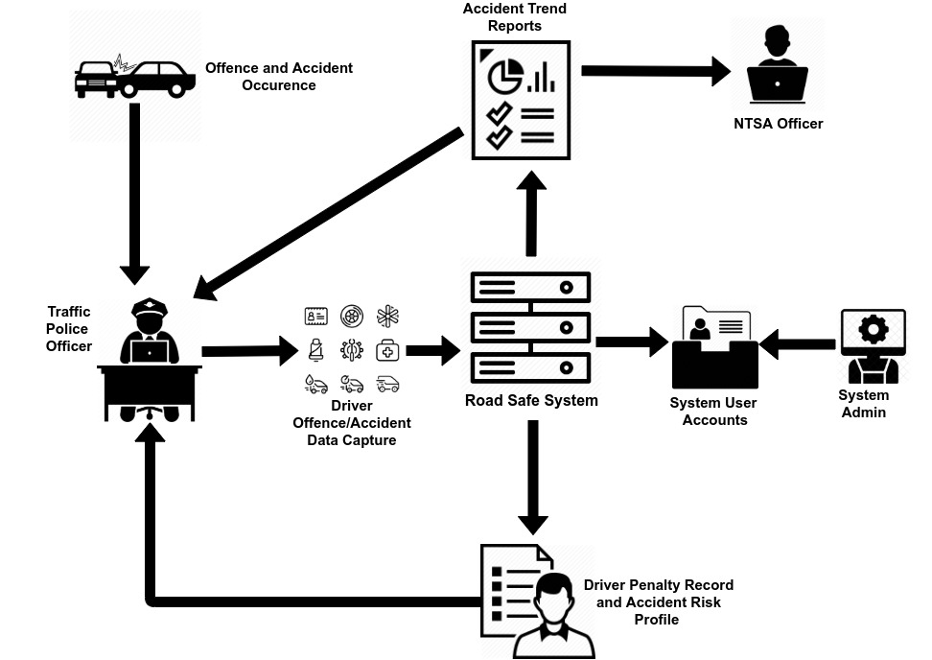

Figure 2.1 Conceptual Framework of the Road Safe System

# System Development Methodology

## Introduction

This chapter highlights the system development methodology that was used to develop Road Safe. It also summarizes the functional and non-functional requirements of the system, tools and techniques that were used, milestones, deliverables and the project schedule.

## Development Methodology

The system methodology used was the modified waterfall methodology. It is a variation of the traditional or pure waterfall methodology. It is flexible and encourages the use of other skilful practices such as iteration (Dennis et al, 2012)

### Modified Waterfall Methodology

Figure 3.1 shows a summary of the steps of the particular version used in developing the Road Safe system.

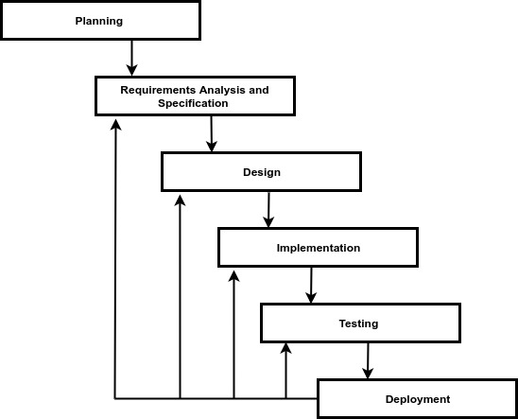

Figure 3. Modified Waterfall Methodology

#### Planning

In this phase, the developer determined the high-level objectives of the system and came up with a system proposal. The developer then determined the technical feasibility for developing the system. A work plan was devised. In addition, a realistic project schedule was developed in order to complete the system on time.

#### Requirements Analysis and Specification

In this phase, the developer focused on creating use cases, dataflow diagrams and an entity relationship diagram with accompanying narratives to document the functional requirements of the system and also understand the full scope of the system. Non functional requirements of the system were also derived.

#### Design

From the entity relationship diagram created in the requirements analysis and specification, a database design was produced which was then translated into a database schema. In addition, the user interface of the system was also designed using basic wire framing representing various interfaces of the web application such as the landing page and dashboard. This phase was iterated several times.

#### Implementation

In this phase, coding of the actual system was carried out. Due to various iterations in both the analysis and design phases, the system coding was also a very dynamic process.

#### Testing

Testing was undertaken to ensure the system met functional and non-functional requirements. Some system vulnerabilities and bugs were resolved.

#### Deployment

The full system was deployed in the developer’s computer mimicking the possible production environment of the system.

## Justification of Modified Waterfall Methodology

The modified waterfall methodology provides proper and well defined iterative steps in developing systems with unclear user requirements. It is also useful in developing systems that are reliable. Finally, it is a useful methodology for a single developer. (Algudah et al, 2015).

## Functional Requirements

These define the different functions of the system and their components.

### Authentication

Users are required to login into the system providing their security credentials (user name and password) to access the system. Each user has specific authorization level and has access only to the specific features pertinent to that level.

### Creation of Driver Records

Authorized and authenticated traffic police are able to create and view individual driver records. In addition, driver records can be edited.

### Creation of Offence Records

Traffic police are able to create an offence record for a driver who already exists in the system. The system subsequently updates the motorist’s driving profile awarding penalty points accordingly and raising the accident risk of the driver.

### Creation of Accident Records

In the case that an offence culminates in an accident, traffic police can create an accident record for an already existing driver that highlights the primary traffic violation leading to the crash. The motorist’s profile is then updated and penalty points awarded accordingly. The accident risk profile of the driver is also raised.

### Search

The system provides search functionality where users are able to search by a single parameter. In the single parameter search, a user can use parameters such as a driver’s name, license number or national identification number.

### Reports

The system can generate summary and trend reports on various types of driver and accident data. Report themes are Driver Gender Segmentation Statistics, Driver to Offence Report, Offences Leading to Accidents Report, Accidents Categorized by Accident Type, Accidents Categorized by Weather Conditions and Severity, Accidents Categorized by Road Surface Condition and Severity

### Creating and Managing User Accounts

The system administrator is able to create new users and subsequently assign user names and passwords. The system administrator can also be able to reset passwords and delete user accounts.

### Audit Trail

The system tracks the activities that each user does. For example, it keeps track of the login and logout times of each user, track the records a user created, edited or viewed.

## Non Functional Requirements

These constitute the intangible parts of the system.

### Availability

The system is available all the time to any device that has access to the internet. The system has a responsive interface as it can adapt to the various screen sizes of the vast array of internet enabled devices.

### Security

The system can only be accessed by users who are registered, authorized and authenticated. Also, privileges are assigned to the various users and functionality limited to the privilege of the user. The system is also able to withstand various types of SQL injection attacks as it uses prepared SQL statements to access the database.

## Tools and Techniques

A wide array of tools and techniques were used to develop the front and back end of the system.

### HTML 5

The mark-up language was used to give structure to the content of the web application.

### CSS 3

It was used to control the presentation of the web application pages including things like colours, layout and fonts. CSS allows the presentation to adapt to different view ports depending on the screen size whether large or small for different devices.

### JavaScript ES6

This is the client script language used for building the front end of the system to add dynamic functionality such as web page interactivity and animation. JavaScript libraries and frameworks such as jQuery were used to build the graphic user interface and provide seamless interactivity in the application.

### MySQL

It is the relational database management system to hold the data for the whole system. Data from the database was updated and manipulated by the Structured Query Language.

### PHP 7

This server side programming language was used to create the back end of the system. Interactivity that requires server connection such as connecting to a MySQL database server are provided by this language

### Apache HTTP Server

It is a web server that was used to run PHP scripts and generate the web pages for the whole application.

### Sublime Text

This was the Integrated Development Environment (IDE) of choice to write code.

## Milestones and Deliverables

This documents the different milestones and deliverables of each phase of the software development life cycle in relation to the system methodology used.

### Functional Requirements Specification

The detailed functional requirements of the system were documented using a use case diagram and supporting use case narratives.

### Database Design

In this milestone, the logical and physical designs of the database were developed. This process was iterated until the final database that meets all the data requirements was created.

#### Logical design

Once the database was conceptually designed, an entity relationship model was created detailing relationships between entities. An entity relationship diagram was created to visually represent the model.

#### Physical Database Design

Thephysical database model shows all table structures, including column name, column data type, column constraints, primary key, foreign key, and relationships between tables.

#### Database implementation

The physical database design was implemented in MySQL database management system software and the supporting software phpMyAdmin.

# System Analysis and Design

## Introduction

This chapter documents the analysis and design phases of the system development lifecycle. The paradigm that was followed is the Structured System and Analysis Design (SSAD) approach. This is because the system was developed through procedural programming techniques.

## Analysis Diagrams

In line with this approach, the system analyst developed the following diagrams in the analysis phase: use case diagram, context diagram, level 0 data flow diagram and entity relationship diagram.

### Use Case Diagram

The use case diagram is a graphic depiction of the interactions among the elements of the system which includes identifying the users of the system. The use case diagram was used to clarify and organize the system requirements. Figure 4.1 shows the use case diagram of the Road Safe System.

The use case diagram clearly identifies 3 users or actors who interact with the system. These are the Traffic Police Officer, NTSA officer and System Administrator. The Traffic Police Officer constitutes any authorized and authenticated investigating police officer who appends new accident records into the system. This user also includes supervising police officers who validate accident records for accuracy. In addition, the Traffic Police Officer can book errant drivers who commit offences and update their records. The NTSA Officer is an authorized and authenticated officer who is able to access the system and generate accident trend analysis reports for decision making and road policy formation. The System Administrator is in charge of creating user profiles and managing them. In addition, the System Administrator is able to check and monitor user activities. All users of the system are required to provide user credentials which include the username and password in order to login to the system and use it.

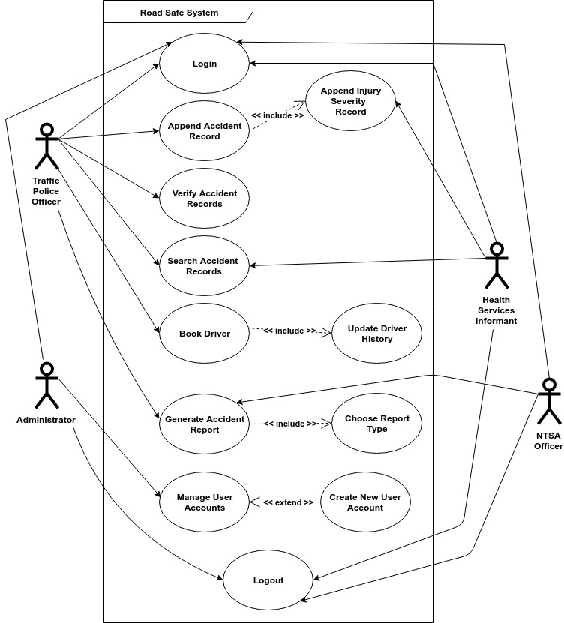

Figure 4.1 Use Case Diagram

### Data Flow Diagrams

Data Flow diagrams were used to map out the flow of information for various processes in the system. The data flow diagrams were decomposed into the context level diagram and level 0 data flow diagram. Gane and Sarson notation was used to represent the shapes.

#### Context Diagram

The context diagram shows the basic overview of the whole system. It shows the system as a single high-level process with its relationships to external entities. Figure 4.2 shows the context diagram of the Road Safe system.

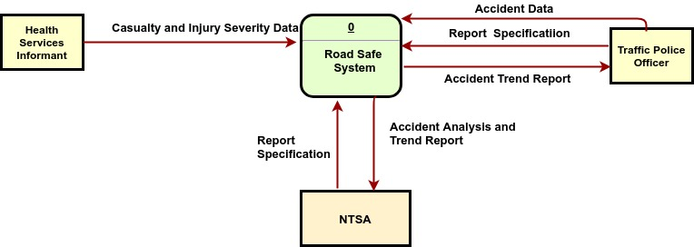

Figure 4.2Context Level Diagram

#### Level 0 Data Flow Diagram

The level 0 data flow diagram is more detailed than the context diagram. It breaks the system down to the main processes that can be analysed and improved on a more intricate level.Figure 4.3 highlights the Level 0 data flow diagram of the Road Safe system decomposed to 5 processes.

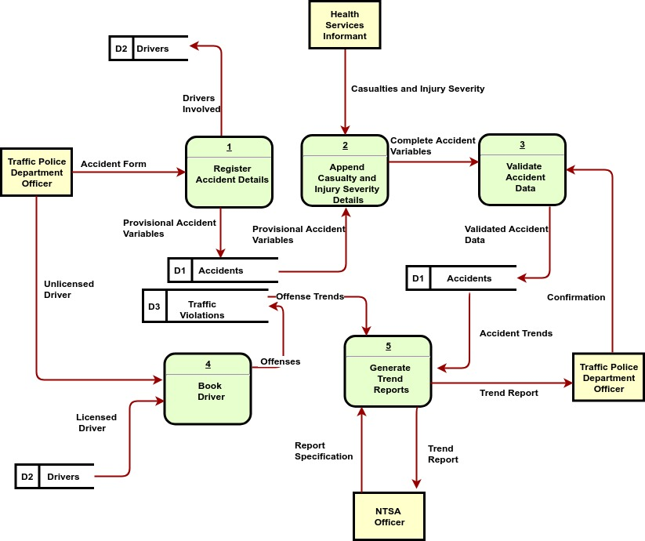

Figure 4.3 Level 0 Data Flow Diagram

### Entity Relationship Diagram

The entity relationship diagram illustrates the logical structure of a database. It is used to sketch out the design of the database. It highlights the relationships that exist between entities. The diagram was used to visualize how the accident data is connected in a general way in order to construct the relational database for the system. Figure 4.4 shows the entity relationship for the Road Safe system. 6 entities were identified with the main attribute for each entity clearly underlined. Not all attributes for each entity are highlighted.

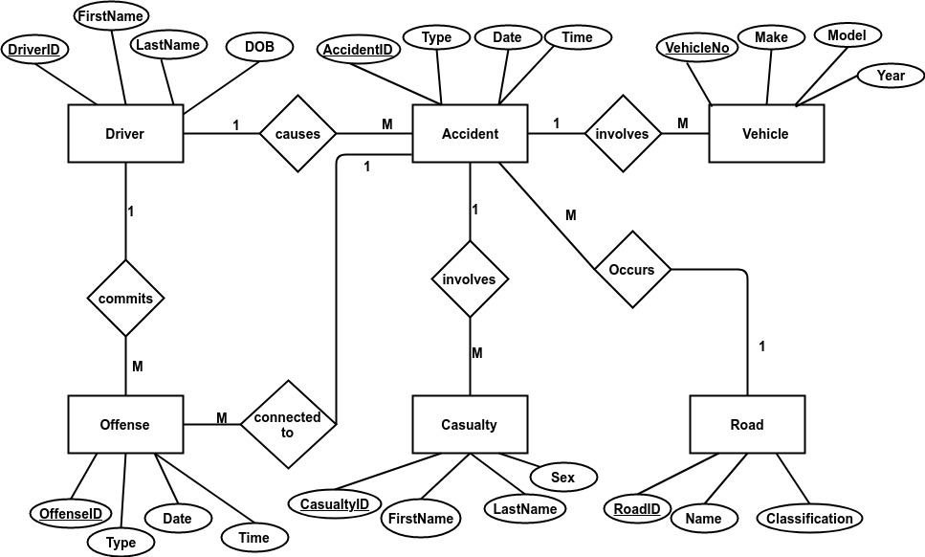

Figure 4.4 Entity Relationship Diagram

## Design Diagrams

In the design phase, the following diagrams were drafted: database schema and system architecture diagram

### Database Schema

A database schema is a collection of metadata that describes the relationships between objects and information in a database. The database schema was derived from the entity relationship diagram. Figure 4.5 shows the database schema of the system. It highlights the table structures, including column name, column data type, column constraints, primary keys, foreign keys, and relationships between tables.

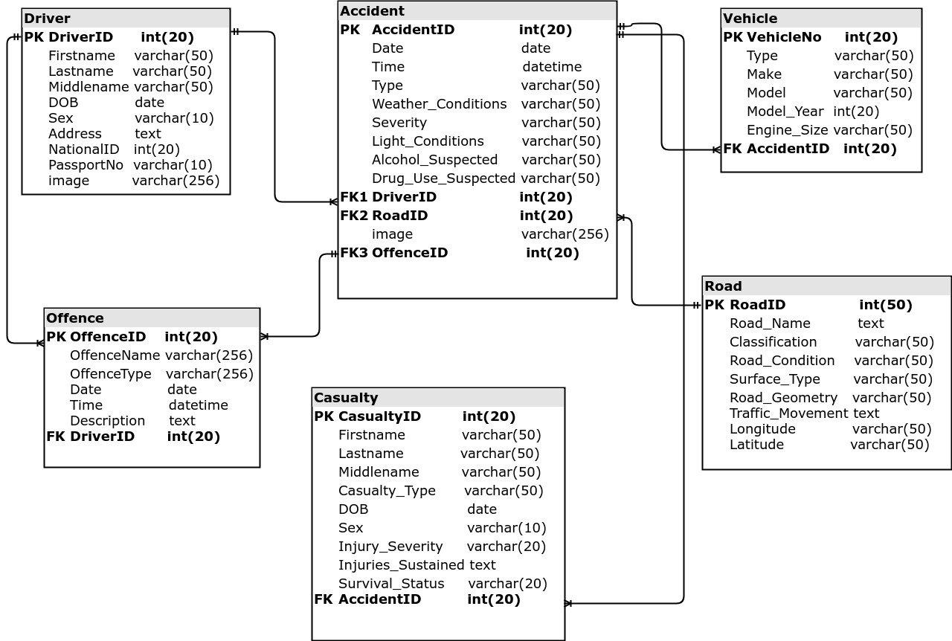

Figure 4.5 Database Schema

### System Architecture

System architecture is a conceptual model that defines the structure, behaviour and more views of a system. It consists of system components such as hardware and software that work together to implement the overall system. Figure 4.6 shows a simple system architecture diagram of that represents the Road Safe system.

The user accesses the web application through a browser on a mobile phone, tablet or computer. The user types the URL of the web application and hits go. The page request is then sent to the Apache Web Server. The web server then collects the requested page from the document root. The web server will then send content of the file to the PHP interpreter and execute the PHP code. If there is a database query within the PHP file, it is executed and transacted via the MySQL database management system and data retrieved from the database in accordance to the query. The interpreter then generates the output and Apache sends the content to the browser where it is rendered on the user’s screen according to their device view port. Static components such as CSS, image files, JavaScript files do not need to be executed by the PHP interpreter as they are immediately handled by the browser.

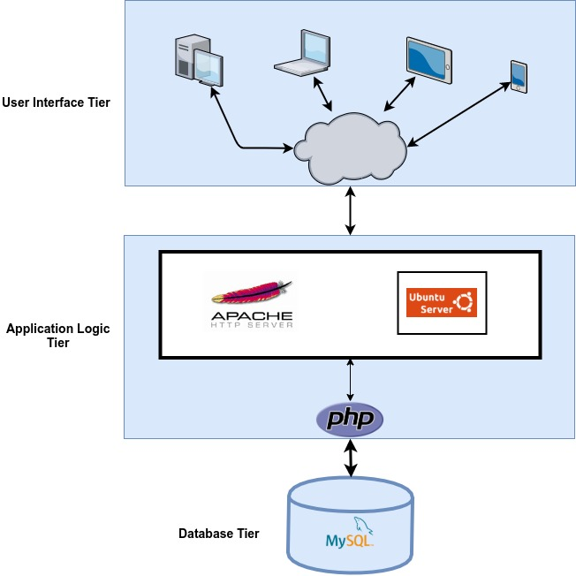

Figure 4.6 System Architecture

# System Implementation and Testing

## Introduction

This chapter summarizes how the system was created including the physical design, hardware specifications, software specifications and dependencies. In addition, the chapter details how the system met quality standards through testing.

## Description of Implementation Environment

This section provides an overview of the hardware and software specifications that were required for the system to be implemented and to be fully operational.

### Hardware Specifications

The most important considerations that were taken into account for specifying the hardware requirements pertained to the functionality of the web and database servers.   
These require higher hardware specifications. Table 5.1 provides a brief summary of the minimum hardware requirements to implement and execute the system.

Table 5.1 Hardware Specifications (Minimal and Recommended)

|  |  |  |
| --- | --- | --- |
| **Item** | **Minimal Specifications (Combined Web and Database Server)** | **Recommended Specifications (Combined Web and Database Server)** |
| **Processor** | 2 x 1.6 GHZ CPU | 4 x 1.6 GHZ |
| **RAM** | 3.5 GB | 7 GB |
| **Hard Disk Storage** | 1 x 40 GB of free space or more is recommended for the software listed in the software requirements | |

Table 5.2 shows the hardware specifications of the computer used to develop and test the Road Safe system.

Table 5.2 Developer’s Computer Specifications

|  |  |
| --- | --- |
| **Item** | **Specifications** |
| **Processor** | 4 x 2.50 GHZ Intel Core i5 CPU |
| **RAM** | 8 GB |
| **Hard Disk Storage** | 750 GB |

From the foregoing, the developer’s computer met all the minimum and recommended specifications in order to develop and test the system.

### Software Specifications

The system was developed for a traditional LAMP (Linux, Apache, MySQL, PHP) environment.

#### Operating System

Road Safe was designed to run in a standard Linux operating/file system. The system was developed within the Ubuntu Linux 18.04 Long Term Support (LTS) operating system. It is possible to run the system in a Windows environment. However, file system restrictions or inherent behaviours arcane to that environment will have to be taken into consideration.

#### Web Server

Road Safe was designed to work with Apache Web Server version 2.x. There are no special Apache configurations required to run the Road Safe System.

#### Database Server

Road Safe was designed to work with the MySQL relational database management system. It also works reasonably well in the community forked version of MySQL, MariaDB version 10.1.x. Road Safe was designed to be compatible with MySQL version 8.x.

For the system to run efficiently certain grant privileges are required to be active. These are: DELETE, INSERT, SELECT, UPDATE and LOCK TABLES. In addition, the system utilizes the PDO database API.

#### Dependencies

Road Safe utilizes AdminLTE which is a popular open source web application template for admin dashboards and control panels. In addition, a number of plug-ins as highlighted in Table 5.3 are required for Admin LTE to function appropriately to produce a rich user experience.

Table 5.3 User Interface Dependencies

|  |  |
| --- | --- |
| **Plug-in** | **Description** |
| Datepicker | A JavaScript library with supporting CSS styling that provides a flexible date picker widget in the Bootstrap style. |
| Timepicker | A JavaScript plug-in that provides a simple time picking component in Bootstrap style. |
| ICheck | A JavaScript plug-in that provides identical HTML inputs across all major browsers and devices on both desktop and mobile. |
| DataTables | A plug-in for the jQuery JavaScript library that provides highly advanced features for HTML tables from any client or server-side data source such as search functionality, pagination and multi-column ordering. |

## Description of Testing

Software testing is a verification process for quality assessment and improvement. Quality in the context of the Road Safe system refers to whether the system satisfied user needs and expectations. Quality was therefore assessed to see whether the system conformed to the defined functional and non-functional requirements. The objectives of testing the system included finding out whether the system worked correctly (positive testing), finding faults in the system by trying to make parts fail (negative testing) and reducing the risk of system failure.

### Testing Paradigm

The main testing paradigm used was black box testing. In the context of the system, the actual program execution was examined to expose possible failures. Observances of behavioural and performance properties was also undertaken. Both typical and carefully chosen input values were provided as test data to check form behaviour.

Black box testing was chosen to simply establish that the web application meets its intended use from the viewpoint of the system users who don’t need to know the intricate inner workings of the system. However, some limited white box testing was undertaken to ensure that MySQL queries used in generating reports worked as intended.

### Subset of Functional and Non Functional Requirements Tested

Testing was undertaken to ascertain that various aspects of the already defined functional and non-functional requirements were met.

#### Authentication

Positive and negative value inputs were used to check the login functionality. Logout functionality was also tested to find out whether user sessions were deleted. Authorization levels of various user roles were also examined to find out whether defined functionality did not overlap with one another. For example, a user whose user role is defined as police cannot be able to access functionality of a user defined as an admin.

#### Creation of Driver Records

Data validation on the various form HTML inputs were undertaken to ensure that data being inserted into the database is of the proper format. Text fields such as driving license number and national number must be unique and thus these fields were tested to ensure that if a user attempts to enter a number that is already in existence in the system an error message is generated. In addition, text fields such as first name, last name and middle name were tested to ensure that the only accept one name type each.

#### Search

Road Safe System provides a general text filtering functionality to be able to search for a particular driver’s information. The search functionality was tested to see whether it could search the first name, last name or middle name of a driver individually or all the three parameters together in aggregate. Also, it was tested to see whether it could effectively filter driver information based on unique parameters such as license number or national identification number.

#### Reports

The system produces 2 driver related reports and 6 accident related reports. All were tested when driver and accident records were appended to the system to see whether there was discernable change in the reports.

#### Security

Security is as a non-functional requirement. Security was tested on the basis of basic SQL injection attacks and cross side scripting attacks to ensure the integrity and confidentiality of system data and also ensure user sessions cannot be hijacked.

#### Availability

As a non-functional requirement, availability was tested based on the responsiveness of the web application when displayed on various view-port sizes corresponding to the wide array of device screen sizes including laptops, tablets and wide screen smart phones.

## Testing Results

Testing results are shown in terms of functional and non-functional requirements as previously outlined.

### Authentication

Table 5.4 summarizes the test cases that were executed for authentication and the subsequent results thereafter.

Table 5.4 Authentication Test Results

|  |  |  |  |  |  |
| --- | --- | --- | --- | --- | --- |
| **Test Case #** | **Description** | **Test Data** | **Expected Outcome** | **Actual Result** | **Status (Pass/Fail)** |
| 1 | Verify if user will be able to login with a valid username and password | Username is ‘Steve05’ and password is ‘Steve05’ | User will be directed to dashboard and successfully logged in | As Expected | Pass |
| 2. | Verify that user cannot login with a valid username and invalid password | Username is ‘Steve05’ and password ‘389383su’ | User alerted of invalid username/password combination | As Expected | Pass |
| 3. | Verify that user cannot login with an invalid username and valid password | Username is ‘Steve06’ and password ‘Steve05’ | User alerted of invalid username/password combination | As Expected | Pass |
| 4. | Verify login when the username and password are left blank and submit button clicked | Username and password fields empty | Text tool tip alerts user to input a username | As Expected | Pass |

### Creation of Driver Records

Table 5.5 shows the tests and results carried out to ascertain form inputs when creating a new driver record.

Table 5.5 New Driver Creation Test Results

|  |  |  |  |  |  |
| --- | --- | --- | --- | --- | --- |
| **Test Case #** | **Description** | **Test Data** | **Expected Outcome** | **Actual Result** | **Status (Pass/Fail)** |
| 6. | Verify that the National ID field only accepts unique numbers | 333020 which already exists in the database | Error message indicating that the national ID number already exists in the database generated | As Expected | Pass |
| 7. | Verify that Driving License field only accepts unique numbers | ‘RXM118’ which already exists in the database | Error message indicating that the driving license number already exists in the database is generated | As Expected | Pass |
| 8. | Verify that First Name field only accepts a single name and does not allow user to add other names other than the first name | ‘Stephen Nandi’ | User alerted that the first name format is invalid when submit button is clicked. | As Expected | Pass |

### Search

Table 5.6 shows the tests undertaken to ensure that the search functionality worked as intended.

Table 5.6 Search Functionality Testing and Results

|  |  |  |  |  |  |
| --- | --- | --- | --- | --- | --- |
| **Test Case #** | **Description** | **Test Data** | **Expected Outcome** | **Actual Result** | **Status (Pass/Fail)** |
| 9. | Verify the search functionality can filter information when first name, middle name and last name are supplied as inputs | ‘Stephen Maringu Nandi’ | Display truncated information of all persons with the name ‘Stephen Maringu Nandi’ who exist in the database | As Expected | Pass |
| 10. | Verify the search functionality can search for a particular national ID number that exists in the database | 333020 | Display truncated driver information of the motorist whose national ID is 333020 | As Expected | Pass |

### Availability

Table 5.7 shows the testing undertaken to prove that the user interface of the system can scale to fit the viewport size of the multitude of devices available.

Table 5.7 User Interface Responsiveness Testing

|  |  |  |  |  |  |
| --- | --- | --- | --- | --- | --- |
| **Test Case #** | **Description** | **Test Data** | **Expected Outcome** | **Actual Result** | **Status (Pass/Fail)** |
| 11. | Verify the user interface scales to fit screen of small devices with a viewport size of 576 pixels or less | Browser size scaled down to represent small device with width of 576px | Menus, Tables, Images and other user interface elements arranged in a stack to allow for efficient presentation of information | As Expected | Pass |
| 12. | Verify the user interface scales to fit screen of medium devices with a viewport size of 768 pixels or less | Browser size scaled down to represent small device with width of 768px | User interface elements stacked or scaled to a minimum of 60% of actual size | As Expected | Pass |

# Conclusions, Recommendations and Future Works

## Conclusions

Most road safety data systems that were reviewed only address final outcomes of accidents. Road Safe has been able to address some of the intermediate outcomes of accidents and analyse this in greater detail. For example, the road safe system takes into consideration how a driver’s traffic violation or offence history can determine the risk of that driver getting into an accident in the future by profiling him using a penalty point system and assigning a weighted mean on each of the driver’s specific offences.

Road Safe also analyses which specific driver offences give rise to the most accidents on the roads which is not adequately addressed in the road safety systems reviewed. This is an important aspect in road safety as policy makers can make changes in regulations that curb those specific offences in earnest and thereby reduce road carnage.

## Recommendations

Road Safe was tested and deployed on an Apache HTTP web server which unfortunately uses more resources than nginx by default and cannot handle as many visitors at the same time. It is recommended that the Road Safe system be deployed on an nginx web server in a production environment for best performance and efficiency.

The system was also developed in a PHP 7 environment with some backward compatibility to PHP 5.6. However, for the best user experience, the production server should have at least PHP 7.0.1 installed as a minimum.

## Future Works

The main users of the system are the Traffic Police and NTSA. However, individual drivers need to be aware of their driving records so that they can be adequately informed of their status and subsequently improve their driving habits to avoid further penalties and suffer the ramifications. Thus, it would be imperative to have a driver module where motorists can log into their individual accounts, view their records and even appeal to the relevant authorities through the system should there be a discrepancy in the records. Motor insurance companies can also be part of the system where they can be able to view the driving records of their clients and decide which premiums drivers should pay based on their accident risk profile

References

Abudulhafedh, A. (2017). *Road Traffic Crash Data: An Overview on Sources, Problems, and Collection Methods*. Retrieved from <http://doi.org/10.4236/>

Algudah, M. (2015). *Agile Methods for Software Engineering Student Projects: A Proposed Hybrid Methodology*. Retrieved from <https://www.researchgate.net/publication/316943277_Agile_Methods_for_Software_Engineering_Students_Project_A_Proposed_Hybrid_Methodology>

Asingo, P.O. (2004). The Institutional and Organizational Structure of Public Road Transport

In Kenya. IPAR

Dennis A., Wixom B.H., Roth R.M., (2012). *Systems Analysis and Design*. 5th Edition. USA: John Wiley and Sons Inc.

Derdus K.M., Ozianyi V.M. (2015). *A Mobile Solution for Road Accident Data Collection*. Retrieved from https://su-plus.strathmore.edu/bitstream/handle/11071/3793/A%20Mobile%20Solution%20for%20Road%20Accident%20Data.pdf?sequence=1&isAllowed=y

Essays, UK. (November 2018). *The Road Traffic Crash Data System in Kenya*. Retrieved from <https://www.ukessays.com/essays/economics/road-traffic-crash-data-system-in-kenya-economics-essay.php?vref=1>

Kagwe, W. (2010, November 4). Tracking System Set to Rein in Errant Drivers. *Daily Nation.* Retrieved from <https://www.nation.co.ke/business/Tracking-system-set-to-rein-in-errant-drivers/996-1046820-15auiadz/index.html>

Kual A., Sinha VS., Pathak YK., Singh A., Kopoor AK., Sharma S., Singh S. (2005). *Fatal Road Traffic Accidents, Study of Distribution, Nature and Type of Injury.* JIAFM

National Transport and Safety Authority (2019). *Accidents Statistics.* Retrieved from <http://www.ntsa.go.ke/index.php?option=com_content&view=article&id=213&Itemid=706>

National Transport and Safety Authority (2012). *About Us*. Retrieved from <http://www.ntsa.go.ke/index.php?option=com_content&view=article&id=71&Itemid=468>

National Transport and Safety Authority (2015). Draft National Road Safety Action Plan 2015-2010. Retrieved from ntsa.go.ke/docs/DRAFT NATIONAL ROAD SAFETY ACTION PLAN 2018-2023-DKK.pdf

World Health Organization (2018, May 24). *The Top Ten Causes of Death*. Retrieved from <https://www.who.int/news-room/fact-sheets/detail/the-top-10-causes-of-death>

World Health Organization (2012). *Road Safety in Kenya*. Retrieved from https://www.who.int/violence_injury_prevention/road_traffic/countrywork/ken/en/

# Appendix

Gantt chart showing the system schedule for the project

