STAGE 3 · YEAR B · UNIT 23 Length & Time · Pre-test / Post-test | WORD LABS SOLO

Name __________________ | Class __________________ | Date __________________

RED — Foundation R1–R4
R1 measure length with metres and kilometres  Answer the following about length.  a) 1 kilometre = ____ metres. ________  b) Which unit is best for the length of a pencil? ____________  c) Which unit is best for the distance between two towns? ____________ | R2 calculate perimeter of squares, rectangles and triangles  Find the perimeter of each shape.  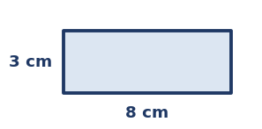  a) Rectangle (8 cm by 3 cm): perimeter = __________  b) A square with sides of 5 cm: perimeter = __________  c) A triangle with sides 4 cm, 6 cm and 7 cm: perimeter = ____________
R3 record and interpret lengths in decimal notation  Record each length in the unit shown.  a) 1 m 25 cm in metres = __________  b) 250 cm in metres = __________  c) 6 mm in centimetres = __________  d) 1500 m in kilometres = __________ | R4 read and convert 12- and 24-hour time  Convert between 12- and 24-hour time.  a) Write 3:30 pm in 24-hour time. __________  b) Write 08:15 in 12-hour time. ____________  c) Write 21:45 in 12-hour time. __________

YELLOW — On-level Y1–Y5
Y1 convert between metric units of length  Convert each length.  a) 3 m = __________  b) 4.5 km = __________  c) 2500 mm = __________  d) 0.75 m = __________ | Y2 find side lengths needed and calculate perimeter  Answer the following about perimeter.  a) A rectangle has a perimeter of 20 cm and one side of 6 cm. What is the other side?  Answer: __________  b) An equilateral triangle has a perimeter of 21 cm. How long is each side?  Answer: __________
Y3 compare perimeter and area of rectangles  Two rectangles each have a perimeter of 16 cm.  a) A 6 cm × 2 cm rectangle has area __________  b) A 5 cm × 3 cm rectangle has area __________  c) Same perimeter, but the areas are ____________ | Y4 calculate elapsed time  Calculate each elapsed time.  a) From 9:20 am to 11:05 am.  Answer: ________________  b) From 2:40 pm to 4:10 pm.  Answer: ________________
Y5 read timetables and solve duration problems
Answer the following about durations.
a) A bus leaves at 10:15 and arrives at 11:50. How long is the journey?
Answer: ______________
b) A train leaves at 13:40 and the trip takes 50 minutes. What time does it arrive?
Answer: __________

GREEN — Extension G1–G3
G1 area and composite area
Find each area. Show your working.
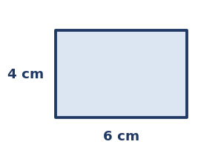
a) Rectangle (6 cm by 4 cm): Area = __________
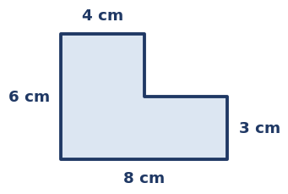
b) L-shaped figure: Area = ____________
G2 distance, speed and time (rates)
Solve each problem. Show your working.
a) A car travels 120 km in 2 hours. What is its speed?
Answer: __________
b) At 50 km/h, how far do you travel in 3 hours?
Answer: __________
G3 interpret distance-time graphs
Use the distance-time graph to answer.
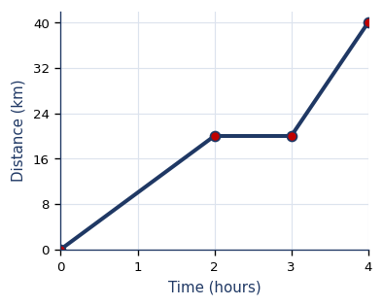
a) How far had the cyclist travelled after 2 hours? __________
b) During which part is the cyclist resting (not moving)? ________________
c) Total distance travelled after 4 hours? __________

STAGE 3 · YEAR B · UNIT 23 Length & Time · Pre-test / Post-test | WORD LABS SOLO

ANSWER KEY · teacher reference — do not print for students

RED — Foundation R1–R4
R1 measure length with metres and kilometres  Answer the following about length.  a) 1 kilometre = ____ metres. 1000  b) Which unit is best for the length of a pencil? centimetres  c) Which unit is best for the distance between two towns? kilometres | R2 calculate perimeter of squares, rectangles and triangles  Find the perimeter of each shape.    a) Rectangle (8 cm by 3 cm): perimeter = 22 cm  b) A square with sides of 5 cm: perimeter = 20 cm  c) A triangle with sides 4 cm, 6 cm and 7 cm: perimeter = 17 cm
R3 record and interpret lengths in decimal notation  Record each length in the unit shown.  a) 1 m 25 cm in metres = 1.25 m  b) 250 cm in metres = 2.5 m  c) 6 mm in centimetres = 0.6 cm  d) 1500 m in kilometres = 1.5 km | R4 read and convert 12- and 24-hour time  Convert between 12- and 24-hour time.  a) Write 3:30 pm in 24-hour time. 15:30  b) Write 08:15 in 12-hour time. 8:15 am  c) Write 21:45 in 12-hour time. 9:45 pm

YELLOW — On-level Y1–Y5
Y1 convert between metric units of length  Convert each length.  a) 3 m = 300 cm  b) 4.5 km = 4500 m  c) 2500 mm = 2.5 m  d) 0.75 m = 75 cm | Y2 find side lengths needed and calculate perimeter  Answer the following about perimeter.  a) A rectangle has a perimeter of 20 cm and one side of 6 cm. What is the other side?  Answer: 4 cm  b) An equilateral triangle has a perimeter of 21 cm. How long is each side?  Answer: 7 cm
Y3 compare perimeter and area of rectangles  Two rectangles each have a perimeter of 16 cm.  a) A 6 cm × 2 cm rectangle has area 12 cm²  b) A 5 cm × 3 cm rectangle has area 15 cm²  c) Same perimeter, but the areas are different | Y4 calculate elapsed time  Calculate each elapsed time.  a) From 9:20 am to 11:05 am.  Answer: 1 hour 45 minutes  b) From 2:40 pm to 4:10 pm.  Answer: 1 hour 30 minutes
Y5 read timetables and solve duration problems
Answer the following about durations.
a) A bus leaves at 10:15 and arrives at 11:50. How long is the journey?
Answer: 1 hour 35 minutes
b) A train leaves at 13:40 and the trip takes 50 minutes. What time does it arrive?
Answer: 14:30

GREEN — Extension G1–G3
G1 area and composite area
Find each area. Show your working.

a) Rectangle (6 cm by 4 cm): Area = 24 cm²

b) L-shaped figure: Area = 36 cm²
G2 distance, speed and time (rates)
Solve each problem. Show your working.
a) A car travels 120 km in 2 hours. What is its speed?
Answer: 60 km/h
b) At 50 km/h, how far do you travel in 3 hours?
Answer: 150 km
G3 interpret distance-time graphs
Use the distance-time graph to answer.

a) How far had the cyclist travelled after 2 hours? 20 km
b) During which part is the cyclist resting (not moving)? the flat section (2-3 h)
c) Total distance travelled after 4 hours? 40 km

