STAGE 3 · YEAR B · UNIT 28 Position & Chance · Pre-test / Post-test | WORD LABS SOLO

Name __________________ | Class __________________ | Date __________________

RED — Foundation R1–R3
R1 plot and label points from coordinates in the first quadrant, and read the coordinates of given points
Use the grid, then answer the questions.
a) Plot and label these points: A(3, 2) B(5, 4) C(1, 5)
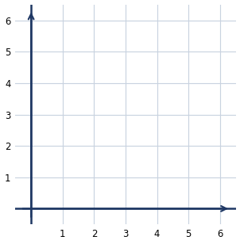
b) The point where the two axes meet is the origin. Its coordinates are __________
c) In the coordinate (4, 2), which number gives the horizontal position? ________
R2 recognise when the outcomes of a chance experiment are equally likely
Answer the following about chance.
a) When you roll a fair six-sided die, are all six outcomes equally likely? ________
b) A bag holds 3 red and 1 blue marble. Is drawing red or blue equally likely? ________
c) Explain what 'equally likely' means.
____________________________________________
R3 represent the probability of an outcome of a chance experiment as a fraction
Write each probability as a fraction.
a) Rolling a 4 on a fair six-sided die: ________
b) Rolling an even number on a fair die: ____________
c) Drawing a red marble from a bag of 2 red and 3 blue: ________
d) Flipping heads on a fair coin: ________

STAGE 3 · YEAR B · UNIT 28 Position & Chance · Pre-test / Post-test | WORD LABS SOLO

YELLOW — On-level Y1–Y6
Y1 plot, label and read points in all four quadrants of the number plane  Use the grid to answer the questions.  a) Plot and label: P(−3, 2) Q(2, −4)  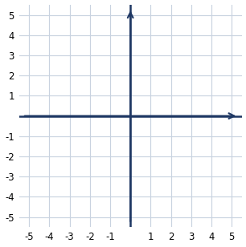  b) In which quadrant is the point (3, −2)? __________  c) In which quadrant is the point (−4, 5)? __________ | Y2 describe how a point's coordinates change when it is translated across an axis  Point A is shown on the grid below.  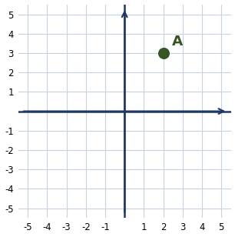  a) A is translated 4 right. New coordinates: __________  b) A is translated 3 down. New coordinates: __________  c) When a point moves left or right, which coordinate changes? ____________
Y3 describe how a point's coordinates change when it is reflected across an axis  Point A(3, 4) is shown. The x-axis is marked in red.  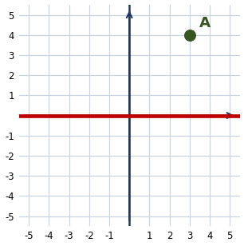  a) Reflect A across the x-axis. New coordinates: __________  b) Reflect A across the y-axis. New coordinates: __________  c) Reflecting across the x-axis changes the sign of which coordinate? ____________ | Y4 create random generators to follow set probabilities, and assign probabilities using fractions, decimals and percentages  A blank spinner with 8 equal sections is shown.    a) Shade the spinner so red comes up half the time. How many sections is that?  Answer: __________  b) Write the probability 1/4 as a percentage. ________
Y5 assign probabilities as fractions to outcomes that are not equally likely  This spinner has 10 equal sections: 2 red, 3 blue and 5 green. Write each probability as a fraction.  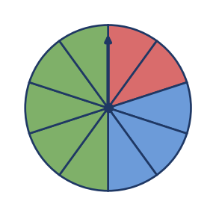  a) P(red) = __________  b) P(blue) = ________  c) P(green) = __________ | Y6 compare expected and observed frequencies over small and large numbers of trials, and sample with replacement  Answer the following about expected and observed frequency.  a) A fair coin is flipped 50 times. About how many heads would you expect?  Answer: __________  b) A fair die is rolled 60 times. About how many times would you expect a 3?  Answer: __________  c) Do observed results usually match the expected results more closely over many trials or few trials? ______________

STAGE 3 · YEAR B · UNIT 28 Position & Chance · Pre-test / Post-test | WORD LABS SOLO

GREEN — Extension G1–G3
G1 plot points with non-whole coordinates and recognise linear relationships across rules, tables, coordinate pairs and graphs
Answer the following about the rule y = x + 1.
a) Complete the table of values for y = x + 1.
x | 0 | 1 | 2 | 3
y
b) The point (2.5, 3) is plotted. Between which two whole numbers on the x-axis does it sit? ____________
c) In the rule y = x + 1, what is y when x = 10? ________
G2 list the sample space and express the probability of an event as favourable ÷ total, on the 0-1 scale
A fair six-sided die is rolled.
a) List the sample space (all possible outcomes). ______________________
b) P(rolling a number greater than 4) = ____________
c) On the 0-1 scale, what is the probability of a certain event? ________
d) The probabilities of all outcomes in a sample space add up to ________
G3 compare theoretical (expected) probability with observed probability (relative frequency) from repeated trials
Answer the following.
a) The theoretical probability of rolling a 2 on a fair die is ________
b) A die is rolled 30 times and a 2 comes up 7 times. Write the observed probability (relative frequency) as a fraction.
Answer: __________
c) Why might the observed probability be different from the theoretical probability?
____________________________________________

STAGE 3 · YEAR B · UNIT 28 Position & Chance · Pre-test / Post-test | WORD LABS SOLO

ANSWER KEY · teacher reference — do not print for students

RED — Foundation R1–R3
R1 plot and label points from coordinates in the first quadrant, and read the coordinates of given points
Use the grid, then answer the questions.
a) Plot and label these points: A(3, 2) B(5, 4) C(1, 5)

b) The point where the two axes meet is the origin. Its coordinates are (0, 0)
c) In the coordinate (4, 2), which number gives the horizontal position? 4
R2 recognise when the outcomes of a chance experiment are equally likely
Answer the following about chance.
a) When you roll a fair six-sided die, are all six outcomes equally likely? yes
b) A bag holds 3 red and 1 blue marble. Is drawing red or blue equally likely? no
c) Explain what 'equally likely' means.
→ Each outcome has the same chance of happening.
R3 represent the probability of an outcome of a chance experiment as a fraction
Write each probability as a fraction.
a) Rolling a 4 on a fair six-sided die: 1/6
b) Rolling an even number on a fair die: 3/6 (or 1/2)
c) Drawing a red marble from a bag of 2 red and 3 blue: 2/5
d) Flipping heads on a fair coin: 1/2

STAGE 3 · YEAR B · UNIT 28 Position & Chance · Pre-test / Post-test | WORD LABS SOLO

YELLOW — On-level Y1–Y6
Y1 plot, label and read points in all four quadrants of the number plane  Use the grid to answer the questions.  a) Plot and label: P(−3, 2) Q(2, −4)    b) In which quadrant is the point (3, −2)? fourth  c) In which quadrant is the point (−4, 5)? second | Y2 describe how a point's coordinates change when it is translated across an axis  Point A is shown on the grid below.    a) A is translated 4 right. New coordinates: (6, 3)  b) A is translated 3 down. New coordinates: (2, 0)  c) When a point moves left or right, which coordinate changes? the x-coordinate
Y3 describe how a point's coordinates change when it is reflected across an axis  Point A(3, 4) is shown. The x-axis is marked in red.    a) Reflect A across the x-axis. New coordinates: (3, −4)  b) Reflect A across the y-axis. New coordinates: (−3, 4)  c) Reflecting across the x-axis changes the sign of which coordinate? the y-coordinate | Y4 create random generators to follow set probabilities, and assign probabilities using fractions, decimals and percentages  A blank spinner with 8 equal sections is shown.    a) Shade the spinner so red comes up half the time. How many sections is that?  Answer: 4 sections  b) Write the probability 1/4 as a percentage. 25%
Y5 assign probabilities as fractions to outcomes that are not equally likely  This spinner has 10 equal sections: 2 red, 3 blue and 5 green. Write each probability as a fraction.    a) P(red) = 2/10 (or 1/5)  b) P(blue) = 3/10  c) P(green) = 5/10 (or 1/2) | Y6 compare expected and observed frequencies over small and large numbers of trials, and sample with replacement  Answer the following about expected and observed frequency.  a) A fair coin is flipped 50 times. About how many heads would you expect?  Answer: about 25  b) A fair die is rolled 60 times. About how many times would you expect a 3?  Answer: about 10  c) Do observed results usually match the expected results more closely over many trials or few trials? many trials

STAGE 3 · YEAR B · UNIT 28 Position & Chance · Pre-test / Post-test | WORD LABS SOLO

GREEN — Extension G1–G3
G1 plot points with non-whole coordinates and recognise linear relationships across rules, tables, coordinate pairs and graphs
Answer the following about the rule y = x + 1.
a) Complete the table of values for y = x + 1.
x | 0 | 1 | 2 | 3
y | 1 | 2 | 3 | 4
b) The point (2.5, 3) is plotted. Between which two whole numbers on the x-axis does it sit? 2 and 3
c) In the rule y = x + 1, what is y when x = 10? 11
G2 list the sample space and express the probability of an event as favourable ÷ total, on the 0-1 scale
A fair six-sided die is rolled.
a) List the sample space (all possible outcomes). 1, 2, 3, 4, 5, 6
b) P(rolling a number greater than 4) = 2/6 (or 1/3)
c) On the 0-1 scale, what is the probability of a certain event? 1
d) The probabilities of all outcomes in a sample space add up to 1
G3 compare theoretical (expected) probability with observed probability (relative frequency) from repeated trials
Answer the following.
a) The theoretical probability of rolling a 2 on a fair die is 1/6
b) A die is rolled 30 times and a 2 comes up 7 times. Write the observed probability (relative frequency) as a fraction.
Answer: 7/30
c) Why might the observed probability be different from the theoretical probability?
→ With few trials, results vary by chance; over many trials the observed probability gets closer to the theoretical.

