STAGE 3 · YEAR B · UNIT 30 Angles & Time · Pre-test / Post-test | WORD LABS SOLO

Name __________________ | Class __________________ | Date __________________

RED — Foundation R1–R4
R1 measure angles up to 360° using a protractor  Use your protractor to measure each angle. Write the size in degrees.  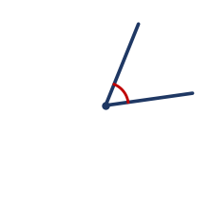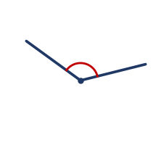  a) Angle a (left) = ________  b) Angle b (right) = ________ | R2 estimate angles using benchmarks and record using the degrees symbol (°)  Estimate the size of the angle using benchmarks. Do not measure it.  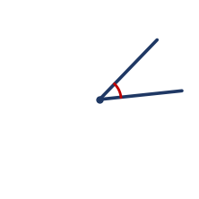  a) My estimate is about ________  b) Is the angle more or less than a right angle? ________  c) An angle smaller than 90° is called __________
R3 create angles with a protractor and classify them as acute, obtuse or reflex  Classify each angle as acute, obtuse or reflex.  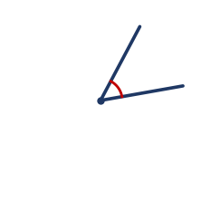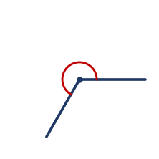  a) The left angle is __________  b) The right angle is __________  c) An angle between 90° and 180° is called __________ | R4 compare 12- and 24-hour time, convert between them, and read and use timetables  Answer the following about 12- and 24-hour time.  a) Write 3:45 pm in 24-hour time. __________  b) Write 07:20 (24-hour) in 12-hour time. ____________  c) Write 21:00 in 12-hour time. __________  d) A bus leaves at 14:10. Write this in 12-hour time. __________

YELLOW — On-level Y1–Y6
Y1 perpendicular lines meet at right angles; identify angle types formed by intersecting lines  Answer the following about angles formed by lines.  a) Two lines that cross at 90° are called ______________  b) Angles on a straight line add to ________  c) Angles at a point (a full turn) add to ________ | Y2 recognise right angles, angles on a straight line and angles at a point in diagrams  Use the diagram, then answer.  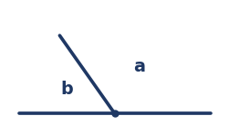  a) Angles a and b lie on a straight line. They add to ________  b) The symbol used to mark a right angle is a small ____________
Y3 adjacent angles add to 90° and 180°; find a missing adjacent angle  Find the missing angle in each diagram.  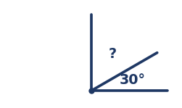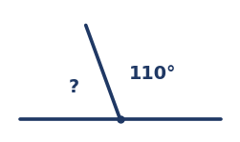  a) Left diagram (angles add to 90°). ? = ________  b) Right diagram (angles add to 180°). ? = ________ | Y4 angles at a point add to 360° (angle of revolution)  Use the diagram. The angles meet at a point.  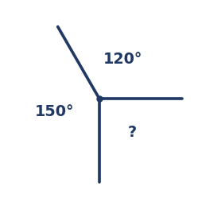  a) Angles at a point add to ________  b) Find the missing angle. ? = ________
Y5 calculate elapsed time from start and finish times using bridging strategies  Calculate each elapsed time. Show your working.  a) A film starts at 6:40 pm and finishes at 8:15 pm. How long is it?  Answer: ________________  b) How long is it from 9:50 am to 11:20 am?  Answer: ________________ | Y6 solve duration problems in 12- and 24-hour time, and represent time intervals as decimals  Answer the following.  a) A train leaves at 13:25 and arrives at 15:10. How long is the trip?  Answer: ________________  b) Write 30 minutes as a decimal part of an hour. ____________  c) Write 1 hour 15 minutes as a decimal. ____________

GREEN — Extension G1–G3
G1 complementary, supplementary and vertically opposite angles
Answer the following about angle pairs.
a) Two angles that add to 90° are called ______________
b) Two angles that add to 180° are called ______________
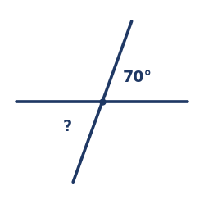
c) Two straight lines cross. The angle opposite 70° is __________________
G2 find unknown angles using angle relationships and reasoning
Find each unknown angle, giving a reason.
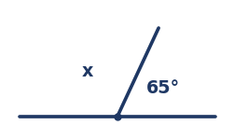
a) Find x. ________________________
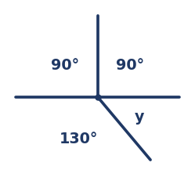
b) Find y. ________________________
G3 angles formed by a transversal across parallel lines (corresponding, alternate, co-interior)
Two parallel lines are cut by a transversal. One angle is 110°.
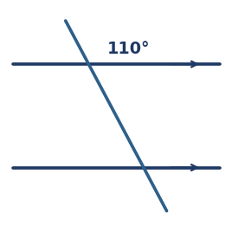
a) The angle corresponding to 110° is __________
b) The co-interior (allied) angle to 110° is __________
c) Angles in matching positions at each crossing are called ________________

STAGE 3 · YEAR B · UNIT 30 Angles & Time · Pre-test / Post-test | WORD LABS SOLO

ANSWER KEY · teacher reference — do not print for students

RED — Foundation R1–R4
R1 measure angles up to 360° using a protractor  Use your protractor to measure each angle. Write the size in degrees.    a) Angle a (left) = 60°  b) Angle b (right) = 130° | R2 estimate angles using benchmarks and record using the degrees symbol (°)  Estimate the size of the angle using benchmarks. Do not measure it.    a) My estimate is about 40°  b) Is the angle more or less than a right angle? less  c) An angle smaller than 90° is called acute
R3 create angles with a protractor and classify them as acute, obtuse or reflex  Classify each angle as acute, obtuse or reflex.    a) The left angle is acute  b) The right angle is reflex  c) An angle between 90° and 180° is called obtuse | R4 compare 12- and 24-hour time, convert between them, and read and use timetables  Answer the following about 12- and 24-hour time.  a) Write 3:45 pm in 24-hour time. 15:45  b) Write 07:20 (24-hour) in 12-hour time. 7:20 am  c) Write 21:00 in 12-hour time. 9:00 pm  d) A bus leaves at 14:10. Write this in 12-hour time. 2:10 pm

YELLOW — On-level Y1–Y6
Y1 perpendicular lines meet at right angles; identify angle types formed by intersecting lines  Answer the following about angles formed by lines.  a) Two lines that cross at 90° are called perpendicular  b) Angles on a straight line add to 180°  c) Angles at a point (a full turn) add to 360° | Y2 recognise right angles, angles on a straight line and angles at a point in diagrams  Use the diagram, then answer.    a) Angles a and b lie on a straight line. They add to 180°  b) The symbol used to mark a right angle is a small square
Y3 adjacent angles add to 90° and 180°; find a missing adjacent angle  Find the missing angle in each diagram.    a) Left diagram (angles add to 90°). ? = 60°  b) Right diagram (angles add to 180°). ? = 70° | Y4 angles at a point add to 360° (angle of revolution)  Use the diagram. The angles meet at a point.    a) Angles at a point add to 360°  b) Find the missing angle. ? = 90°
Y5 calculate elapsed time from start and finish times using bridging strategies  Calculate each elapsed time. Show your working.  a) A film starts at 6:40 pm and finishes at 8:15 pm. How long is it?  Answer: 1 hour 35 minutes  b) How long is it from 9:50 am to 11:20 am?  Answer: 1 hour 30 minutes | Y6 solve duration problems in 12- and 24-hour time, and represent time intervals as decimals  Answer the following.  a) A train leaves at 13:25 and arrives at 15:10. How long is the trip?  Answer: 1 hour 45 minutes  b) Write 30 minutes as a decimal part of an hour. 0.5 hours  c) Write 1 hour 15 minutes as a decimal. 1.25 hours

GREEN — Extension G1–G3
G1 complementary, supplementary and vertically opposite angles
Answer the following about angle pairs.
a) Two angles that add to 90° are called complementary
b) Two angles that add to 180° are called supplementary

c) Two straight lines cross. The angle opposite 70° is 70° (vertically opposite)
G2 find unknown angles using angle relationships and reasoning
Find each unknown angle, giving a reason.

a) Find x. 115° (angles on a straight line add to 180°)

b) Find y. 50° (angles at a point add to 360°)
G3 angles formed by a transversal across parallel lines (corresponding, alternate, co-interior)
Two parallel lines are cut by a transversal. One angle is 110°.

a) The angle corresponding to 110° is 110°
b) The co-interior (allied) angle to 110° is 70°
c) Angles in matching positions at each crossing are called corresponding angles

