STAGE 3 · YEAR B · UNIT 34 Measurement — Mass, Length, Perimeter & Decimals · Pre-test / Post-test | WORD LABS SOLO

Name __________________ | Class __________________ | Date __________________

RED — Foundation R1–R4
R1 recognise % means per cent; connect benchmark fractions, decimals and percentages  Answer the following about percentages.  a) Write 50% as a fraction. ________  b) Write 1/4 as a percentage. ________  c) Write 0.1 as a percentage. ________  d) % means ________________ | R2 convert between metric units of mass (kg↔g, kg↔tonnes)  Convert each mass.  a) 3 kg = __________  b) 2500 g = __________  c) 4 tonnes = __________  d) 1500 kg = ____________
R3 read and record mass and length in decimal notation to 3 decimal places  Record each measurement in the unit shown.  a) 1250 g in kilograms = ____________  b) 6 mm in centimetres = __________  c) 1 m 75 cm in metres = __________  d) 825 mL in litres = ____________ | R4 generate the whole quantity from a non-unit fractional part  Find the whole quantity. Show your working.  a) 3/4 of a number is 18. What is the number?  Answer: ________  b) 2/5 of a length is 8 m. What is the whole length?  Answer: ________

YELLOW — On-level Y1–Y6
Y1 solve problems involving different units of mass  Solve each mass problem. Show your working.  a) A recipe needs 250 g of flour. How much for 4 batches, in kilograms?  Answer: __________  b) A box weighs 2.5 kg. What do 6 boxes weigh?  Answer: __________ | Y2 convert between metres and kilometres and compare lengths in the same unit  Convert and compare lengths.  a) 3 km = __________  b) 2500 m = __________  c) Which is longer, 1.2 km or 1150 m? __________  d) Order (smallest first): 800 m, 1.5 km, 950 m ____________________
Y3 investigate and compare perimeters of rectangles with the same area  Three rectangles each have an area of 12 cm².  a) A 1 cm × 12 cm rectangle has perimeter __________  b) A 2 cm × 6 cm rectangle has perimeter __________  c) A 3 cm × 4 cm rectangle has perimeter __________  d) Same area, but the perimeters are ____________ | Y4 determine the number of different rectangles for a given area  Answer the following.  a) List the whole-number side lengths of rectangles with area 24 cm².  ____________________________________________  b) How many different rectangles is that? ________
Y5 solve length and perimeter problems, including different units of length  Solve each problem. Show your working.  a) A rectangular garden is 5 m by 3 m. What is its perimeter?  Answer: __________  b) A square has a perimeter of 28 cm. How long is each side?  Answer: __________ | Y6 solve word problems adding and subtracting decimals; justify the strategy  Solve each problem. Show your working.  a) A plank is 2.4 m long. You cut off 0.85 m. How much is left?  Answer: __________  b) Two parcels weigh 1.250 kg and 0.75 kg. What is the total?  Answer: __________

GREEN — Extension G1–G3
G1 use formulas to find the area of triangles and parallelograms
Use the formulas to find each area. Show your working.
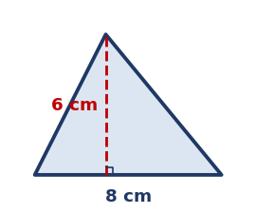
a) Triangle, A = ½ × b × h: Area = ____________
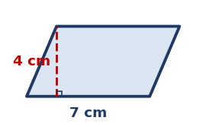
b) Parallelogram, A = b × h: Area = ____________
G2 find the area of composite shapes; convert between area units (cm², m²)
Answer the following.
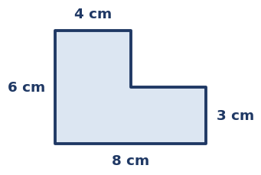
a) Find the area of the L-shaped figure. ____________
b) 1 m² = ____ cm². __________
G3 find the perimeter of composite shapes and the circumference of circles
Answer the following.

a) Find the perimeter of the L-shaped figure above. ____________
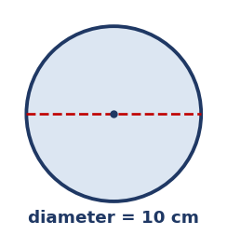
b) Estimate the circumference of this circle (C ≈ 3.14 × d). ________________

STAGE 3 · YEAR B · UNIT 34 Measurement — Mass, Length, Perimeter & Decimals · Pre-test / Post-test | WORD LABS SOLO

ANSWER KEY · teacher reference — do not print for students

RED — Foundation R1–R4
R1 recognise % means per cent; connect benchmark fractions, decimals and percentages  Answer the following about percentages.  a) Write 50% as a fraction. 1/2  b) Write 1/4 as a percentage. 25%  c) Write 0.1 as a percentage. 10%  d) % means per cent (out of 100) | R2 convert between metric units of mass (kg↔g, kg↔tonnes)  Convert each mass.  a) 3 kg = 3000 g  b) 2500 g = 2.5 kg  c) 4 tonnes = 4000 kg  d) 1500 kg = 1.5 tonnes
R3 read and record mass and length in decimal notation to 3 decimal places  Record each measurement in the unit shown.  a) 1250 g in kilograms = 1.250 kg  b) 6 mm in centimetres = 0.6 cm  c) 1 m 75 cm in metres = 1.75 m  d) 825 mL in litres = 0.825 L | R4 generate the whole quantity from a non-unit fractional part  Find the whole quantity. Show your working.  a) 3/4 of a number is 18. What is the number?  Answer: 24  b) 2/5 of a length is 8 m. What is the whole length?  Answer: 20 m

YELLOW — On-level Y1–Y6
Y1 solve problems involving different units of mass  Solve each mass problem. Show your working.  a) A recipe needs 250 g of flour. How much for 4 batches, in kilograms?  Answer: 1 kg (1000 g)  b) A box weighs 2.5 kg. What do 6 boxes weigh?  Answer: 15 kg | Y2 convert between metres and kilometres and compare lengths in the same unit  Convert and compare lengths.  a) 3 km = 3000 m  b) 2500 m = 2.5 km  c) Which is longer, 1.2 km or 1150 m? 1.2 km  d) Order (smallest first): 800 m, 1.5 km, 950 m 800 m, 950 m, 1.5 km
Y3 investigate and compare perimeters of rectangles with the same area  Three rectangles each have an area of 12 cm².  a) A 1 cm × 12 cm rectangle has perimeter 26 cm  b) A 2 cm × 6 cm rectangle has perimeter 16 cm  c) A 3 cm × 4 cm rectangle has perimeter 14 cm  d) Same area, but the perimeters are different | Y4 determine the number of different rectangles for a given area  Answer the following.  a) List the whole-number side lengths of rectangles with area 24 cm².  → 1×24, 2×12, 3×8, 4×6  b) How many different rectangles is that? 4
Y5 solve length and perimeter problems, including different units of length  Solve each problem. Show your working.  a) A rectangular garden is 5 m by 3 m. What is its perimeter?  Answer: 16 m  b) A square has a perimeter of 28 cm. How long is each side?  Answer: 7 cm | Y6 solve word problems adding and subtracting decimals; justify the strategy  Solve each problem. Show your working.  a) A plank is 2.4 m long. You cut off 0.85 m. How much is left?  Answer: 1.55 m  b) Two parcels weigh 1.250 kg and 0.75 kg. What is the total?  Answer: 2 kg

GREEN — Extension G1–G3
G1 use formulas to find the area of triangles and parallelograms
Use the formulas to find each area. Show your working.

a) Triangle, A = ½ × b × h: Area = 24 cm²

b) Parallelogram, A = b × h: Area = 28 cm²
G2 find the area of composite shapes; convert between area units (cm², m²)
Answer the following.

a) Find the area of the L-shaped figure. 36 cm²
b) 1 m² = ____ cm². 10 000
G3 find the perimeter of composite shapes and the circumference of circles
Answer the following.

a) Find the perimeter of the L-shaped figure above. 28 cm

b) Estimate the circumference of this circle (C ≈ 3.14 × d). ≈ 31.4 cm

