STAGE 3 · YEAR B · UNIT 37 Multiplicative Relations & Measurement · Pre-test / Post-test | WORD LABS SOLO

Name __________________ | Class __________________ | Date __________________

RED — Foundation R1–R6
R1 use the term product; multiply 2 or 3 numbers; list the factors of a number  Answer the following.  a) The product of 6 and 7 is ________  b) 2 × 3 × 4 = ________  c) List all the factors of 16. ______________________ | R2 determine whether a number is prime, composite or neither  Answer the following about prime and composite numbers.  a) Is 7 prime or composite? __________  b) Is 12 prime or composite? __________  c) Is 1 prime, composite or neither? __________
R3 use the area model to multiply a 2-digit number by a 1-digit number  Use the area model to multiply.  a) 23 × 4  × 20 3  4  Total = __________ | R4 calculate the area of a rectangle in square metres (and cm2, km2)  Find the area of the rectangle.  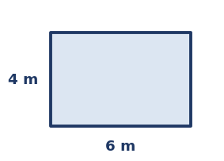  a) Area (in m²) = __________  b) 1 m² = ____ cm². __________
R5 show rectangles with the same perimeter can have different dimensions and areas  Two rectangles each have a perimeter of 12 cm.  a) A 5 cm × 1 cm rectangle has area __________  b) A 4 cm × 2 cm rectangle has area __________  c) Same perimeter, but the areas are ____________ | R6 find the volume of a rectangular prism (layers) and calculate it in cm3  Find the volume of the rectangular prism.  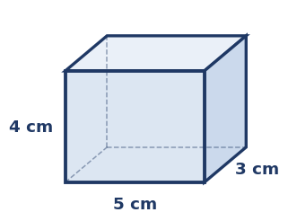  a) Volume = l × w × h = ____________  b) The bottom layer holds 5 × 3 = __________

YELLOW — On-level Y1–Y5
Y1 transform a parallelogram into a rectangle and calculate its area  Use the parallelogram to answer.  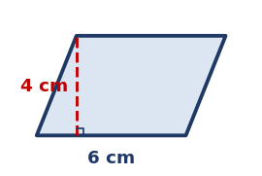  a) A parallelogram rearranges into a rectangle with the same base and ____________  b) Area (base 6 cm, height 4 cm) = ____________ | Y2 recognise a triangle as half a parallelogram and calculate its area  Use the triangle to answer.  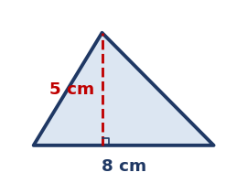  a) A triangle is ____ of a parallelogram with the same base and height. __________  b) Area = ½ × 8 × 5 = ____________
Y3 explain a cubic metre and calculate volumes of rectangular prisms in m3  Answer the following about volume in cubic metres.  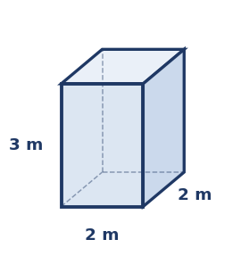  a) A cubic metre is a cube measuring 1 m × 1 m × __________  b) Volume of this prism (2 m × 2 m × 3 m) = ____________ | Y4 select efficient strategies to multiply up to 4-digit by 1- and 2-digit numbers  Solve each. Show your working.  a) 2345 × 6 = ____________  b) 1240 × 23 = ____________
Y5 solve volume word problems; same volume can have different dimensions
Solve each problem. Show your working.
a) A box is 4 cm × 3 cm × 2 cm. What is its volume?
Answer: __________
b) Give different dimensions for another box with a volume of 24 cm³.
Answer: ________________

GREEN — Extension G1–G3
G1 apply area formulas for triangles & parallelograms and find composite areas
Find each area. Show your working.
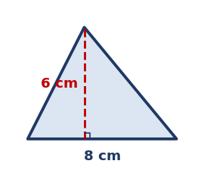
a) Triangle, A = ½ bh (base 8 cm, height 6 cm) = ____________
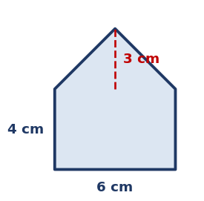
b) Composite figure (rectangle + triangle) = ______________
G2 use V = base area x height (V = Ah) for prisms, including triangular prisms
Use V = base area × height (V = A × h).
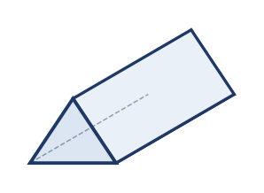
a) A triangular prism has base area 6 cm² and length 10 cm. Volume = ________________
b) A prism has base area 12 cm² and height 5 cm. Volume = ____________
G3 apply divisibility tests; write a number as a product of its prime factors (index notation)
Answer the following.
a) Is 36 divisible by 3? ____________
b) Write 12 as a product of prime factors. ________________
c) Write 24 as a product of primes in index form. ____________

STAGE 3 · YEAR B · UNIT 37 Multiplicative Relations & Measurement · Pre-test / Post-test | WORD LABS SOLO

ANSWER KEY · teacher reference — do not print for students

RED — Foundation R1–R6
R1 use the term product; multiply 2 or 3 numbers; list the factors of a number  Answer the following.  a) The product of 6 and 7 is 42  b) 2 × 3 × 4 = 24  c) List all the factors of 16. 1, 2, 4, 8, 16 | R2 determine whether a number is prime, composite or neither  Answer the following about prime and composite numbers.  a) Is 7 prime or composite? prime  b) Is 12 prime or composite? composite  c) Is 1 prime, composite or neither? neither
R3 use the area model to multiply a 2-digit number by a 1-digit number  Use the area model to multiply.  a) 23 × 4  × 20 3  4 80 12  Total = 92 | R4 calculate the area of a rectangle in square metres (and cm2, km2)  Find the area of the rectangle.    a) Area (in m²) = 24 m²  b) 1 m² = ____ cm². 10 000
R5 show rectangles with the same perimeter can have different dimensions and areas  Two rectangles each have a perimeter of 12 cm.  a) A 5 cm × 1 cm rectangle has area 5 cm²  b) A 4 cm × 2 cm rectangle has area 8 cm²  c) Same perimeter, but the areas are different | R6 find the volume of a rectangular prism (layers) and calculate it in cm3  Find the volume of the rectangular prism.    a) Volume = l × w × h = 60 cm³  b) The bottom layer holds 5 × 3 = 15 cubes

YELLOW — On-level Y1–Y5
Y1 transform a parallelogram into a rectangle and calculate its area  Use the parallelogram to answer.    a) A parallelogram rearranges into a rectangle with the same base and height  b) Area (base 6 cm, height 4 cm) = 24 cm² | Y2 recognise a triangle as half a parallelogram and calculate its area  Use the triangle to answer.    a) A triangle is ____ of a parallelogram with the same base and height. half  b) Area = ½ × 8 × 5 = 20 cm²
Y3 explain a cubic metre and calculate volumes of rectangular prisms in m3  Answer the following about volume in cubic metres.    a) A cubic metre is a cube measuring 1 m × 1 m × 1 m  b) Volume of this prism (2 m × 2 m × 3 m) = 12 m³ | Y4 select efficient strategies to multiply up to 4-digit by 1- and 2-digit numbers  Solve each. Show your working.  a) 2345 × 6 = 14070  b) 1240 × 23 = 28520
Y5 solve volume word problems; same volume can have different dimensions
Solve each problem. Show your working.
a) A box is 4 cm × 3 cm × 2 cm. What is its volume?
Answer: 24 cm³
b) Give different dimensions for another box with a volume of 24 cm³.
Answer: e.g. 6 × 2 × 2, or 8 × 3 × 1

GREEN — Extension G1–G3
G1 apply area formulas for triangles & parallelograms and find composite areas
Find each area. Show your working.

a) Triangle, A = ½ bh (base 8 cm, height 6 cm) = 24 cm²

b) Composite figure (rectangle + triangle) = 33 cm²
G2 use V = base area x height (V = Ah) for prisms, including triangular prisms
Use V = base area × height (V = A × h).

a) A triangular prism has base area 6 cm² and length 10 cm. Volume = 60 cm³
b) A prism has base area 12 cm² and height 5 cm. Volume = 60 cm³
G3 apply divisibility tests; write a number as a product of its prime factors (index notation)
Answer the following.
a) Is 36 divisible by 3? yes (3 + 6 = 9)
b) Write 12 as a product of prime factors. 2 × 2 × 3 (2² × 3)
c) Write 24 as a product of primes in index form. 2³ × 3

