STAGE 3 · YEAR B · UNIT 39 Time, Transformations & Angles · Pre-test / Post-test | WORD LABS SOLO

Name __________________ | Class __________________ | Date __________________

RED — Foundation R1–R4
R1 classify angles as acute, right, obtuse, straight or reflex  Classify each angle.  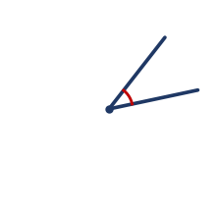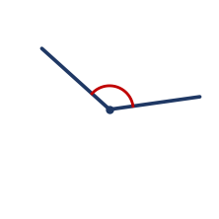  a) The left angle is __________  b) The right angle is __________  c) An angle of exactly 180° is a ____________ | R2 measure angles of up to 360° using a protractor  Use your protractor to measure each angle.  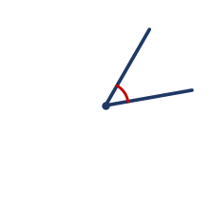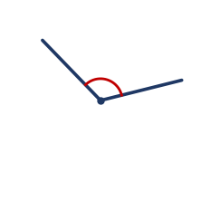  a) Angle a (left) = ________  b) Angle b (right) = ________
R3 create (draw) angles of up to 360° using a protractor  Answer the following about drawing angles.  a) To draw an angle, line up the protractor's centre on the ____________  b) A right angle measures ________  c) A full turn measures ________ | R4 find missing angles on a straight line, at a point and at a right angle  Find the missing angle in each diagram.  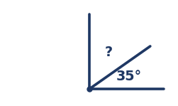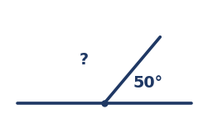  a) Left (angles add to 90°): ? = ________  b) Right (angles add to 180°): ? = ________

YELLOW — On-level Y1–Y6
Y1 identify angle types and parts (vertex/arms) in diagrams  Use the diagram to answer.  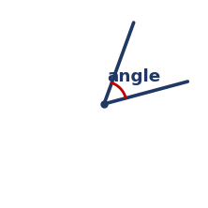  a) The point where the two arms meet is the ____________  b) The two straight sides of an angle are the __________  c) An angle bigger than 180° is a ____________ | Y2 describe transformations (translate, reflect, rotate)  Answer the following about transformations.  a) Sliding a shape is a ____________  b) Flipping a shape over a line is a ____________  c) Turning a shape about a point is a ____________
Y3 dissect and rearrange one shape to make another  Answer the following.  a) A rectangle is cut along its diagonal. What two shapes are made?  Answer: ____________  b) When you rearrange the pieces of a shape, the total area stays the __________ | Y4 calculate elapsed time using bridging and rounding  Calculate each elapsed time.  a) From 10:40 am to 1:15 pm.  Answer: ________________  b) From 7:50 pm to 9:20 pm.  Answer: ________________
Y5 represent commonly used time intervals as decimals  Write each time interval as a decimal of an hour.  a) 30 minutes = ________  b) 15 minutes = ________  c) 45 minutes = ________  d) 1 hour 30 minutes = ________ | Y6 solve duration problems in 12- and 24-hour time  Solve each duration problem.  a) A train leaves at 13:15 and arrives at 15:45. How long is the trip?  Answer: ______________  b) Write 9:30 pm in 24-hour time.  Answer: __________

GREEN — Extension G1–G3
G1 complementary, supplementary and vertically opposite angles
Answer the following about angle pairs.
a) Two angles adding to 90° are ____________
b) Two angles adding to 180° are ____________
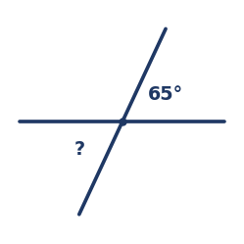
c) Two lines cross. The angle opposite 65° is ________________
G2 angles on parallel lines cut by a transversal
Two parallel lines are cut by a transversal. One angle is 115°.
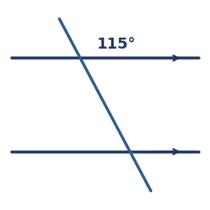
a) The corresponding angle is __________
b) The co-interior (allied) angle is __________
G3 solve numerical angle problems using reasoning
Find each unknown angle, giving a reason.
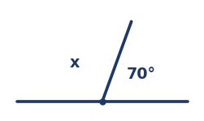
a) Find x. __________________
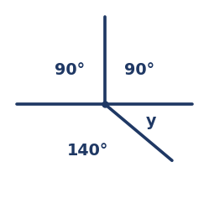
b) Find y. __________________

STAGE 3 · YEAR B · UNIT 39 Time, Transformations & Angles · Pre-test / Post-test | WORD LABS SOLO

ANSWER KEY · teacher reference — do not print for students

RED — Foundation R1–R4
R1 classify angles as acute, right, obtuse, straight or reflex  Classify each angle.    a) The left angle is acute  b) The right angle is obtuse  c) An angle of exactly 180° is a straight angle | R2 measure angles of up to 360° using a protractor  Use your protractor to measure each angle.    a) Angle a (left) = 50°  b) Angle b (right) = 120°
R3 create (draw) angles of up to 360° using a protractor  Answer the following about drawing angles.  a) To draw an angle, line up the protractor's centre on the vertex  b) A right angle measures 90°  c) A full turn measures 360° | R4 find missing angles on a straight line, at a point and at a right angle  Find the missing angle in each diagram.    a) Left (angles add to 90°): ? = 55°  b) Right (angles add to 180°): ? = 130°

YELLOW — On-level Y1–Y6
Y1 identify angle types and parts (vertex/arms) in diagrams  Use the diagram to answer.    a) The point where the two arms meet is the vertex  b) The two straight sides of an angle are the arms  c) An angle bigger than 180° is a reflex angle | Y2 describe transformations (translate, reflect, rotate)  Answer the following about transformations.  a) Sliding a shape is a translation  b) Flipping a shape over a line is a reflection  c) Turning a shape about a point is a rotation
Y3 dissect and rearrange one shape to make another  Answer the following.  a) A rectangle is cut along its diagonal. What two shapes are made?  Answer: two triangles  b) When you rearrange the pieces of a shape, the total area stays the same | Y4 calculate elapsed time using bridging and rounding  Calculate each elapsed time.  a) From 10:40 am to 1:15 pm.  Answer: 2 hours 35 minutes  b) From 7:50 pm to 9:20 pm.  Answer: 1 hour 30 minutes
Y5 represent commonly used time intervals as decimals  Write each time interval as a decimal of an hour.  a) 30 minutes = 0.5 hours  b) 15 minutes = 0.25 hours  c) 45 minutes = 0.75 hours  d) 1 hour 30 minutes = 1.5 hours | Y6 solve duration problems in 12- and 24-hour time  Solve each duration problem.  a) A train leaves at 13:15 and arrives at 15:45. How long is the trip?  Answer: 2 hours 30 minutes  b) Write 9:30 pm in 24-hour time.  Answer: 21:30

GREEN — Extension G1–G3
G1 complementary, supplementary and vertically opposite angles
Answer the following about angle pairs.
a) Two angles adding to 90° are complementary
b) Two angles adding to 180° are supplementary

c) Two lines cross. The angle opposite 65° is 65° (vertically opposite)
G2 angles on parallel lines cut by a transversal
Two parallel lines are cut by a transversal. One angle is 115°.

a) The corresponding angle is 115°
b) The co-interior (allied) angle is 65°
G3 solve numerical angle problems using reasoning
Find each unknown angle, giving a reason.

a) Find x. 110° (angles on a straight line)

b) Find y. 40° (angles at a point add to 360°)

