STAGE 3 · YEAR B · UNIT 40 Integers, Decimals, Percentages & the Cartesian Plane · Pre-test / Post-test | WORD LABS SOLO

Name __________________ | Class __________________ | Date __________________

RED — Foundation R1–R5
R1 compare and order decimals to 3 decimal places  Answer the following about decimals.  a) Which is larger: 0.5 or 0.45? ________  b) Is 0.7 equal to 0.700? ________  c) Order (smallest first): 0.3, 0.25, 0.305 __________________  d) Round 0.467 to 2 decimal places. ________ | R2 place integers on a number line  Use the number line to answer.  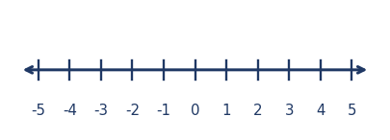  a) What integer is 3 less than 1? ________  b) Which is smaller: −3 or −1? ________  c) What is the opposite of 4? ________
R3 benchmark fractions, decimals, percentages & find 10%  Answer the following.  a) Write 1/2 as a percentage. ________  b) Write 0.25 as a percentage. ________  c) 10% of 80 = ________  d) 10% of $4.50 = __________ | R4 multiply and divide decimals by powers of 10  Multiply or divide by powers of 10.  a) 3.6 × 10 = ________  b) 2.5 × 100 = ________  c) 47 ÷ 10 = ________  d) 8.2 ÷ 100 = __________
R5 the Cartesian coordinate system (4 quadrants)
Use the coordinate plane to answer.
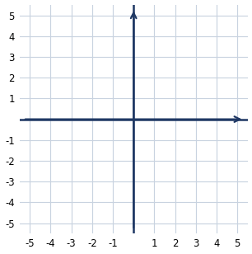
a) In which quadrant is the point (3, −2)? __________
b) The point where the axes meet is the __________
c) In (x, y), x is measured along the ____________

YELLOW — On-level Y1–Y5
Y1 estimate discounts and calculate sale prices  Solve each. Show your working.  a) A $40 jacket has 25% off. How much do you save?  Answer: ________  b) What is the sale price? ________  c) Estimate 10% off a $19.95 item.  Answer: __________ | Y2 add and subtract decimals to solve word problems  Solve each problem. Show your working.  a) You have $20 and spend $7.45. How much is left?  Answer: __________  b) Two lengths are 1.25 m and 0.8 m. What is the total?  Answer: __________
Y3 solve multistep word problems  Solve each multistep problem. Show your working.  a) You buy 4 pens at $1.50 each and a $3 notebook. What is the total?  Answer: __________  b) Share $45 equally among 3 people, then each spends $5. How much does each have left?  Answer: ____________ | Y4 multiply decimals (mental strategies & estimation)  Work out or estimate each.  a) 0.5 × 8 = ________  b) 0.3 × 6 = ________  c) Estimate 4.9 × 3. __________  d) 2.5 × 4 = ________
Y5 order of operations and brackets
Evaluate each using the order of operations.
a) 4 + 3 × 2 = ________
b) (4 + 3) × 2 = ________
c) 20 − 8 ÷ 2 = ________
d) 3 × (6 − 2) = ________

GREEN — Extension G1–G3
G1 add, subtract and order integers
Answer the following about integers.
a) −3 + 5 = ________
b) 4 − 7 = ________
c) −2 − 6 = ________
d) Order (smallest first): −1, 3, −4, 0 ________________
G2 percentages of quantities and percentage change
Solve each. Show your working.
a) 15% of 200 = ________
b) A $60 item increases by 20%. What is the new price?
Answer: __________
c) A $80 item is reduced to $60. What percentage discount is that?
Answer: __________
G3 plot points and linear relationships on the Cartesian plane
Use the coordinate plane to answer.
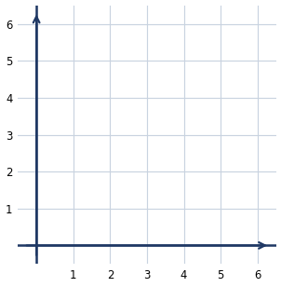
a) Plot (1, 2), (2, 4) and (3, 6). What pattern do the points form?
Answer: ____________
b) The rule connecting x and y is: y = x × ________

STAGE 3 · YEAR B · UNIT 40 Integers, Decimals, Percentages & the Cartesian Plane · Pre-test / Post-test | WORD LABS SOLO

ANSWER KEY · teacher reference — do not print for students

RED — Foundation R1–R5
R1 compare and order decimals to 3 decimal places  Answer the following about decimals.  a) Which is larger: 0.5 or 0.45? 0.5  b) Is 0.7 equal to 0.700? yes  c) Order (smallest first): 0.3, 0.25, 0.305 0.25, 0.3, 0.305  d) Round 0.467 to 2 decimal places. 0.47 | R2 place integers on a number line  Use the number line to answer.    a) What integer is 3 less than 1? −2  b) Which is smaller: −3 or −1? −3  c) What is the opposite of 4? −4
R3 benchmark fractions, decimals, percentages & find 10%  Answer the following.  a) Write 1/2 as a percentage. 50%  b) Write 0.25 as a percentage. 25%  c) 10% of 80 = 8  d) 10% of $4.50 = 45c | R4 multiply and divide decimals by powers of 10  Multiply or divide by powers of 10.  a) 3.6 × 10 = 36  b) 2.5 × 100 = 250  c) 47 ÷ 10 = 4.7  d) 8.2 ÷ 100 = 0.082
R5 the Cartesian coordinate system (4 quadrants)
Use the coordinate plane to answer.

a) In which quadrant is the point (3, −2)? fourth
b) The point where the axes meet is the origin
c) In (x, y), x is measured along the horizontal axis

YELLOW — On-level Y1–Y5
Y1 estimate discounts and calculate sale prices  Solve each. Show your working.  a) A $40 jacket has 25% off. How much do you save?  Answer: $10  b) What is the sale price? $30  c) Estimate 10% off a $19.95 item.  Answer: about $2 off | Y2 add and subtract decimals to solve word problems  Solve each problem. Show your working.  a) You have $20 and spend $7.45. How much is left?  Answer: $12.55  b) Two lengths are 1.25 m and 0.8 m. What is the total?  Answer: 2.05 m
Y3 solve multistep word problems  Solve each multistep problem. Show your working.  a) You buy 4 pens at $1.50 each and a $3 notebook. What is the total?  Answer: $9  b) Share $45 equally among 3 people, then each spends $5. How much does each have left?  Answer: $10 | Y4 multiply decimals (mental strategies & estimation)  Work out or estimate each.  a) 0.5 × 8 = 4  b) 0.3 × 6 = 1.8  c) Estimate 4.9 × 3. about 15  d) 2.5 × 4 = 10
Y5 order of operations and brackets
Evaluate each using the order of operations.
a) 4 + 3 × 2 = 10
b) (4 + 3) × 2 = 14
c) 20 − 8 ÷ 2 = 16
d) 3 × (6 − 2) = 12

GREEN — Extension G1–G3
G1 add, subtract and order integers
Answer the following about integers.
a) −3 + 5 = 2
b) 4 − 7 = −3
c) −2 − 6 = −8
d) Order (smallest first): −1, 3, −4, 0 −4, −1, 0, 3
G2 percentages of quantities and percentage change
Solve each. Show your working.
a) 15% of 200 = 30
b) A $60 item increases by 20%. What is the new price?
Answer: $72
c) A $80 item is reduced to $60. What percentage discount is that?
Answer: 25%
G3 plot points and linear relationships on the Cartesian plane
Use the coordinate plane to answer.

a) Plot (1, 2), (2, 4) and (3, 6). What pattern do the points form?
Answer: a straight line
b) The rule connecting x and y is: y = x × 2

