**Synchronous**

const fs = require('fs');

let startTime = new Date().getTime();

try {

const data = fs.readFileSync('./test.txt', 'utf8');

console.log(data);

} catch (err) {

console.error(err);

}

setTimeout(function () {

var endTime = new Date().getTime();

console.log("Duration =" + (endTime - startTime));

});

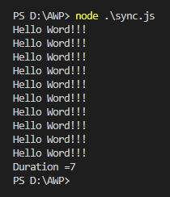

**Asynchronous**

const fs = require('fs/promises');

async function example() {

try {

const data = await fs.readFile('./test.txt', { encoding: 'utf8' });

console.log(data);

} catch (err) {

console.log(err);

}

}

let startTime = new Date().getTime();

example();

setTimeout(function () {

var endTime = new Date().getTime();

console.log("Duration =" + (endTime - startTime));

});

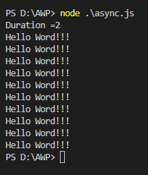

**Text File:**

**Hello Word!!!**

**Hello Word!!!**

**Hello Word!!!**

**Hello Word!!!**

**Hello Word!!!**

**Hello Word!!!**

**Hello Word!!!**

**Hello Word!!!**

**Hello Word!!!**

**Hello Word!!!**