**PLANPAL**

**MAIN CONTACT**

* **Nicholas DeVeau: ndeveau1@student.gsu.edu**

**TEAM MEMBERS**

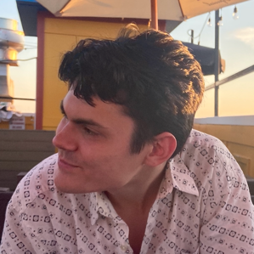**Nicholas DeVeau**

*I’m Nick DeVeau, a senior undergrad in Computer Science with a strong background in web development, automation, and software engineering. My experience ranges from writing processes for embedded systems in C to building web and mobile applications in C# using the .NET framework. I’ve interned at The Red Cross as a web developer and am currently working at Oshkosh on the Intelligent Automation Team, where I develop solutions to streamline corporate processes and boost productivity. I’ve been involved in software/ hardware development since highschool, taking part in various freelance projects. I'm excited to continue expanding my portfolio and adding new projects to my GitHub :).*

**Jannatul Zaman**

*My name is Jannatul Zaman and I am a student at Georgia State University. I am currently in my fourth year of education and will receive a bachelor’s in computer science by May of 2025. My goal in this journey is to maximize my capability in understanding and writing programs for future use. I plan to use what I’ve learned in the past four years to solve problems met in the world of technology today. Other than that obvious requirement, other skills that are to be honed are those in communication, planning, time management, and most importantly, creativity. So far, I have no notable projects but am able to understand several languages such as Python, HTML, and C++.*

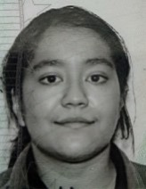

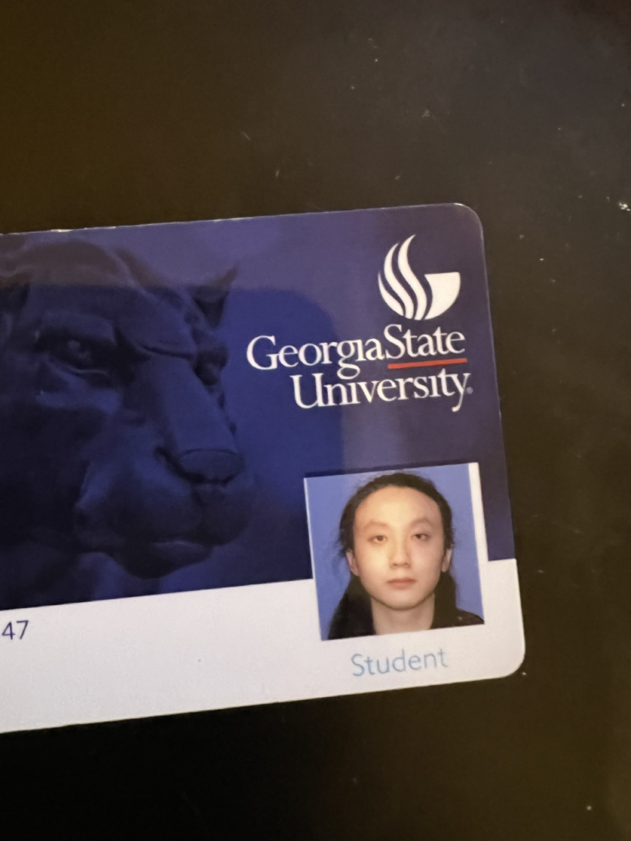**Zihao Li**

*I'm Zihao Li, an enthusiastic and motivated software engineer with a strong foundation in Java and Python. Currently, I'm diving into C# to expand my skill set. Although I'm still building experience in the field, my eagerness to learn and grow drives me to take on new challenges. I'm dedicated to continuous improvement and am committed to becoming a valuable member of the team.*

**Joshua Jones**

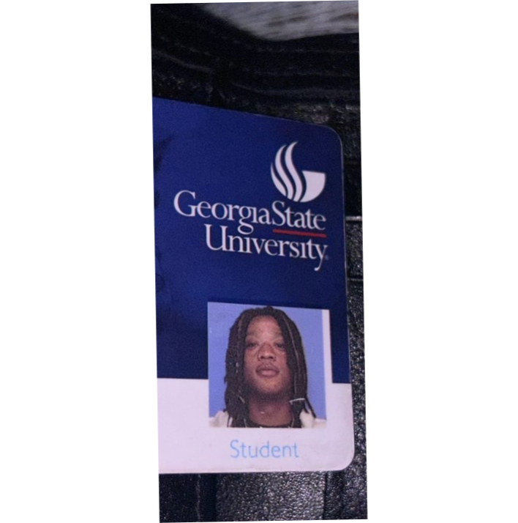

*I am Joshua Jones, a senior at Georgia State University, majoring in Computer Science. Growing up on the Southside of Atlanta, I’ve always had a drive to push myself and connect with technology, to open up new doors for myself to learn new skills.  I’ve gotten pretty good at programming in Java, Python, and C++  and used those skills in projects like the Car Data Evaluation, where I dug into data to find what really matters. Being an IB High School Graduate and a National Beta Club award recipient are accomplishments I’m proud of, but they’re just stepping stones. I’m all about blending where I’m from with where I’m going, using both to fuel my success.*

**Vrutik Patel**

*I am a dedicated and lifelong student pursuing Computer Science at Georgia State University with a passion for technology and software development. Through my academic journey, I have gained a solid foundation in programming languages such as Java, JavaScript, Python, and HTML. My experiences, including various software development projects, have deepened my understanding of the field and enhanced my technical skills. Driven by a desire to help others succeed in computer science, I strive to contribute effectively to any team or project, leveraging my knowledge and passion to make a meaningful impact.*

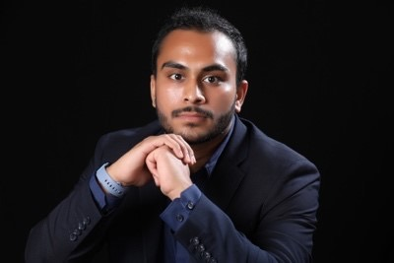

**TEAM STRENGTHS**

*Our development team is diverse and well-rounded, with each member bringing specialized skills to the project. Nick provides leadership in documentation, submissions, and repository management. Zihao and Joshua strengthen the backend and database management, ensuring robust data handling. Jannatul offers creative front-end design skills, while Vrutik focuses on implementing these designs effectively. Together, the team balances technical expertise and effective communication, promoting collaborative development and rapid iteration through regular meetings and clear version control practices.*

**METHODS OF COMMUNICATION**

We will communicate via Discord, or Text message for more urgent matters. Team members have a 24-hour response time obligation for Discord and 1 hour response obligation for text messages.

**MEETINGS**

In person general stand-up meetings are held during class on Tuesday and Thursday. We will hold a virtual code review meeting on Friday at 12:00pm. Every other week will be a new sprint, so at the end of the sprint that code review should be reviewing completed tasks for that sprint.

General stand-up meetings will only require a computer and a general idea of what you are currently working on. Code review meetings require ability to share screens and a good idea of how your code works.

Any person can be responsible for keeping track of time. Nicholas DeVeau is in charge of notes.

**VERSION CONTROL**

We will be using Github and Github desktop for source control. There will be a primary ‘main branch’ and a ‘development branch’.

At the end of the sprint development will be merged with main. For now there are no rules with pushing to the development branch, approval not needed.

**DIVISION OF WORK**

NOTE: Each person is not responsible for one part of the project. These are general divisions of management. Each person is entitled to document, develop or test any part of the project when needed.

* + Each Team mate will be responsible for development.
  + Nick will oversee documentation, along with submissions, and repository management.
  + Zihao and Joshua will be responsible for managing back end / database.
  + Jannaful will be responsible for front end design
  + Vrutik will be responsible for front end implementation

**HANDLING NON-CONTRIBUTION**

Team members who refuse to collaborate and attend meetings after one week unexcused will be reported to the professor.

**SUBMISSION OF ASSIGNMENTS**

Nick is Responsible for submissions. Any meeting before or on a deadline will have allocated time for review and submission.

**CONTIGENCY PLANNING**

* **Absenteeism, Dropouts:** Report to professor, if team mate continues to not appear, responsibilities must be re-organized.
* **Academic Dishonesty:** A conversation with the professor will need to happen to ensure those who did work honestly get credit.

**GITHUB ACCOUNTS AND REPOSITORY**

https://github.com/NickDeVeau/Planpal

* **Nick DeVeau:** NickDeVeau
* **Zihao Li:** Vermandss
* **Jannatul Zaman:** jzaman3
* **Vrutik Patel:** Vrutik2
* **Joshua Jones**: JoshJ552

**Virtual or Physical Meeting Evidence**

* **Date of Meeting:** 09/03/2024
* **Meeting Platform:** In person