Ultimate TinyMCE
Usage Instructions and Documentation
Author: Josh Lobe
Version 1.2
November 25th, 2011

Table of Contents:
- Introduction
- Download and Installation
- Admin Settings Page
- Buttons for Row Three
- Buttons for Row Four
- Tricks and Workarounds
  - Adding iframes
- Changelog

Introduction:
WordPress seems to be here to stay. I have worked on quite a few content management systems (Joomla, Dolphin, WordPress) and I must say I enjoy the flexibility and customization potential of WordPress. It has been a delight working with members of the community and developing this amazing plugin with the suggestions and feedback from the users… and I thank each of you.
I wrote the “Ultimate TinyMCE” plugin for those who are not comfortable with HTML. Using the HTML tab of the wordpress editor can give you much more power over control and customization of your content. But not everyone is savvy with the language.
This is where the Visual mode of the editor comes in handy. True, you can use the visual editor to create content for your blogs; but does it give you the power to fully customize your content? Out of the wordpress box, my answer would have to be “No”.
However, by tweaking the Visual mode of the editor, we can modify it to behave much more friendly to the users of wordpress. Hence… my plugin. “Ultimate TinyMCE” adds a few new features to the buttons already included with the editor by default; but it also adds approximately 30 new buttons to rows three and four of the editor. So, let’s begin with downloading and installing the plugin.

Download and Installation:
Open up your admin panel, and go to your “Plugins” menu. Click “Add New”. In the search bar, type Ultimate TinyMCE. Click “Details” for the plugin, and then click “Install” in the popup window. Once downloaded; click “Activate” to activate the plugin.
You should see Ultimate TinyMCE installed in your active plugins. The plugin has an admin settings page which can be access be either (1) clicking “settings” from the active plugins page, or (2) clicking “Settings” on the left admin menu, then clicking “Ultimate TinyMCE”.

Admin Settings Page:
The Plugin is written so that each button is NOT selected by default. If this is the first time installing the plugin, you will want to go to this page and “check” each of the buttons you would like included in the editor. All of the buttons in the Row 3 settings will appear in row three of your editor. And the same is true for the Row 4 buttons. I plan to add a feature which will allow you to decide which row to include each individual button. I think this will help give a “cleaner” look for people who may not use all the buttons.
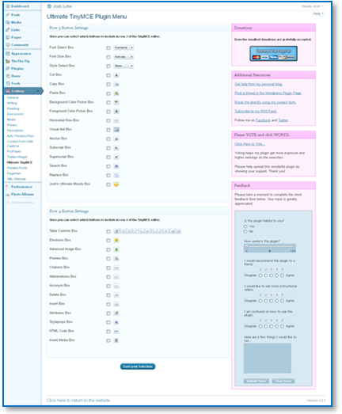
Admin Menu Settings Page
Buttons for Row 3:
Let’s look at each new button, and briefly describe how it functions.
Font Select Box:
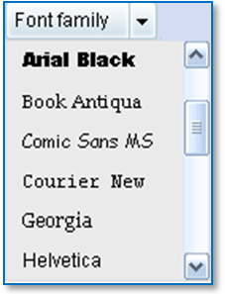
The “font select” box is a drop-down menu allowing you to choose from seventeen different fonts, most of which are considered “web-safe”, meaning they are viewed pretty consistently across different browsers and platforms.
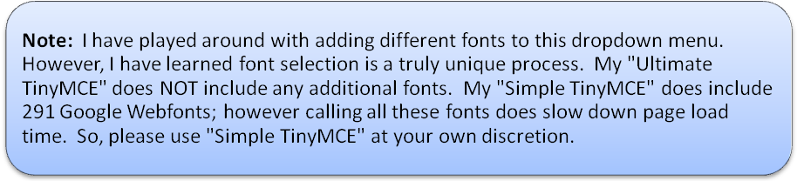

Font Size Box:
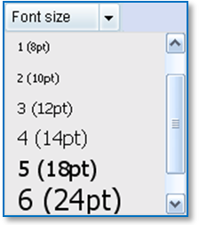
The font size is pretty self-explanatory. If anyone has any use for additional sizes in this box, you can use my contact information found at the end of this document, and make a request.
Style Select Box:
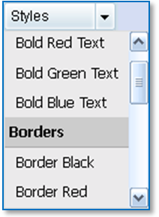
This button has a lot of potential. My original intention was to have this button “import” your current theme’s stylesheet, and automatically list the styles here in the drop-down. This would allow you to maintain consistency within your theme. However, this has proved difficult, and in the meantime I have included a small list of predefined styles.
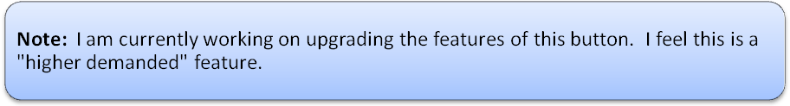

Cut , Copy , and Paste Boxes:

Since playing around with this plugin, I have noticed these buttons are not supported consistently across browsers. Currently, using Opera 11.52 and FireFox 7, they are not supported. I will probably end up removing these buttons in a future update.

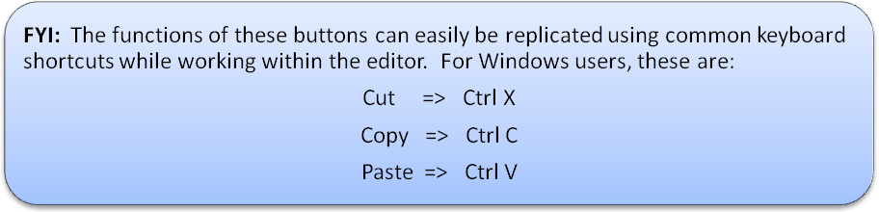

Background Color Picker Box:
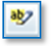
This box will allow you to add a colored background to an area you select. You can highlight an entire area, or you can select a specific line, word, or letter of text.
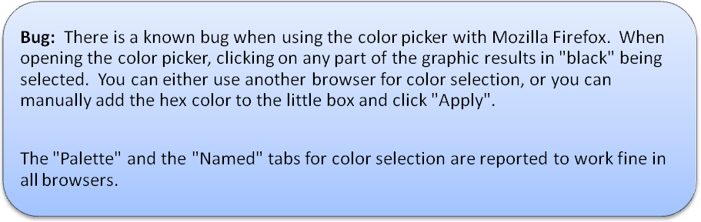

Foreground Color Picker Box:
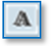
This box functions exactly the same way as the “Select Text Color” box found in row 2 of the editor. This is probably another button I will remove in a future update; as it’s just redundant.

Horizontal Rule Box:

I just noticed (upon writing this tutorial) I have accidentally mis-named this on the admin options page. It should read “Horizontal Rule Box”. This icon simply inserts a line horizontally across the width of your page. It is very useful when created long lists of conent, and need to visually separate one section from another.
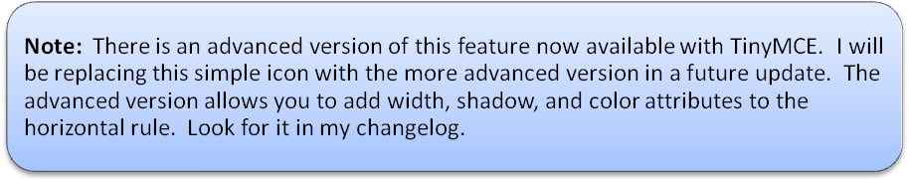

Visual Aid Box:

The visual aid box is used to toggle guidelines for elements like tables. When you create a table, your cells will contain a guideline around them. You can toggle this guideline with this button. This button is always enabled by default whenever opening the editor; however you can turn it off if you like.

Anchor Box:

The anchor box can be used to set page anchors throughout your post or page. Say you have a post with an extremely long section of content. Rather than having users scroll to the bottom of your page, you can insert page anchors.
- Let’s assume you have a section named “Conclusion” at the bottom of your page. So, at the top, we want to create a link to the conclusion section.
- Scroll to the bottom, and highlight the area where you want the user to be linked to, for instance the word “Conclusion.
- Click the anchor button and name the anchor something unique, like “conclusion”.
- Go back to the top of your content, and type the word you would like the user to click to be linked to the bottom.
- Highlight it, and click the “Insert/Edit Link” button on the top row.
- Choose your anchor from the dropdown list, in our case “conclusion”.
- That’s it. Now view your page and click your newly created anchor link.

Subscript and Superscript Boxes:

These buttons don’t really need an explanation. They allow you to easily add subscript and superscript text within your document. These buttons work great in conjunction with the “Special Characters” button found in the second row; perfect for math gurus, and documents requiring formula visual references.

Search and Replace Boxes:

Upon close examination of this plugin, I noticed these two buttons function exactly the same. Again, this is redundant, and one will be removed in a future update.
These buttons allow you to easily find and replace all instances of a certain word or phrase, without having to go through the document line by line. One word of advice; be careful when using this feature to not inadvertently change something you didn’t intend. Always double-check your changes.

Josh’s Ultimate Moods Box:

This is just a feature I wanted to pass along to you. They originated from my days with the Dolphin platform. I wanted to integrate them into wordpress. They simply allow you to add a little “mood” to your blog posts and pages.

Buttons for Row 4:
Table Controls Box:
The table controls are probably one of the most complex features of TinyMCE. Unfortunately, it can also be the most unstable. Utilizing tables in your content can dramatically enhance the visual perception of your pages. In this example, I am just going to cover the basics. Feel free to explore the other options at your convenience to unleash the true power.
After clicking the “Insert Table” button, a popup will display:
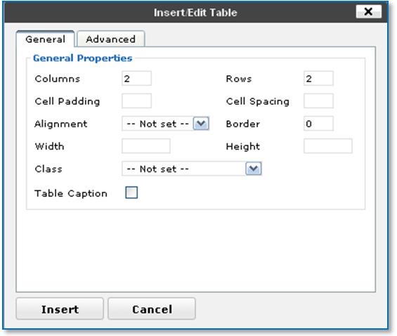
Table Controls General Tab
Here you can choose the number of columns and rows to display in your table. You can also set the cell padding (the space between the content and the cell border), and the cell spacing (the distance between individual cells). The other attributes can be set to specific user preferences also.

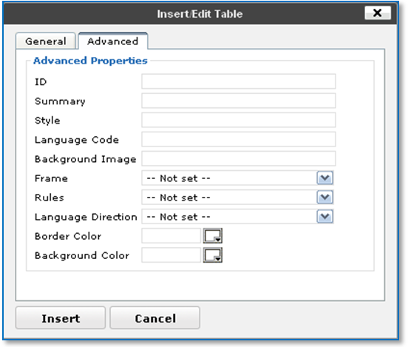
Table Controls Advanced Tab
The advanced tab allows you even further customization of your tables. You can select border colors, background colors, or even a background image.
After you insert your initial table, the rest of the table controls become available. These are briefly described here:
- Table Row Properties
  - Set the attributes of individual row properties (colors, alignment, height, etc).
  - Note the selector box toward the bottom of the popup window allowing you different options of which rows to apply the selection.
- Table Cell Properties
  - Functions the same as the Row Properties.
  - Again, note the selector box toward the bottom of the popup window.
- Insert Row Before
  - Simply inserts a new row above the currently selected row.
- Insert Row After
  - Simply inserts a new row after the currently selected row.
- Delete Row
  - Simply deletes the currently selected row.
- Insert Column Before
  - Simply inserts a new column above the currently selected column.
- Insert Column After
  - Simply inserts a new column after the currently selected column.
- Delete Column
  - Simply deletes the currently selected column.
- Split Merged Table Cells
  - This button will separate any merged cells. Highlight the area you wish to separate and click the button.
- Merge Table Cells
  - This button allows you to merge two existing cells into one bigger cell. This is very useful for creating column headers and row descriptions.
  - Cells can be merged either vertically or horizontally.

Emotions Box:

This is the default button included with TinyMCE for showing the emoticon menu. I was not impressed with the small selection of emoticons, so I have added many new ones. Simply select which emoticon to use and it will be inserted into your content.

Advanced Image Box:

This button falls short in one big way. It does not allow you to upload an image directly from the popup box. However, the reason I wanted to include this button is because it allows you to easily use the mouseover and mouseout features, which add a nice touch to any website.
To create a mouseover effect on an image:
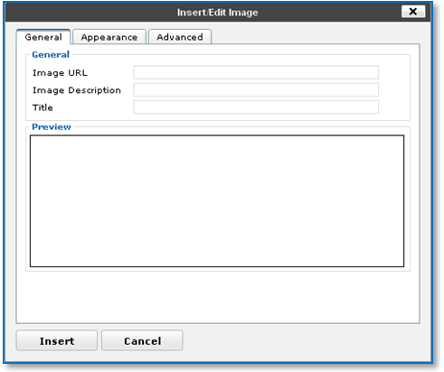
- Click the button to open the popup box.
- Type the URL of your image in the “Image URL” box. You may also enter a description and title.
- Click the Advanced Tab.
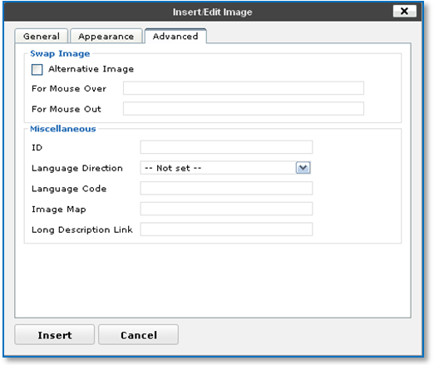
- Check the “Alternate Image” box.
- “For Mouse Out”, Insert the same url as your link image from above.
- “For Mouse Over”, Insert the url to the image you would like to show on hover.
- Click Insert and you will now have a cool hover image effect. This is perfect for menu buttons and banners. Simply create two images with contrasting shadows, and watch the magic.
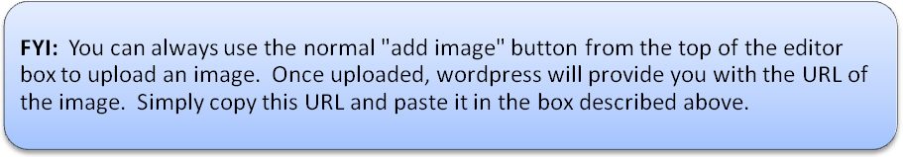

Preview Box:

This nifty button will provide you with a fast way of previewing your content before saving changes. Yes, you can always click “Preview” from the wordpress menu, and see the changes live… but if you are doing this 100 times a post, it can be pretty time-consuming. Instead, just click this button, and you will see a live version of your content area in a cool popup window. This window loads MUCH faster than a completely new page refresh. I find myself using it more and more frequently. Frankly, I don’t know what I’d do without it now.

Citations Box:

I’m not too impressed with this button. As far as I can tell, all it does is add an italicized style to your font. This one will probably also be removed in a future update.

Abbreviations Box:

Using this button, you can select some text and insert a hover affect; showing an abbreviation of your selected text. For example, if you had “USA” in your text, you could highlight it, click the button, and type “The United States of America” in the title box. Your text will now show a dotted underline, informing your viewers there is more, and when you hover with your mouse, a small box will popup with your abbreviation.

Acronym Box:

This button basically functions the same way as the abbreviations button above; but in reverse. You could have “The United States of America” in your text, and insert this button with the title “USA”.
Hmmm, after typing this; I have to ask myself why you couldn’t I use just one button since they both basically function the same way. I may combine these into one button in a future upgrade.

Delete and Insert Boxes:

I honestly have no clue what these two buttons do. I am open to anyone’s feedback if you figure this one out. Please use any of my contact methods in the admin settings page.

Attributes Box:

This is another button which has potential power; so I will come back with an updated version of this documentation and dive further into how to use this button. For those who like to experiment on their own; look into javascript events. There are tons of possibilities with this button. I think I am going to set up a form where we can all share our experimentations with these features.

Styleprops Box (Edit CSS Style):

And yet another button which is going to require much more detail in a future update of this documentation. This button allows you to take complete control over different CSS attributes of your content.
Please begin to play around with this feature and familiarize yourself with the basic usage. This button is another top priority (only the second mentioned in this documentation) for me to enhance.
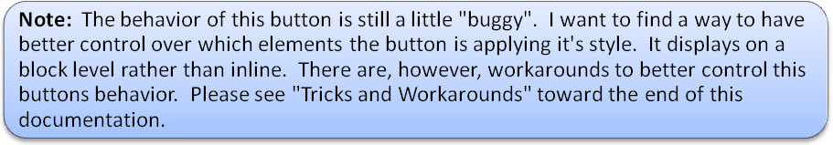

HTML Code Box:

This button is another of my favorites. One of those, “What would I do without it’s”. This button allows you to open up and edit the HTML source without having to switch between editor views. The biggest advantage is that it does NOT mangle your code when switching. Anyone who has switched back and forth has seen this tragedy in action.
With this button, the HTML source is opened up in a fast-loading popup window. You can edit the source code right there, and update your changes without affecting the layout of your content in the visual editor.
This button is also useful when “fine-tuning” some of the other options in tinymce. For instance, using the attributes button will sometimes apply a background color across the entire page rather than just the selected text. You can use this button to change the <p> tags to <span> tags, and this will adjust the background color to just the area of the selected text.

Insert Media Box:

This button will allow you to easily embed a variety of media styles into your content area. Some examples include flash files, windows media files, and quicktime files.
You can also control properties like transparency, autoplay, looping, and spacing.

Tricks and Workarounds:
In this section, I plan to add various “buggy” features I find in tinymce and show the workarounds I use to better control the “bug”. Some of the features in tinymce are beyond my control, and I am unable to resolve directly. However, in this section, I will share my findings with you.

Using the <iframe> tag in the visual editor
It has been brought to my attention when trying to add <iframe> tags, the visual editor gets “hung up” or stops responding altogether. Here is the best workaround I have found for this.
- On your edit post screen, find the “Custom Fields” menu box below the editor.

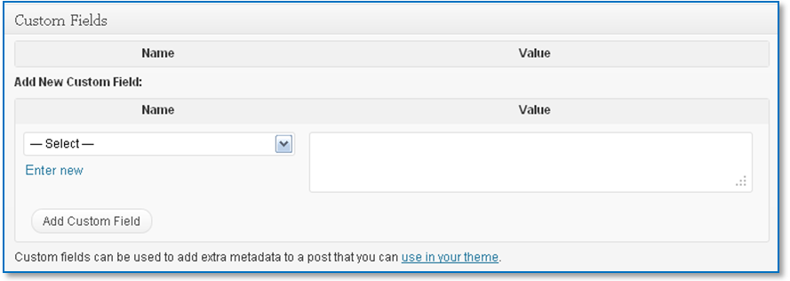

- If you don’t see “Custom Fields” box, you may need to click “Screen Options” at the top of the page, and then check the “Custom Fields” box.

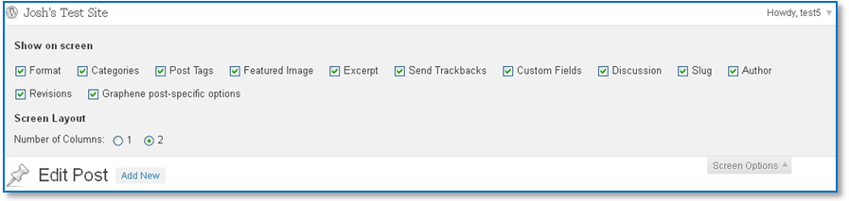

- Now, under the “Custom Fields” box, enter a unique name for each iframe you are inserting. In this example, I am inserting two different youtube videos; each using the iframe code from youtube. (You may need to click “Enter New”)

- Then, in the “Value” box, just paste your iframe code you would like to insert into your post.

- This is what my final code looks like for my first youtube video.

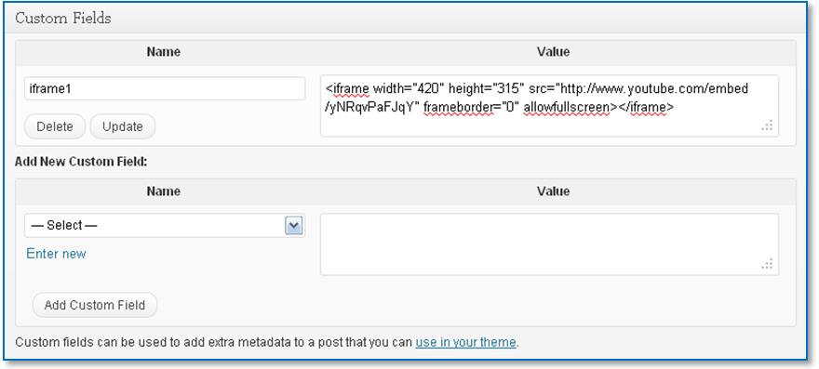

- Then, just keep doing the same for each <iframe> you would like to insert. Remember to keep the “Name” for each iframe unique. Here are both youtube videos added:

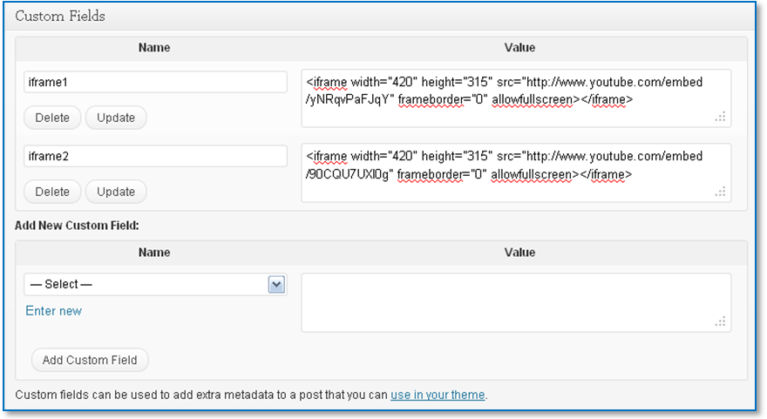

- The last thing is to insert this into your “Visual” or “HTML” section of your post. Just go to a new line where you want to display your iframe, and use this shortcode:
[field name=iframe1] or [field name=iframe2]
Basically, you are creating and using a shortcode with “field name” on the left side of the equals sign. And on the right side of the equals sign is the unique name you created in your custom fields. It should look like this:
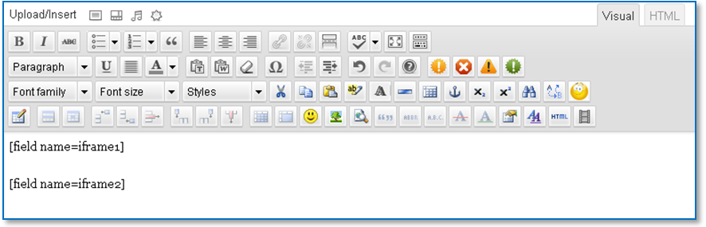

- And that’s it. Your published page should look similar to this:
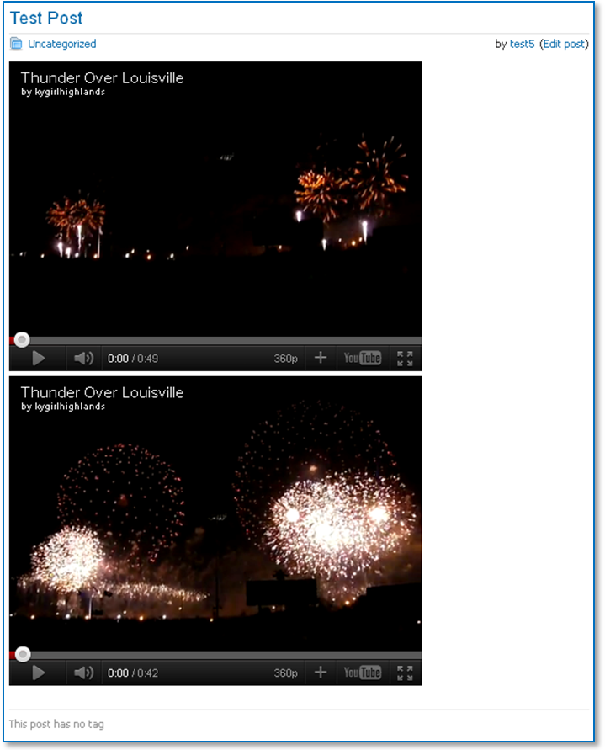

Changelog:
Version 1.2 November 25, 2011
- Added section on how to use iframes in the “Tricks and Workarounds”.
Version 1.1 November 23, 2011
- This is the first version of this documentation.
- Updated versions’ changes will be logged here.

