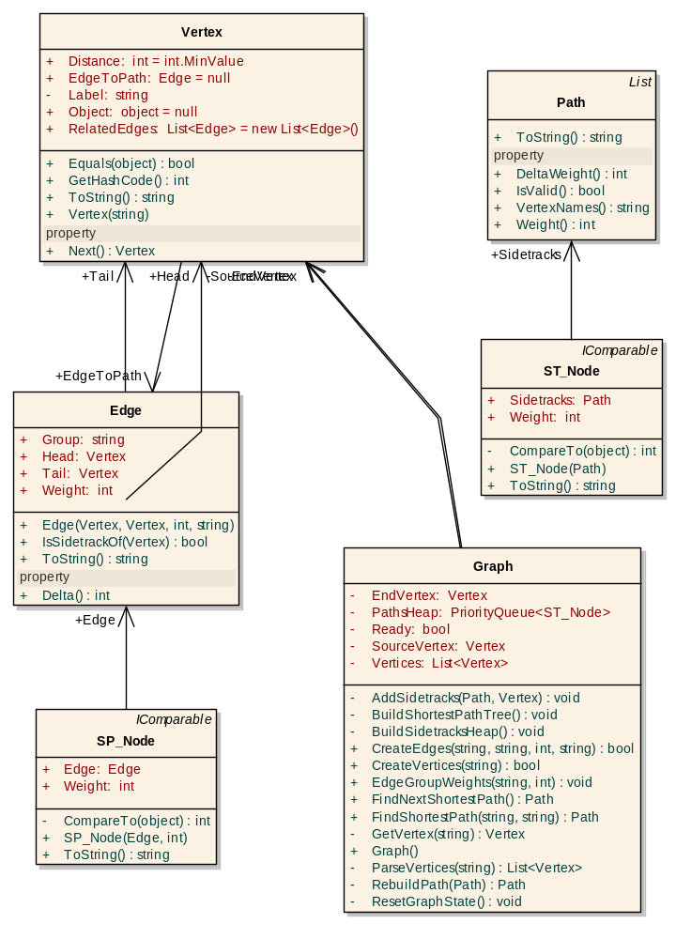

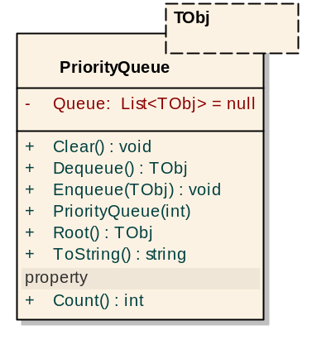

BuildShortestPathTree method:

Reset Graph State
Start from endpoint vertex
Set distance for endpoint vertex = 0

Create a queue for pending edges to evaluate (called “the fringe” in some texts)

Loop
If there is pending vertex to evaluate
Traverse all incoming and valid edges for this vertex
Store them into the fringe

Extract next shortest weighted edge from the fringe
If there is no pending edge
Finished!

If tail (vertex) of extracted edge has not been evaluated
Distance from vertex to endpoint = edge’s weight + distance from edge’s head to endpoint
Mark this edge as a shortest path edge for current vertex
else
Do not traverse this vertex in next loop
End Loop

BuildSidetracksHeap method:

Create a heap (queue) to store sidetracks for each path (weight is the sum of deltas of sidetracks) *
Store in queue an empty sidetrack list, representing the shortest path

Start to evaluate from start vertex in shortest path
Loop
For each sidetrack outcoming from current vertex
Create a copy of previous vertex’s sidetrack list
Add sidetrack to list
Store sidetrack list into the heap
End for
If there is a next vertex in shortest path
Recursively evaluate sidetracks for next vertex
else
Finished!
End Loop

Sidetracks are those outcoming edges that are not part of the shortest path
Delta of a sidetrack is the extra distance to take comparing with the shortest path
Shortest path edges always have a delta = 0

Internal storage of PathsHeap

Each path is represented uniquely by its sidetracks collection.
Sidetracks are represented here by its delta values. Rest of edges in each path are extracted from shortest path (S-D-E-F-J-T)
Empty collection (first) represents shortest path

Eppstein’s original example graph
S
A
C
B
D
E
G
F
H
I
T
J
2
9
18
20
10
8
14
25
11
13
27
14
15
15
20
12
7
Shortest path tree
Other paths

Distances to endpoint and sidetracks
55
56
22
36
42
33
7
23
37
19
0
11
3
9
4
1
10
6

Modified example
S
A
C
B
D
E
G
F
H
I
T
J
2
9
18
20
10
8
14
25
11
13
27
14
15
15
20
12
7
K
5
16
35
30

