Weekly New Issue Market Update
Week ending 22 Sep 2026 | SEC-registered corporate bond issuance | Prepared by Nick Dugdale
$7.1bn | 7 / 11 | 98% | +90bp
Volume this week (avg $25.2bn) | Deals / bonds priced | Investment grade share | Median senior IG 10y spread (prior +106bp)
SUMMARY
IG issuance totaled 7.1bn across 7 deals (11 bonds) in the week of Sep 16–22. Financials led at 4.5bn, with Utilities, Consumer, and Real Estate filling out the mix. IG captured 98% of volume; spreads tightened across most tenors versus the prior three-week average.
NOTABLE DEALS
Issuer | Priced | Rating | Ccy | Size ($m eq.) | Bonds | Tenors | Spread (bps)
The Toronto-Dominion Bank | 21 Sep | A | USD | 3,750 | 4 | 2y, 5y, 10y | +45 to +85
DICK'S Sporting Goods | 22 Sep | BBB | USD | 1,000 | 2 | 10y, 30y | +125 to +160
CenterPoint Energy Houston Electric | 21 Sep | A | USD | 700 | 1 | 5y | +58
Brookfield Finance | 21 Sep | A- | USD | 600 | 1 | 5y | +82
Brown-Forman | 17 Sep | A- | USD | 500 | 1 | 5y | +60
Agree Limited Partnership | 17 Sep | BBB+ | USD | 400 | 1 | 10y | +90
* includes subordinated or hybrid bonds. Spreads over each bond's benchmark (UST for USD, Bunds/mid-swaps for EUR, gilts for GBP).
PRICING CONTEXT: 25 AUG 2026 TO 22 SEP 2026
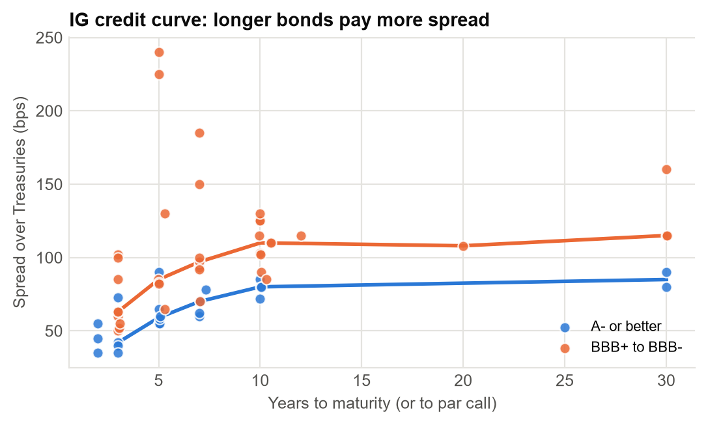 | 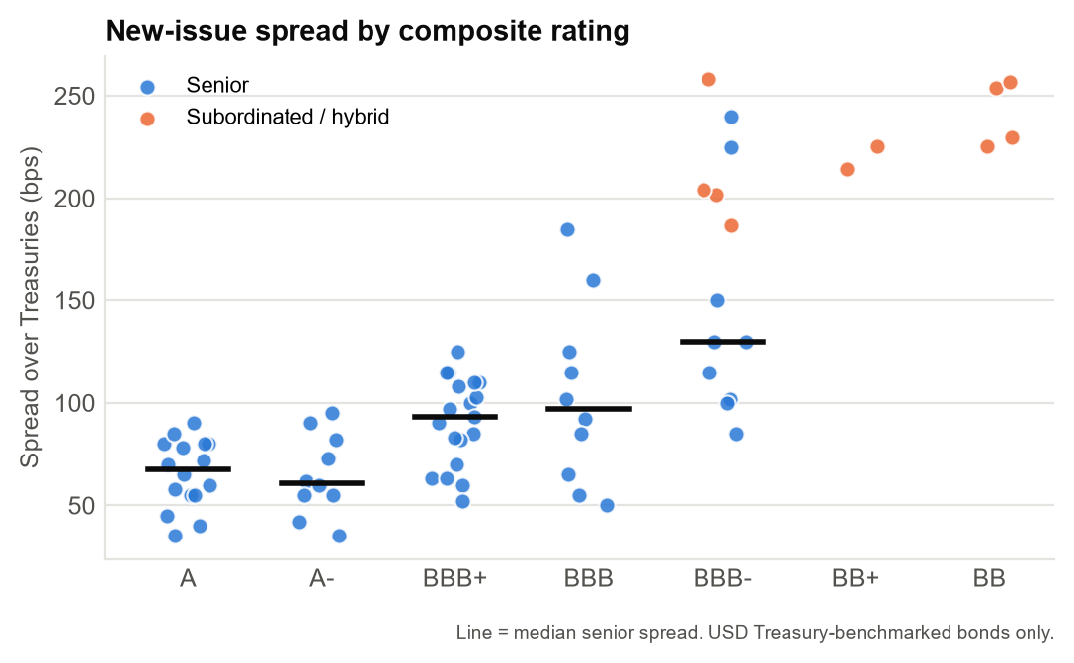
KEY THEMES
- TD Bank (A-rated, 3.75bn, 2/5/10y at +45 to +85) anchored week; spreads tight in senior IG, tightest at 1–3y (45bps).
- Curve steepness evident: 1–3y at 45bps, 10y at 90bps, 30y+ at 160bps; long-end notably wider than prior three-week median.
- DICK'S Sporting Goods (BBB, 1bn, 10y/30y at +125 to +160) tapped consumer; financials dominated sector volume.
Source: SEC EDGAR pricing term sheets (form FWP), 25 Aug 2026 to 22 Sep 2026. Terms extracted from filings with Claude (claude-haiku-4-5-20251001); all figures computed in Python from the extracted data. Commentary drafted by Claude from those figures and checked number-by-number against them. Extraction QC: 98.1% of 771 extracted values traced to source filings; 100.0% correct on a manual spot check of 122 values. LIMITATIONS: covers SEC-registered deals only, so excludes 144A/Reg S issuance (most US high yield and many European deals); volumes are a sample, not the market. Non-USD sizes converted at Federal Reserve H.10 rates for 2026-09-18. Composite rating = middle of Moody's/S&P/Fitch; sector is a model classification. Tenor measured to par call where earlier. Automated draft for discussion; not investment advice.

