Monthly New Issue Market Update
September 2026 | SEC-registered corporate bond issuance | Prepared by Nick Dugdale
$86.2bn | 55 / 105 | 87% | +102bp
Volume this month | Deals / bonds priced | Investment grade share | Median senior IG 10y spread, 16 bond(s)
SUMMARY
September 2026 saw $86.2bn across 55 deals (105 bonds). IG represented 87% of volume. Financials dominated at $31.3bn; Technology, Industrials and Consumer followed. Senior IG spreads showed minimal comparables to prior period; 10y printed at 102bp median.
NOTABLE DEALS
Issuer | Priced | Rating | Ccy | Size ($m eq.) | Bonds | Tenors | Spread (bps)
Aon North America | 14 Sep | BBB+ | USD | 13,500 | 7 | 3y, 5y, 7y, 10y, 12y, 20y, 30y | +63 to +115
GlaxoSmithKline Capital | 08 Sep | A | USD | 6,500 | 6 | 3y, 5y, 7y, 10y, 30y | +40 to +80
Amazon.com | 09 Sep | AA- | GBP | 5,683 | 4 | 3y, 6y, 12y, 19y | +53 to +93
Uber Technologies | 09 Sep | BBB+ | EUR | 5,159 | 5 | 3y, 6y, 8y, 12y, 20y | +69 to +147
Dell International | 09 Sep | BBB+ | USD | 5,000 | 4 | 3y, 5y, 7y, 11y | +60 to +110
The Toronto-Dominion Bank | 21 Sep | A | USD | 3,750 | 4 | 2y, 5y, 10y | +45 to +85
* includes subordinated or hybrid bonds. Spreads over each bond's benchmark (UST for USD, Bunds/mid-swaps for EUR, gilts for GBP).
PRICING CONTEXT: 20 AUG 2026 TO 30 SEP 2026
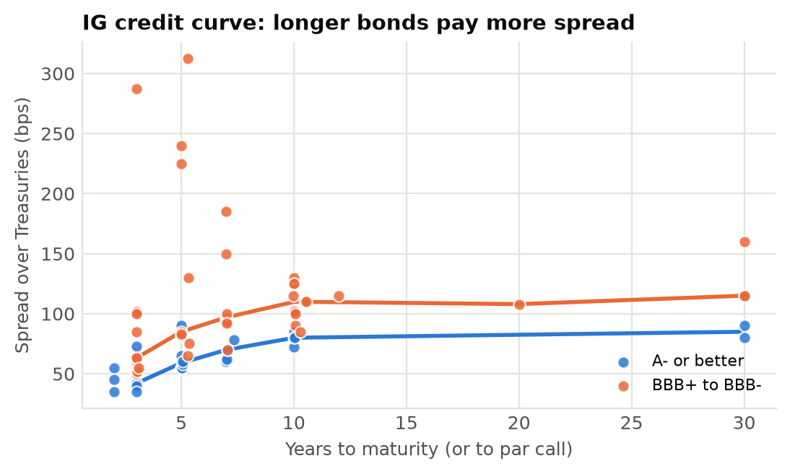 | 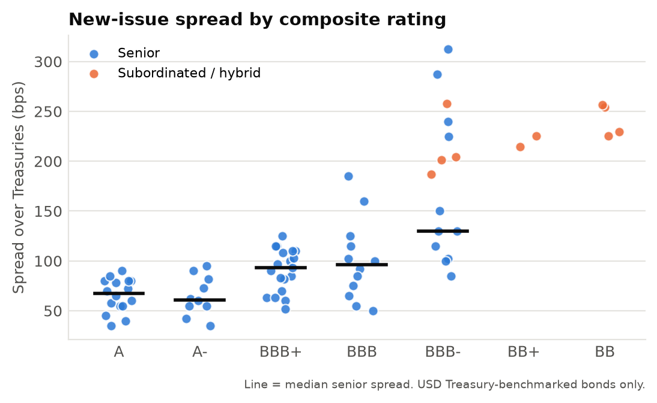
KEY THEMES
- Financials drove flow with $31.3bn; 10 hybrid/sub deals embedded in month's total. Tech sustained secondary role at $15.2bn despite marquee issuers (Uber EUR, Dell, Amazon GBP). Senior IG curve: 1-3y 55bp, 5y 78bp, 10y 102bp, 30y+ 115bp median; spread profile widens by tenor.
Source: SEC EDGAR pricing term sheets (form FWP), 20 Aug 2026 to 30 Sep 2026. Terms extracted from filings with Claude (claude-haiku-4-5-20251001); all figures computed in Python from the extracted data. Commentary drafted by Claude from those figures and checked number-by-number against them. Extraction QC: 97.8% of 863 extracted values traced to source filings; 100.0% correct on a manual spot check of 122 values. LIMITATIONS: covers SEC-registered deals only, so excludes 144A/Reg S issuance (most US high yield and many European deals); volumes are a sample, not the market. Non-USD sizes converted at Federal Reserve H.10 rates for 2026-09-18. Composite rating = middle of Moody's/S&P/Fitch; sector is a model classification. Tenor measured to par call where earlier. Automated draft for discussion; not investment advice.

