Monthly New Issue Market Update
October 2026 | SEC-registered corporate bond issuance | Prepared by Nick Dugdale
$64.4bn | 22 / 56 | 86% | +90bp
Volume this month (avg $89.0bn) | Deals / bonds priced | Investment grade share | Median senior IG 10y spread, 9 bond(s) (prior +102bp)
SUMMARY
October 2026 saw $64.4bn in 56 bonds across 22 deals, 86% IG. Tech and Financials dominated at $27.0bn and $23.0bn respectively. Curve dynamics mixed: 1–3y and 5y widened, while 7y, 10y and 30y+ tightened.
NOTABLE DEALS
Issuer | Priced | Rating | Ccy | Size ($m eq.) | Bonds | Tenors | Spread (bps)
Microsoft | 29 Oct | AAA | USD | 25,000 | 10 | 2y, 3y, 5y, 7y, 10y, 20y, 30y, 40y | +25 to +105
JPMorgan Chase & | 13 Oct | NR | USD | 7,000 | 3 | 3y, 10y | +70 to +90
HSBC Holdings | 29 Oct | A- | USD | 4,250 | 2 | 5y, 10y | +105 to +130
The Procter & Gamble | 26 Oct | AA- | USD | 4,000 | 4 | 5y, 7y, 10y, 30y | +30 to +60
Barclays PLC | 29 Oct | BBB+ | USD | 4,000 | 3 | 3y, 5y, 10y | +100 to +143
The Procter & Gamble | 27 Oct | AA- | EUR | 3,726 | 4 | 4y, 8y, 12y, 20y | +38 to +120
* includes subordinated or hybrid bonds. Spreads over each bond's benchmark (UST for USD, Bunds/mid-swaps for EUR, gilts for GBP).
PRICING CONTEXT: 20 AUG 2026 TO 31 OCT 2026
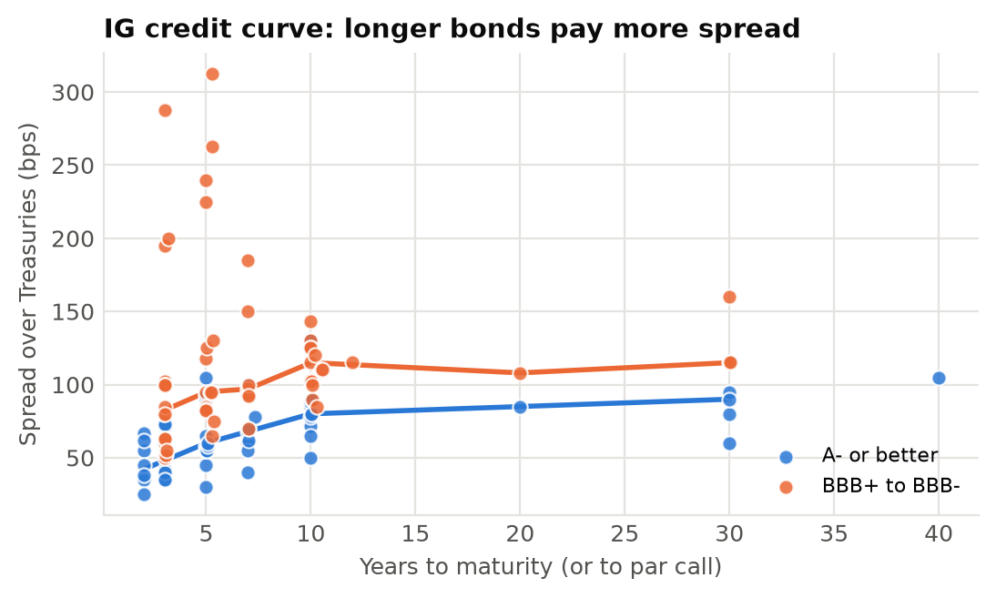 | 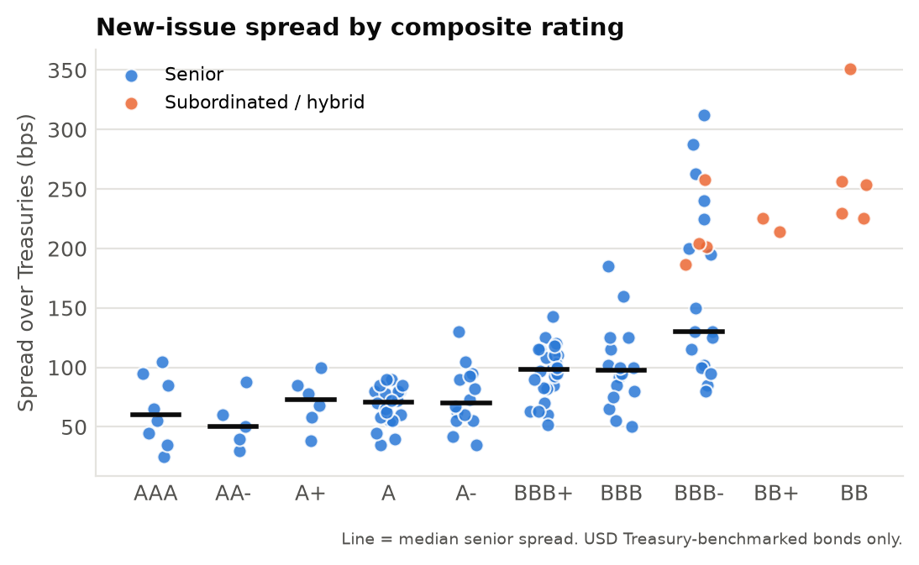
KEY THEMES
- Tech issuance surge led month, with Microsoft's $25bn 10-bond transaction across 2–40y tenors at +25 to +105 setting large-issuer tone.
- Spread volatility uneven across curve: 1–3y wider at 76bp, 5y wider at 94bp versus prior; 10y tighter at 90bp, 30y+ tighter at 95bp.
- Financials active with 4 of top 6 deals; JPMorgan, HSBC, Barclays issued across short and mid tenors at +70–+143 range.
Source: SEC EDGAR pricing term sheets (form FWP), 20 Aug 2026 to 31 Oct 2026. Terms extracted from filings with Claude (claude-haiku-4-5-20251001); all figures computed in Python from the extracted data. Commentary drafted by Claude from those figures and checked number-by-number against them. Extraction QC: 98.4% of 1290 extracted values traced to source filings; 100.0% correct on a manual spot check of 122 values. LIMITATIONS: covers SEC-registered deals only, so excludes 144A/Reg S issuance (most US high yield and many European deals); volumes are a sample, not the market. Non-USD sizes converted at Federal Reserve H.10 rates for 2026-09-18. Composite rating = middle of Moody's/S&P/Fitch; sector is a model classification. Tenor measured to par call where earlier. Automated draft for discussion; not investment advice.

