ETL, EDA & Data Analysis — credit_dt Fraud Dataset
Nick Einstein
Sentinel Fraud Detection Project

Introduction
This document describes the Extract–Transform–Load (ETL) pipeline, Exploratory Data Analysis (EDA), and subsequent data analysis performed on the credit_dt fraud transaction dataset used in the Sentinel platform. The dataset consists of pre-split training and test CSVs (fraudTrain.csv and fraudTest.csv) with rich transaction, geographic, and demographic attributes. All steps below are implemented in Python modules under src/data/ and src/etl/ and executed automatically when running python main.py.

Part 1 — ETL Process
ETL prepares raw CSV rows into a clean, balanced, model-ready matrix. For credit_dt we use a provider-supplied train/test split rather than random stratified splitting.

1.1 Extract (Data Ingestion)
- Source files: data/credit_dt/fraudTrain.csv (~1.3M rows full file) and fraudTest.csv (~555k rows).
- Training sample cap: 200,000 rows · Test sample cap: 100,000 rows (config.yaml).
- Module: DataIngestStage → load_credit_dt_splits() in src/data/credit_dt.py.
- Raw columns include: trans_date_trans_time, cc_num, merchant, category, amt, gender, state, lat, long, merch_lat, merch_long, city_pop, unix_time, is_fraud.

1.2 Transform — Featurization
Raw PII and identifiers are excluded; modelling features are engineered as follows:
Step | Operation | Output column(s)
Target | is_fraud → Class (0/1) | Class
Time | Parse trans_date_trans_time | trans_hour, trans_dow
Geography | Haversine(cardholder lat/long, merchant coords) | distance_km
Categoricals | Label encoding fit on training vocabulary | category, gender, state
Numeric | amt, lat, long, merch_lat, merch_long, city_pop, unix_time | as-is (numeric)

Final model feature vector (13 columns):
- amt, lat, long, merch_lat, merch_long, city_pop, unix_time, trans_hour, trans_dow, distance_km, category, gender, state
Stable encodings are saved to artifacts/credit_dt_featurizer.json so scoring uses the same category/gender/state maps as training.

1.3 Transform — Cleaning
- Remove duplicate rows (drop_duplicates: true in config).
- Median imputation for missing numeric values (none observed in sampled data).
- Duplicates in train sample: 0.
- Missing columns in sample: none.

1.4 Transform — Train/Test Split Strategy
Unlike Kaggle creditcard.csv (random 80/20 stratified split), credit_dt uses the official fraudTrain / fraudTest files. This preserves the provider's temporal or sampling design and avoids leakage from reshuffling.

1.5 Load — SMOTE Class Balancing
SMOTE (Synthetic Minority Over-sampling Technique) is applied only to the training set after featurization. The test set is never resampled, so evaluation reflects real imbalance.
- Library: imbalanced-learn SMOTE.
- Parameters: sampling_strategy=auto, k_neighbors=5, random_state=42.
- Purpose: increase fraud class representation so CatBoost learns minority patterns.
- Pre-SMOTE baseline (X_train_raw) is retained for KS drift monitoring.
Figure 1: Class counts before and after SMOTE (train sample).
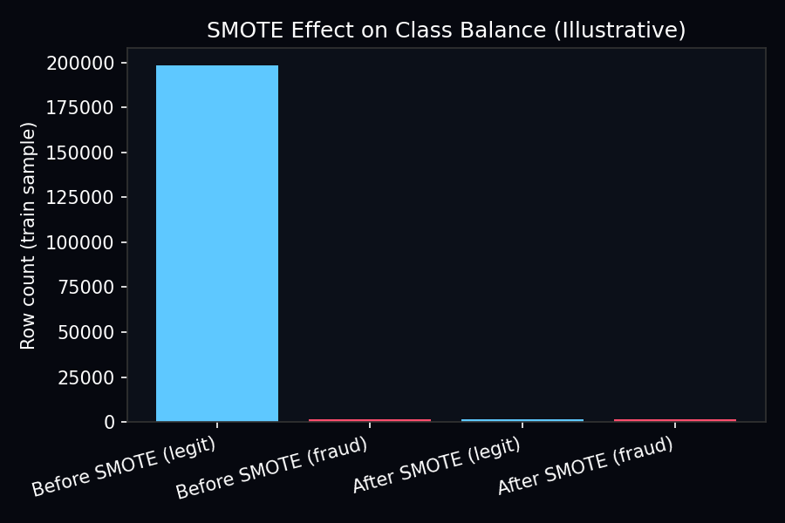

1.6 ETL Output Artifacts
- X_train (SMOTE-balanced), X_test (original distribution), y_train, y_test.
- artifacts/feature_columns.json — feature manifest.
- artifacts/credit_dt_featurizer.json — categorical maps and numeric defaults.
- ETL module: src/etl/pipeline.py (ETLPipeline.run()).

Part 2 — Exploratory Data Analysis (EDA)
EDA was conducted on the sampled train and test sets to understand class imbalance, transaction amounts, categorical risk patterns, and temporal behaviour before modelling.

2.1 Dataset Overview
Metric | Train (sample) | Test (sample)
Rows analysed | 200,000 | 100,000
Fraud transactions | 1645 | 402
Fraud rate | 0.8225% | 0.4020%
Mean amount ($) | 71.17 | 69.29
Median amount ($) | 47.66 | 47.32
US states | 50 | 50
Merchant categories | 14 | 14

2.2 Class Imbalance
Fraud is extremely rare (~0.82% in train sample, ~0.40% in test sample). This ~1000:1 imbalance motivates SMOTE on training data and ROC-AUC / F1 as primary metrics rather than raw accuracy.
Figure 2: Legitimate vs fraud transaction counts.
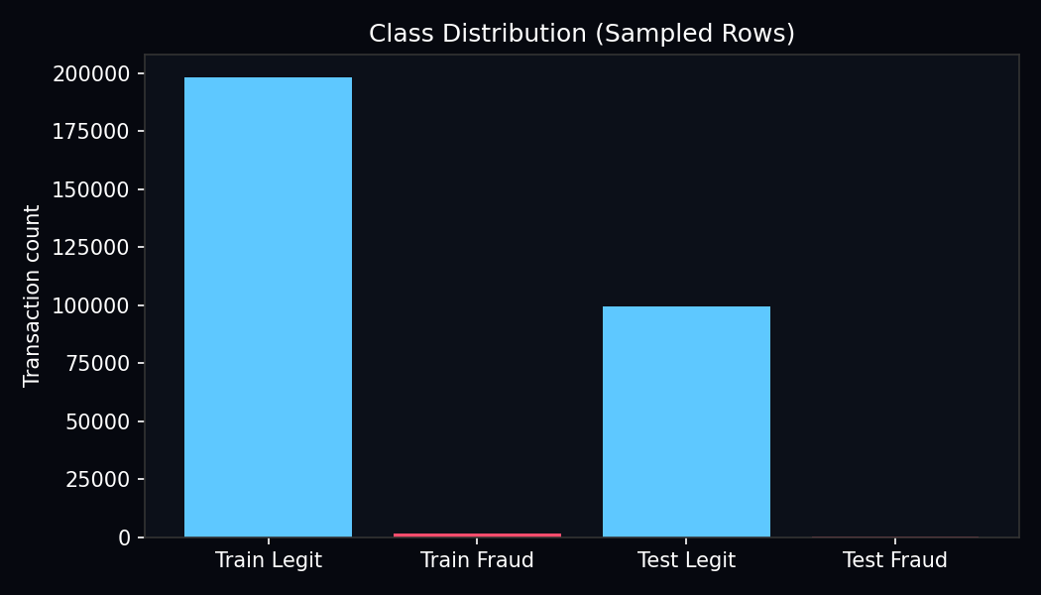

2.3 Transaction Amount Analysis
Fraudulent transactions have substantially higher amounts than legitimate ones in the train sample: mean $509.35 (fraud) vs $67.54 (legitimate). This supports amount (amt) as an important predictive feature alongside category.
Figure 3: Log-transformed amount distributions by class.
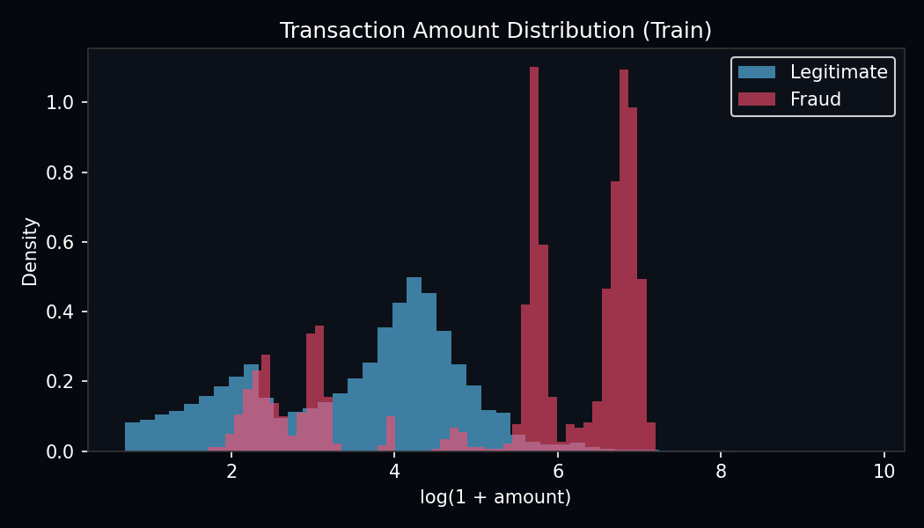

2.4 Categorical Analysis
Merchant category shows the strongest variation in fraud rate. Categories such as shopping_net and misc_net often exhibit higher fraud rates than grocery or gas categories. Gender (F/M) and US state (50 codes) provide additional segmentation.
Figure 4: Fraud rate by merchant category.
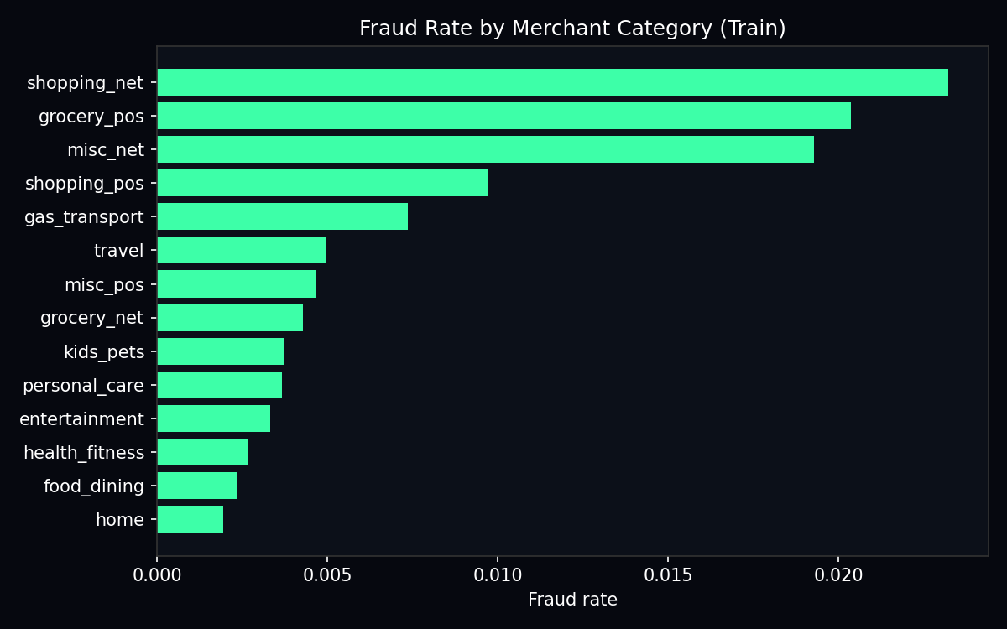

2.5 Temporal Analysis
Transaction hour (derived from trans_date_trans_time) shows time-of-day patterns in fraud rate. trans_hour and trans_dow are included as explicit features; unix_time captures absolute epoch time for longer-term drift.
Figure 5: Fraud rate by hour of day.
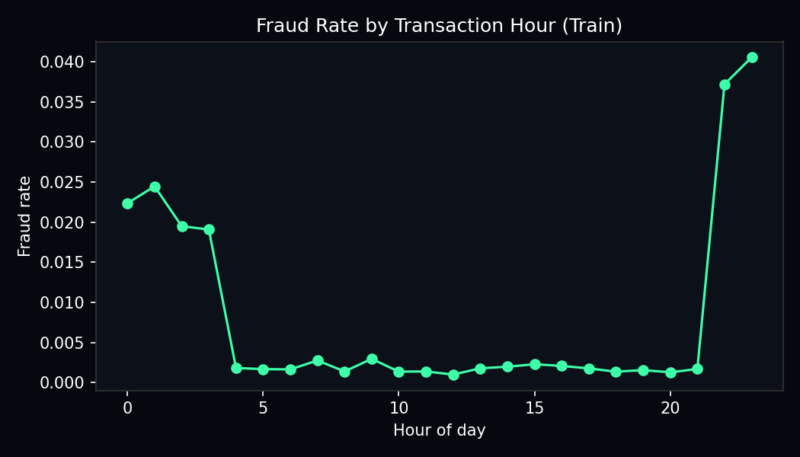

2.6 Geographic Analysis
Each row contains cardholder (lat, long) and merchant (merch_lat, merch_long) coordinates. EDA motivated the derived feature distance_km using the Haversine great-circle formula. Large distances between cardholder and merchant locations can indicate card-not-present fraud or compromised credentials used remotely.

2.7 PCA Visualization (Post-Scaling)
After StandardScaler, 2-component PCA is fit on the training set for visualization only (not used as CatBoost inputs). The scatter plot colours points by Class (fraud vs legit).
Figure 6: PCA projection of scaled training features (saved at artifacts/plots/pca_train.png).
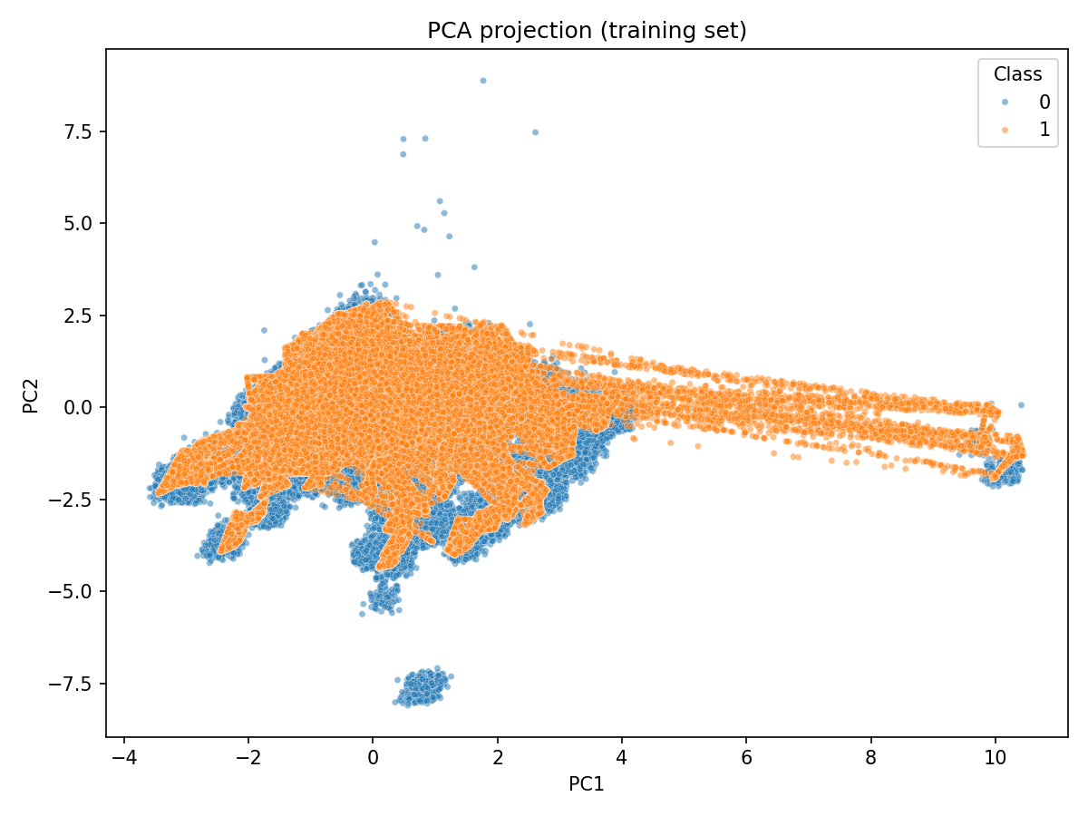

Part 3 — Data Analysis (Post-ETL)
After ETL and feature engineering, we performed supervised learning, feature importance analysis, and distributional drift analysis between train and test.

3.1 Feature Engineering (Post-ETL)
- StandardScaler: zero mean, unit variance per feature (fit on SMOTE-balanced train).
- Scaler saved to artifacts/scaler.joblib for serving.
- PCA (2 components): exploratory visualization only.
- Module: src/engineering/features.py (FeatureEngineer).

3.2 Supervised Model — CatBoost
Gradient boosted trees (CatBoost) classify fraud using scaled features. auto_class_weights=Balanced further addresses imbalance. Hyperparameters: 500 iterations, depth 6, learning rate 0.05, eval_metric AUC.

3.3 Model Performance (Test Set)
Metric | Value | Notes
ROC-AUC | 0.9851 | Ranking quality on held-out fraudTest
F1 Score | 0.6887 | Precision/recall balance at threshold 0.5
Threshold | 0.50 | fraud_probability ≥ 0.5 → fraud flag

3.4 Feature Importance Analysis
CatBoost feature importance (artifacts/feature_importance.csv) shows merchant category dominates (~64%), followed by transaction amount (~11%) and gender (~9%). Geographic coordinates and distance_km contribute smaller but non-zero importance.
feature | importance
category | 63.60976712683712
amt | 11.47331556568562
gender | 9.458028834214954
city_pop | 3.0733510150363568
trans_hour | 2.8253365759437874
unix_time | 2.7962355426448946
state | 1.740665115527161
lat | 1.5552342896744635
long | 1.4836565313151917
trans_dow | 1.183353698121395
merch_long | 0.3200384630754156
distance_km | 0.257810525496898
merch_lat | 0.2232067164267547

3.5 Drift Analysis (Train vs Test)
Kolmogorov–Smirnov (KS) two-sample tests compare each feature's distribution in pre-SMOTE training data (baseline) vs the test set. Significant drift (p < 0.05) was observed for unix_time and trans_dow, indicating temporal shift between splits. This is expected and is monitored in production via DriftMonitor.
feature | ks_statistic | p_value | drift_detected
unix_time | 1.0 | 0.0 | True
trans_dow | 0.0609899999999999 | 5.096326418128745e-216 | True
city_pop | 0.0050099999999999 | 0.0701625730733133 | False
amt | 0.004205 | 0.1886024973340859 | False
state | 0.0037449999999999 | 0.3063578335308146 | False
trans_hour | 0.00373 | 0.3109233933819292 | False
lat | 0.00355 | 0.3693536596575814 | False
distance_km | 0.0035449999999999 | 0.3710718114013248 | False
merch_lat | 0.0033199999999999 | 0.453446483151372 | False
category | 0.0025249999999999 | 0.7879782839665836 | False
long | 0.00221 | 0.8998948166234672 | False
merch_long | 0.00218 | 0.908601340144916 | False
gender | 0.00048 | 1.0 | False

3.6 Anomaly Analysis — Isolation Forest
An unsupervised Isolation Forest (contamination=0.002) is trained on scaled features to score anomalous transactions in the real-time stream, complementing supervised CatBoost.

3.7 Key EDA-Driven Decisions
- Use SMOTE on train only because fraud rate < 1%.
- Keep category as encoded feature — highest importance in the model.
- Engineer distance_km from coordinates identified in geographic EDA.
- Use ROC-AUC and F1 instead of accuracy due to imbalance.
- Monitor KS drift on time features where train/test distributions differ.
- Retain raw is_fraud labels separately from model predictions in the UI.

Summary
The ETL pipeline transforms raw credit_dt CSVs into 13 numeric modelling features with stable encodings and SMOTE-balanced training data. EDA confirmed extreme class imbalance, higher fraud amounts, category-driven risk, and temporal patterns. Post-ETL analysis yielded strong ranking performance (ROC-AUC 0.9851) with actionable feature importance and drift reports that feed the governance layer of the Sentinel platform.

Prepared by Nick Einstein — Sentinel Fraud Detection Project.

