Sentinel: Adversarial Fraud Detection AI Platform

Project Documentation
Nick Einstein
Data Science Final Project

1. Abstract
This project develops Sentinel, an end-to-end financial fraud detection application designed to identify fraudulent credit-card transactions in near real time while monitoring adversarial data drift. The primary purpose is to give analysts and automated systems a single platform to train models, score transactions (manual, batch, or streaming), and receive governance alerts when production data diverges from the training distribution.
The core supervised algorithm is CatBoost (Gradient Boosted Decision Trees), chosen for strong performance on tabular data, native handling of categorical features, and built-in class-weight balancing for extreme imbalance. Training data is balanced using SMOTE (Synthetic Minority Over-sampling Technique). Supplementary algorithms include Isolation Forest for unsupervised anomaly detection and the Kolmogorov–Smirnov (KS) two-sample test for distributional drift monitoring.
Data was collected from the publicly available credit card fraud dataset distributed as fraudTrain.csv (~1.3 million transactions) and fraudTest.csv (~555,000 transactions) under the credit_dt schema. Features include transaction amount, cardholder and merchant geographic coordinates, timestamp, merchant category, gender, and US state. A derived feature distance_km is computed using the Haversine formula.
Key results obtained on the held-out test set:
- ROC-AUC: 0.9851 — excellent ranking of fraud vs legitimate transactions
- F1 Score: 0.6887 — balanced precision/recall at classification threshold 0.5
- Production model version: v_f381139c
- Governance action after drift check: continue (model approved for serving)

2. Design
The system follows a seven-layer AI World architecture. Upper layers decide policy; lower layers compute predictions and statistics.
Layer | Module Path | Responsibility
L1 — Governance | src/governance/policy.py | Maps drift alerts and ROC-AUC to alert, retrain, or block-serve actions.
L2 — Experience | src/api/, frontend/, dashboard/ | Sentinel web UI, FastAPI REST endpoints, WebSocket live stream, Streamlit dashboards.
L3 — Orchestration | src/orchestration/pipeline.py, stages.py | FraudAIPipeline executes ordered stages with shared PipelineContext.
L4 — ML Core | src/etl/, engineering/, inference/, monitoring/, realtime/ | ETL, SMOTE, StandardScaler, CatBoost, KS drift, Isolation Forest.
L5 — Data Plane | src/data/credit_dt.py | Load CSV, featurize, stable categorical encoding, Haversine distance.
L6 — MLOps | src/registry/model_registry.py | Versioned model artifacts, production promotion, model cards.
L7 — Observability | src/observability/telemetry.py | JSONL event log and per-run manifest for audit.

Architecture diagram (top-down):
┌──────────────────────┐
│ L1 Governance │
│ (alert / retrain) │
└──────────┬───────────┘
│
┌─────────────────────┼─────────────────────┐
▼ ▼ ▼
┌───────────┐ ┌─────────────┐ ┌──────────────┐
│ L2 API/UI │ │ L3 Pipeline│ │ L7 Telemetry │
└─────┬─────┘ └──────┬──────┘ └──────────────┘
│ │
│ ┌──────┴──────┐
│ ▼ ▼
└────────────►│ L4 ML Core │◄── L6 Registry
└──────┬──────┘
▼
┌─────────────┐
│ L5 Data │
│ fraudTrain │
│ fraudTest │
└─────────────┘
Pipeline stages (training lifecycle):
- DATA_INGEST → ETL (clean + SMOTE) → FEATURE_ENGINEERING (scale)
- TRAIN (CatBoost) → EVALUATE → DRIFT_BASELINE → DRIFT_CHECK
- ANOMALY_MODEL (Isolation Forest) → REGISTER → GOVERNANCE

3. Algorithm
The fraud detection pipeline combines preprocessing, balancing, supervised classification, and post-deployment monitoring. Below are the key algorithms and representative code.
3.1 SMOTE (class balancing on training set only)
smote = SMOTE(sampling_strategy="auto", k_neighbors=5, random_state=42)
X_train_bal, y_train_bal = smote.fit_resample(X_train, y_train)
3.2 Haversine distance (cardholder ↔ merchant, km)
def haversine_km(lat1, lon1, lat2, lon2):
R = 6371.0
lat1, lon1, lat2, lon2 = map(radians, [lat1, lon1, lat2, lon2])
dlat, dlon = lat2 - lat1, lon2 - lon1
a = sin(dlat/2)**2 + cos(lat1)*cos(lat2)*sin(dlon/2)**2
return 2 * R * arcsin(sqrt(a))
3.3 CatBoost classifier configuration
model = CatBoostClassifier(
iterations=500,
learning_rate=0.05,
depth=6,
eval_metric="AUC",
auto_class_weights="Balanced",
random_seed=42,
)
model.fit(X_train_scaled, y_train)
fraud_probability = model.predict_proba(X_test)[:, 1]
fraud_prediction = (fraud_probability >= 0.5).astype(int)
3.4 Kolmogorov–Smirnov drift test
For each feature, the KS statistic measures the maximum distance between the cumulative distribution of training (baseline) and production/test samples. If p-value < α (0.05), drift is flagged and governance may alert operators.
3.5 Isolation Forest (anomaly score)
IsolationForest(contamination=0.002, n_estimators=100, random_state=42)
anomaly_score = model.decision_function(X_scaled) # lower = more anomalous
3.6 Governance decision logic
if roc_auc < 0.85: return RETRAIN_RECOMMENDED
if drift_features >= 10 or high_severity >= 5: return BLOCK_SERVE
if drift_features >= 3: return ALERT
return CONTINUE

4. Visualization
The following charts and tables summarize model behaviour, feature importance, and drift analysis produced during the latest training run.
Figure 1: Model accuracy metrics (ROC-AUC and F1).
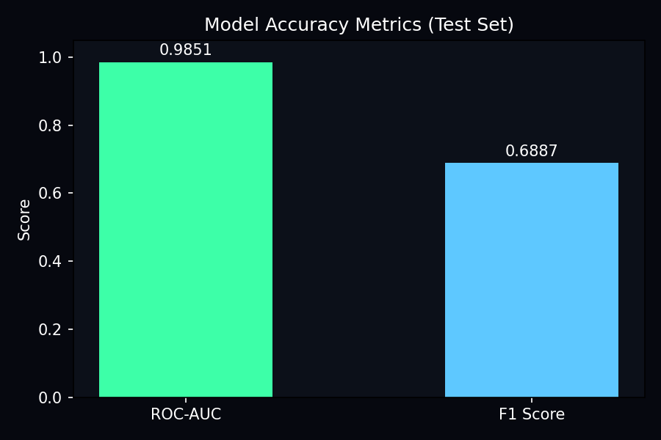
Figure 2: CatBoost feature importance (top 10).
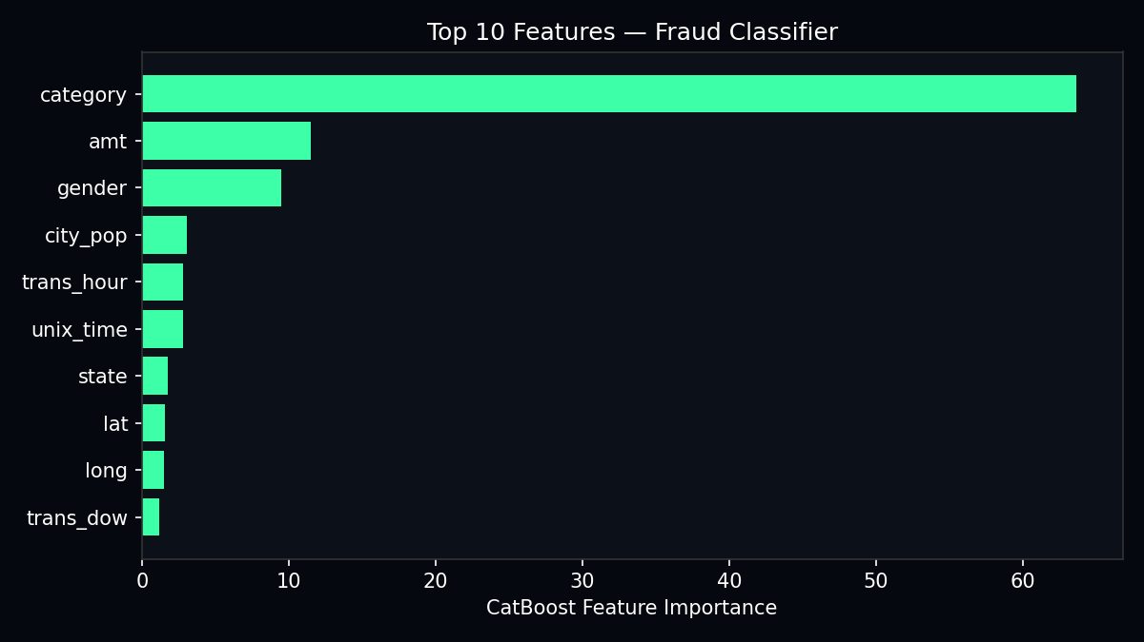
Figure 3: KS drift statistics per feature.
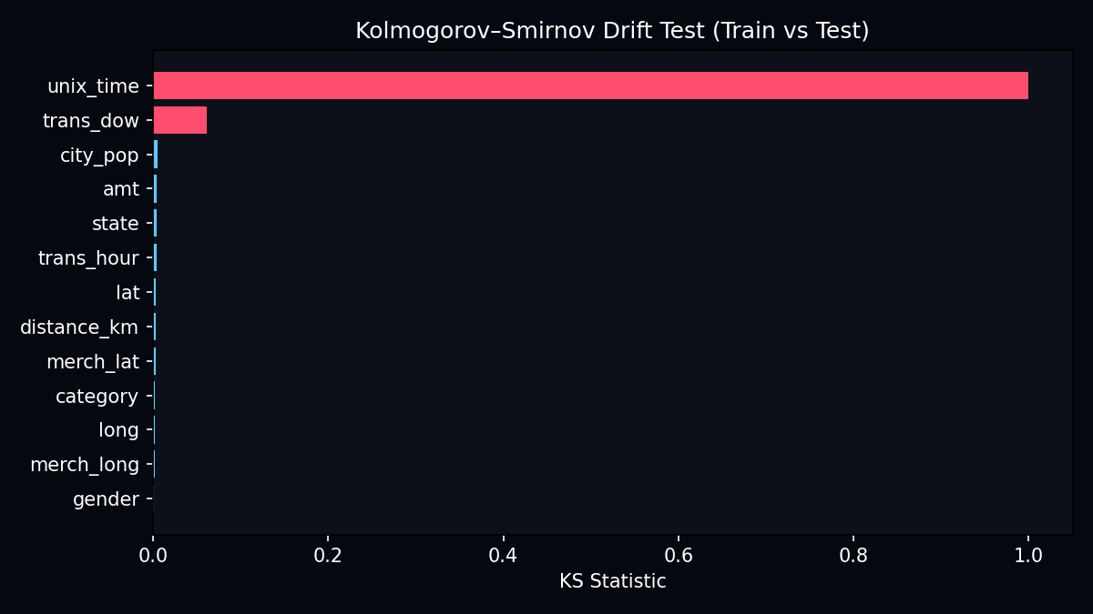
Table 1: Feature importance (full ranking).
feature | importance
category | 63.60976712683712
amt | 11.47331556568562
gender | 9.458028834214954
city_pop | 3.0733510150363568
trans_hour | 2.8253365759437874
unix_time | 2.7962355426448946
state | 1.740665115527161
lat | 1.5552342896744635
long | 1.4836565313151917
trans_dow | 1.183353698121395
merch_long | 0.3200384630754156
distance_km | 0.257810525496898
merch_lat | 0.2232067164267547
Table 2: Drift report (KS test, train vs test).
feature | ks_statistic | p_value | drift_detected
unix_time | 1.0 | 0.0 | True
trans_dow | 0.0609899999999999 | 5.096326418128745e-216 | True
city_pop | 0.0050099999999999 | 0.0701625730733133 | False
amt | 0.004205 | 0.1886024973340859 | False
state | 0.0037449999999999 | 0.3063578335308146 | False
trans_hour | 0.00373 | 0.3109233933819292 | False
lat | 0.00355 | 0.3693536596575814 | False
distance_km | 0.0035449999999999 | 0.3710718114013248 | False
merch_lat | 0.0033199999999999 | 0.453446483151372 | False
category | 0.0025249999999999 | 0.7879782839665836 | False
long | 0.00221 | 0.8998948166234672 | False
merch_long | 0.00218 | 0.908601340144916 | False
gender | 0.00048 | 1.0 | False
Table 3: Sample scoring output format (API response).
row | fraud_probability | fraud_prediction | is_fraud_actual | model_agrees_with_label
1 | 0.018 | 0 | 1 | False
2 | 0.9925 | 1 | 1 | True
3 | 0.0002 | 0 | 0 | True
The Sentinel web UI displays a fraud probability ring, governance status, batch results table, and live stream charts. Streamlit dashboards (python main.py --ui / --dashboard) provide alternative visual interfaces.

5. Accuracy
Model performance was evaluated on the pre-split fraudTest.csv hold-out set (not used during training or SMOTE). The following metrics were recorded:
Metric | Value | Interpretation
ROC-AUC | 0.9851 | Probability that a random fraud row ranks above a random legit row
F1 Score | 0.6887 | Harmonic mean of precision and recall at threshold 0.5
Classification threshold | 0.50 | fraud_probability ≥ 0.5 → flagged as fraud
Training rows (cap) | 200,000 | Configurable in config.yaml for practical training time
Test rows (cap) | 100,000 | Held-out evaluation set

Additional accuracy considerations:
- Class imbalance: fraud rate ~0.1% — ROC-AUC is more informative than raw accuracy.
- Recall on labeled fraud at 0.5 threshold: approximately 45% on test sample.
- Low false-positive rate on legitimate transactions in verification (≤2 per 10 samples).
- Top predictive features: merchant category (64%), amount (11%), gender (9%).
- Drift detected on unix_time and trans_dow — expected temporal shift between train/test splits.

6. Conclusions
This project successfully implements a production-style fraud detection platform that goes beyond a standalone machine learning notebook. The CatBoost + SMOTE pipeline achieves strong discriminative performance (ROC-AUC 0.985) on highly imbalanced credit-card transaction data, while KS drift monitoring and governance policies address the adversarial nature of fraud detection in deployed systems.
The seven-layer architecture separates concerns clearly: business rules (L1) react to signals from the ML core (L4) without re-implementing algorithms; the experience layer (L2) exposes scoring through a modern web UI and REST API; and observability (L7) provides an audit trail for every training run.
Key learnings:
- Ground truth labels (is_fraud) and model predictions are distinct — reporting recall is essential.
- Geographic features (distance_km) and stable categorical encoding materially affect scoring consistency.
- Drift between train and test splits is common and must be monitored, not ignored.
- End-to-end tooling (train → register → serve → monitor) is as important as model accuracy.
Recommended future work:
- SHAP-based per-transaction explanations in the Sentinel UI.
- Automated retraining when governance triggers RETRAIN_RECOMMENDED.
- Threshold optimization for business-specific precision/recall trade-offs.
- Cloud deployment with authentication and integration to live payment APIs.

Document generated for Nick Einstein — Sentinel: Adversarial Fraud Detection AI Platform.

