Model Metrics, Algorithm Depth & Evaluation
Nick Einstein
Sentinel Fraud Detection Project

1. Algorithms in the Stack
The Sentinel platform uses three complementary algorithms: (1) CatBoost gradient boosted decision trees for supervised fraud classification; (2) SMOTE for training-time class balancing; (3) Isolation Forest for unsupervised anomaly scoring in the real-time stream. A fourth analytical method — Kolmogorov–Smirnov drift testing — monitors feature distributions but is not a predictive model.
Algorithm | Type | Role | Artifact
CatBoost | Supervised GBDT | Primary fraud probability | artifacts/models/catboost_fraud.cbm
SMOTE | Resampling | Balance training labels only | Applied in-memory at train time
StandardScaler | Preprocessing | Normalize features before trees | artifacts/scaler.joblib
Isolation Forest | Unsupervised ensemble | Anomaly score in live stream | artifacts/models/anomaly_iforest.joblib
KS test | Statistical test | Drift vs training baseline | artifacts/baselines/feature_distributions.joblib

2. CatBoost Classifier — Model Depth & Structure
CatBoost (Categorical Boosting) builds an ensemble of decision trees sequentially. Each new tree corrects errors from prior trees using gradient boosting. Our configuration targets tabular fraud data with severe class imbalance.

2.1 Hyperparameters (config.yaml)
Parameter | Value | Meaning
depth | 6 | Maximum depth of each decision tree (levels from root to leaf)
iterations | 500 | Number of boosting trees built in the ensemble
learning_rate | 0.05 | Shrinkage per tree — smaller steps, less overfit
eval_metric | AUC | Optimization target during training (ROC area)
auto_class_weights | Balanced | Penalize misclassified minority (fraud) class more
random_seed | 42 | Reproducible training
verbose | 100 | Log every 100 iterations

2.2 What “Depth = 6” Means
Each tree can ask up to six sequential splitting questions (e.g. category < X, then amt < Y, …) before reaching a leaf prediction. Depth 6 balances complexity and generalization: deep enough to capture interactions (category × amount × time), shallow enough to avoid memorizing rare fraud patterns on SMOTE-synthetic points.
- Trees in final model: 500 (one per boosting iteration).
- Input features per tree: 13 (all scaled numeric columns).
- Training rows after SMOTE: 396,710 (balanced classes).
- Output: fraud_probability ∈ [0, 1] via sigmoid of ensemble logit sum.
- Decision rule at serve time: fraud_prediction = 1 if probability ≥ 0.5.

2.3 Mathematical Form (Conceptual)
F(x) = Σ_{t=1}^{T} η · h_t(x) where T = 500 trees, η = 0.05 learning rate
P(fraud) = σ(F(x)) σ = logistic sigmoid
h_t = decision tree of depth ≤ 6 each h_t fits residual gradients

2.4 Why CatBoost for This Problem
- Handles mixed numeric features after encoding without manual one-hot explosion.
- Ordered boosting reduces prediction shift on small fraud samples.
- auto_class_weights complements SMOTE for minority-class recall.
- Strong ROC-AUC on tabular financial data vs single decision trees or logistic regression.

3. SMOTE & Preprocessing Depth
Component | Setting | Detail
SMOTE k_neighbors | 5 | Synthetic fraud points interpolated from 5 nearest real fraud neighbors
SMOTE sampling_strategy | auto | Resample minority until balanced with majority class
SMOTE applied to | Train only | Test set keeps natural ~0.4% fraud rate
StandardScaler | 13 features | μ=0, σ=1 per column; fit on SMOTE-balanced train
PCA | 2 components | Visualization only (pca_train.png); NOT fed to CatBoost

4. Isolation Forest — Anomaly Model Depth
Parameter | Value | Meaning
n_estimators | 100 | Number of random trees in the forest
contamination | 0.002 | Expected anomaly proportion (~0.2% of training sample)
Tree structure | Random splits | Each tree isolates points; shorter path = more anomalous
max_samples | auto (sklearn default) | Subsample per tree for diversity
Output | decision_function | Inverted to anomaly_score (higher = more unusual)
Isolation Forest does not predict fraud labels directly. It flags statistically rare transactions in the real-time WebSocket stream, complementing CatBoost when attack patterns are novel and not present in labelled training data.

5. Evaluation Metrics — Definitions
Metric | Formula / Definition | Why we use it
ROC-AUC | Area under TPR vs FPR curve | Ranking quality; robust to imbalance
Average Precision | Area under precision-recall curve | Focuses on positive (fraud) class
Precision | TP / (TP + FP) | Of flagged transactions, how many are truly fraud
Recall | TP / (TP + FN) | Of all fraud, how many we catch
F1 | 2·P·R / (P + R) | Harmonic mean of precision and recall
Accuracy | (TP+TN) / N | Misleading when fraud < 1% — reported for completeness
Balanced accuracy | Mean of per-class recall | Fairer than raw accuracy under imbalance

6. Measured Results (fraudTest hold-out)
Evaluation on 100,000 test rows (402 fraud, rate 0.40%). Threshold = 0.5 unless noted.
Metric | Value
ROC-AUC | 0.9851
Average Precision (PR-AUC) | 0.7093
F1 Score | 0.6887
Precision | 0.7039
Recall | 0.6741
Accuracy | 0.9976
Balanced Accuracy | 0.8365

6.1 Confusion Matrix
 | Predicted Legit | Predicted Fraud
Actual Legit | 99,484 (True Negative) | 114 (False Positive)
Actual Fraud | 131 (False Negative) | 271 (True Positive)
Interpretation: 271 fraud cases correctly flagged; 131 fraud cases missed; 114 legitimate transactions incorrectly flagged as fraud.
Figure 1: Confusion matrix heatmap.
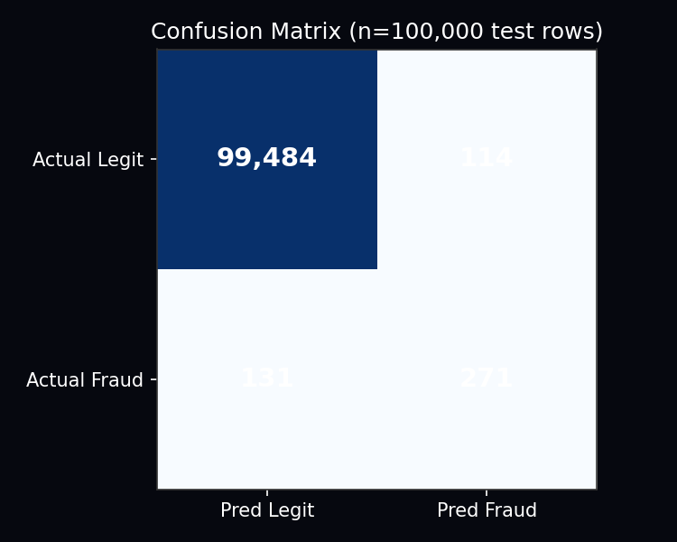

6.2 Per-Class Classification Report
precision recall f1-score support
0 1.00 1.00 1.00 99598
1 0.70 0.67 0.69 402
accuracy 1.00 100000
macro avg 0.85 0.84 0.84 100000
weighted avg 1.00 1.00 1.00 100000
Figure 2: Summary of key metrics at threshold 0.5.
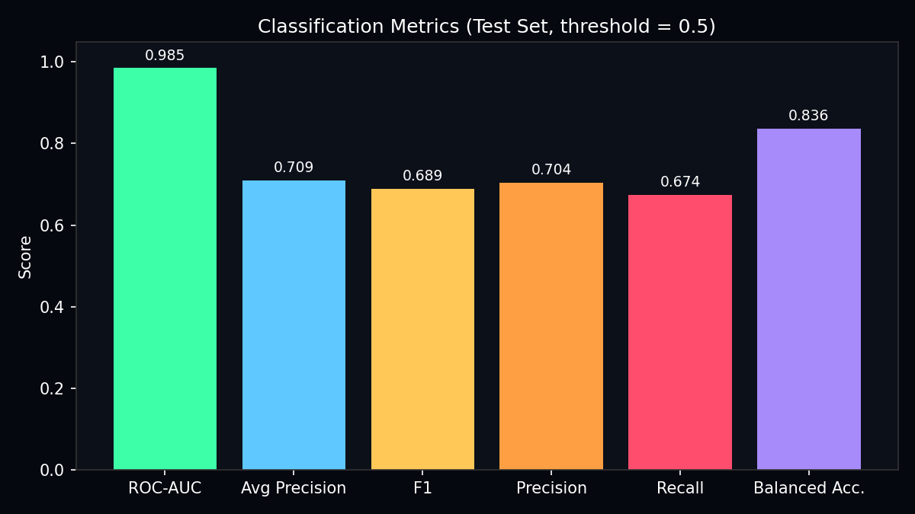

6.3 Threshold Sensitivity
Lowering the threshold increases recall (catch more fraud) but adds false positives. Raising it improves precision but misses more fraud.
Threshold | Precision | Recall | F1 | Transactions flagged
0.1 | 0.356 | 0.791 | 0.491 | 893
0.2 | 0.495 | 0.759 | 0.599 | 616
0.3 | 0.580 | 0.721 | 0.643 | 500
0.4 | 0.634 | 0.694 | 0.663 | 440
0.5 | 0.704 | 0.674 | 0.689 | 385
0.6 | 0.739 | 0.627 | 0.678 | 341
0.7 | 0.819 | 0.585 | 0.682 | 287
0.8 | 0.859 | 0.515 | 0.644 | 241
0.9 | 0.932 | 0.443 | 0.600 | 191
Figure 3: Precision, recall, and F1 vs threshold.
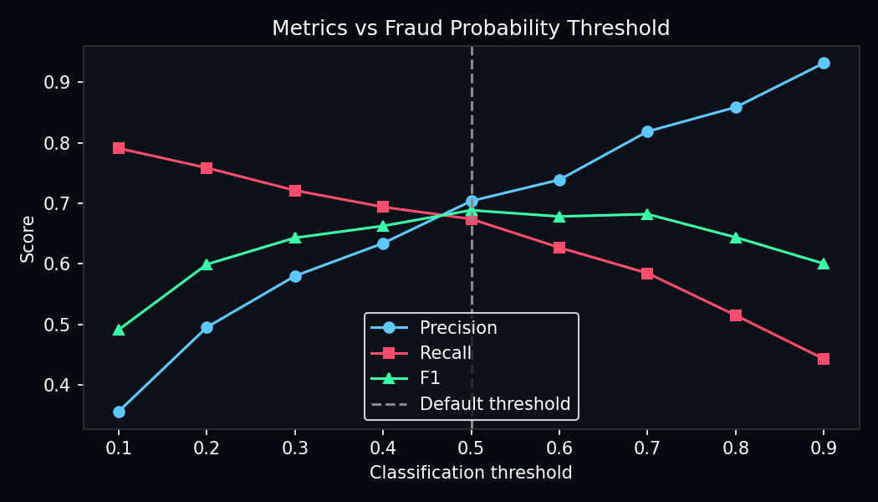

7. Feature Importance (Model Interpretation)
CatBoost reports feature importance as the total gain from splits using each variable across all 500 trees. Higher values mean the feature contributed more to reducing loss.
Rank | Feature | Importance | Role
1 | category | 63.61 | Merchant type — dominant predictor
2 | amt | 11.47 | Transaction amount
3 | gender | 9.46 | Cardholder gender (encoded)
4 | city_pop | 3.07 | City population
5 | trans_hour | 2.83 | Hour of transaction
6 | unix_time | 2.80 | Epoch timestamp
7 | state | 1.74 | US state (encoded)
8 | lat | 1.56 | Cardholder latitude
9 | long | 1.48 | Cardholder longitude
10 | trans_dow | 1.18 | Day of week
11 | merch_long | 0.32 | Merchant longitude
12 | distance_km | 0.26 | Haversine distance km
13 | merch_lat | 0.22 | Merchant latitude
Figure 4: CatBoost feature importance.
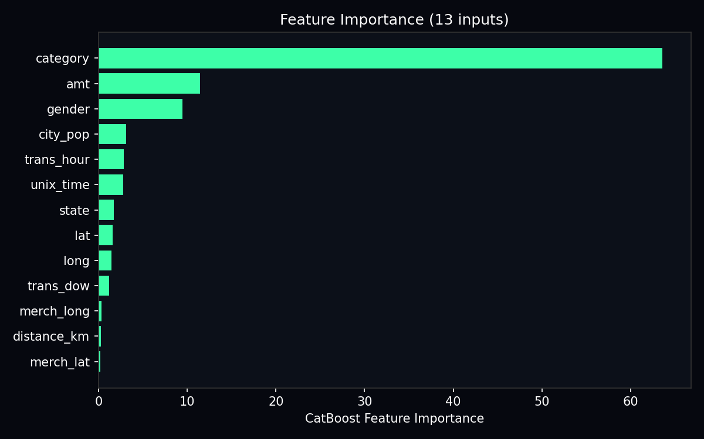

8. Post-Model Analysis Metrics
- KS statistic per feature: max gap between train and test cumulative distributions.
- Drift detected if p-value < α = 0.05 (config monitoring.drift.alpha).
- Governance min_roc_auc = 0.85 — model must exceed this to avoid retrain recommendation.
- Production model version: v_f381139c (registry artifacts/registry/registry.json).

9. Summary
The primary CatBoost ensemble uses 500 trees of depth 6, learning rate 0.05, and balanced class weights on 13 scaled features. On the held-out test set it achieves ROC-AUC 0.9851 with recall 67.41% and precision 70.39% at the default 0.5 threshold. High ROC-AUC confirms strong ranking; moderate recall reflects the difficulty of fraud detection under extreme imbalance and adversarial behaviour.
Prepared by Nick Einstein

