Sentinel: Adversarial Fraud Detection AI
Comprehensive Project Documentation
By:
Nick Mwaura.
&
Festus Koech.
Final Project
MSc. Computer Science
CSCI 5651: Data Science
Professor Kamala Marepalli

Problem Statement & Data Science Context
Credit-card fraud is a binary classification problem under extreme class imbalance: fewer than 1% of transactions are fraudulent. Fraudsters adapt over time (adversarial drift), so a production system must not only train an accurate classifier but also monitor whether incoming data still resembles the training distribution. This project applies the full data science lifecycle: problem definition → EDA → ETL → modelling → evaluation → deployment → monitoring.
- Business problem: flag fraudulent transactions with high recall while limiting false alarms.
- Data problem: ~1000:1 class imbalance; labels only available historically.
- Technical problem: raw CSV contains PII, mixed types, and geographic fields requiring engineering.
- Operational problem: model must be served via API/UI with drift governance.

End-to-End Data Science Workflow Used
Phase | What we did | Project artifact
1. Problem framing | Defined fraud detection + drift monitoring goals | README, config.yaml
2. EDA | Explored imbalance, amounts, categories, time, geography | Section 3, eda_plots/
3. ETL | Featurize, clean, SMOTE train, hold-out test | src/etl/, src/data/credit_dt.py
4. Feature engineering | StandardScaler, PCA viz | src/engineering/, scaler.joblib
5. Modelling | CatBoost + Isolation Forest | catboost_fraud.cbm
6. Evaluation | ROC-AUC, F1, confusion matrix | model_metrics_snapshot.json
7. Deployment | FastAPI + Sentinel UI | src/api/, frontend/
8. Monitoring | KS drift + governance | drift_report.csv, policy.py

1. Abstract
Purpose: We developed Sentinel, an end-to-end financial fraud detection application that scores credit-card transactions in batch and near-real-time, monitors feature drift, and applies business governance when data distributions shift.
Primary algorithm: CatBoost (Categorical Boosting) gradient boosted decision trees — 500 trees, maximum depth 6, learning rate 0.05, with auto_class_weights=Balanced.
Supporting algorithms: SMOTE for training-time class balancing; StandardScaler for feature normalization; Isolation Forest for unsupervised anomaly detection; Kolmogorov–Smirnov (KS) tests for distributional drift monitoring.
Data source: publicly available credit_dt dataset — fraudTrain.csv (~1.3 million rows) and fraudTest.csv (~555,000 rows) containing transaction amount, merchant category, cardholder and merchant coordinates, timestamps, gender, and US state. Training used 200,000 train rows and 100,000 test rows (config.yaml caps).
Results on held-out fraudTest.csv:
Metric | Value
ROC-AUC | 0.9851
F1 Score | 0.6887
Precision | 0.7039
Recall | 0.6741
Average Precision | 0.7093
Balanced Accuracy | 0.8365

2. Exploratory Data Analysis (EDA) → ETL Pipeline
Before modelling, we explored raw fraudTrain/fraudTest CSVs to understand data quality, class balance, and feature behaviour. Findings directly informed ETL and feature engineering.

2.1 EDA Findings
- Class imbalance: ~0.82% fraud in train sample, ~0.40% in test — SMOTE required on train.
- Amount skew: fraud mean ~$509 vs legitimate ~$68 — amt is a strong predictor.
- Category: 14 merchant types with varying fraud rates — top CatBoost feature (~64% importance).
- Time: fraud rate varies by hour — trans_hour and trans_dow engineered from timestamp.
- Geography: cardholder vs merchant coordinates motivate Haversine distance_km feature.
- No missing values in sampled data; duplicates removed in ETL clean step.
Figure 1: Class distribution (train vs test sample)
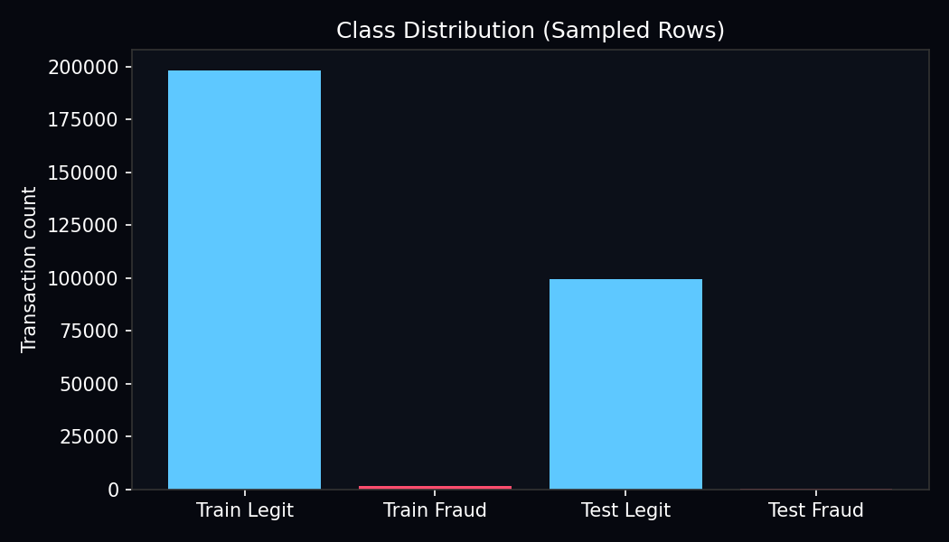
Interpretation:
- Blue bars represent legitimate transactions; red bars represent known fraud.
- The severe imbalance (~1000:1) explains why accuracy alone misleading and SMOTE is applied.
- Test fraud rate is lower than train — evaluation must use precision/recall and ROC-AUC.

Figure 2: Log amount distribution by class
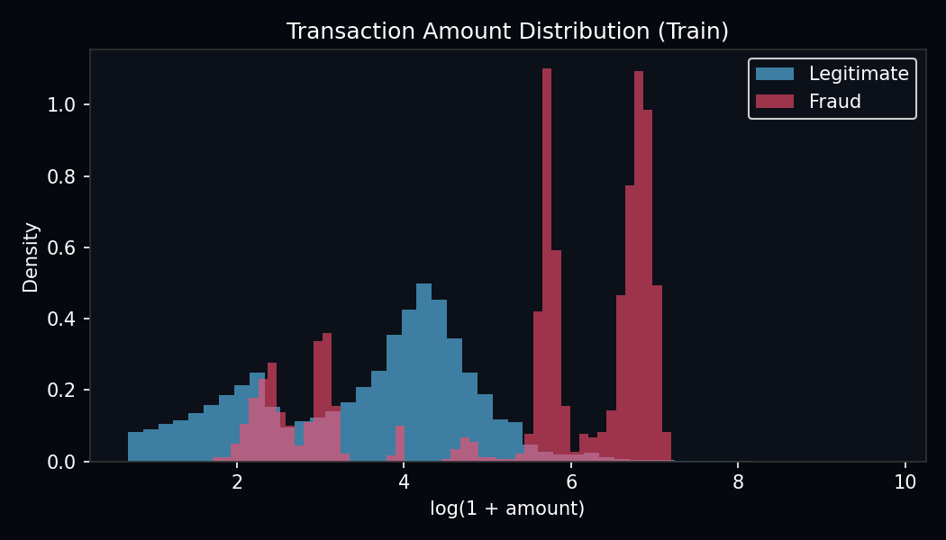
Interpretation:
- Histogram of log(1+amount) separates fraud (red) and legitimate (blue) distributions.
- Fraudulent purchases tend toward higher dollar amounts — supports using amt as a numeric feature.
- Log transform visualizes skew; model uses raw amt after StandardScaler.

Figure 3: Fraud rate by merchant category
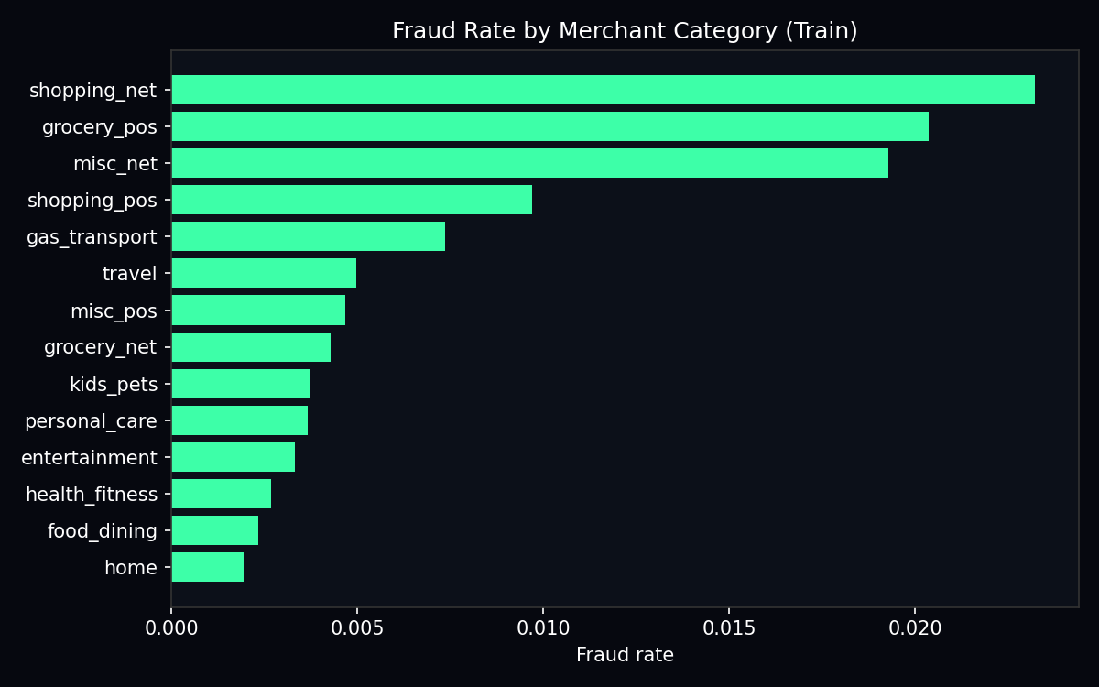
Interpretation:
- Each bar is a merchant category (e.g. shopping_net, travel, grocery).
- Wide variation in fraud rate across categories justifies label-encoding category for CatBoost.
- EDA confirmed category would dominate feature importance — validated post-training at 64%.

Figure 4: Fraud rate by hour of day
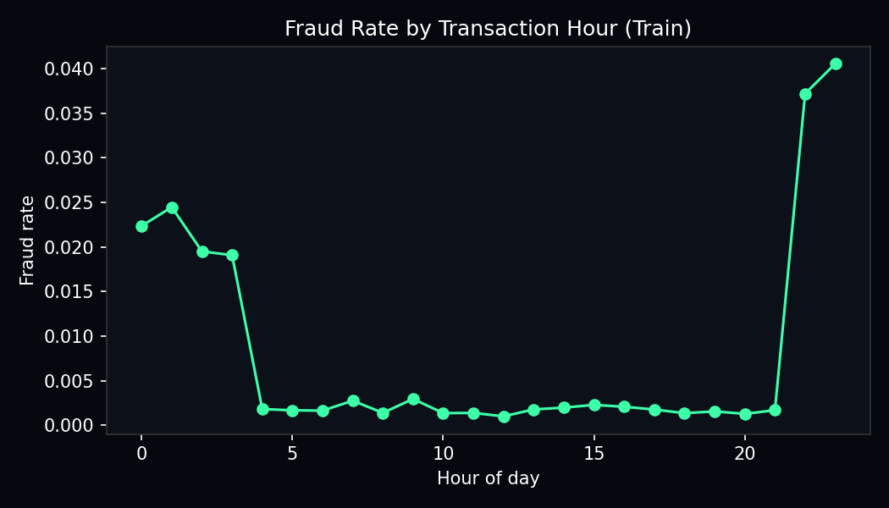
Interpretation:
- Line chart shows how fraud probability changes across 24 hours.
- Temporal patterns justify extracting trans_hour and trans_dow from trans_date_trans_time.
- Later KS drift on unix_time/trans_dow reflects temporal shift between train and test splits.

2.2 ETL Process (Transform after EDA)
ETL stages implemented in src/etl/pipeline.py and src/data/credit_dt.py:
Step | Operation | Rationale from EDA
Extract | Load fraudTrain.csv / fraudTest.csv | Provider pre-split; no random split
Transform — featurize | Haversine distance, time fields, label encoding | EDA showed geo + time + category matter
Transform — clean | Drop duplicates, median impute | Data quality assurance
Transform — SMOTE | Balance train labels only | EDA confirmed <1% fraud rate
Load | X_train, X_test, y_train, y_test + artifacts | Ready for StandardScaler + CatBoost

Figure 5: SMOTE effect on class balance
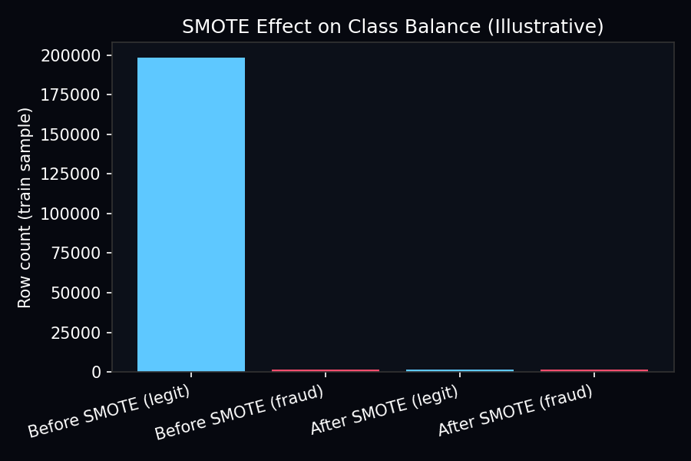
Interpretation:
- Before SMOTE: ~198k legitimate vs ~1.6k fraud in train sample.
- After SMOTE: classes balanced via synthetic fraud points interpolated from k=5 neighbours.
- Test set is never SMOTE'd — evaluation reflects real-world fraud rate (~0.4%).

3. Design — Modules & Architecture
Sentinel follows a seven-layer AI World architecture. Upper layers decide policy; lower layers compute predictions and statistics.
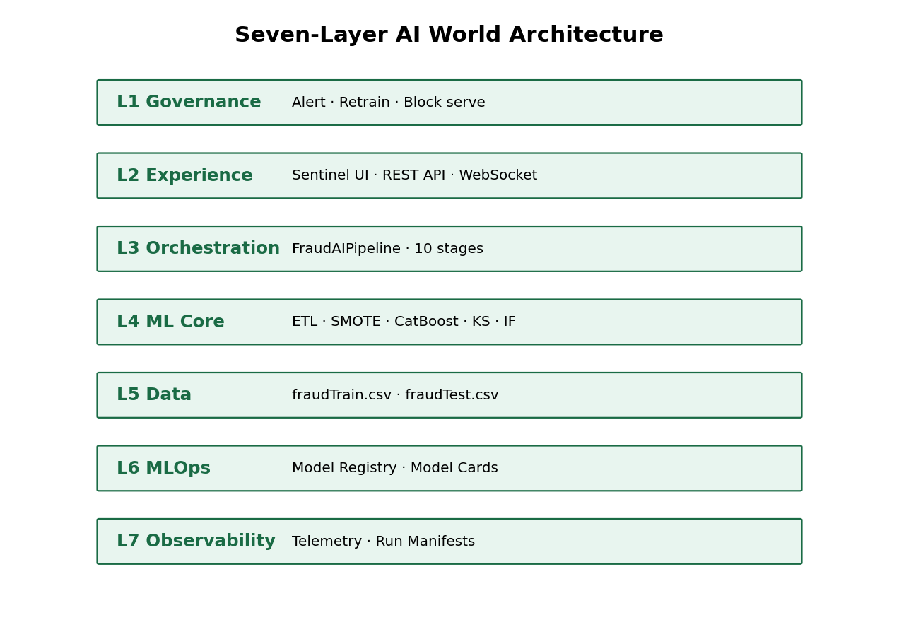
Figure 6: Architecture diagram — data flows from L5 (CSV) through L4 (ML) to L2 (API/UI), with L1 governance reacting to drift and L7 logging every pipeline run.

3.1 Module Details
Layer | Module path | Responsibility
L1 Governance | src/governance/policy.py | Map drift alerts + ROC-AUC → alert/retrain/block
L2 Experience | src/api/, frontend/, dashboard/ | Sentinel UI, REST, WebSocket, Streamlit
L3 Orchestration | src/orchestration/pipeline.py | FraudAIPipeline stage execution
L4 ML Core | src/etl/, engineering/, inference/, monitoring/ | ETL, SMOTE, CatBoost, KS, IF
L5 Data | src/data/credit_dt.py | CSV load, featurizer, stable encodings
L6 MLOps | src/registry/model_registry.py | Versioning, production promotion, model cards
L7 Observability | src/observability/telemetry.py | JSONL events, run manifests

3.2 Pipeline Stages (Orchestration)
- DATA_INGEST → validate CSV paths
- ETL → featurize, clean, SMOTE (train only)
- FEATURE_ENGINEERING → StandardScaler + PCA plot
- TRAIN → CatBoost fit
- EVALUATE → ROC-AUC, F1, confusion matrix
- DRIFT_BASELINE → save train feature distributions
- DRIFT_CHECK → KS test train vs test
- ANOMALY_MODEL → Isolation Forest
- REGISTER → promote to production registry

4. Algorithms & Sample Code
This section presents the mathematical foundations and annotated Python implementations used in the project.

4.1 Haversine Distance (Feature Engineering)
src/data/credit_dt.py
def _haversine_km(lat1, lon1, lat2, lon2):
r = 6371.0
lat1, lon1, lat2, lon2 = map(np.radians, [lat1, lon1, lat2, lon2])
dlat = lat2 - lat1
dlon = lon2 - lon1
a = np.sin(dlat / 2) ** 2 + np.cos(lat1) * np.cos(lat2) * np.sin(dlon / 2) ** 2
return 2 * r * np.arcsin(np.sqrt(np.clip(a, 0, 1)))
Code line / block | Explanation
r = 6371.0 | Earth radius in kilometres for great-circle distance.
map(np.radians, ...) | Convert degrees to radians — required by trig functions.
dlat, dlon | Difference in latitude/longitude between cardholder and merchant.
a = sin²(Δlat/2) + ... | Haversine formula intermediate term.
2 * r * arcsin(√a) | Final distance in km — stored as distance_km feature.

4.2 ETL Pipeline (SMOTE + Clean)
src/etl/pipeline.py
def clean(self, df):
out = df.copy()
if self.etl_cfg.get("drop_duplicates", True):
out = out.drop_duplicates()
for col in out.select_dtypes(include=[np.number]).columns:
if out[col].isna().any():
out[col] = out[col].fillna(out[col].median())
return out
def apply_smote(self, X, y):
smote = SMOTE(sampling_strategy="auto", k_neighbors=5, random_state=42)
X_res, y_res = smote.fit_resample(X, y)
return pd.DataFrame(X_res, columns=X.columns), pd.Series(y_res, name=y.name)
Code line / block | Explanation
df.copy() | Work on a copy — avoid mutating original dataframe.
drop_duplicates() | Remove exact duplicate rows found during EDA.
fillna(median) | Impute missing numeric values with column median.
SMOTE(...) | Create synthetic fraud samples between k=5 nearest fraud neighbours.
fit_resample(X, y) | Return balanced feature matrix and labels for training only.

4.3 CatBoost Classifier
src/inference/engine.py
model = CatBoostClassifier(
iterations=500, learning_rate=0.05, depth=6,
eval_metric="AUC", auto_class_weights="Balanced", random_seed=42)
model.fit(X_train_scaled, y_train)
proba = model.predict_proba(X_test)[:, 1]
preds = (proba >= 0.5).astype(int)
Code line / block | Explanation
iterations=500 | Build 500 sequential decision trees (boosting rounds).
depth=6 | Each tree asks up to 6 split questions — controls model complexity.
learning_rate=0.05 | Shrinkage — each tree contributes 5% weight to ensemble.
auto_class_weights=Balanced | Penalise misclassified fraud more heavily.
predict_proba[:, 1] | Return P(fraud) — probability of positive class.
proba >= 0.5 | Default threshold: flag as fraud if probability ≥ 50%.

4.4 StandardScaler
src/engineering/features.py
X_train_scaled = scaler.fit_transform(X_train)
X_test_scaled = scaler.transform(X_test)
Code line / block | Explanation
fit_transform(X_train) | Learn μ and σ from train; transform train to mean 0, std 1.
transform(X_test) | Apply same μ, σ to test — prevents data leakage.

4.5 KS Drift Monitor
src/monitoring/drift.py
stat, p_value = ks_2samp(ref_train, cur_batch)
drift_detected = p_value < 0.05
Code line / block | Explanation
ks_2samp | Two-sample Kolmogorov–Smirnov test per feature.
ref_train | Baseline distribution from pre-SMOTE training data.
p_value < 0.05 | Reject null hypothesis — distributions differ significantly.

4.6 Full Training Entry Point
main.py / src/orchestration/pipeline.py
# Run complete pipeline:
python main.py
# Internally:
pipeline = FraudAIPipeline(load_config())
pipeline.run_training()
Code line / block | Explanation
FraudAIPipeline | Orchestrator executing all stages in order with shared context.
run_training() | Runs ingest → ETL → engineer → train → evaluate → drift → register.

Appendix A — Line-by-Line: Raw CSV Featurization
src/data/credit_dt.py — simplified
def transform_raw(self, raw_df):
out = raw_df.copy()
out["Class"] = out["is_fraud"].astype(int) # Line 1: target
ts = pd.to_datetime(out["trans_date_trans_time"]) # Line 2: parse time
out["trans_hour"] = ts.dt.hour # Line 3: hour feature
out["trans_dow"] = ts.dt.dayofweek # Line 4: weekday feature
out["distance_km"] = compute_distance_km(out) # Line 5: Haversine
out["category"] = out["category"].apply(encode) # Line 6: label encode
return out[FEATURE_COLUMNS + ["Class"]] # Line 7: select cols
Code line / block | Explanation
Line 1 | Create binary target Class from is_fraud (0=legit, 1=fraud).
Line 2 | Parse string timestamp into datetime for feature extraction.
Line 3 | Hour 0–23 captures time-of-day fraud patterns from EDA.
Line 4 | Day-of-week 0=Monday captures weekly seasonality.
Line 5 | Compute km distance cardholder↔merchant — geo fraud signal.
Line 6 | Map category/gender/state strings to integers using training vocabulary.
Line 7 | Return only the 13 model features plus target — drop PII columns.

5. Visualizations — Charts, Graphs & Tables
All figures below were generated from the latest training run on fraudTest hold-out data. Each includes an interpretation paragraph tied to data science decisions.
Figure 7: Summary accuracy metrics
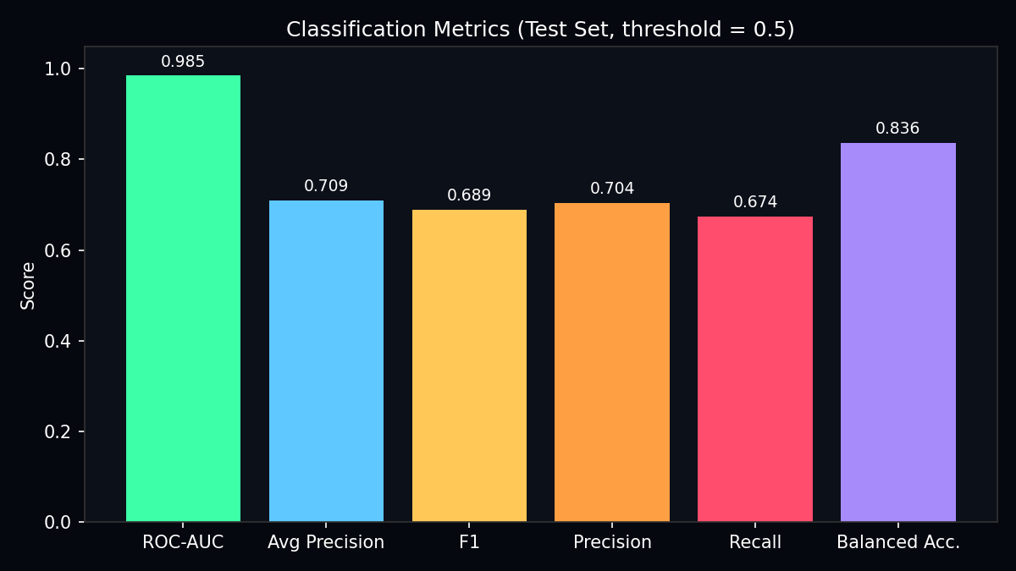
Interpretation:
- Compares ROC-AUC, Average Precision, F1, Precision, Recall, Balanced Accuracy.
- ROC-AUC 0.985 indicates excellent ranking ability despite imbalance.
- Balanced accuracy (0.836) is more informative than raw accuracy (0.998) for this dataset.

Figure 8: Confusion matrix (threshold=0.5)
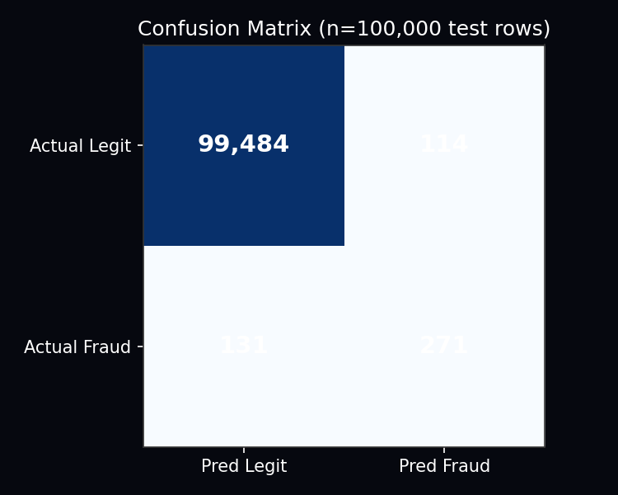
Interpretation:
- True Negatives=99,484: legitimate correctly passed.
- False Positives=114: legitimate incorrectly flagged — customer friction.
- False Negatives=131: fraud missed — financial loss.
- True Positives=271: fraud correctly caught.

Figure 9: Threshold sensitivity analysis
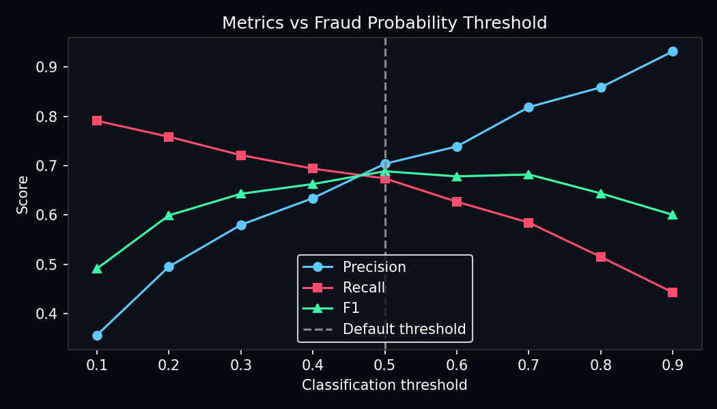
Interpretation:
- Shows precision/recall/F1 trade-off as classification threshold varies 0.1–0.9.
- Lower threshold catches more fraud (higher recall) but increases false alarms.
- Default 0.5 chosen as balanced operating point for coursework demo.

Figure 10: CatBoost feature importance
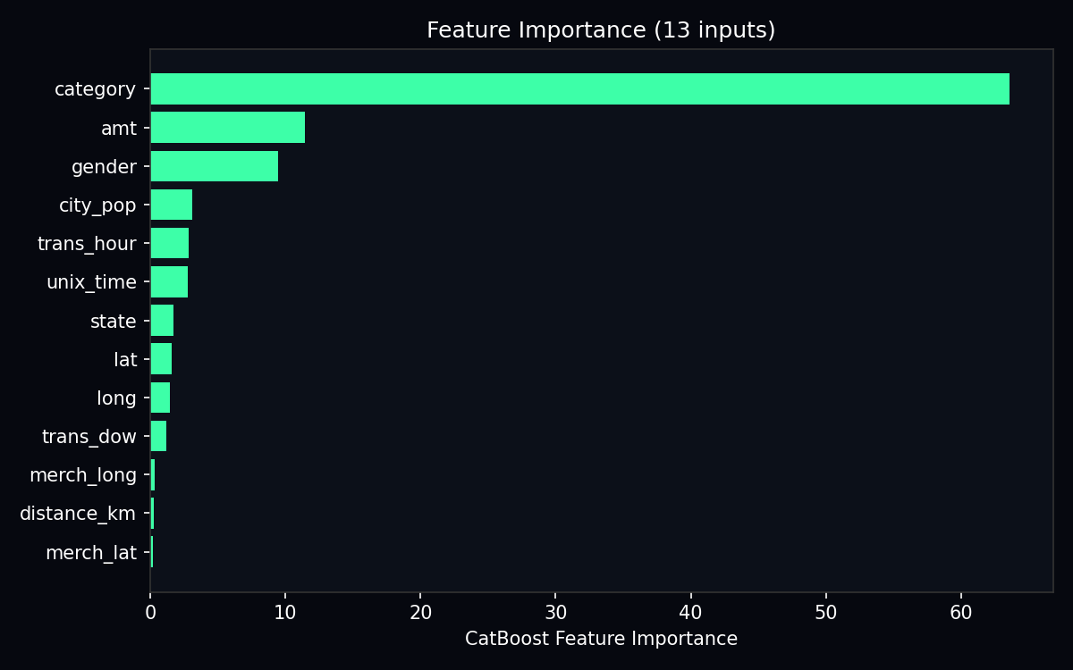
Interpretation:
- Gain-based importance across 500 trees — category dominates at ~64%.
- Confirms EDA finding that merchant type is the strongest fraud signal.
- Geographic features (lat, long, distance_km) contribute smaller but non-zero gain.

Figure 11: KS drift statistics (train vs test)
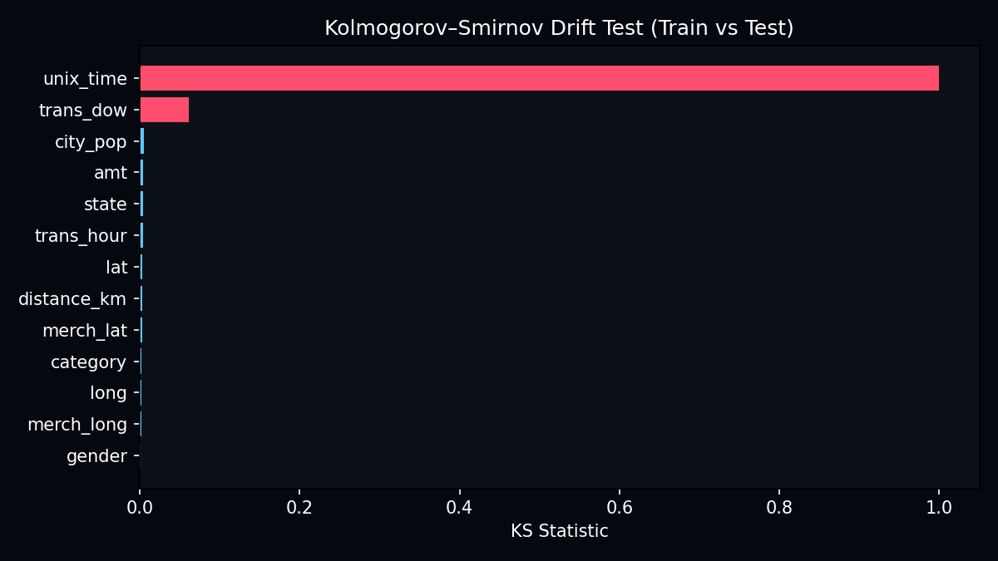
Interpretation:
- Red bars: features with statistically significant drift (p < 0.05).
- unix_time KS=1.0 — complete temporal distribution shift between splits.
- Informs governance alerts and explains why test-set scoring may differ from train expectations.

5.1 Tabular Outputs
Table 1: Feature importance ranking
feature | importance
category | 63.60976712683712
amt | 11.47331556568562
gender | 9.458028834214954
city_pop | 3.0733510150363568
trans_hour | 2.8253365759437874
unix_time | 2.7962355426448946
state | 1.740665115527161
lat | 1.5552342896744635
long | 1.4836565313151917
trans_dow | 1.183353698121395
merch_long | 0.3200384630754156
distance_km | 0.257810525496898
merch_lat | 0.2232067164267547
Table 2: KS drift report
feature | ks_statistic | p_value | drift_detected
unix_time | 1.0 | 0.0 | True
trans_dow | 0.0609899999999999 | 5.096326418128745e-216 | True
city_pop | 0.0050099999999999 | 0.0701625730733133 | False
amt | 0.004205 | 0.1886024973340859 | False
state | 0.0037449999999999 | 0.3063578335308146 | False
trans_hour | 0.00373 | 0.3109233933819292 | False
lat | 0.00355 | 0.3693536596575814 | False
distance_km | 0.0035449999999999 | 0.3710718114013248 | False
merch_lat | 0.0033199999999999 | 0.453446483151372 | False
category | 0.0025249999999999 | 0.7879782839665836 | False
long | 0.00221 | 0.8998948166234672 | False
merch_long | 0.00218 | 0.908601340144916 | False
gender | 0.00048 | 1.0 | False

Table 3: Sample API scoring output format
Field | Example | Meaning
fraud_probability | 0.0180 | Model P(fraud) from CatBoost sigmoid
fraud_prediction | 0 | Binary flag (≥0.5 threshold)
is_fraud_actual | 1 | Ground truth from CSV — not model output
governance_action | alert | Drift policy result from L1 layer

6. Accuracy & Model Performance
All metrics computed on fraudTest.csv hold-out (100,000 rows, 402 fraud, 0.40% fraud rate). Train data was SMOTE-balanced; test data reflects natural imbalance.
Metric | Value | Interpretation
ROC-AUC | 0.9851 | Probability a random fraud row ranks above a random legit row
Average Precision | 0.7093 | Area under precision-recall curve
F1 Score | 0.6887 | Harmonic mean of precision and recall at threshold 0.5
Precision | 0.7039 | 70% of flagged transactions are true fraud
Recall | 0.6741 | 67% of all fraud cases detected at threshold 0.5
Accuracy | 0.9976 | Misleadingly high due to 99.6% majority class
Balanced Accuracy | 0.8365 | Average per-class recall — fairer metric

6.1 Model Structure
Parameter | Value
Algorithm | CatBoost Gradient Boosted Trees
Trees (iterations) | 500
Max depth | 6
Learning rate | 0.05
Features | 13
Train rows (post-SMOTE) | 396,710
Classification threshold | 0.50

6.2 Classification Report
precision recall f1-score support
0 1.00 1.00 1.00 99598
1 0.70 0.67 0.69 402
accuracy 1.00 100000
macro avg 0.85 0.84 0.84 100000
weighted avg 1.00 1.00 1.00 100000

6.3 Threshold Analysis
Threshold | Precision | Recall | F1 | Flagged
0.1 | 0.356 | 0.791 | 0.491 | 893
0.2 | 0.495 | 0.759 | 0.599 | 616
0.3 | 0.580 | 0.721 | 0.643 | 500
0.4 | 0.634 | 0.694 | 0.663 | 440
0.5 | 0.704 | 0.674 | 0.689 | 385
0.6 | 0.739 | 0.627 | 0.678 | 341
0.7 | 0.819 | 0.585 | 0.682 | 287
0.8 | 0.859 | 0.515 | 0.644 | 241
0.9 | 0.932 | 0.443 | 0.600 | 191

7. Conclusions
This data science project successfully delivered Sentinel, a full-stack fraud detection platform grounded in rigorous EDA, reproducible ETL, and modern gradient boosting. CatBoost achieved ROC-AUC 0.9851 on a realistically imbalanced test set, demonstrating strong discriminative ability. EDA-driven features, especially merchant category, transaction amount, and temporal fields , were validated by post-hoc feature importance.

7.1 Key Findings
- EDA must precede ETL: imbalance and category patterns dictated SMOTE and feature selection.
- Geographic distance (Haversine) adds interpretable fraud signal beyond raw coordinates.
- Ground truth (is_fraud) and model predictions are distinct — recall ~67% at default threshold.
- KS drift on temporal features confirms train/test are not identically distributed.
- Seven-layer architecture enables separation of ML computation from business governance.

7.2 Limitations
- Row caps (200k/100k) for practical training — full 1.3M rows would improve coverage.
- Label encoding for categoricals — no explicit embedding of merchant hierarchy.
- No SHAP per-transaction explanations in current UI.
- API lacks authentication — suitable for local demo, not public production.

7.3 Future Work
- SHAP/LIME explanations per transaction in Sentinel UI.
- Automated retraining when governance triggers RETRAIN_RECOMMENDED.
- Threshold optimisation for business-specific cost matrix (FP vs FN costs).
- Cloud deployment with Docker, authentication, and live payment API integration.

