Document: | Private Pilot Training Notes
Aircraft: | Cessna 172/R
Version: | 1.00
Author: | Nick Elsey
Last Modified: | July 16, 2002

Summary
This document is a collection of various bits of information that I accumulated during my private pilot ground and flight training work, which I found difficult to commit to memory and therefore felt the need for somewhere to put it all down on paper. These are my ‘Cliff Notes’ for private pilot training.
Disclaimer
This document is provided 'as is'. I make no warranty, explicit or implied, as to the completeness, accuracy or usefulness of this document. This document is in no way intended to be a comprehensive review of the FAA Practical test Standards for ground work. You should always consult the original documents (AIM, FAR, POH, etc.) for accurate information.
Contents
Solo Flight – PTS Maneuvers 2
Before Every Maneuver: 2
Group 1: Takeoff and Landings 2
Group 2: Emergencies, Stalls and Slow Flight 2
Group 3: Turns, Ground Reference and Navigation 3
Group 4: Other Maneuvers 3
Miscellaneous Information 4
Weight and Balance 4
Cessna 172/R Airspeeds 4
Compass Errors 4
VFR Required Equipment List (91.205) 4
Light Signals 4
Using the Radio 4
Weather and Other Flight Affecting Factors? 5
Am I Ready to Fly? 5
Getting a Weather Brief 5
Weather Sources – Forecasts 5
Weather Sources – Observations 5
Airspace Information 6
Graphical Airspace Summary 7
Other Airspace Information 8
Practical Test Check List 9
Personal Equipment 9
Log Book Endorsements 9
An Airworthy Airplane: 9

Solo Flight – PTS Maneuvers
This section is intended to be used as an in-flight check list while flying solo and working to improve your PTS maneuvers. I’ve split them up into groups, each of which can be accomplished in a couple of hours of flying.

Before Every Maneuver:
Do two 90⁰ clearing turns and then…

Cabin Flow Check:
- Cabin secure - seats & belts.
- Fuel selector to both, fuel cut-off check.
- Flaps as required.
- Mixture to rich. Check engine gauges.
- Check directional gyro.
- Lights (landing, strobe, navigation) as required.

Group 1: Takeoff and Landings

Normal & Cross Wind Take Off
- Set heading bug for wind direction.
- Use decreasing aileron as speed increases
- Stay on the center line.
- Coordinated climb at 75 KIAS (+10/-5).

Normal & Cross Wind Landings
- Flow checks downwind at 1,000’ AGL. Set hdg. bug for wind.
- Abeam runway → 1400 RPM, flaps to 10⁰ below 100 KIAS
- 65 KIAS (+10/-5), full flaps on final
- Pick aim point, keep it in same position in window.
- Round-out at 20’. Pwr slowly to idle. Start looking down rwy.
- Flare at 1’ to 3’ and hold nose up.
- On landing -> Flaps up. Increasing aileron for x-wind.
- Keep to the center line!

Soft Field Take Off
- 10⁰ flaps during before-takeoff checklist.
- Taxi - don’t use brakes, don’t stop, don’t clear final.
- Power up. Nose UP ASAP, not too high.
- At 55 KIAS, level off in ground effect as soon as off runway.
- Accelerate to 75 KIAS and climb (+10/-5).
- Retract flaps once in climb. Maintain V_{Y}!

Soft Field Landing
- Flow checks downwind at 1,000’ AGL. Set hdg. bug for wind.
- Full flaps, 62 KIAS (+10/-5) on final.
- Once runway assured, power to 1,200 RPM rather than idle.
- Power to idle on wheels down. Increasing aileron for x-wind.
- Keep the nose up as long as possible!
- Don’t retract flaps until clear the runway and checked.

Short Field Landing
- Flow checks downwind at 1,000’ AGL. Set hdg. bug for wind.
- Full flaps, 62 KIAS (+10/-5) on final. Watch the speed!
- Power to idle when runway assured.
- Flaps up, brake hard, nose on ASAP after wheels down.
- Increasing aileron for x-wind

Short Field Take Off
- 10⁰ flaps during before-takeoff checklist.
- Taxi into position. Brakes, full power. Check instruments.
- Rotate at 57 KIAS and clear obstacles.
- Accelerate to 75 KIAS and climb (+10/-5).
- Retract flaps once in climb. Maintain V_{Y}!

Forward Slips to Landing
- Power to idle, pitch for 65 KIAS, full flaps
- Turn into wind, opposite rudder.

Go Around
- Power to full, flaps to 20⁰ immediately.
- Pitch for 75 KIAS and climb (+10/-5).
- Flaps to 10⁰ when obstacles cleared.
- Flaps up. Maintain 75 KIAS (don’t accelerate!).

Group 2: Emergencies, Stalls and Slow Flight
Note: A 3,500’ AGL ceiling is recommended for some of these maneuvers.

Emergency Landing
- Airspeed to 65 KIAS (±10).
- Select landing area and upwind direction. Turn towards it.
- Use checklist to identify the problem.
- Use flaps when field is assured.

Emergency Descent
- Flow checks & clearing turns.
- Power to idle, full flaps (make sure in white arc).
- Descend at 80 knots.

Power Off Stall
- Flow checks and clearing turns. Enter at least 3,000 AGL.
- Slow to 65 KIAS, full flaps.
- Power to slowly idle, pitch up - stay coordinated!
- Maintain heading ±10⁰.
- Announce first signs of stall (buffeting, stall warning, etc.).
- Recover ASAP after stall breaks.
- Full pitch, pitch down to horizon. Flaps to 20⁰.
- Flaps to 10⁰ at 65 KIAS, up at 75 KIAS. Climb to orig alt.
Variations:
- Turning: 30⁰ bank max (maintain +0⁰/-10⁰ bank). Recover using rudder only.

Power On Stall
- Flow checks and clearing turns. Enter at least 3,000 AGL.
- Power to, 1500 RPM, airspeed to 60 KIAS
- Pitch up, power to full, stay coordinated!
- Maintain heading ±10⁰.
- Announce first signs of stall (buffeting, stall warning, etc.).
- Recover ASAP after stall breaks – decrease pitch attitude.
- Descend to original altitude.
Recovery:
- Pitch down to horizon
- Pitch → 75 KIAS for recovery climb
Variations:
- Stall during 10⁰ turns. Recover using rudder only.

Slow Flight
- Flow checks and clearing turns.
- Enter & maintain at least 1,500 AGL.
- Slow to 55 KIAS (+10/-5), full flaps (will need more power to maintain airspeed).
- Maintain altitude ±100’, heading ±15⁰, airspeed +10/-5 knots.
Variations:
- Turns – maintain altitude ±100’, angle of bank +0⁰/-10⁰, airspeed +10/-5 knots. Bank not to exceed 30⁰. roll out on heading ±10⁰.
- Climbs & descents. Level off ±100’. Turns while climbing or descending not to exceed 20⁰.

Group 3: Turns, Ground Reference and Navigation

Steep Turns
- Flow checks & clearing turns.
- At least 1,500 AGL. Airspeed 95 KIAS
- 45⁰ bank (±5⁰). Roll out on heading (±10⁰). Reverse direction.
- Maintain altitude ±100’, airspeed ±10 knots.
Variations:
- Steep turn during slow flight.

Rectangular Course
- Flow checks, clearing turns & pick landing point.
- Determine wind direction & speed.
- Enter on 45⁰ to downwind at 1,200 MSL (1,000 AGL) at 95 KIAS.
- Ground track ½ mile from field – half way up wing strut.
- Exit at entry point.
- Maintain altitude ±100’, airspeed ±10 knots.

S-Turns
- Flow checks, clearing turns & pick landing point.
- Determine wind direction & speed.
- Enter on downwind at 1,000 MSL (800 AGL) at 95 KIAS with first turn to left.
- Wings level on crossing line.
- Reverse direction and exit at entry point.
- Maintain altitude ±100’, airspeed ±10 knots.

Turns Around a Point
- Flow checks, clearing turns & pick landing point.
- Determine wind direction & speed.
- Enter on downwind at 1,000 MSL (800 AGL) at 95 KIAS with first turn to left.
- Steepest bank no more than 45⁰.
- Two turns and exit at entry point.
- Maintain altitude ±100’, airspeed ±10 knots.

Pilotage
- Follows planned course solely by reference to landmarks.
- Relate landmarks to chart symbols.
- Navigate by pre-computed headings, ground speeds & elapsed time.
- Corrects for planned / actual fuel, GS and headings.
- Verify position to within 3 NM at all times.
- Arrive at ETA ±5 minutes.
- Maintain altitude ±200’, heading ±15⁰.

Navigation Systems
- Select and identify navigation facility.
- Location position by radials, bearings or coordinates.
- Intercept & track radial or bearing.
- Recognize station passage, loss of signal.
- Maintain altitude ±200’.

Group 4: Other Maneuvers
These are not in the PTS, or cannot be accomplished during solo flight.

Instrument Flight
- Straight & level flight: Maintain altitude ±200’, heading ±20⁰, airspeed ±10 knots.
- Constant Airspeed Climbs & Descents: Level off at altitude ±200’, heading ±20⁰, airspeed ±10 knots.
- Turns to Headings: Standard rate turn. Roll out on heading ±200. Maintain altitude ±200’, airspeed ±10 knots.
- Recovery from unusual attitudes:
Nose high – power up, pitch down and wings level.
Nose low – power idle, wings level, then pitch up.

Elevator Trim Stall
- Setup for slow flight.
- Trim for full nose up.
- Power to idle. Descend at 500 fpm.
- Full power – pitch up to go around attitude. Don’t allow nose to go too high.
- Allow to stall. Neutralize ailerons and use rudder to correct only! Don’t allow nose to pitch up again during recovery.

Other Maneuvers Favored by your FAA Examiner!

Miscellaneous Information

Weight and Balance
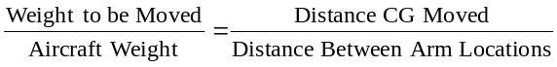

Cessna 172/R Airspeeds
V_{S0} | 33 KIAS | Stall speed w/ full flaps (lower white arc)
V_{FE} | 85 KIAS | Max speed w/ full flaps (upper white arc)
V_{S1} | 44 KIAS | Stall speed no flaps (lower green arc)
V_{NO} | 129 KIAS | Max structural cruising speed calm air (bottom yellow arc)
V_{A} | 99 KIAS | Maneuvering speed
V_{NE} | 163 KIAS | Never exceed speed (top yellow arc)
V_{X} | 57 KIAS | Best angle of climb
V_{Y} | 79 KIAS | Best rate of climb (at sea level)

Compass Errors
Accel On E/W hdgs: Accelerates North Deaccelerates South
Turn On N/S hdgs: Overshoots South Undershoots North

VFR Required Equipment List (91.205)

Day (most fatal ace) | Night (flaps)
Manifold Pressure Indicator  Oil Pressure Gauge  Seat Belt/Shoulder Harness  Tachometer  Fuel Quantity Gauge  Altimeter  Temp. Gauge (Oil/Water)  Air Speed Indicator  Landing Gear Position Indc.  Anti Collision Lights (post ’96)  Compass  ELT | Fuses  Landing Lights (only for hire)  Anti Collision Lights (all craft)  Position Lights  Source of Power
Also – Floatation gear and flares if operated for hire off shore.

Light Signals

Signal | Surface | In Flight
Steady Green | OK to take off | OK to land
Flashing Green | OK to Taxi | Return to Land
Steady Red | Stop | Continue circle
Flashing Red | Clear the runway | Unsafe-don’t land
Flashing White | Return to starting p | ---
Red / Green | Exercise caution | Exercise caution

Using the Radio

FSS: Open Flight Plan
You ➔ [FSS name] radio, Cessna [call sign], receiving [outlet frequency]. {Wait}
FSS ⬅ [call sign] Standby / Proceed.
You ➔ Request activate VFR flight plan to [destination], off at [minutes] past the hour, [call sign]
FSS ⬅ [call sign] Roger, flight plan activated, monitor [airport] ASOS / ATIS…
You ➔ Monitoring [airport] ASOS / ATIS, [call sign].
➔McMinnville radio, Cessna 9514P, receiving 122.45 | ⬅ 14P go ahead.
➔Request activate VFR flight plan to Kelso, off at 15 minutes past the hour, 14P | ⬅ 14P roger, flight plan activated, monitor Portland ATIS on 128.35.
➔ Monitoring Portland ATIS, 14P | end

ATC: Request Flight Following
You ➔ [Airport] approach, Cessna [call sign], with request. {Wait}
ATC ⬅ [call sign] Standby / Proceed.
You ➔ Cessna 172, currently [position relative to NavAid], [altitude] / [climbing thru current alt to final alt],VFR to [destination], request flight following. [call sign]
ATC ⬅ [call sign], Rodger, squawk [code].
You ➔ Squawk [code], [call sign].
➔Portland approach, Cessna 9514P, with request. | ⬅ 9514P go ahead.
➔Cessna 172, currently 10 miles out on 80 radial from Newberg VOR, climbing thru 3 thousand for 4 thousand 500 hundred. VFR to Kelso. Request flight following, 9514P | ⬅ 9514P, squawk 0134.
➔ Squawk 0134, 9514P | ⬅ 9514P, radar contact established.
➔ Rodger, 9514P | end

ATC: Frequency Change / Handoff
ATC ⬅ [call sign] contact [service] on [freq].
You ➔ [freq], [call sign], g’day.
You ➔ {Change frequencies and listen before transmitting}
You ➔ [service], [call sign] with you at [current alt.].

ATC: Request Clearance
You ➔ [Airport] approach, Cessna [call sign]
ATC ⬅ [call sign] Standby / Proceed.
You ➔ Cessna 172, Currently [position relative to NavAid / waypoint], at [altitude], inbound for landing [call sign].
ATC ⬅ [call sign], Rodger….{May give squawk code, vector, position reporting procedures}
You ➔ [Repeat clearance details], [call sign].
➔Portland approach, Cessna 9514P, with request. | ⬅ 9514P go ahead.
➔Cessna 172, currently over Lake Oswego at 4 thousand, inbound for landing, 9514P | ⬅ 9514P, squawk 0134, report position 2 miles south.
➔ Squawk 0134, report 2 miles south, 9514P | ⬅ 9514P, radar contact established.
➔ Rodger, 9514P | end

Weather and Other Flight Affecting Factors?

Am I Ready to Fly?

i’m safe | pave
Illness  Medication  Stress  Alcohol  Fatigue  Emotion | Pilot  Aircraft  enVironment  External pressure

Getting a Weather Brief
Be prepared to give for a standard briefing
(1) Pilot
(2) Aircraft call sign
(3) VFR Flight
(4) Departure Point & route
(5) Destination
(6) Type of aircraft
(7) Departure time
(8) Estimated Time En-route
And you will get:
(1) Adverse conditions (SIGMETS, Cnv SIGMETS, AIRMETS)
(2) Overall Synopsis
(3) Current weather (METARS)
(4) Pilot Reports
(5) Forecast Weather (TAF - En-route & destination)
(6) Winds Aloft
(7) NOTAMS

Weather Sources – Forecasts
FA: Area Forecasts (e.g. San Francisco for western states). 12 hour forecast with addition 6 hour outlook.
TAF: Terminal Aerodrome Forecast: 24 hour forecast for selected airports.
FD: Winds and Temperatures Aloft Forecast.
Prognostic Charts: Significant Weather Prognostic Charts. Four panels showing weather from the surface up to FL240 (top 2 charts), and surface weather (lower two), for 12 hours hence (left two) and for 24 hours hence (right two). Upper panels show sky & visibility conditions, turbulence & freezing. Lower panels show highs, lows, fronts and other significant weather.
TWEB: See below.

Weather Sources – Observations
METAR: Routine weather observation from human observers, plus AWOS and ASOS data.
SPECI: Non-routine weather observation
PIREP: En-route pilot report
AWOS: Automated Weather Observing System. Various levels provide different amounts of data. VHF access.
ASOS: Automated Surface Observing System. Newer than AWOS. VHF and phone access.
Weather Depiction Chart: Summarizes METAR data, showing sky and visibility data. Indicates areas of MVFR and IFR.
Radar Summary Chart: Summarizes radar detected precipitation data, esp. thunderstorms, etc. Shows intensity, type, height, direction and speed.
Radar Weather Report: Text version of the Radar Summary Chart.
EFAS: En-route Flight Advisory Service. Provided by Flight Watch (122.0), gives data on actual weather, winds, turbulence, icing, thunderstorm activity, etc. along route. Also allow pilots to report same (PIREPs). Transmits AIRMETS, SIGMETS and Convective SIGMETS.
TWEB: Transcribed Weather Broadcasts. Continuous recordings of weather & aeronautical information, transmitted from some VORs and NDBs. Mainly route orientated, includes forecasts also.
AIRMET: Airmen’s Meteorological Information. Information pertinent to small single aircraft on: icing & freezing (AIRMET Zulu); turbulence, winds & wind shear (AIRMET Tango); IFR conditions, visibility and mountain obscurement (AIRMET Sierra). Issued every 6 hours or as required.
SIGMET: Significant Meteorological Information. Information pertinent to all pilots on: severe / extreme turbulence not associated with thunderstorms; severe icing (other than TS); dust-storms, sand-storms & volcanic ash reducing vis to <3m; volcanic eruption. Issued as needed.
Convective SIGMET: Significant Meteorological Information, pertinent to all pilots on thunderstorms (due to surface winds > 50 kts; ¾” or larger hail), embedded thunderstorms, a line of thunderstorms and tornadoes. Issued at 55 past each hour, valid for 2 hours with additional 4 hour outlook. Issued for each of 3 regions.
HIWAS: Hazardous InFlight Weather Advisory Service. Continuous broadcast of all in flight weather advisories (SIGMET, Convective SIGMET, AIRMET and urgent PIREPs).

Airspace Information
 | Class G  “Go for it” | Class E  “Elsewhere” | Class D  “Dialogue” ^{[2]} | Class C  “Crowded” | Class B  “Busy” | Class A  “Altidtude”
Category | <— Uncontrolled —> | <————————————————————————— Controlled —————————————————————————>
Altitude limits | Upper:  - Below controlled airspace  - 14,500’ MSL  - 1,500’ AGL (if GL 14,500+ MSL)  Lower:  - Ground | Upper: 18,000’ MSL  Lower:  - 1,200 AGL+ (blue fuzzy o/s tire tread)  - 1,200 AGL (blue fuzzy)  - 700’ AGL (magenta fuzzy)  - GL (magenta dashed line)  Also above FL 600. | Ground to MSL ceiling, indicated by box:    (normally 2,500’ AGL). [-48] indicates up to 4,799 AGL. | Normally GL to 4,000 AGL (surface area) and 1,200’ to 4,000 AGL (shelf), but look for indicated MSL altitudes:   | Various. Look for indicated MSL limits:    Typically 6,000 to 8,000 AGL. | 18,000’ MSL (Fl 180) to 60,000’ MSL (FL 600). Use pressure altitude.
Lateral limits | All airspace not designated as controlled | Indicated boundaries. Also victor airways^{[3]} | Blue dashed line. | Solid magenta line. Surface normally 5 nm, shelf 10 nm. | Solid blue line. Outer limit typically 15 to 30 nm. | Everywhere
2-way Radio? | No | No | Yes
Transponder requirements^{[1]} | None | Use it if you have it |  | Mode C required within lateral limits and up to 10,000 MSL | Mode C required, also from 30 nm out and up to 10,000 MSL. | Mode C required
Before you can enter | No requirements | No requirements | Radio contact w/ tower | Radio contact (in outer area) | ATC Clearance | N/A - no VFR!
Services | Weather reporting only | VFR separation if time allows | Tower provides safe traffic flow on & near airport. No VFR separation in air. | Tower provides ATC separation for all aircraft. Some VFR separation. | Tower provides ATC separation for all aircraft | ATC full tracking and separation
VFR limits | No limits | Ground visibility 3 SM and cloud ceiling 1,000+ AGL (special VFR may be available) |  |  |  | N/A - no VFR!
VFR limits | No limits |  |  |  | Private pilot (poss. students w/ endorsement) | N/A - no VFR!
Speed limit | 250 KIAS below 10,000 MSL. |  |  |  |  | None
Speed limit |  |  | 200 KIAS 2,500’ AGL & 4 nm out |  | 200 KIAS in VFR airspace above & below class B | None

 | Class G | Class E |  | Class D, C and B
VFR Cloud clearance | - Day 0-1,200 AGL: Clear of clouds  - Night 0-1,200 AGL: ↓500 ↑1000 ↔2000^{[4]}  - 1,200 AGL to 9,999 MSL: ↓500 ↑1000 ↔2000  - 1,200 AGL+ & FL100+: ↓1000 ↑1000 ↔1 sm | - <FL 100: ↓500 ↑1000 ↔2000  - FL 100+: ↓1000 ↑1000 ↔1 sm |  | 500’ below, 1000’ above, 2000’ horiz,  except class B (clear of clouds).
VFR visibility | - 0-1,200 AGL: 1 sm day, 3 sm night  - 1,200 AGL to FL 100: 1 sm day, 3 sm night  - 1,200 AGL+ & FL 100+: 5 sm | - <FL 100: 3 sm  - FL 100+: 5 sm |  | 3 statute miles
In Summary | Always 500’ below, 1000’ above, 2000’ horizontal, and 3 sm visibility, except:
In Summary | ◆ Class B: Clear of clouds   Class E, above 10,000 MSL: 1000, 1000, 1 sm and 5 sm visibility |  | ⬥ Class G, above 10,000 MSL and 1,200 AGL: 1000, 1000, 1 sm and 5 sm visibility   Class G, day, 1200 AGL to 10,000 MSL: 500, 1000, 2000 and 1 sm visibility  ❺ Class G, day, up to 1200 AGL: Clear of clouds and 1 sm visibility
Notes
- Mode C transponder required in all airspace at or above 10,000’ MSL, excluding airspace at or below 2,500 AGL.
- Part time airports revert to class E surface area outside operating hours.
- Victor airways are 1,200 AGL to 18,000 MSL and 4 nm either side and are designated class E.
- Can be 1 to 3 sm visibility and clear of clouds in class G at night if in traffic pattern and within ½ m of runway.

Graphical Airspace Summary
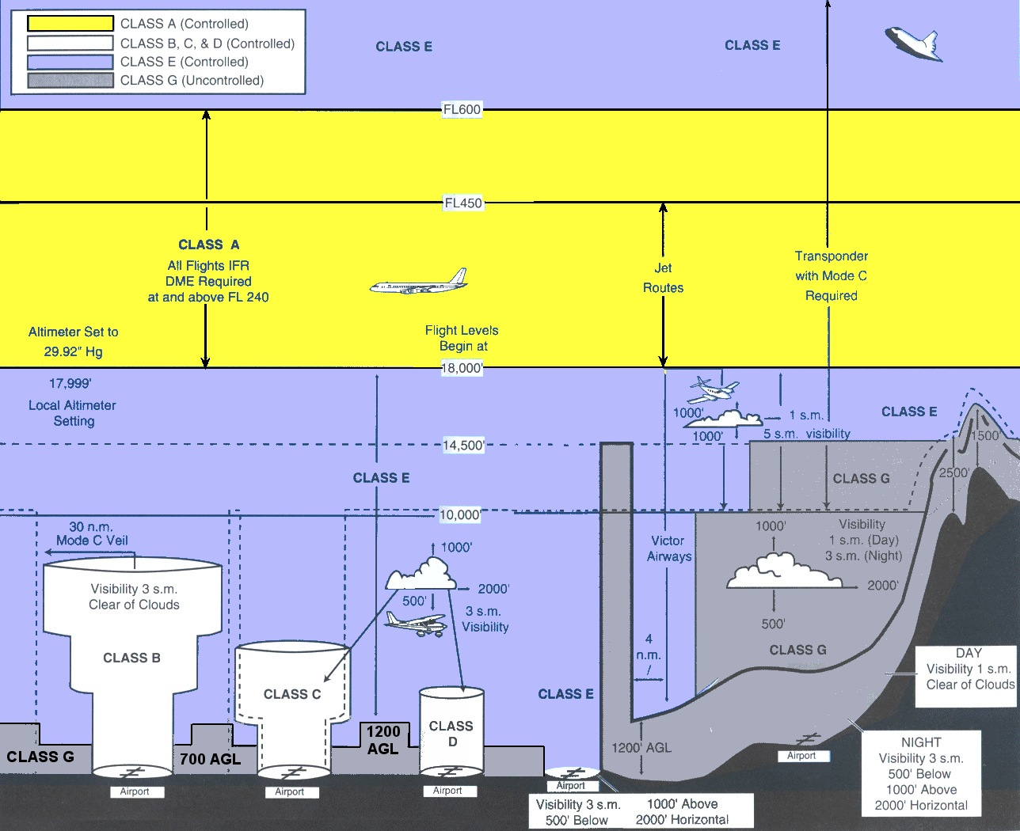

Other Airspace Information

Special Use Airspace Areas
Prohibited: Entry not allowed at any time. Areas such as over the White House.
Restricted: Invisible hazards, missiles, gunnery, etc. Entry prohibited during operating hours.
Warning: Invisible hazards, missiles, gunnery, etc. 3 to 12 nm of shore. Access not restricted, but vigilance required.
Military Operation (MOA): High density training. Access not restricted, but vigilance required.
Alert: Pilot training or other unusual activities. Access not restricted, but vigilance required.
National Security: See NOTAMs and charts for details.
Special Conservation: Wildlife, etc. Fly at least 2,000 AGL.
Airport Advisory: Within 10 nm of an airport with a onsite FSS.
Terminal Radar Service (TRSA): Provides aircraft advisory information. See charcoal line on chart for limits.
Military Training Routes: High speed (excess of 250 knots) aircraft. 3 digit # if over 1500 AGL, 4 digit otherwise. IR for IFR flights, VR for VFR flights.

Airspace Notes

Practical Test Check List
So, you think you’re ready for the FAA check ride? Well, don’t forget:

Personal Equipment
- Hood or foggles
- Watch
- Current aeronautical charts
- E6B computer
- Plotter
- Completed flight plan
- Completed flight navigation Log with weight & balance data
- Current AIM
- Current Airport Facility Directory
- Other ‘appropriate publications’
- Personal Records
- Photo Identification with signature
- Pilot Certificate
- Current medical certificate
- Completed 8710-1 form with instructor sign off
- Airman knowledge test report with instructor sign off on missed questions (FAR 61.105(b))
- Examiner’s fee / check book

Log Book Endorsements
- Instructor endorsement for FAR 61.105(a) – ground training
- Instructor endorsement for FAR 61.107(a) – flight proficiency
And logbook must show the following aeronautical experience (FAR 61.109):
- 3 hours cross country training❶
- 3 hours night flying training❷, that includes:
- One cross country flight over 100 nm distance❸
- 10 take offs and landings to a full stop❹
- 3 hours of instrument flying❺
- 3 hours of flight training in the past 60 days prior to the test❻
- 10 hours of solo flight, including❼
- 5 hours of solo cross country❽
- One solo cross country flight over 150 nm, with full stop landings at a minimum of 3 points, and one segment of at least 50 nm. ❾
- 3 take off and landings to a full stop at an airport with a control tower. ❿
Note – Suggest you pencil in the circled numbers above next to the relevant logbook entries.

An Airworthy Airplane:

Airplane Documents
- Airworthiness Certificate
- Registration Certificate
- Operating Limitations
- Pilot’s Operating Handbook

Airplane Maintenance Records
- Airframe Logbook
- Engine Logbook
- Proof of 100 hour inspection
- Proof of annual inspection
- Proof of ELT inspection (last 12 months)
- Proof of Transponder inspection (last 24 months)

