https://www.housingagency.ie/data-hub/housing-cost-overburden

https://data.cso.ie/ RIA02

https://data.gov.ie/dataset/ria02-rtb-average-monthly-rent-report

https://www.statista.com/statistics/1415962/average-residential-rent-ireland/

https://www.cso.ie/en/releasesandpublications/hubs/p-hh/housinghub/homepricesrents/rents/

sorted
new houses price:
- second hands house
- national house figure
- unit
- characters in the row[0]

house cost overburden
- Ôªø in header and row[0]
- Merge six separate csv files to one

average monthly rent
- remove header and (RTB Average Monthly Rent Report) row[0]

https://www.canva.com/colors/color-wheel/

difficulties: install packages in terminal and shells was difficult, tried many methods, pagal and pandas pdc
when visualize housing cost overburden the coding skills required exceed my abilities of understanding, my initial idea was use loops and panda extracting information from the big csv file and put ratio of every years together on a big chart.
Instead, I used decomposition technique of computer thinking breaks things down to six graphs represented each year data individually. The code was much concise and easier to understand, use row position and index locate relevant data for each year as they been arranged to repeat for every four rows.

Improvement: I didn’t consider the difficulties of cascading housing cost overburden data from six years together, I should add years label to the house_cost_overburden_.csv file when clean it from the raw data so it will be easier to separate each years information when I further processing data at later stage.

Analyze why housing cost overburden for household has no mortgage exist is higher than those have mortgage in the year 2020 https://chatgpt.com/g/g-p-6764689f5184819191cb35057b327c8b-coursework/c/6764b009-71a4-8003-bc5f-e983298e35d1

reference to six stages of software development leavingcert computer science

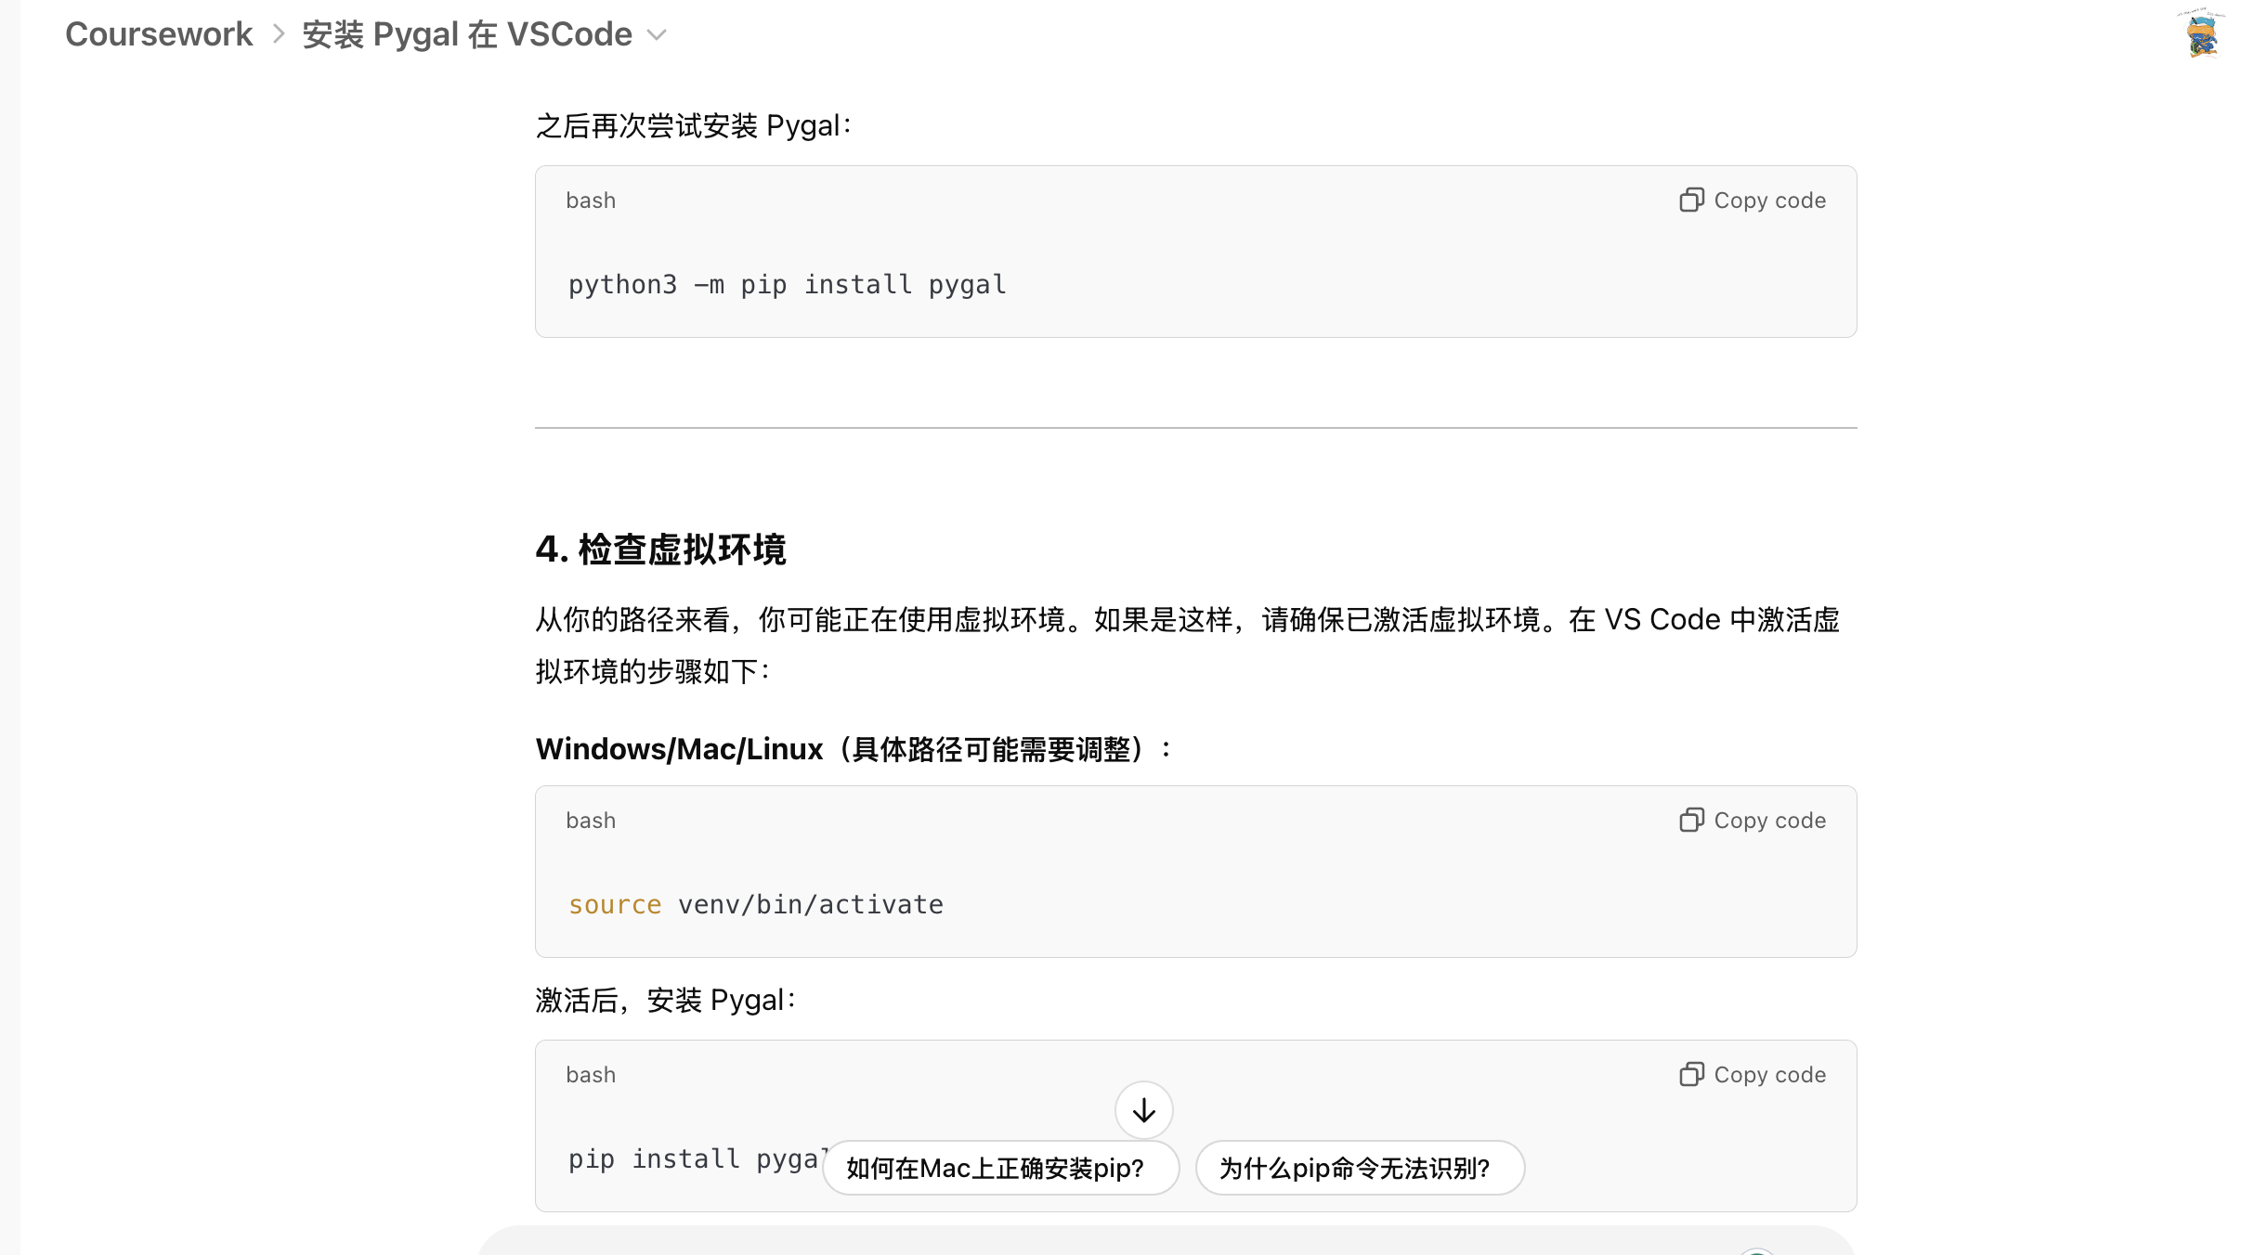

average rent per month data is based on all bedroom and property types in Dublin

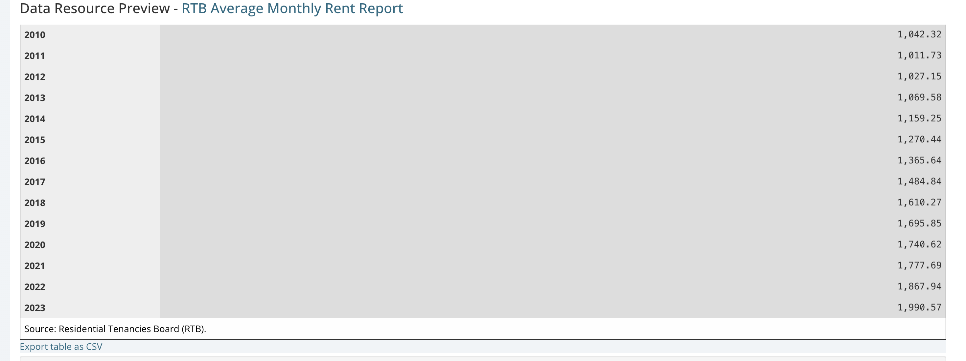

advance 3 depends on user budget give recommendation of rent or buy house
display rent for ten years or buy a house with mortgage compare
if user enter area outside of Dublin, compare their budget with the average data of rent

program ethnic concern
the form may leak personal privacy information
prompt user to enter fake name

add functional and unit testing table

http://files.nesc.ie/nesc_background_papers/c19-housing.pdf (the implication of Covid-19 for housing in Ireland)

review after investigation stage1
- Evidence of research on the brief, including existing solutions and the chosen topic area:
  - Included: Yes, you have provided evidence of research on the housing crisis in Ireland and existing solutions.
  - Improvement: Ensure that the evidence is clearly cited and integrated smoothly into the text.
- Research on existing interactive information systems that inspired the project:
  - Included: Yes, you mentioned the Irish government's website and the data available there.
  - Improvement: Provide more details on how these systems inspired your project and what specific features you plan to incorporate.
- Initial understanding of the topic before research:
  - Included: Yes, you mentioned your initial understanding of the housing crisis.
  - Improvement: Elaborate more on your initial assumptions and how they evolved through your research.
- Discussion of two alternative project ideas that were considered but rejected:
  - Included: No, this part is missing.
  - Improvement: Include a brief discussion of two alternative project ideas and why they were not chosen.
- Explanation of the final project choice and its rationale:
  - Included: Yes, you explained the rationale behind choosing the "Housing Data Hub."
  - Improvement: Strengthen the rationale by linking it more explicitly to the research findings and the needs of the target audience.
- Evidence of the use of Google Advanced search for research:
  - Included: Yes, you mentioned using Google Advanced search.
  - Improvement: Provide specific examples of search queries and how they helped in your research.
  - Included: Partially, you mentioned using Python for data processing and visualization.
  - Improvement: Discuss other potential technologies and tools that could be used in the project.
- Identification of potential stakeholders and end-users:
  - Included: No, this section is missing.
  - Improvement: Identify the potential stakeholders and end-users of your project and discuss their needs and expectations.
- Section adheres to the 400-word limit:
  - Included: No, the text exceeds the 400-word limit.
  - Improvement: Condense the text to meet the word limit while retaining the essential information.

Float chart: Drawit.io

https://whimsical.com/

w3school web fonts

key word outlier

https://youtube.com/shorts/mdxizwKE-Z8?si=rxifoQJkZDGDX8tW
# Embedding in a web page — pygal 2.0.0 documentation from https://www.pygal.org/en/stable/documentation/web.html
https://www.pygal.org/en/stable/installing.html
https://www.pygal.org/en/3.0.0/documentation/styles.html

