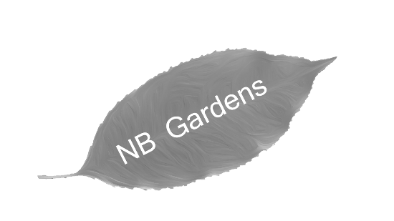

**NB Gardens**

66 James Close

Ravenwood

Staines

ST3 4LE