Short-Term Energy Load Forecasting
for EV Charging Load Management
Exploratory study using household energy data as a proxy for building load
Main result: recent power history and time of day were much more useful than adding many weather and room-sensor variables. Linear Regression and a small Neural Network performed best, but sudden human-driven spikes remained difficult to predict.

1. Goal
The goal was to test a simple idea for an EV charging station: predict building load about 30 minutes ahead, then use that prediction to decide whether EV charging current should stay high or be reduced. The model predicts future load; a separate control rule would convert that prediction into a charger current limit.
The dataset contains energy measurements every 10 minutes. Because this is household data rather than real commercial EVSE data, it is used here as a proxy to demonstrate the forecasting method and the engineering thought process.

2. How the investigation developed
- Start with a Random Forest using current load, hour, outdoor conditions, wind, and a small number of indoor measurements.
- Add many more features to see if more information improves the forecast. It did not; the error became worse.
- Add short-term load history: current load plus 10, 20, and 30 minute lag values. Performance improved sharply.
- Compare three models on the same four load-history inputs: Random Forest, Linear Regression, and a small Neural Network.
- Study the failures. Large spikes were often missed, so the investigation shifted from “which model is best?” to “which spikes are actually predictable?”
- Analyze correlations, same-time behavior across days, high-load vs normal events, and time-of-day probability.
Model / feature comparison
Experiment | Inputs | MAE | RMSE
RF - basic | Load + time/weather + T1/RH1 | 87.49 | 129.68
RF - many features | Most measured variables | 136.80 | 179.95
RF - lags + context | Load history + context | 75.29 | 112.41
RF - load history | Now + 10/20/30 min lags | 44.92 | 87.95
Linear Regression | Now + 10/20/30 min lags | 39.51 | 80.15
Neural Network | Now + 10/20/30 min lags | 39.60 | 79.09

3. Model results: simple models were competitive
The first important result was that complexity did not automatically improve accuracy. Adding many sensor variables made the Random Forest worse. The best Random Forest used only recent load history. Linear Regression then improved the MAE further, and the Neural Network produced the lowest RMSE, but the Linear and Neural results were very close.
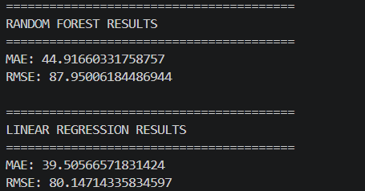 | 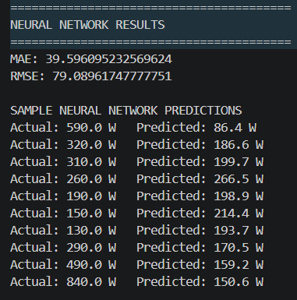
Figure 1. Model output: Random Forest, Linear Regression, and Neural Network.
The sample Neural Network predictions show the main limitation. Normal values can be predicted reasonably well, but some large events are missed badly (for example, an actual value near 590 while the prediction stays near the normal range). This led to the next question: are these spikes random, or do they have warning signs?

4. Why the spikes became the main research question
A graph of the same clock times on different days showed that the load can be quiet on one day and spike on another. That means “same hour yesterday” is not enough by itself. It also suggested that household behavior - cooking, laundry, electric appliances switching on - can create sudden step changes that do not always have a smooth buildup.
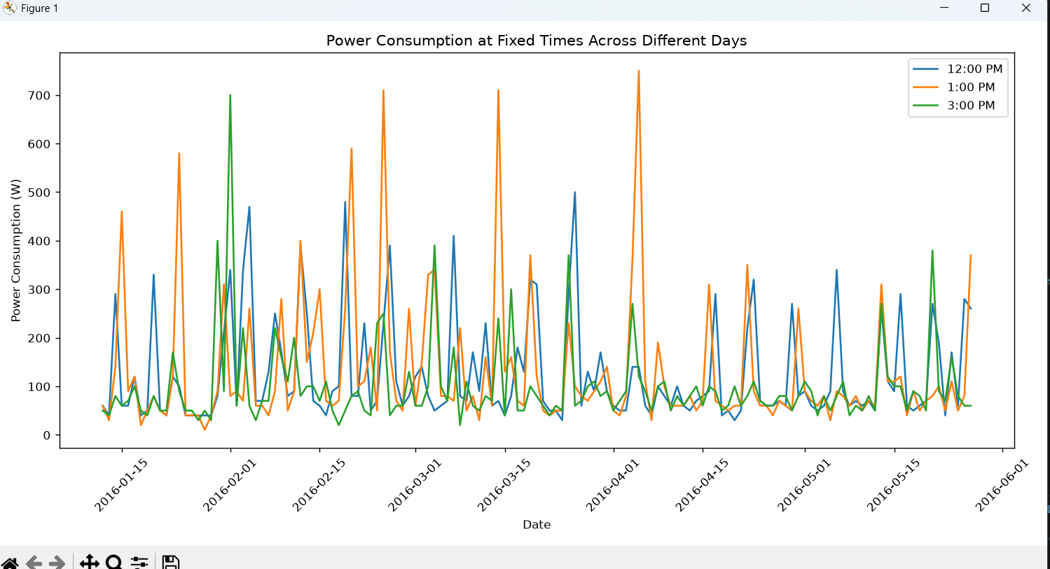
Figure 2. Power at 12 PM, 1 PM, and 3 PM across many days. Large spikes appear on some days but not others.

5. Correlation and feature checks
The correlation analysis confirmed that recent load history was the strongest signal for the 30-minute target. Current load had a correlation around 0.44 with the future target, followed by the 10-, 20-, and 30-minute lag values. The one-day-ago value, hour, lights, temperatures, humidity, wind, and other variables were much weaker.
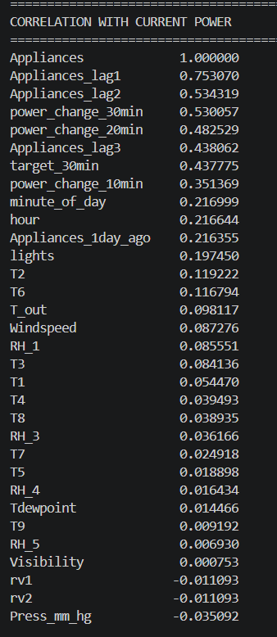 | 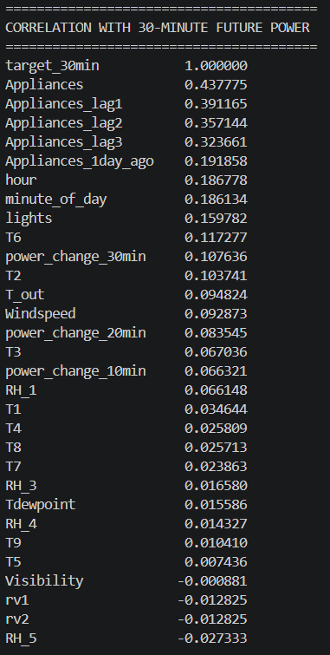
Figure 3. Correlation with current load (left) and with 30-minute future load (right).
Rate-of-change features were also tested. They were weaker than the absolute load-history values. This was useful because it showed that the model benefits more from knowing the recent load level than from a simple “rising or falling” slope.

6. High-load events do have a measurable buildup on average
A high-load event was defined as a future target above 300. Across the full dataset, there were 1,131 high-load events and 18,598 normal events. The average history before high-load events was clearly higher than before normal events.
Time before event | High-load avg | Normal avg | Difference
60 min | 165.19 | 93.55 | +71.64
50 min | 171.22 | 93.18 | +78.04
40 min | 182.16 | 92.52 | +89.64
30 min | 201.66 | 91.33 | +110.33
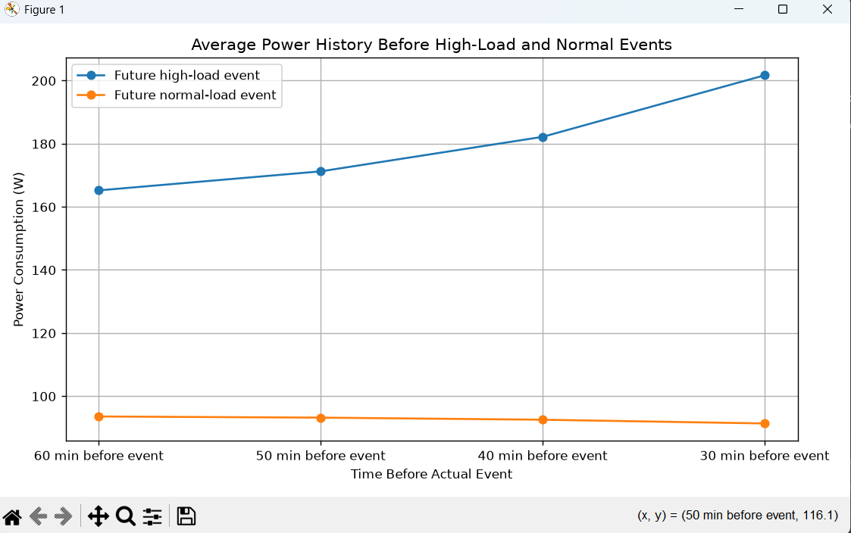
Figure 4. Average load history before future high-load and normal events.

7. Some spikes are predictable; some are abrupt
The average trend is strong, but individual events are mixed. Some high-load events show a clear rise before the target. Others jump from a flat, low history to a large future value. Those abrupt cases are difficult to predict from load history alone and are likely influenced by events that are not directly measured in this dataset, such as a person switching on a large appliance.
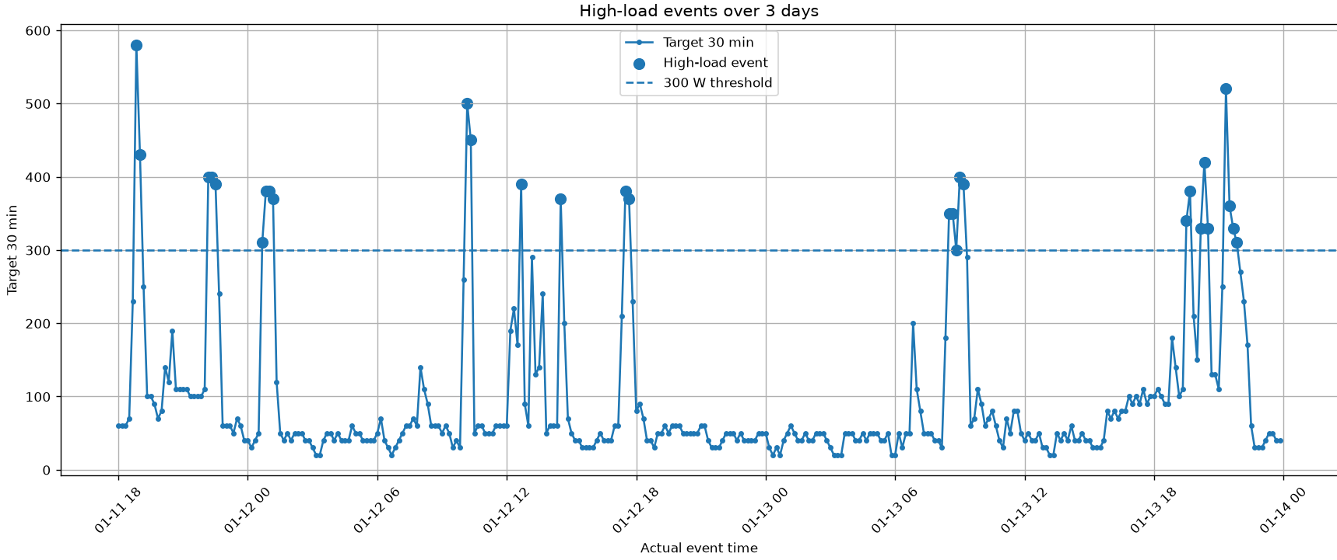
Figure 5. Three-day view of future high-load events. Some spikes cluster; others appear abruptly.
This is an important conclusion rather than a failure. A forecasting system does not need to predict every sudden action perfectly to be useful. It can still identify periods with elevated risk and reserve electrical capacity before those periods.

8. Time of day added a strong practical signal
The full-dataset hourly probability graph showed a clear daily pattern. High-load probability is very low overnight, rises during the morning, and is highest in the late afternoon and early evening. The peak is around 17:00-18:00, with the 18:00 hour close to 20%.
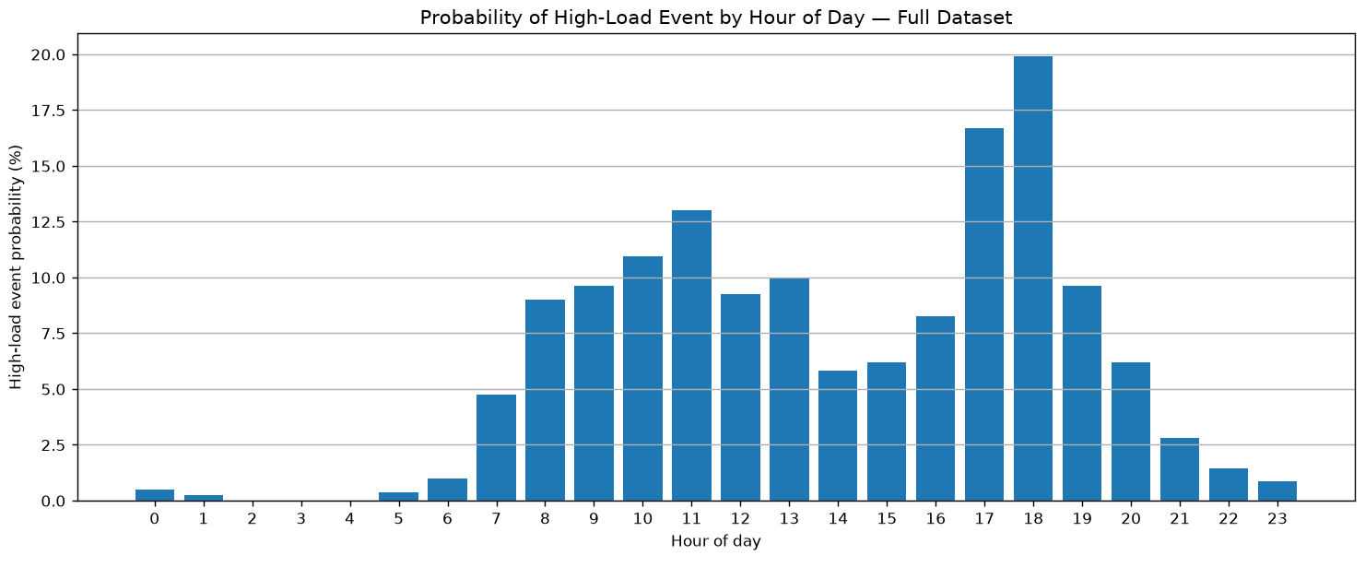
Figure 6. Probability of a high-load event by hour of day across the full dataset.
This also explains why the simple linear correlation with “hour” looked weak: the relationship is not a straight line. The risk rises and falls through the day. For a final model, time should be represented as a daily cycle rather than as a single raw hour number.

9. How this applies to EV charging
The practical control concept is simple:
- Read current building load and recent load history.
- Use the forecasting model to estimate load about 30 minutes ahead.
- Combine the forecast with time-of-day risk and other available operational data.
- If future building load is expected to be high, temporarily reduce EV charging current.
- If building load is expected to stay low, allow higher charging current.
- Keep charger limits, electrical ratings, and safety rules in a separate deterministic control layer.
In a real commercial system, the model could be improved with features that this dataset does not contain: number of connected EVs, requested charging power, building occupancy, HVAC schedules, tariff periods, weather forecast, historical peak demand, and known equipment schedules.

10. Limitations
- The source data comes from one household, not from a commercial building or EV charging site.
- The dataset does not identify which appliance caused each spike, so a specific cause (for example, stove or dryer) cannot be proven.
- Some spikes have almost no warning in the previous load values. Those events cannot be predicted reliably from load history alone.
- The 300-unit high-load threshold was chosen for this experiment. A real site would set thresholds from service capacity, charger ratings, and operating policy.

11. Conclusion
Conclusion in simple terms: the future load is not fully predictable, but it is not random either. Recent load history gives useful warning, and time of day gives another strong signal. The best results came from simple load-history models, while adding many unrelated sensor values made performance worse. A practical EV charging controller could use this forecast as a risk signal and reduce charging current before likely high-load periods, while accepting that some sudden human-driven spikes will still happen without warning.
The most useful engineering lesson from this study is the investigation process itself: start simple, measure the error, inspect the failures, test one hypothesis at a time, and keep only the features that prove useful. That process can be transferred directly to real EV charging and commercial-building load data.

