Predicting Miami Hotel Chiller Electricity Consumption
Phase 1 — Energy Prediction | Project report | October 2026

Executive summary
This study trained linear regression and neural-network models to estimate hourly electricity consumption of a simulated hotel chiller. The study combines five EnergyPlus operating scenarios with chilled-water setpoints of 6.7, 7, 8, 9 and 10°C. Introducing direct and diffuse solar radiation improved overall predictive performance. Linear regression delivered the lowest overall test error, while neural networks showed advantages for certain higher-load conditions and a specialized network improved performance on the low-load subset.

Data and methods
Input features (nine): chilled-water setpoint, mean indoor temperature, mean indoor humidity, outdoor dry-bulb temperature, outdoor relative humidity, hour, month, direct solar radiation and diffuse solar radiation. The target is hourly chiller electricity energy in kWh, converted from joules. The experiment used an 80% training / 20% testing chronological split and evaluated MAE, RMSE and R². These measurements reflect simulated EnergyPlus data, not independently validated real-building meter readings.

Overall held-out performance
Model | MAE (kWh) | RMSE (kWh) | R²
Linear regression — 7 features | 8.49 | 11.01 | 0.8895
Linear regression — 9 features | 6.81 | 8.63 | 0.9321
Neural network — 7 features | 8.39 | 12.44 | 0.8591
Neural network — 9 features | 7.10 | 10.00 | 0.9089
The addition of solar radiation is associated with improved results for both models on the same chronological test period. It does not establish a causal explanation for all errors.

Seasonal performance
Test month | Linear regression MAE | Neural network MAE
October | 5.45 kWh | 2.47 kWh
November | 6.48 kWh | 5.89 kWh
December | 7.65 kWh | 10.07 kWh
The neural network had lower errors in October and November, while linear regression had lower errors in December. The month-specific differences are descriptive; they do not isolate which underlying physical variable drives the change.

Low-load investigation (<75 kWh)
Model | MAE | RMSE | R²
Linear regression | 8.772 | 10.953 | 0.7268
Original neural network | 13.501 | 16.064 | 0.4123
Specialized low-load neural network | 8.020 | 9.734 | 0.7842
The low-load-specific neural network improved performance when trained on 5,761 low-load samples and evaluated against 2,594 low-load test samples. The subset was selected using observed electricity demand, so this is an offline study rather than a directly deployable model-selection scheme.

Interpretation and limitations
- Adding solar radiation was beneficial, but residual errors remain substantial at some low loads.
- A neural-network training R² near 0.994 versus test R² near 0.909 suggests a generalization gap; it does not independently prove its cause.
- Some predictions were negative, which is physically unrealistic; a production approach needs constraints or postprocessing.
- Daily averages combine all five setpoint scenarios and can hide hourly prediction errors. A single-setpoint comparison is more appropriate for time-series interpretation.
- The original script includes an early illustrative setpoint-savings test but this report does not claim validated optimal setpoints or proven energy savings.

Selected figures
Daily average observed and predicted consumption across all setpoint scenarios.
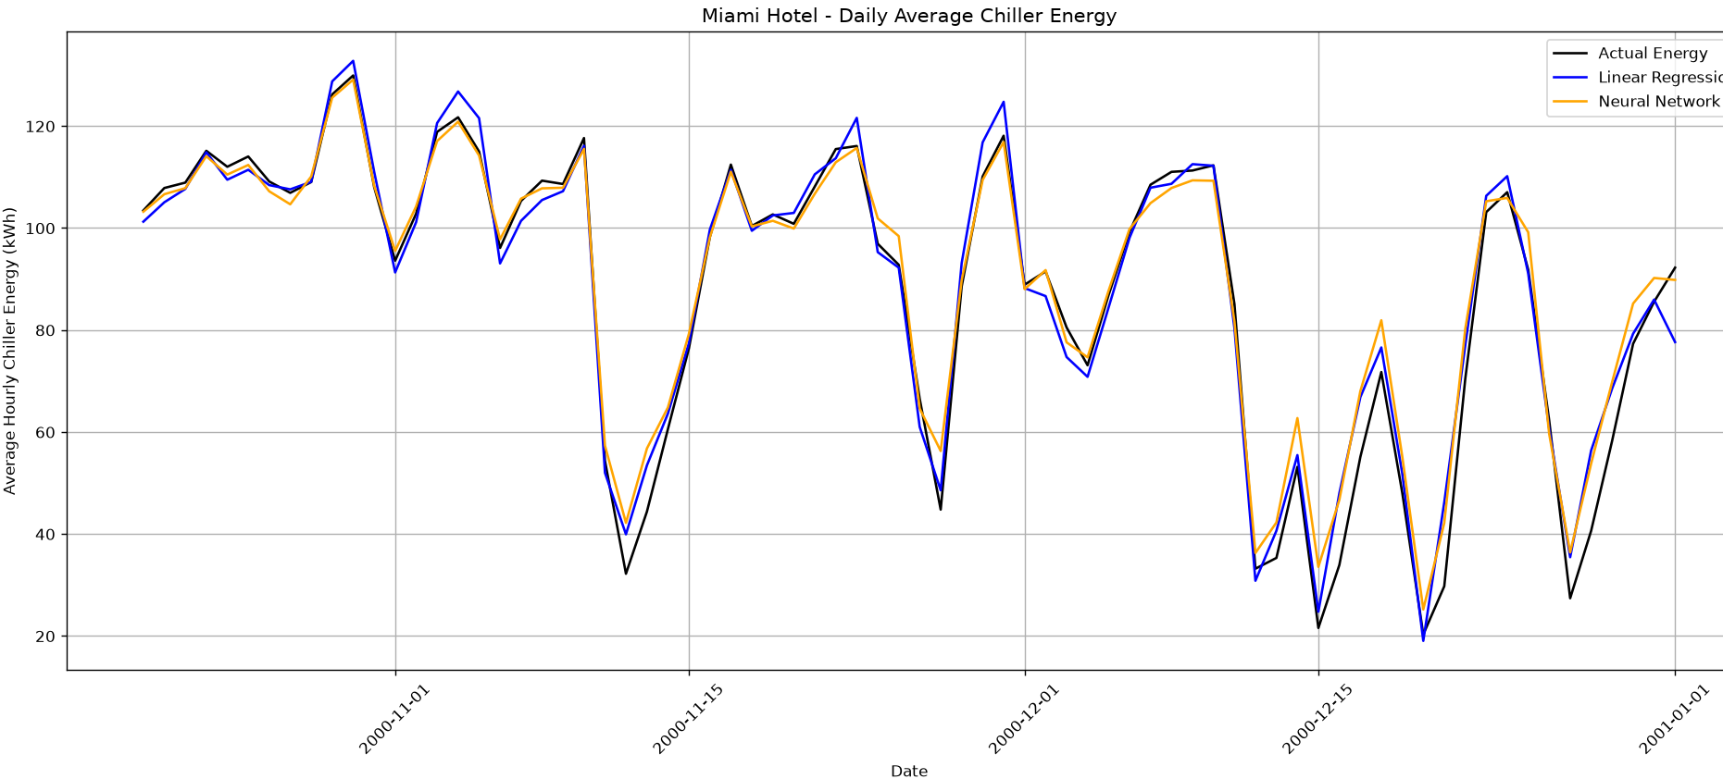
Test-set errors grouped by chiller electricity consumption range.
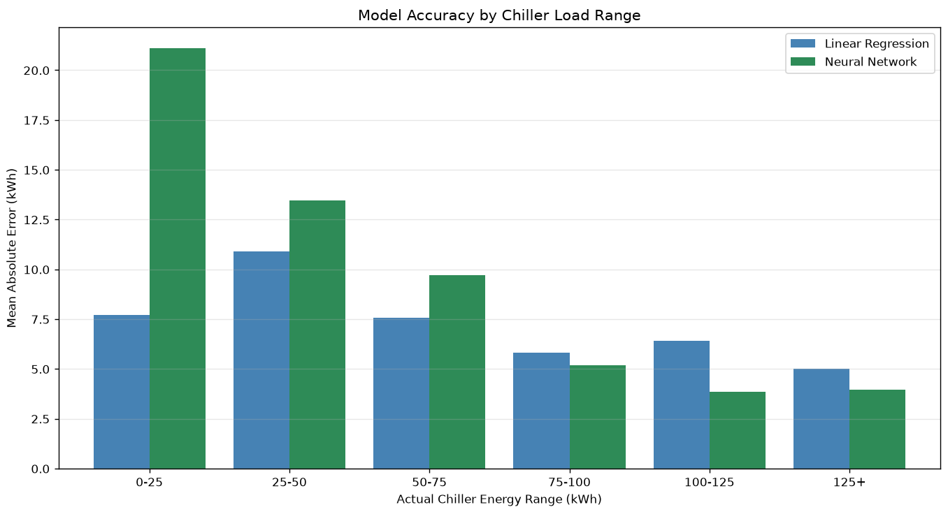
Low-load prediction errors for linear regression and neural network variants.
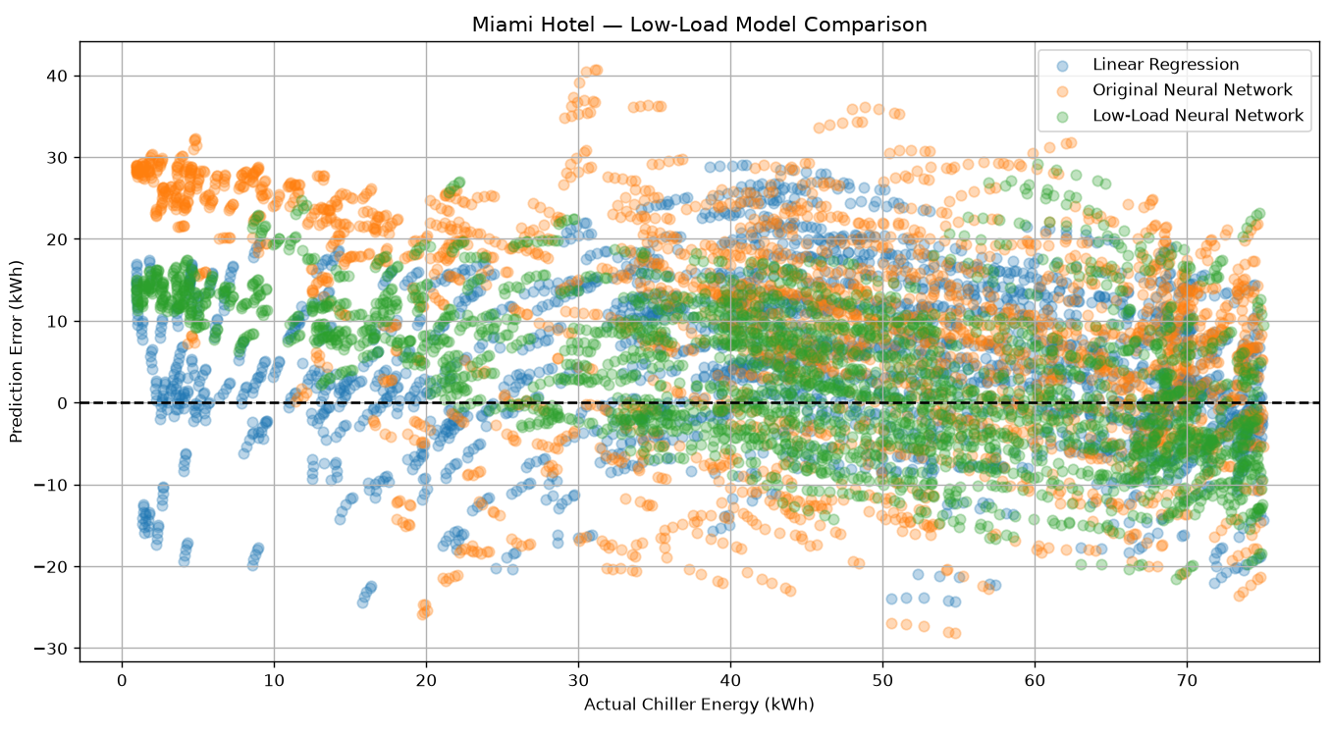
Illustrative higher-load day. Multiple setpoints overlap at each hour.
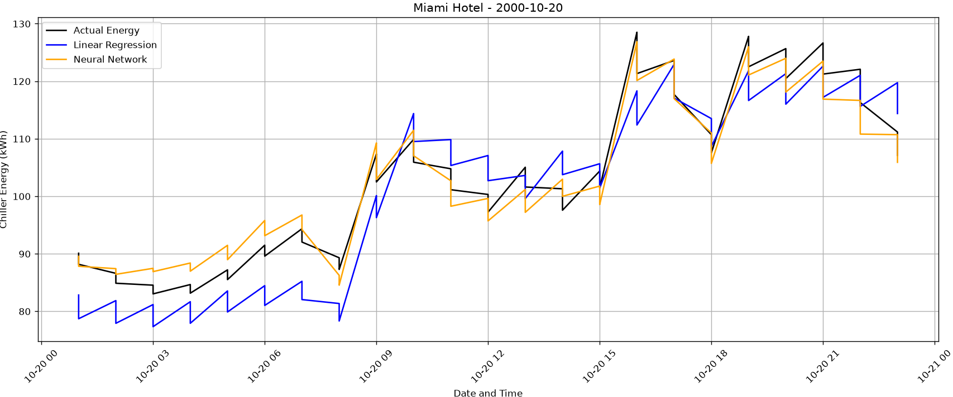
Illustrative lower-load day. Multiple setpoints overlap at each hour.
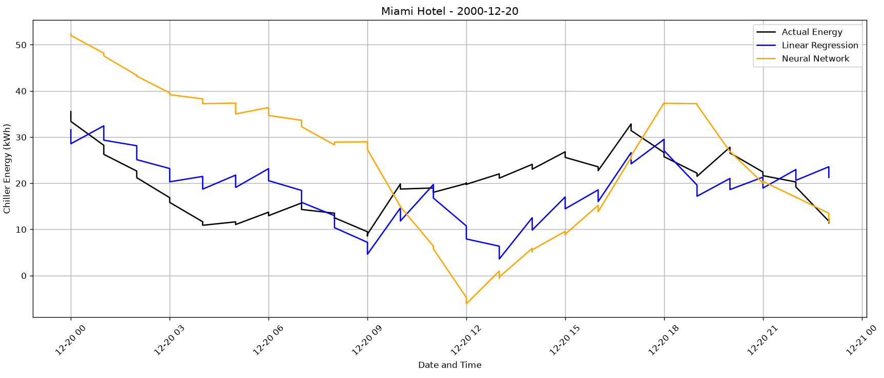

Next phase: chilled-water setpoint optimization
A separate project can evaluate 6.7–10°C setpoints under comparable weather and occupancy conditions, quantify predicted electricity savings, and constrain indoor temperature, humidity and operating requirements. An optimization decision must not use future observed consumption as an input. Validation against simulated scenarios and, eventually, measured BMS data will be needed before field deployment.

Reproducibility notes
The accompanying Python script is the investigator’s working analysis code and may require the five original CSV data files and some cleanup before reproducible execution. The original EnergyPlus CSV files are not included. Figures and numerical metrics are from the supplied analysis outputs and conversation; they have not been independently rerun from raw data for this report.

