

ELEX 7660: Lab 1

7-Segment LED Decoder

|  |  |  |
| --- | --- | --- |
| Nicholas Huttemann | 12/01/2019 | Set: T |

Table of Contents

1 Modules 3

1.1 Decode2 3

1.2 Bcitid 3

1.3 Decode7 4

1.4 Schematic 4

1.5 Compilation Report 5

Table of Figures

Figure 1: Decode2 Waveform 3

Figure 2: Bcitid Waveform 3

Figure 3: Decode7 Waveform 4

Figure 4: Circuit schematic created by Quartus 4

Figure 5: Compilation Report 5

# Modules

## Decode2

// decode2.sv - ELEX 7660 – 2 to 4 decoder. Selects which digit of the 7-segment LED Display to enable.

// Nicholas Huttemann 2018-01-12

**module** decode2 **(** **input** **logic** **[**1**:**0**]** digit**,**

**output** **logic** **[**3**:**0**]** ct**);**

**always_comb**

**case(**digit**)**

0 **:** ct **=** 4'b0001**;**

1 **:** ct **=** 4'b0010**;**

2 **:** ct **=** 4'b0100**;**

3 **:** ct **=** 4'b1000**;**

**endcase**

**endmodule**

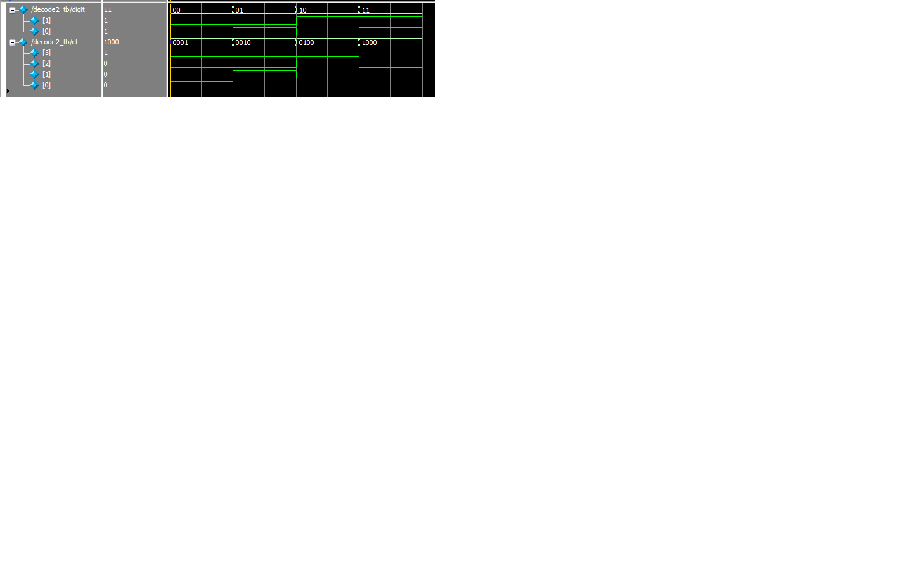

Figure 1: Decode2 Waveform

## Bcitid

// bcitid.sv - ELEX 7660 - Module that selects and stores the last 4 digits of my student ID

// Nicholas Huttemann 2018-01-12

**module** bcitid **(** **input** **logic** **[**1**:**0**]** digit**,**

**output** **logic** **[**3**:**0**]** idnum**);**

**always_comb**

**case(**digit**)**

3 **:** idnum **=** 0**;**

2 **:** idnum **=** 4**;**

1 **:** idnum **=** 3**;**

0 **:** idnum **=** 9**;**

**endcase**

**endmodule**

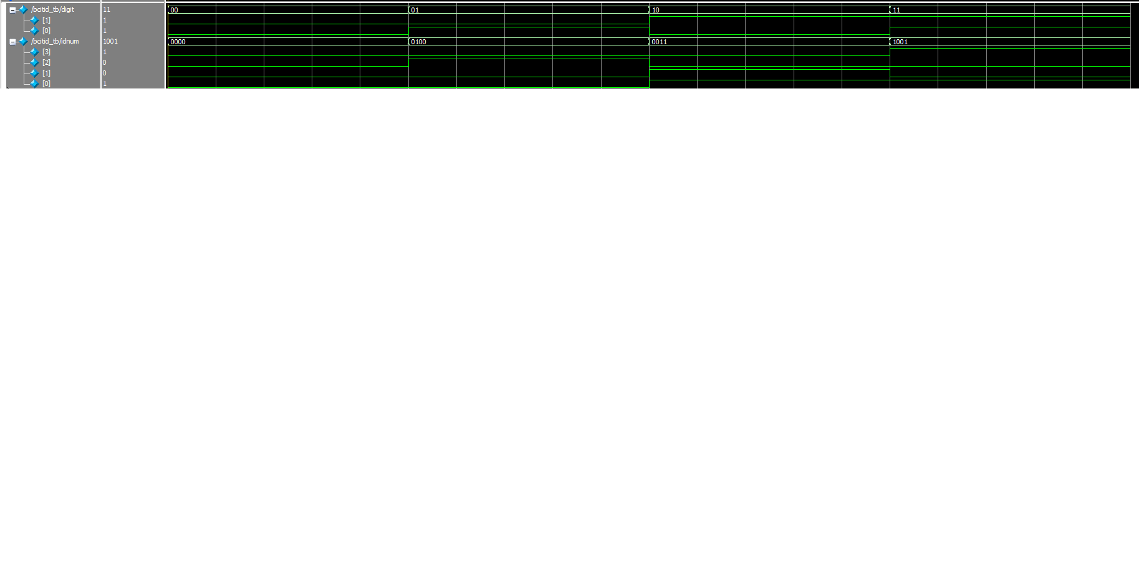

Figure 2: Bcitid Waveform

## Decode7

// decode7.sv - ELEX 7660 – Converts ‘num’, a decimal integer 0 – 9 (10 for DP), into an 8-bit vector ‘leds’ that will light up corresponding segments on a 7-segment LED.

// Nicholas Huttemann 2018-01-12

**module** decode7 **(** **input** **logic** **[**3**:**0**]** num**,**

**output** **logic** **[**7**:**0**]** leds**);**

**always_comb**

**case(**num**)**

0 **:** leds **=** 8'b11000000**;**

1 **:** leds **=** 8'b11111001**;**

2 **:** leds **=** 8'b10100100**;**

3 **:** leds **=** 8'b10110000**;**

4 **:** leds **=** 8'b10011001**;**

5 **:** leds **=** 8'b10010010**;**

6 **:** leds **=** 8'b10000010**;**

7 **:** leds **=** 8'b11111000**;**

8 **:** leds **=** 8'b10000000**;**

9 **:** leds **=** 8'b10010000**;** //Updated to new style of 9

10**:** leds **=** 8'b01111111**;**

**endcase**

**endmodule**

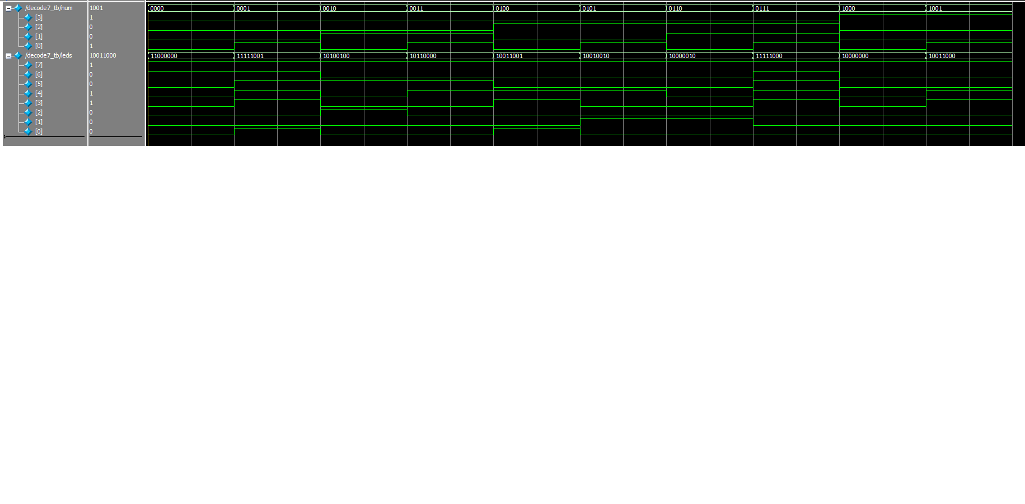

Figure 3: Decode7 Waveform

## Schematic

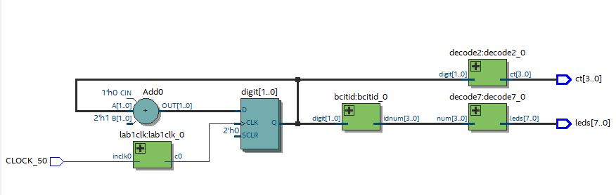

Figure 4: Circuit schematic created by Quartus

## Compilation Report

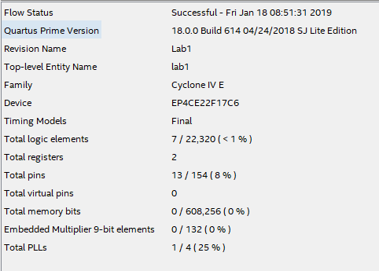

Figure 5: Compilation Report