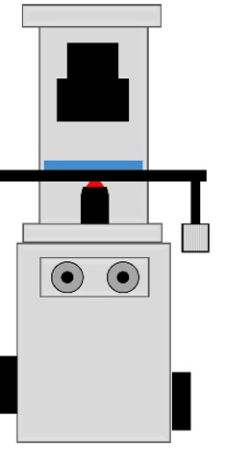

Aurox Clarity Module



**Camera**

**CoolLED**

300

Deformable Mirror

300

**Key**

Mirror

Lens