Technical Test

# Bug Finding / Fixing (~20 mins)

In the Visual Studio solution there is a project called “AjaxSearch” which contains several bugs. It is a simple MVC application that filters a set of contacts in a quick and reactive way (with the goal of providing a good/fluid user experience).

Please would you find and fix the following bug:

* When users on slow links use the site (e.g. modems / mobile) they sometimes get the wrong set of results back.

Notes:

* If you cannot diagnose/fix the problem please do not worry, but instead would you make some suggestions as to the cause & any potential fixes.
* Please see the next page for detailed reproduction steps.

# New Code (~60 mins)

In the solution please open the “NewCode1” project and quickly familiarise yourself with the classes contained within it.

Once familiar please can you:

* Implement the AddNode method in NewCode1\BST\Tree.cs so it populates a Binary Search Tree.

Notes:

* Please do not look up implementations from the internet.
* You are welcome to change any of the classes as you want.
* Ideally, I would like the implementation to be a generic so that it can be used as a bit of library code.
* While there is a unit tests project, you are not required to test drive the code.

From Wikipedia:

*In computer science, a binary search tree (BST), sometimes also called an ordered or sorted binary tree, is a node-based binary tree data structure which has the following properties:*

* *The left subtree of a node contains only nodes with keys less than the node's key.*
* *The right subtree of a node contains only nodes with keys greater than the node's key.*
* *The left and right subtree must each also be a binary search tree.*
* *There must be no duplicate nodes.*

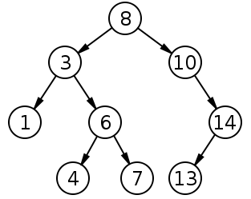

# Ajax Search Reproduction Steps

1. Open TechTest.sln in Visual Studio 2019
2. Open the Package Manager Console and run:

Update-Package -reinstall

1. In the Solution Explorer, right click the “AjaxSearch” project, and select “Set as startup Porject”
2. Start the debugger / application (so your browser opens on it)
3. Launch Fiddler web debugging proxy ( <https://www.telerik.com/download/fiddler/fiddler4> ) [Note. you may need to launch it “As Administrator” so it can capture the local host traffic]
4. Set Fiddler to Simulate Modem Speeds

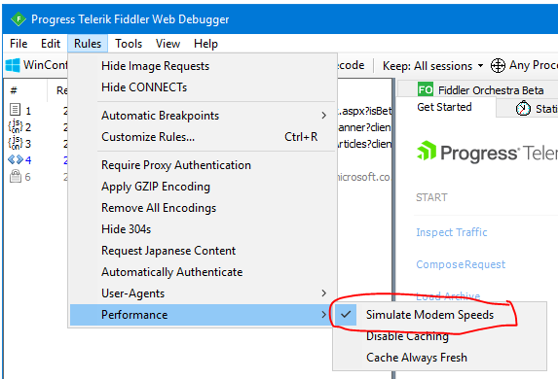

1. In your browser; search for “x”; then remove the text and very quickly retype the “x”. If all went well, you should be looking at the full set of contacts and not just the ones which contain the letter “x”.

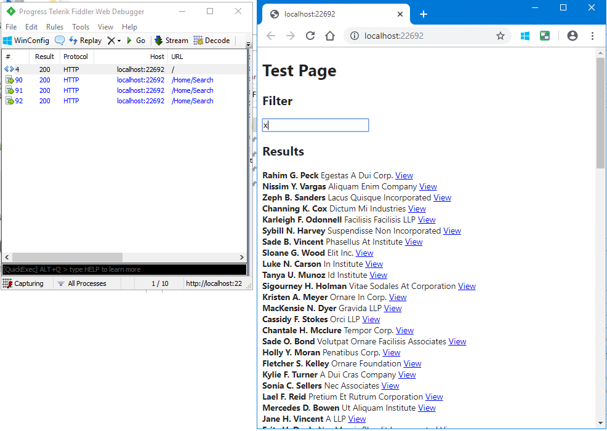

# Returning your solution to us

Our email system blocks executable and zip files; so would you be kind enough to create a GIT patch file. E.g. run the following command and send the resulting file:

git format-patch origin/master --stdout > techtest.patch