**DC-DC Converter**

1. Dimensions:

* Nominal Current: 1A
* Input Voltage: 22v - 30v
* Output Voltage: 5v & 3.3v
* Nominal Power: 5W

1. Description:

This circuit consist in an energy converter circuit which input can vary between 22v to 30v, and the outputs will be the input voltage limited to 1A and 2 constant 5v and 3.3v. The power dissipation of the circuit is based with the internal voltage regulator LM7805 which transform the input voltage higher than 8v and lower of 32v to a constant output voltage of 5v, and this voltage is used as input for a MCP1792T voltage regulator to obtain the 3.3v

1. Schematic:

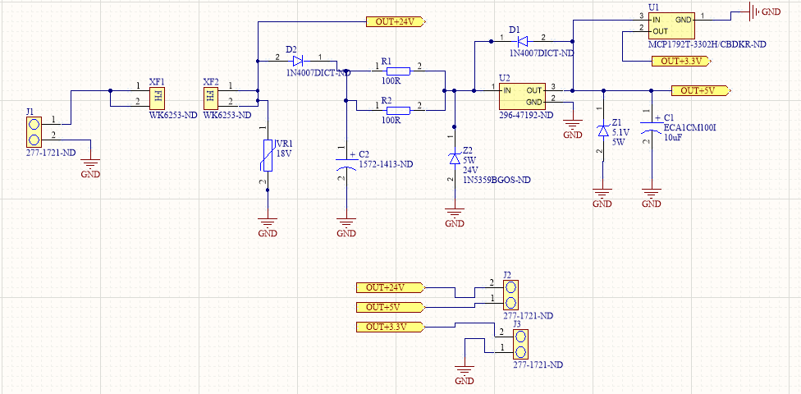

The circuit is integrated with terminal block (J1) in the input, to set the input voltage between 22v and 30v and the neutral line of the voltage source. Then is set a fuse holder ( XF1 and XF2 ) to be used with a 1A Fuse of 6.5mm of diameter and 37mm of length, to limit the input current on the circuit, so when load is consuming more than 1A this Fuse breaks. Following the fuse holder, it is set in parallel a varistor (VR1) which is used to shortcut the circuit when the voltage is higher than 30v, causing that the fuse breaks for excess of current consumed by this element. Then we have the diode (D2) used as an extra protection of the circuit in case of high current consumption.

In parallel we have the capacitor (C2) used to save energy in terms of voltage so in case the input voltage drops, this can energize the load in limited period, and also the capacitor can provide current to the load, avoiding consumption of current in the input. Then is set 2 resistors ( R1 and R2) used to limit the current in the input of the lm7805 (U2) through a voltage drops generate between the input voltage and the 24V Zener (Z2) so when input voltage is higher than 24v there will be a differential of voltage between the resistors and this will cause a current draining to the lm7805. Above this regulator, there is a diode (D1) used to avoid that the current return in case of issues with source than can affect the direction of the current. In the same way, there is a 5v Zener (Z1) and a 16v capacitor (C1) to keep the output voltage on 5v as long as there is not voltage dropped in the input, and also use this capacitor to supply the 5V to the input of the MCP1792T (U1) and obtain the 3.3v required in the output. Finally, these 3 voltages and the ground will be set in the output by 2 terminal blocks (J2 and J3), ready to be used to supply low consume loads.

1. PCB Design

