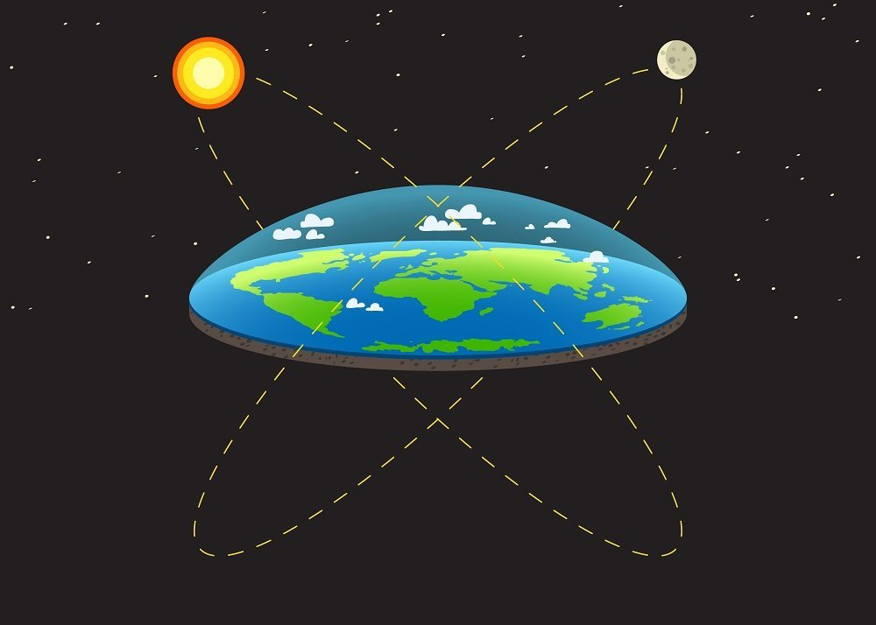

Join the truth,

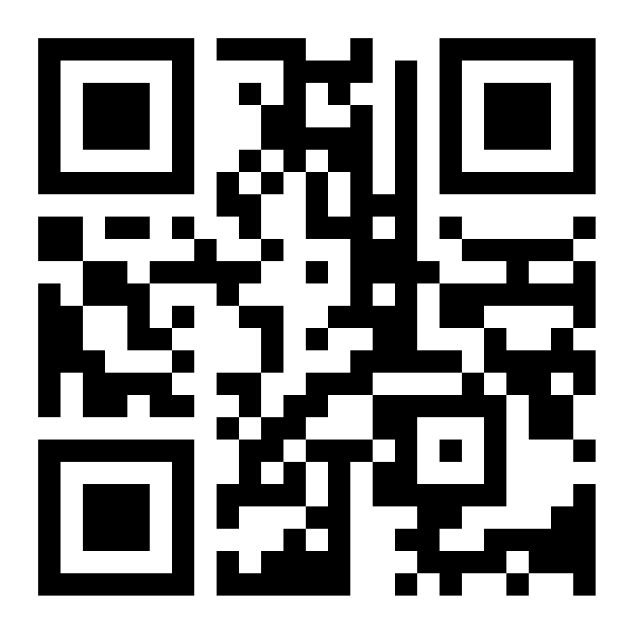join the flat earth society:

Find out how the government and teachers lied to us for years.