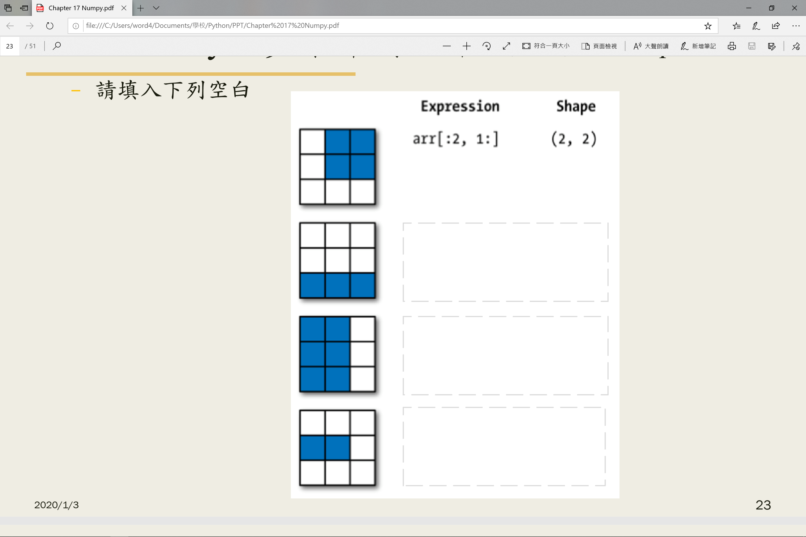

arr[1, :2] (2, )

arr[:, :2] (3, 2)

arr[2, :] (3, )