* Team name:

**Dine and Dash**

* Team member names:

**Laura Klions**

**Chase King**

**Nick Maude**

**Jeff Parker**

* Initial project description:

**Create an android app to allow users to track stats related to the busyness of the dining halls on campus. The user would be able to select which hall they are interested in visiting, and be able to see general information about the dining hall such as pictures, location, hours and types of food served at the location. The user would also be able to see how busy the hall is at any given point in time. What is the typical throughput of a person eating in versus dining out.**

**The app will originally be based off of observations and statistically analysis to determine average trends and capacity. Over time time data could be collected through the app, a camera with an AI to determine how many people are present in the dining hall, or even an API to track the number of people in a given area. Users would each create a profile with their student ID. If enough students downloaded the app user information could also be used tracked and used to support the data being presented within the app.**

**The first version of the app is planned to include information only for Boyd dining hall. The app will be developed using Android Studio in c++**.

* Target scenarios: (If the project is successfully completed, how would a user use your project and for what purposes? Give concrete examples and provide step by step descriptions.)

**A student has 30 minutes before their next class and are not sure if they have time to eat. They open the app, see that the line to Boyd dining hall is approximately 4 minutes long, and then they decide they have enough time.**

**A student is not sure what is being served at their dining hall today. The dine and dash app will provide students with menus with all food served.**

**A student is going to the dining hall with a large group of friends and wants to know the likelihood of finding enough seating for the group.**

* Initial project storyboard or GUI prototype (hand sketch images are acceptable)

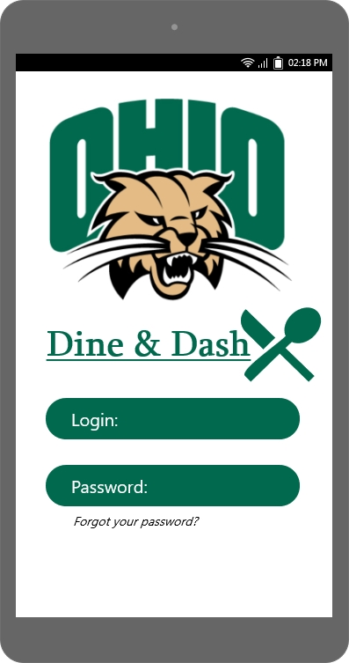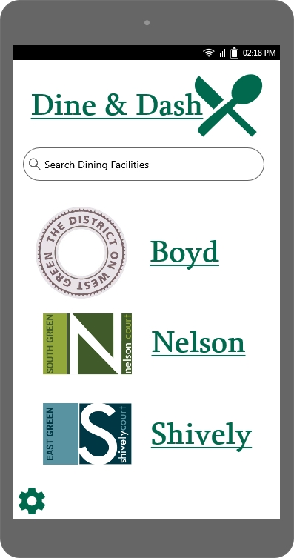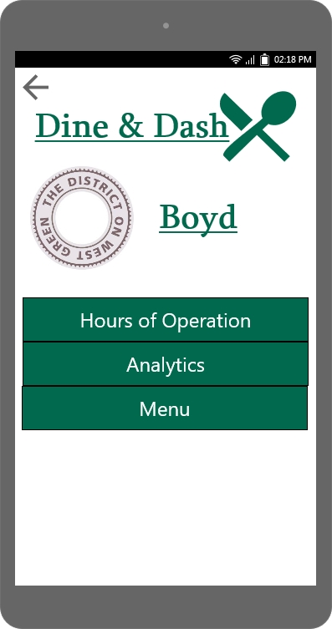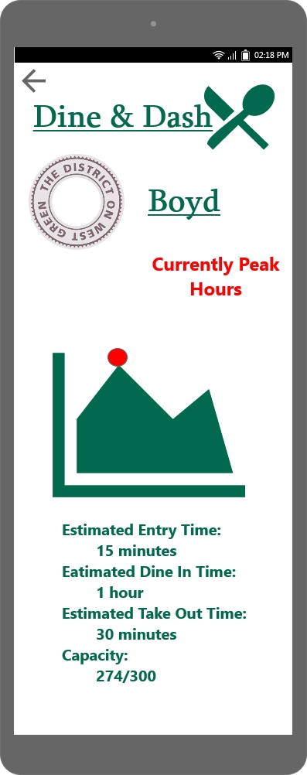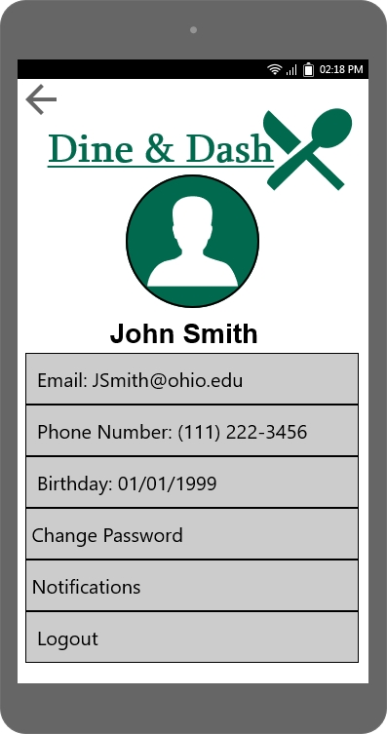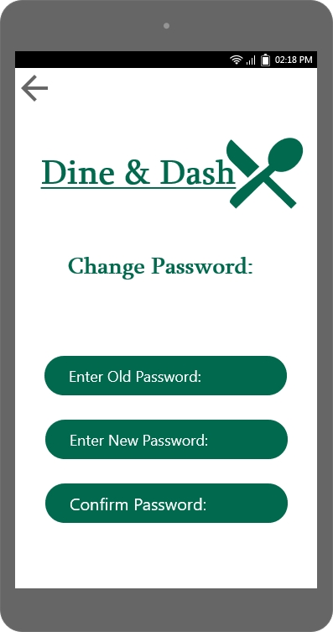

* Technology/Platform/ToolChain/Languages

**MockPlus, GIT, Android Studio, C++**

* Two weekly time slots to meet (and location)

**Tuesday 2:00 PM, Thursday 2:00 PM**

* The URL of your github git repo. (Add Github ID: drchangliu and krerkkiat to your repo.)

<https://github.com/NickMaude/Dine-n-Dash->

* The goals of your first two-week sprint. (Be sure to include individual sprint goals for all members.)

**Group Goals:**

**9-11-19**

**Finish StoryBoard Concept**

**9-17-19**

**Decide on Data Collection Method (Observations/Statistical Analysis, wireless data, nearby API, other)**

**9-19-19**

**Begin Data collection**

Secondary: Simple mock Android App