Code:

import csv

def get_median(lis, pos):

if len(lis) % 2 == 0:

return (float(lis[len(lis) // 2 - 1][pos]) + float(lis[len(lis) // 2][pos])) / 2

else:

return float(lis[(len(lis) + 1) / 2][pos])

def printer(lis):

print("{:<30}{:<30}{:<30}".format("China", "Brazil", "USA"))

for i in range(len(lis)):

print("{:<30}".format(lis[i]), end="")

print(end='\n\n')

with open('income_growth.csv') as csv_file:

growth = list(csv.reader(csv_file, delimiter=','))

mean_values = [0, 0, 0]

median_values = [0, 0, 0]

standard_deviation = [0, 0, 0]

for i in growth:

if growth.index(i) != 0:

for j in range(1, len(i)):

mean_values[j - 1] += float(i[j]) / (len(growth) - 1)

for i in growth:

if growth.index(i) != 0:

for j in range(1, len(i)):

standard_deviation[j - 1] += (float(i[j]) - mean_values[j - 1])**2 / (len(growth) - 2)

standard_deviation[0] = standard_deviation[0] ** 0.5

standard_deviation[1] = standard_deviation[1] ** 0.5

standard_deviation[2] = standard_deviation[2] ** 0.5

growth = growth[1:]

growth = sorted(growth, key=lambda x: float(x[1]))

median_values[0] = get_median(growth, 1)

growth = sorted(growth, key=lambda x: float(x[2]))

median_values[1] = get_median(growth, 2)

growth = sorted(growth, key=lambda x: float(x[3]))

median_values[2] = get_median(growth, 3)

print("Mean Values:")

printer(mean_values)

print("Median Values:")

printer(median_values)

print("Standard Deviation Values:")

printer(standard_deviation)

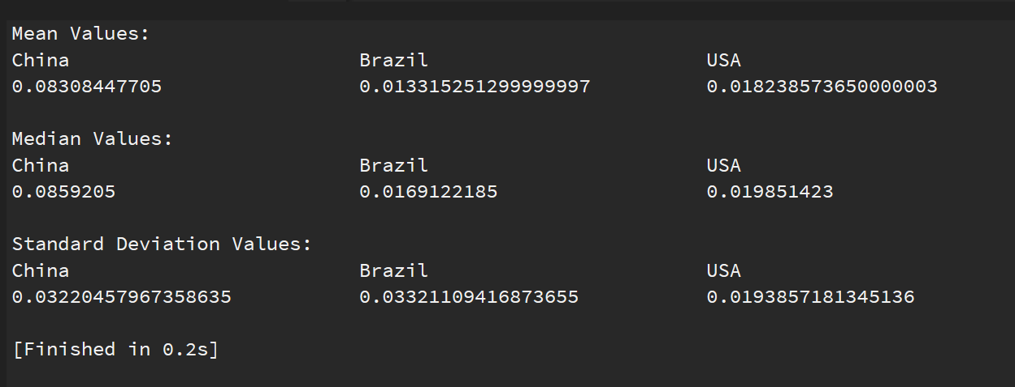Output Screenshot:

Project submitted by:

Nikhil Kunjoor

SRN: PES2UG19EC085

PRN: PES2201900294

Class: E Section