Technical Support Document

For

Insomnia
  - 2-D Interactive Game

Prepared by
Lopsided Productions:
Jessica Coffel, Tom DiGuido, and Nick Pokusa

  - Document Version: 1.1
  - Date: 05/05/26

  - Table of Contents
1 Introduction 4
1.1 Purpose 4
1.2 Scope 4
1.3 Audience 4
2 Code Documentation 4
2.1 How to Install and Run 4
2.2 Entry Point 5
2.3 Logic Flow 5
2.4 Error Handling 5
2.5 Code Conventions 5
3 Product Documentation 6
3.1 Game Summary 6
3.2 Use Case Overview 6
4 Software Architecture 8
4.1 Logical Architecture 8
4.2 Technical Architecture 8
5 Data Structures 8
5.1 Core Data Elements 8
5.2 Data Relationships 9
6 Sequence and Flow Diagram 10
7 Development Workflow 10
7.1 Typical Development Tasks 10
7.2 Build Process 10
8 Troubleshooting and Debugging 11
8.1 Common Issues 11
8.2 Debugging Approach 11
9 Technical Decision Log 11
10 System Modification Guide 11
11 Future Enhancements 12
12 Document Management 12
12.1 Contributors 12
12.2 Version Control 12

Introduction

Purpose
This document provides technical guidance for developers who will inherit, maintain, and extend the Insomnia game. It focuses on system logic, architecture, and working with the codebase.

Scope
This document includes:
- Code structure and organization
- System architecture
- Core logic and workflows
- Build and execution instructions
- Technical decisions
- Troubleshooting and debugging

Audience
- Future developers
- Technical maintainers
- Contributors to the project

Code Documentation

How to Install and Run
- Install GameMaker Studio 2
- Open the project .yyp file
- Allow assets to load
- Click Run in GameMaker

Download GameMaker from:
https://gamemaker.io/en

Entry Point
The game begins in the Main Menu room, where obj_game_controller initializes the game state and handles transitions to gameplay.

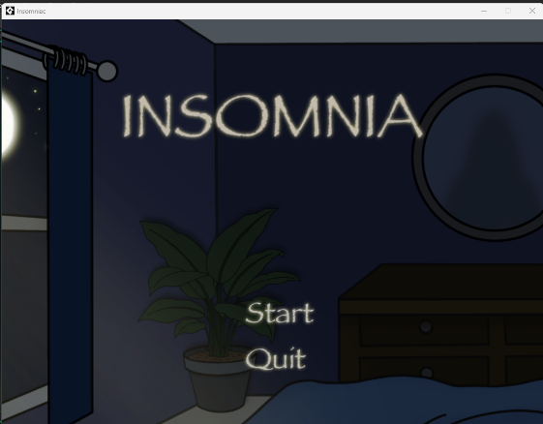

Logic Flow
Core Game Loop:
- Initialize game state
- Load level (night)
- Player activates sleep
- Sleep meter increases
- Monster triggers threat
- Player responds via environment
- Win (100%) OR Game Over

Error Handling
- Invalid inputs are ignored
- Game resets on failure
- State transitions handle recovery

Code Conventions
- Object-based naming: obj_*
- Scripts: verb-based naming
- Variables: descriptive and consistent

Product Documentation

Game Summary
The system provides an interactive gameplay experience where users must manage sleep progression while responding to threats from monsters.

Use Case Overview
Primary Use Case:
- Player attempts to complete a level by reaching 100% sleep
Secondary Use Cases:
- Player responds to threats
- Player interacts with the environment
- Player navigates menus

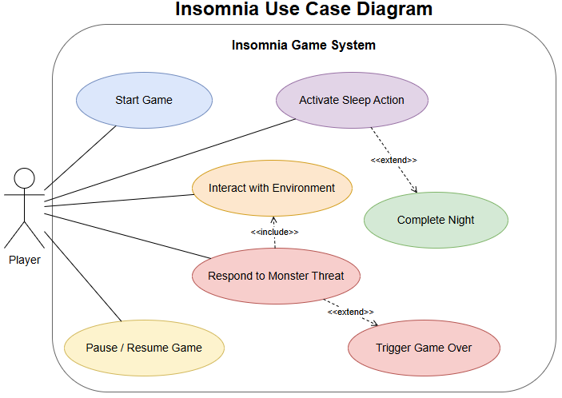

Use Case Diagram – Player Interaction
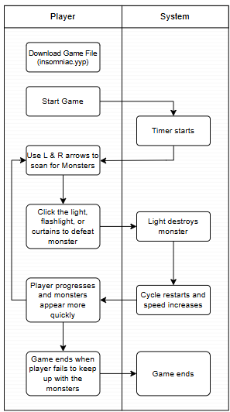

Software Architecture

Logical Architecture
Core Systems:
- Game State Manager
- Sleep Meter
- Monsters
- Environment
- Level Progression
- UI
- Audio / sound effects

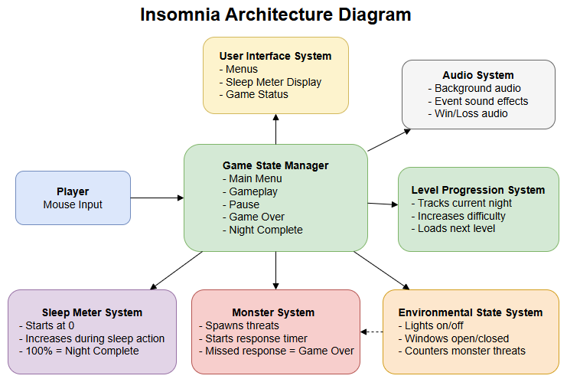

Technical Architecture
- Runs locally on Windows
- Built using GameMaker Studio 2
- Event-driven object-based architecture
- No external services

Data Structures

Core Data Elements
- Sleep Meter (0–100)
- Monster State
- Environment State
- Game State

Data Relationships
- Sleep Meter determines win
- Monster determines loss
- Environment affects monster
- UI reflects all states

Sequence and Flow Diagram
Diagram for:
- Game loop execution
- Monster event handling
- Sleep meter progression
- User interaction flow
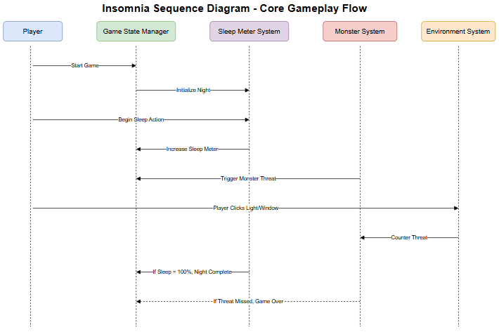

Development Workflow

Typical Development Tasks
- Modify object behavior
- Add new gameplay elements
- Adjust difficulty parameters
- Test functionality

Build Process
- Open project in GameMaker
- Select Windows target
- Build executable
- Test output
- Export executable (.exe) for distribution

Troubleshooting and Debugging

Common Issues
Issue | Cause | Resolution
Game not running | Missing runtime | Reinstall GameMaker
Input failure | Event misconfiguration | Check object events
Game freeze | Infinite loop | Debug Step events

Debugging Approach
- Identify failing system
- Inspect object events
- Check variable values
- Test in isolation
Example:
If a monster does not trigger:
- Check Step event logic
- Verify object is active in the room
- Confirm spawn timing conditions

Technical Decision Log
Decision | Reason
GameMaker Studio 2 | Efficient for 2D development
Point-and-click gameplay | Simple interaction model
No networking | Reduced complexity

System Modification Guide
This section provides guidance for developers on how to extend, modify, and maintain the Insomnia system.

Adding a New Level:
- Create a new room in GameMaker
- Add required objects (player, monsters, UI)
- Configure difficulty parameters
- Update level progression logic in obj_game_controller

Adding a New Monster:
- Create a new monster object
- Define behavior in Step event
- Add spawn logic to controller
- Integrate with Game Over condition

Adjusting Difficulty:
- Modify sleep meter increase rate
- Adjust monster spawn frequency
- Change response time windows

Adding New Interactions:
- Create new environment object
- Define interaction behavior
- Link object state to monster system

Future Enhancements
- Additional levels
- More advanced AI
- Improved UI/UX
- Expanded audio system

Document Management

Contributors

Role | Name
Technical Architect | Nick Pokusa
Project Manager | Jessica Coffel
Business Analyst | Tom DiGuido

Version Control

Date | Version | Author | Section | Amendment
04/29/26 | 1.0 | Tom DiGuido | All | Initial draft
05/05/26 | 1.1 | Tom DiGuido | All | Edits and inserted images and diagrams.

