

Practices for Secure Software Report

Table of Contents
Document Revision History 3
Client 3
Instructions 3
Developer 4
1. Algorithm Cipher 4
2. Certificate Generation 4
3. Deploy Cipher 4
4. Secure Communications 4
5. Secondary Testing 4
6. Functional Testing 4
7. Summary 4
8. Industry Standard Best Practices 4

Document Revision History

Version | Date | Author | Comments
1.0 | 6/27/26 | Nick Ridente

Client



Instructions

Submit this completed practices for secure software report. Replace the bracketed text with the relevant information. You must document your process for writing secure communications and refactoring code that complies with software security testing protocols.

- Respond to the steps outlined below and include your findings.
- Respond using your own words. You may also choose to include images or supporting materials. If you include them, make certain to insert them in all the relevant locations in the document.
- Refer to the Project Two Guidelines and Rubric for more detailed instructions about each section of the template.

Developer
Nick Ridente

Algorithm Cipher

For this project, I chose to implement the SHA-256 (Secure Hash Algorithm 256-bit) cryptographic hash algorithm to meet Artemis Financial’s data verification requirements. SHA-256 is part of the SHA-2 family of hash functions and is one of the most widely used and trusted algorithms in modern software security.
SHA-256 works by taking any input data and producing a fixed-length 256-bit (32-byte) hash output, commonly represented as a 64-character hexadecimal string. This is known as a one-way function, meaning the original data cannot be reconstructed from the hash. SHA-256 uses a series of bitwise operations, modular additions, and compression functions across 64 rounds of processing to produce its output. The algorithm does not use random numbers or symmetric/asymmetric keys. Instead, it is a deterministic hashing function, meaning the same input will always produce the same output hash.
SHA-256 was developed by the National Security Agency (NSA) and published by the National Institute of Standards and Technology (NIST) in 2001 as part of the SHA-2 standard. It was designed to replace the older SHA-1 algorithm, which had known weaknesses. Today, SHA-256 remains a gold standard for data integrity verification and is used in a wide range of applications including TLS/SSL certificates, blockchain technology, and file verification systems. It has not been broken or compromised and is currently recommended by NIST for secure systems.
SHA-256 was the best choice for Artemis Financial because it provides a reliable way to verify that data has not been tampered with during transmission. By generating a checksum of the data before and after transfer, the receiving party can compare the two hashes and confirm the data arrived intact. This directly addresses the company’s need for a secure file verification step in its web application.

Certificate Generation
To enable HTTPS communication, I generated a self-signed SSL certificate using the Java Keytool command-line utility. The certificate was generated using an RSA 2048-bit key pair with a validity of 365 days and stored in a PKCS12 keystore file (keystore.p12). The certificate was then exported as a CER file (artemis.cer) using the keytool export command. The screenshot below shows both the CER file and the keystore.p12 file successfully generated and saved in the project’s src/main/resources folder.

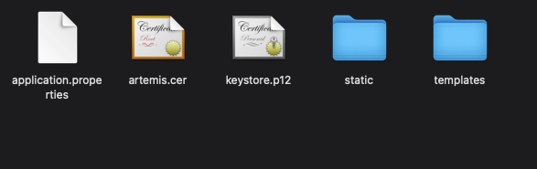
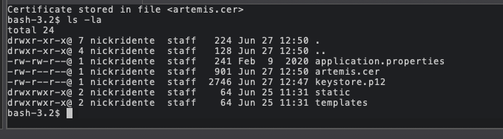

Deploy Cipher
To implement SHA-256 checksum verification, I refactored SslServerApplication.java to add a REST endpoint at /hash. When a user visits this endpoint, the application takes a static data string containing my name, runs it through Java’s MessageDigest class using SHA-256, and returns both the original data string and the resulting hexadecimal checksum to the browser. The screenshot below shows the checksum verification running successfully, displaying the data string and its corresponding SHA-256 hash value.

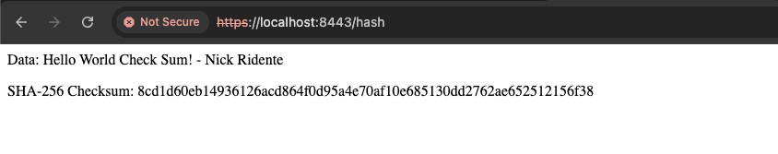

Secure Communications
To convert the application from HTTP to HTTPS, I updated the application.properties file with SSL configuration settings pointing to the keystore.p12 file. This enabled encrypted TLS communication on port 8443. After running the application, I navigated to https://localhost:8443/hash in a browser. The browser displayed a "Not Secure" warning, which is expected with a self-signed certificate since it has not been verified by a trusted certificate authority. However, the connection is still encrypted using TLS, confirming that HTTPS is working correctly. The screenshot below shows the secure webpage running on port 8443.



Secondary Testing
After refactoring the code, I ran a secondary static analysis using the OWASP Dependency-Check Maven plugin (version 9.0.9) to verify my changes did not introduce any new security vulnerabilities. The tool scans all project dependencies and cross-references them against the National Vulnerability Database (NVD) to identify known CVEs. The dependency check identified 92 vulnerabilities across 11 dependencies. However, all of these exist in the third-party libraries included in the original project (Spring Boot, Tomcat, SnakeYAML, etc.) and were not introduced by my refactored code. The SHA-256 hash endpoint and SSL configuration I added use only built-in Java security libraries, which showed no vulnerabilities. The screenshots below show the refactored code running without errors and the output from the dependency-check report.

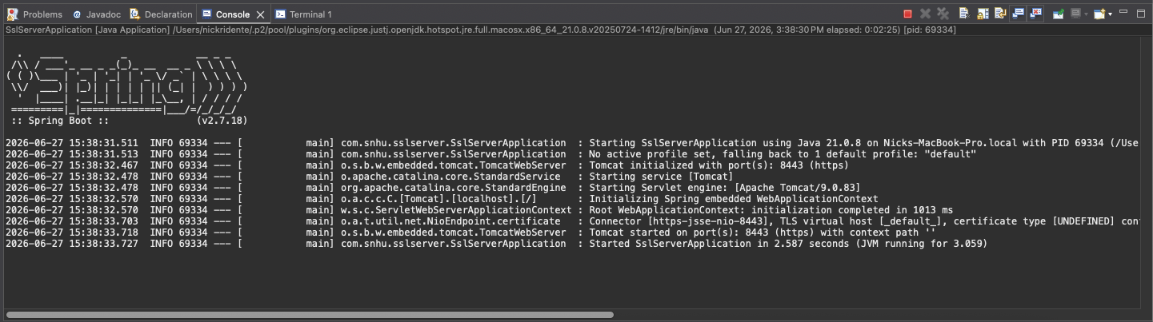

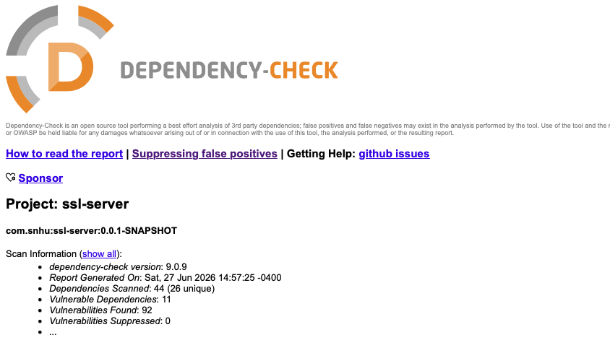

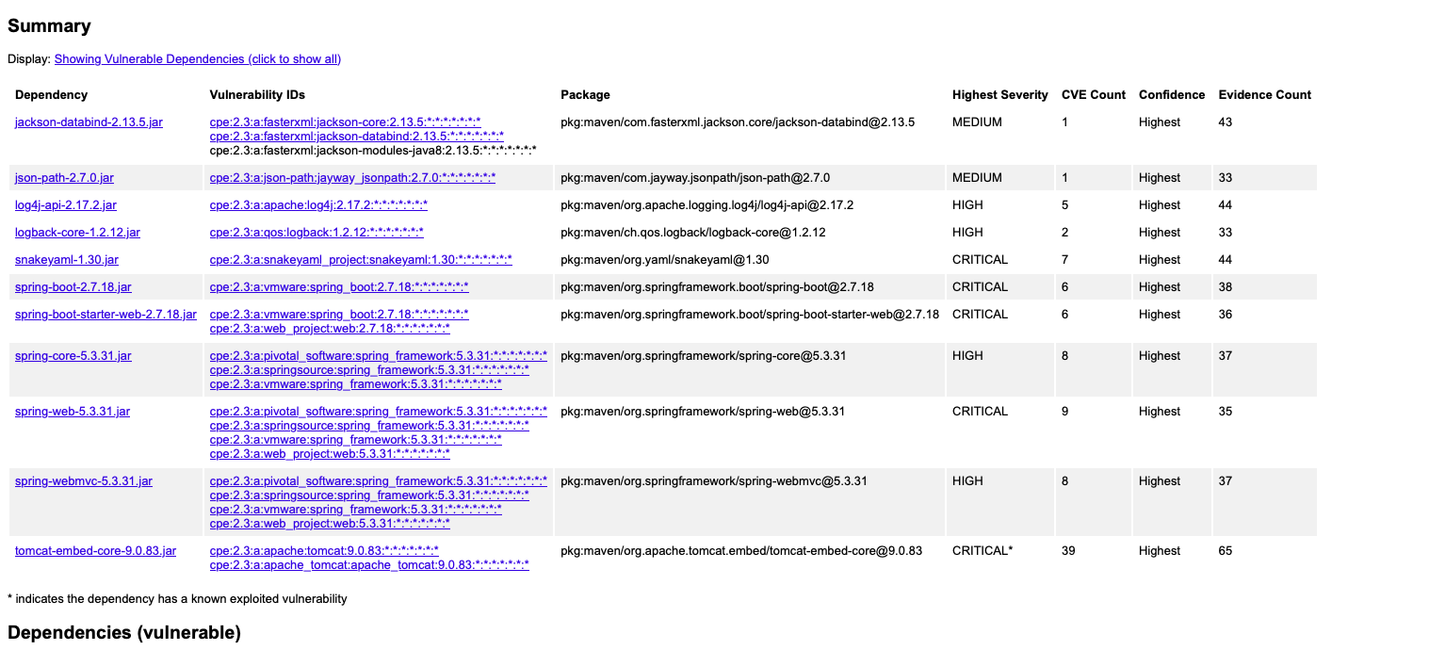

Functional Testing
I performed a manual review of the refactored code to identify any syntactical, logical, or security vulnerabilities. The /hash endpoint does not accept any user input, operating on a static data string, which eliminates the risk of injection attacks. SHA-256 is implemented using Java’s built-in MessageDigest class, following the best practice of never writing custom cryptographic logic. The application is configured to use HTTPS exclusively on port 8443, ensuring all communication is encrypted. The code is clean, well-structured, and follows standard Java conventions with no hardcoded sensitive data in the source files. The screenshot below shows the refactored code running in Eclipse without any errors.

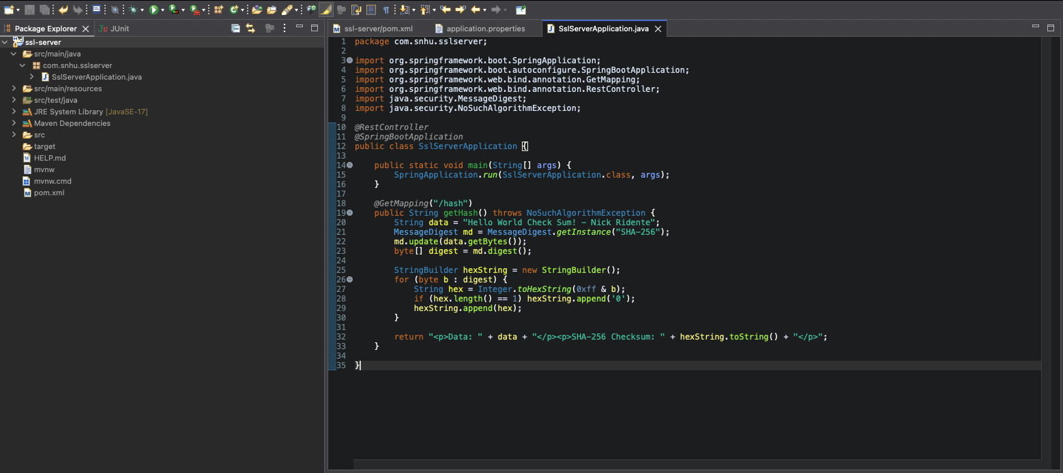

Summary

In this project, I refactored Artemis Financial’s existing Spring Boot web application to add secure communication mechanisms and data verification capabilities. Referring to the Vulnerability Assessment Process Flow Diagram, the areas of security I addressed through refactoring include Cryptography, where I implemented SHA-256 hashing to provide checksum verification ensuring data integrity during transmission; Client/Server security, where I converted the application from HTTP to HTTPS by configuring SSL/TLS using a self-signed certificate generated with Java Keytool, ensuring all data exchanged between client and server is encrypted; and APIs, where I added a new REST endpoint (/hash) that exposes the checksum functionality to clients securely over HTTPS. The layers of security I added work together to protect Artemis Financial’s data. The SSL certificate encrypts the communication channel while the SHA-256 checksum allows the receiver to verify the integrity of the data, ensuring sensitive financial data cannot be intercepted or tampered with during transmission.

Industry Standard Best Practices

Throughout this project, I applied several industry standard best practices for secure coding to maintain and enhance the security of Artemis Financial’s software application. Rather than writing custom cryptographic code, I used Java’s built-in MessageDigest class to implement SHA-256 hashing, following the industry best practice of never rolling your own crypto, which reduces the risk of implementation flaws. By configuring the application to use HTTPS exclusively on port 8443, I followed the industry standard of encrypting all data in transit, preventing man-in-the-middle attacks where an attacker could intercept unencrypted HTTP traffic. I used the PKCS12 keystore format, which is the current industry standard for storing cryptographic keys and certificates, replacing the older JKS format. I also generated a 2048-bit RSA key pair for the SSL certificate, meeting the current NIST recommendation for minimum key length. Finally, I used the OWASP Dependency-Check tool to perform static analysis on all project dependencies, following the best practice of regularly scanning for known vulnerabilities in third-party libraries. Applying these best practices is critical not just for the security of individual applications but for the overall well-being of Artemis Financial as a company. A security breach involving customer financial data could result in significant financial losses, regulatory penalties, and long-term damage to the company’s reputation. By building security into the development process from the start, rather than treating it as an afterthought, the company reduces its risk exposure and builds trust with its customers.

