**Homework #1**

**Question #1: Knowing Docker Tags**

* Which tag has the following text? – *Automatically remove the container when it exits*
  + **Answer:** --rm
  + 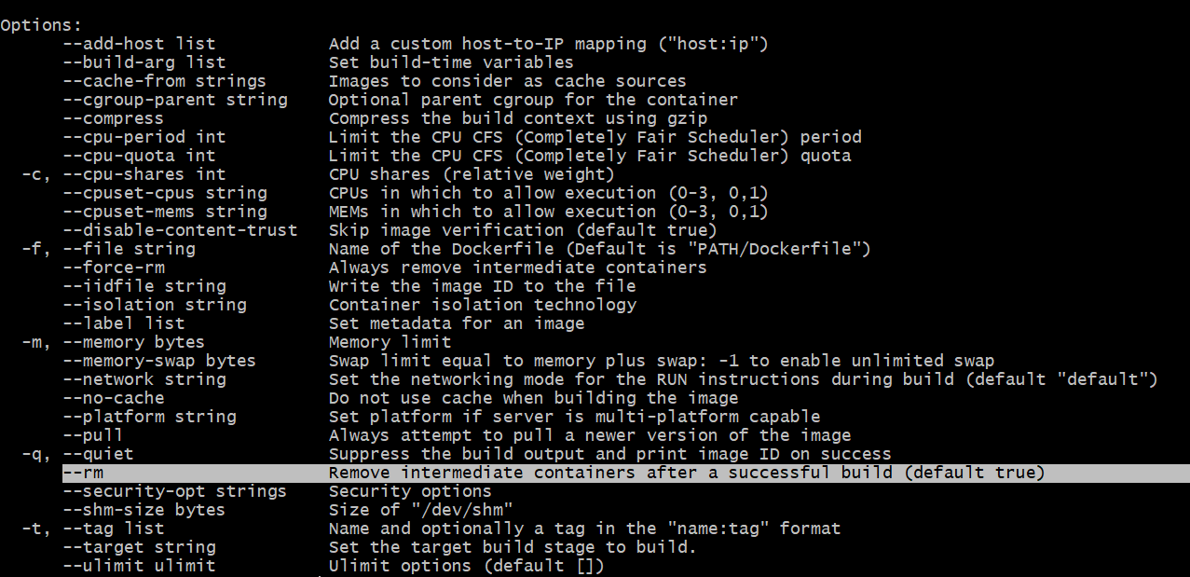

**Question #2: Understanding Docker First Run**

* Run docker with the python:3.9 image in an interactive mode and the entrypoint of bash. Now check the python modules that are installed (use pip list).
* What is the version of the package *wheel?*
  + **Answer:** 0.42.0
  + 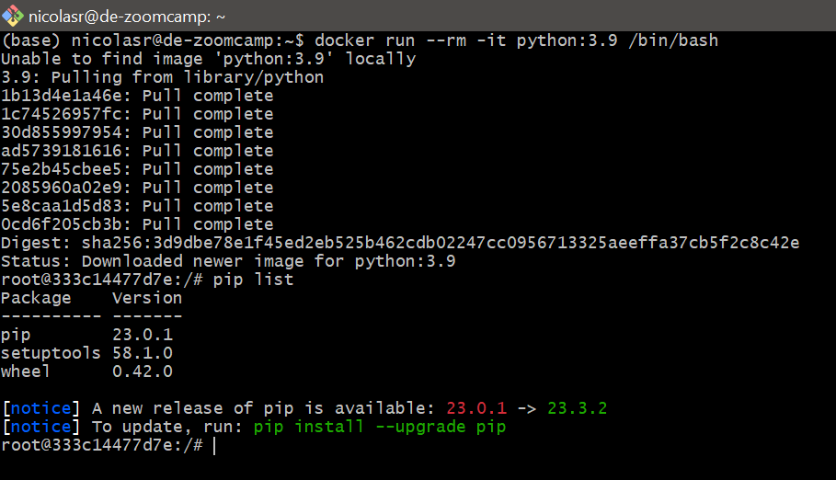

**Question #3: Count Records**

* How many taxi trips were totally made on September 18th 2019?
  + **Answer:** 15612
  + 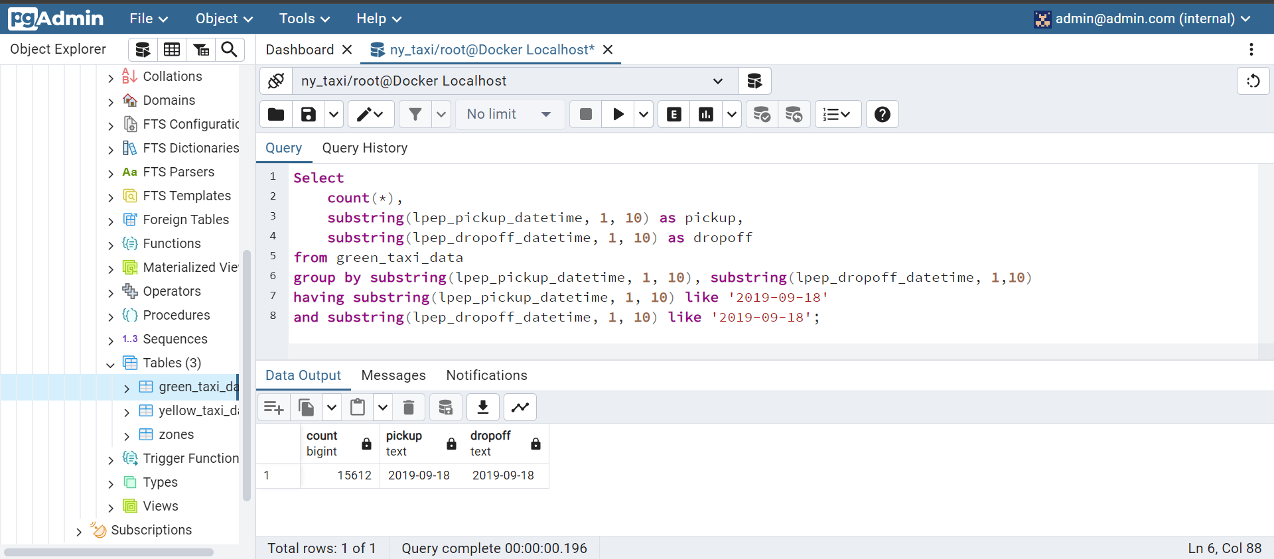

**Question #4: Largest Trip for Each Day**

* Which was the pick-up day with the largest trip distance?
  + **Answer:** 2019-09-26
  + 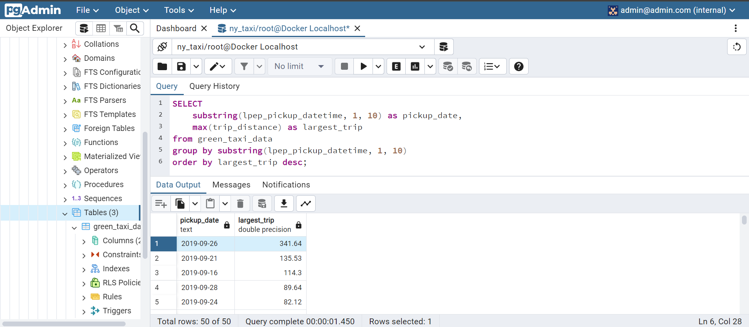

**Question #5: Three Biggest Pick Up Boroughs**

* Consider lpep_pickup_datetime in ‘2019-09-18’ and ignoring Borough has ‘Unknown’.
* Which were the three pick-up boroughs that had a sum of total_amount superior to 50,000?
  + **Answer:** “Brooklyn”, “Manhattan”, “Queens”
  + 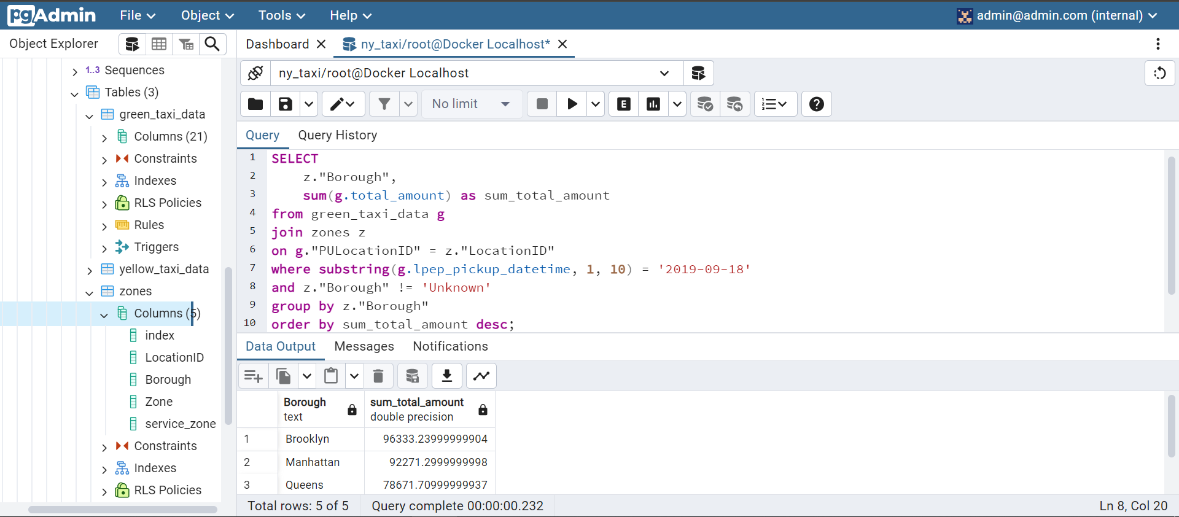

**Question #6: Largest Tip**

* For the passengers picked up in September 2019 in the zone name ‘Astoria’ which was the drop-off zone that had the largest tip?
  + **Answer:** “JFK Airport”
  + 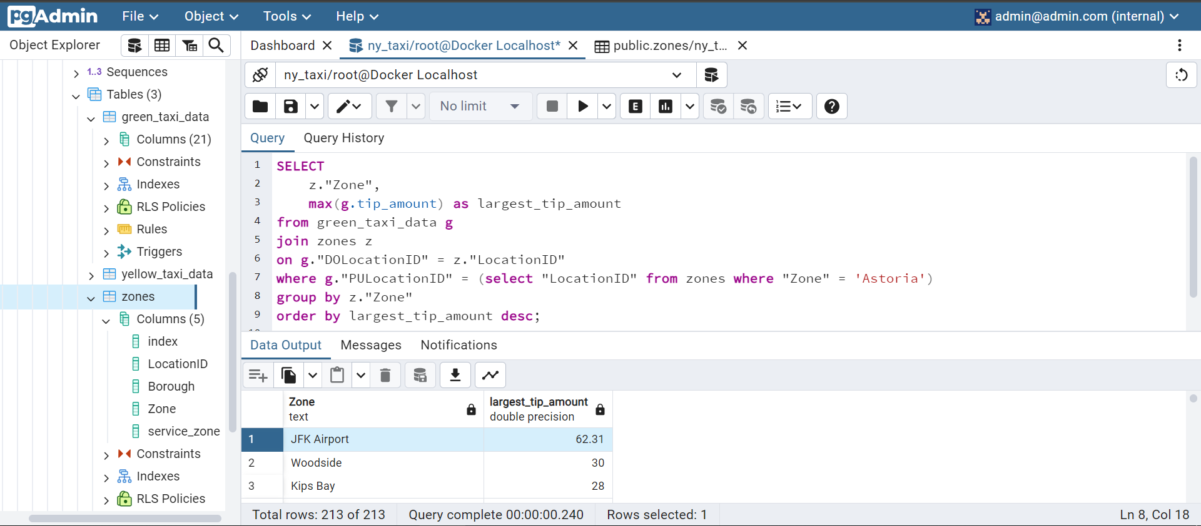

**Question #7: Creating Resources**

* After updating the main.tf and variable.tf files run the following command:

*terraform apply*

* 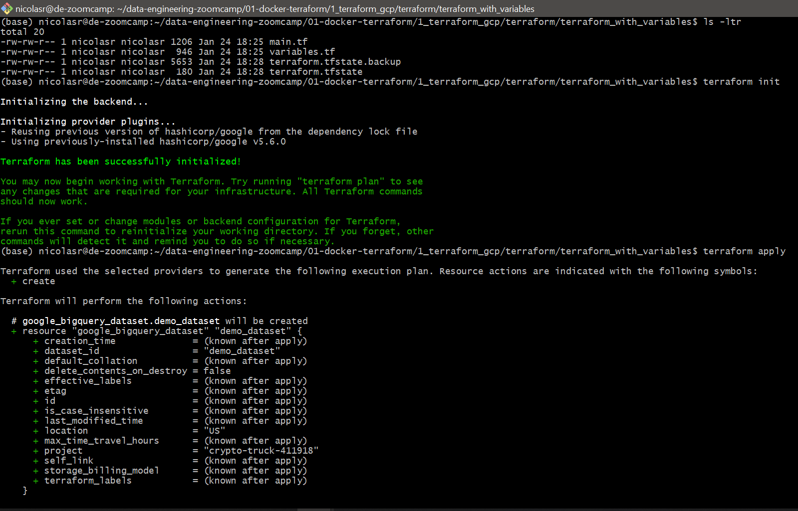
* 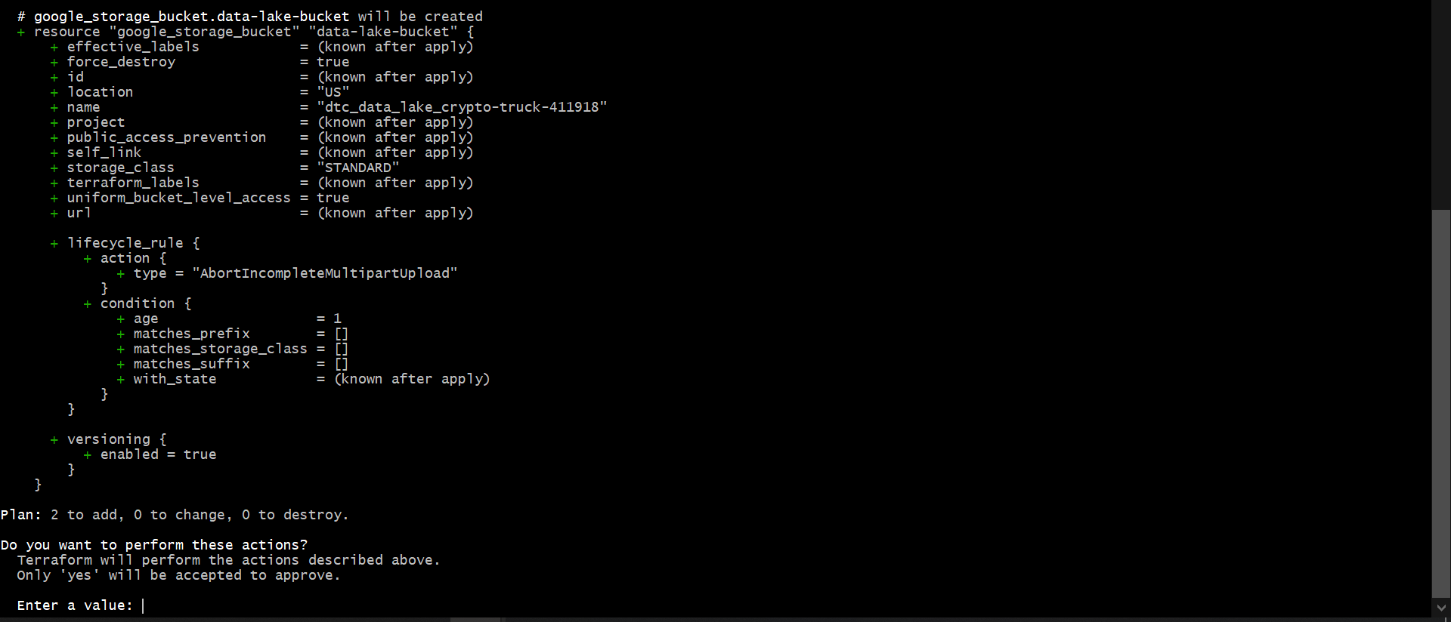
* Terraform used the selected providers to generate the following execution plan.
* Resource actions are indicated with the following symbols:
* + create
* Terraform will perform the following actions:
* **# google_bigquery_dataset.demo_dataset** will be created
* + resource "google_bigquery_dataset" "demo_dataset" {
* + creation_time = (known after apply)
* + dataset_id = "demo_dataset"
* + default_collation = (known after apply)
* + delete_contents_on_destroy = false
* + effective_labels = (known after apply)
* + etag = (known after apply)
* + id = (known after apply)
* + is_case_insensitive = (known after apply)
* + last_modified_time = (known after apply)
* + location = "US"
* + max_time_travel_hours = (known after apply)
* + project = "crypto-truck-411918"
* + self_link = (known after apply)
* + storage_billing_model = (known after apply)
* + terraform_labels = (known after apply)
* }
* **# google_storage_bucket.data-lake-bucket** will be created
* + resource "google_storage_bucket" "data-lake-bucket" {
* + effective_labels = (known after apply)
* + force_destroy = true
* + id = (known after apply)
* + location = "US"
* + name = "dtc_data_lake_crypto-truck-411918"
* + project = (known after apply)
* + public_access_prevention = (known after apply)
* + self_link = (known after apply)
* + storage_class = "STANDARD"
* + terraform_labels = (known after apply)
* + uniform_bucket_level_access = true
* + url = (known after apply)
* + lifecycle_rule {
* + action {
* + type = "AbortIncompleteMultipartUpload"
* }
* + condition {
* + age = 1
* + matches_prefix = []
* + matches_storage_class = []
* + matches_suffix = []
* + with_state = (known after apply)
* }
* }
* + versioning {
* + enabled = true
* }
* }
* **Plan:** 2 to add, 0 to change, 0 to destroy.
* **Do you want to perform these actions?**
* Terraform will perform the actions described above.
* Only 'yes' will be accepted to approve.
* **Enter a value:**