**Homework #2**

**Question #1: Data Loading**

* Once the dataset is loaded, what’s the shape of the data?
  + **Answer:** 266,855 rows x 20 columns
  + 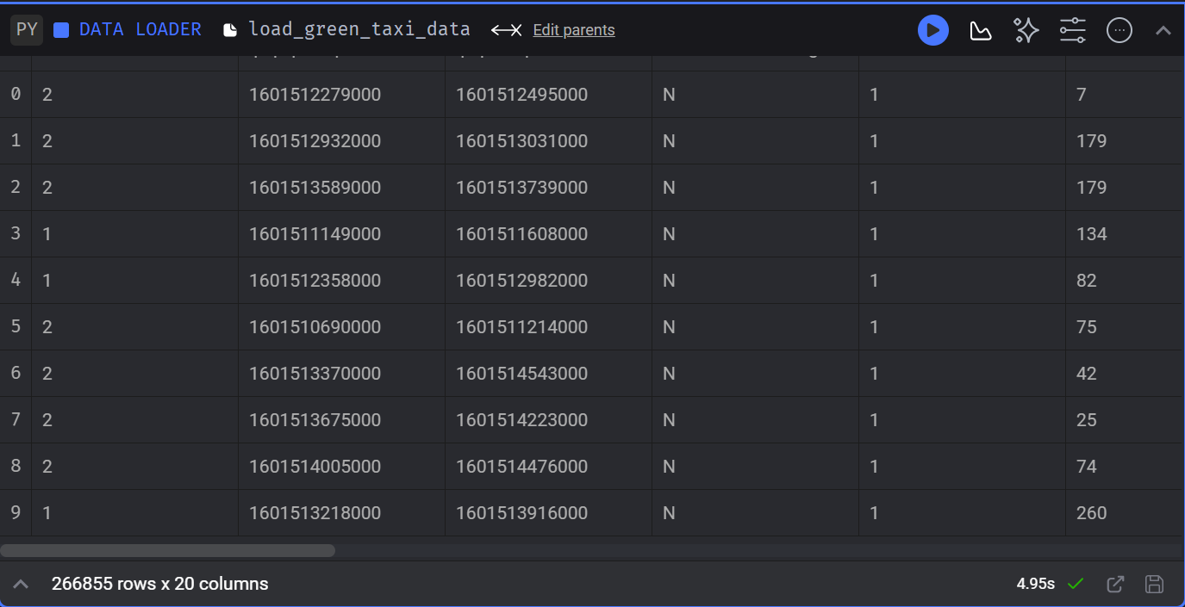

**Question #2: Data Transformation**

* Upon filtering the dataset where the passenger count is greater than 0 *and* the trip distance is greater than zero, how many rows are left?
  + **Answer: 139,370 rows**
  + 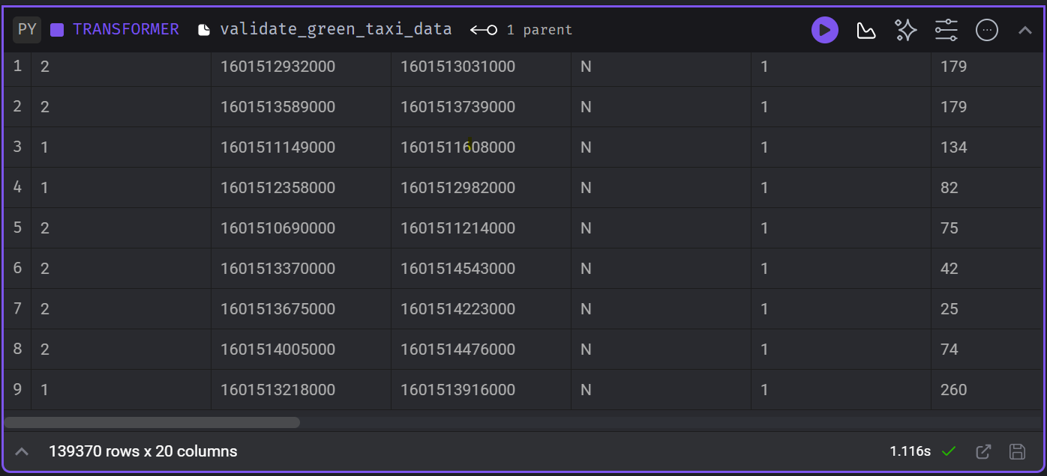

**Question #3: Data Transformation**

* Which of the following creates a new column *lpep_pickup_date* by converting *lpep_pickup_datetime­* to a date?
  + **Answer: data[‘lpep_pickup_date’] = data[‘lpep_pickup_datetime’].dt.date**
  + 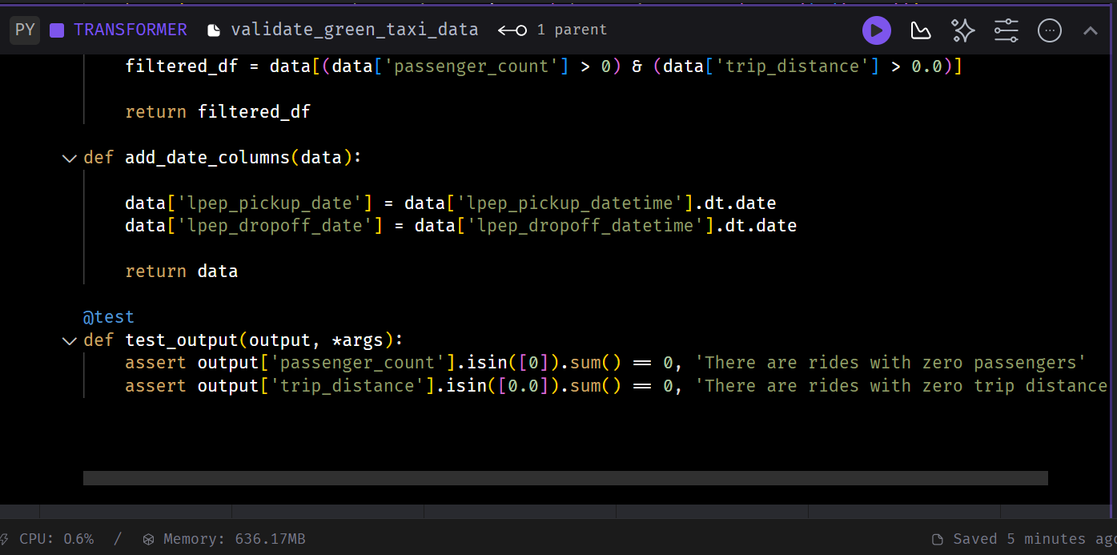

**Question #4: Data Transformation**

* What are the existing values of *VendorID* in the dataset?
  + **Answer: 1 or 2**
  + 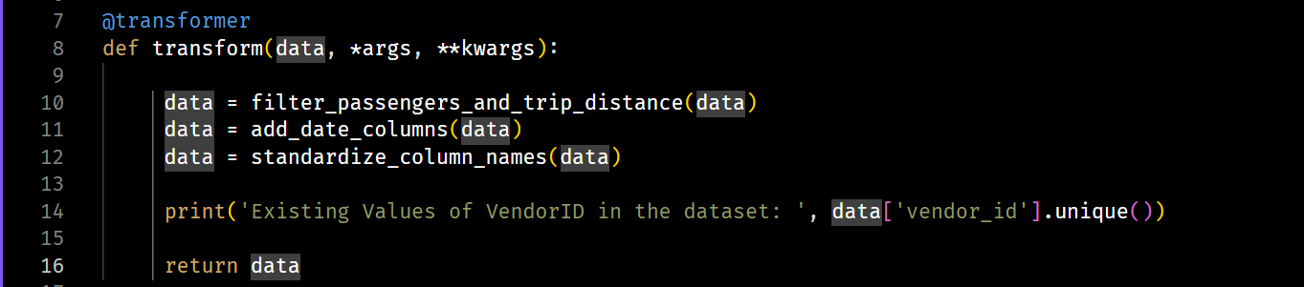
  + 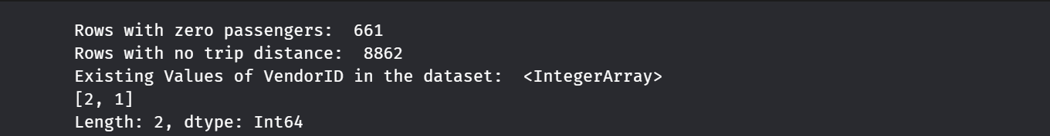

**Question #5: Data Transformation**

* How many columns need to be renamed to snake case?
  + **Answer: 4**
  + 
  + 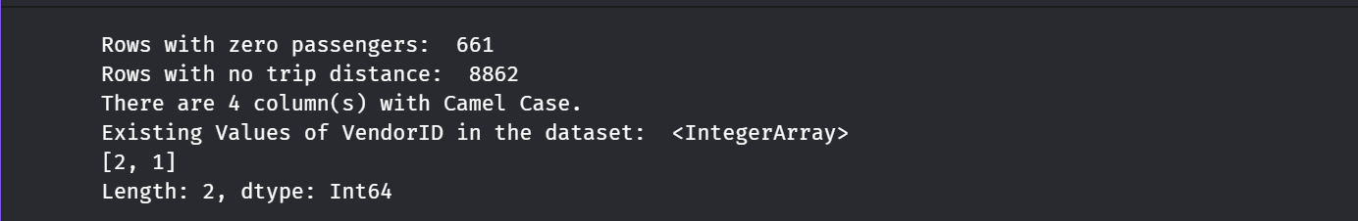

**Question #6: Data Exporting**

* Once exported, how many partitions (folders) are present in Google Cloud?
  + **Answer: 96**
  + 