**“dlt” Workshop Homework**

**Question #1**

* What is the sum of the outputs of the generator for limit = 5?
  + **Answer: 8.382332347441762**
  + 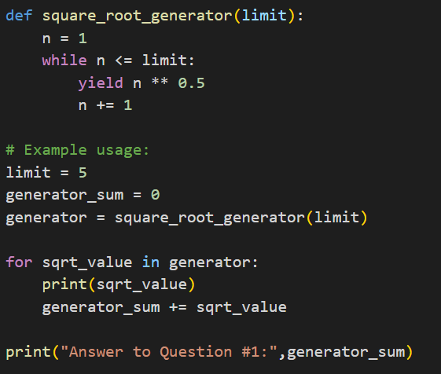
  + 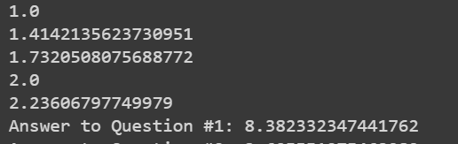

**Question #2**

* What is the 13th number yielded by the generator?
  + **Answer: 3.605551275463989**
  + 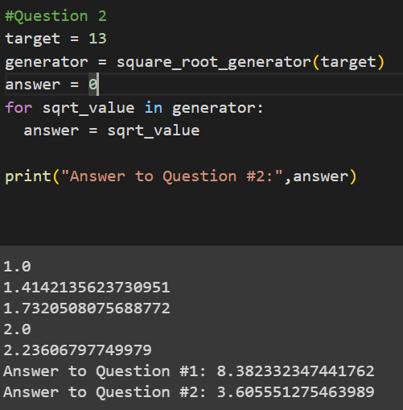

**Question #3**

* Append the 2 generators. After correctly appending the data, calculate the sum of all ages of people.
  + **Answer: 353**
  + 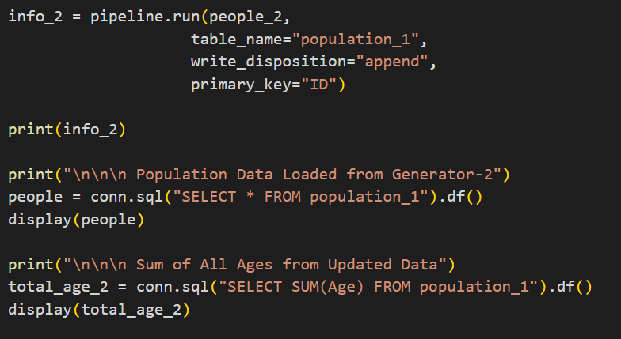
  + 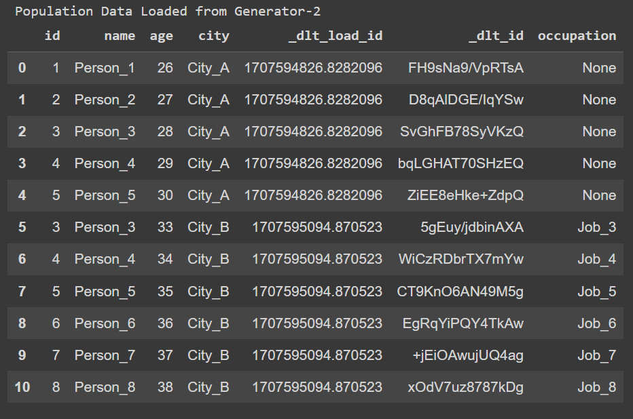
  + 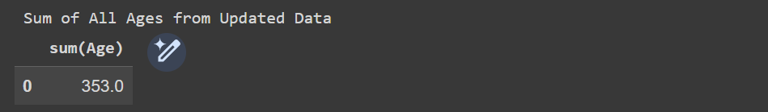

**Question #4**

* Merge the 2 generators using the ID column. Calculate the sum of ages of all the people loaded as described above.
  + **Answer: 266**
  + 
   