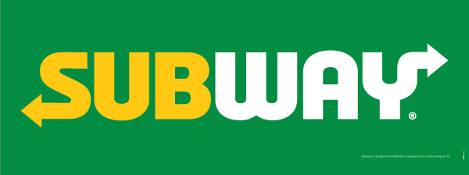

Subway ordering guide

Contents

Subway Ordering System 3

Ordering Your Sandwich 3

# Subway Ordering System

This guide walks you through ordering a sandwich online at Subway.

Ordering Your Sandwich  
  
Tip: If you’d like to change your selected items, just click **Previous** to go to a previous choice and change it.

1. To begin your order, select the size you’d like, and then click **Next**.
2. Select the type of bread for your sandwich, and then click **Next**.
3. Select the meat for your sandwich, and then click **Next**.
4. Select the type of cheese, and then click **Next**.
5. Select which veggies you’d like, and then click **Next**.  
   You can select multiple veggies.
6. Select which sauces you’d like, and then click **Next**.  
   You can select multiple sauces.
7. Select **Yes** if you’d like salt and pepper on your sandwich, or select **No** for no salt or pepper.
8. Review your selected choices.
9. If you’d like to change any selection, just click **Previous**.