**Just Survive**

**Technical Design Document**

Version A1.x.x

NOTE: There are still the placeholder texts that need to be removed once information is finalized

**Version History**

|  |  |  |
| --- | --- | --- |
| **Version Number** | **Edited By** | **Date** |
| A1.x.1 | Nick Lemmon – First pass of information | 1/28/2020 |
| A1.x.2 | Nick Lemmon – Added Graphics and another risk | 2/25/2020 |
| A1.x.3 | Nick Lemmon – Filled out more basic information | 2/25/2020 |
| A1.x.4 | Anthony D’Alessandro - Edited the document | 3/6/2020 |
|  |  |  |
|  |  |  |
|  |  |  |

**Table of Contents**

**Game Overview** **3**

Game Summary 3

Platform 3

**Development Overview** **3**

Development Team 3

Development Environment 3

*Development Hardware* *3*

*Development Software* *3*

*External Code* *3*

**Game Mechanics** **4**

Main Technical Requirements 4

Architecture 4

Game Flow 4

Graphics 4

Audio 4

Artificial Intelligence 4

Networking 5

Physics  5

**User Interface** **5**

Game Shell 5

Play Screen 6

**Technical Risk** **6**

# Game Overview

## Game Summary

The game is a First Person Shooter mixed with a Tower Defense. The goal is, to alone or as a group of up to 4, fight off waves of enemies that are trying to get to a generator. This is done by the player themselves as they fight off the waves but with emphasis on towers to help you. The player can purchase new towers in a shop to assist you in fighting off hordes.

## Platform

* Windows 10 with Keyboard and Mouse

# Development Overview

## Development Team

Nick Lemmon - Team Lead, Programming

Austin Brant – 3D Models

Anthony D’Alessandro – Programming

Heidi Alipda – Level Design

Vanessa Rakoczy - Programming

## Development Environment

The environment that we will be working in is J-316 with each other and peers as well as in our personal rooms during our time away from school.

### Development Hardware

We will be working with various types of Windows PC’s. Mainly windows 10. A graphics card from a GTX 970 to GTX 1060. A processor from intel core 5 5th gen to intel core 7 7th gen.

### Development Software

We will be using Unreal Engine 4.24 as the base for our game. Visual studio will be used to code. 3DS Max will be used for modeling. A Github is setup for version control.

### External Code

We will not have any external code except with what comes with Unreal 4.24

# Game Mechanics

## Main Technical Requirements

The game requires AI, a player and towers. The enemy needs to follow a path and attack the players in the game. The player needs an inventory, a gun and money. The towers need to be spawned using a shop system and target enemies. These few elements are key to the games playability while the rest of the mechanics are to help the game be more enjoyable.

## Architecture

The game has an item system, which includes towers, guns and supplies. The guns interact with the inventory and the player. The supplies interact with the player. The towers are purchased and placed from our UI system and also shoot the enemies. The UI System needs to be displayed and exited during game time. It has buttons that display the specific tower information when clicked and tell the player which tower is being purchased and tell the game where it is being placed. The inventory needs to know of the players guns and which one is active. The round manager keeps track of which round and enemy is to be spawned during gameplay.

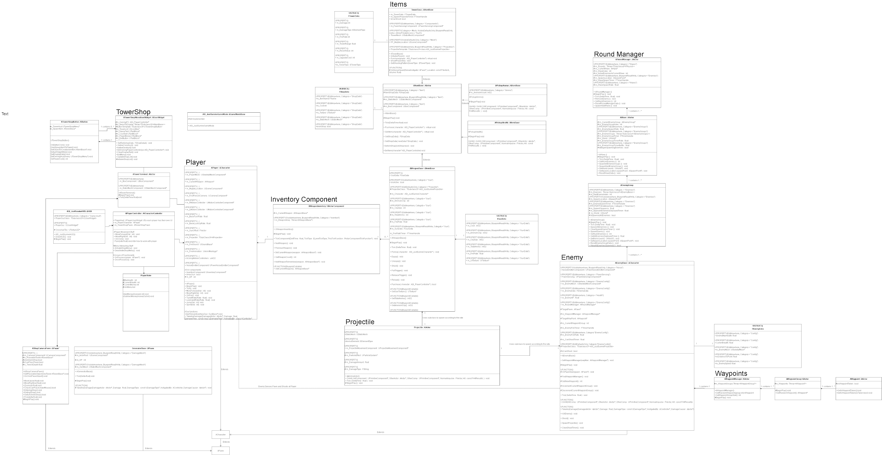

## Game Flow

The main control scheme for the game will be keyboard and mouse. We need the mouse to interact with the menu and to place the towers. Until we learn how to interact with UI with a controller the game will be restricted to using the Mouse to interact with the entire tower purchasing and placing system. The player can use various buttons to move around interact with the game world.

## Graphics

The game will consist of 3D graphics themed around western and steampunk elements. The game will have robot-like enemies with some science fiction weapons taking place in a western themed level.

## Audio

The only audio in the game as of now is the default gunshot sound effect.

## Artificial Intelligence

The enemies move from waypoint to waypoint. If they sense a pawn they will shoot.

The towers will sense the enemy pawns and rotate towards them and shoot.

## Networking

Networking is to be implemented

## Physics

The projectiles connect with the players and enemies. The player ray casts to be able to interact with enemies.

# User Interface

This section describes how information is presented to the player, and how input is received in return. This includes display layout, feedback, controls, and so on.

## Game Shell

There are 2 main menus in the game. The first main menu displays an active gun and gun data with a crosshair. The second menu is the tower shop UI.

## Play Screen

The main player screen contains a reticle and gun information. That aids the player in knowing their current gun and ammo count during play time.

The other menu will be the tower shop. Where you can interact with the menu and also the game world. The player will use the mouse to interact

# Technical Risk

Being unfamiliar with all of Unreal can lead to the programmers having to learn specific things before properly implementing them into the game. This can cause not every planned mechanic to be available by alpha 1 and can leave the player without some information that they need to enjoy the game. Not knowing how to properly network the game in the second stage will also pose some problems as code currently written may need to be re-written and refactored for use with networking.