465 Project Paper
AI Applications in Sports Betting
Maxime Argenson, Nicholas Was, Troy DiLillio, Richard Zielenski

Abstract
This project has put together a variety of models to explore the variety of analytics related to sports. Our project began with a compiling of data to use for our work. We sought data that had high utility, so it could be used for a variety of purposes. First, we built a Multilayer Perceptron to predict the winner of any given hockey game. This is perhaps the most obvious use for an AI in regards to analyzing sports statistics, so it was a goal of the project to see how effectively it could accomplish this task when compared to other algorithms. We built a Long-Short Term Memory Network, to predict the winner of a game as it went on. We found that mid-game predictions had more room for “getting ahead” of sports betting related odds. Since the mid-game odds were more variable there were greater opportunities to take advantage of imperfect odds calculations on the end of gambling websites. However, this model was found to be ineffective so we later switched to a Gradient Boosting algorithm to accomplish this task. It performed rather well comparatively. A Convolutional Neural Network was also built to further test the possibilities around live win predictions. The data needed for a proper usage of the CNN isn’t easily publicly available, but from the limited testing we could do, it seemed the CNN was an effective data handler. Sentiment Analysis was developed to attempt to extrapolate ideas about teams chances from sentiment online. We wanted to see if the “wisdom of the crowd” was useful for gaining insight into sports related topics that raw data might not make obvious. We found it to be rather ineffective, with much more positive sentiment than expected. All of these things were compiled into an easy to access GUI, to simulate what a user on a website dedicated to sports analytics might see.

Background
For the past three decades, sports analytics has been a rapidly growing part of all competition on the highest level. In the early 90’s baseball began this evolution by adopting a new system to use basic statistics to build the best team possible based on player evaluations. Although highly controversial at the time, it soon became the gold standard for professional teams. The implementation of this ideology started a ripple effect across many other professional sports such as baseball, football, and soccer. These sports work best with advanced analytics as they rely much more on individual efforts than others. For example, baseball ultimately comes down to pitcher against batter. It has taken much longer for the use of advanced analytics to be implemented in sports such as hockey as there are many more nuances to what makes a team perform well.
Recently, there has been a second wave of sports analytics centered around gambling as new legislation passed in 2018 legalized sports betting in the USA. Betting sites have quickly become increasingly wealthy as sports betting is now considered one of the most popular forms of gambling in the country. The increase in attention with these analytics also has come at the same time as the most recent AI wave which has come about through the development of new algorithms and the availability of big data. Because of this, many companies and teams are now employing large numbers of machine learning engineers to build models to either help their team win or help get more accurate predictions for sports betting.
Our project centers around the relatively new use of AI in hockey analytics. With the increasing capabilities of AI models, we hope to break through common perceptions of the upper bound on win prediction in the National Hockey League (NHL) specifically.
Hockey is a very complicated sport to predict accurately as it is very fast paced yet low scoring. This allows for a large amount of variance from game to game with the best teams rarely winning more than 70 percent of their games. We chose to take on this problem because there is a great opportunity to find relationships in statistics that are misjudged or not seen by the average analyst. Because the most sophisticated public machine learning models for win prediction in hockey are only 62 percent accurate, it leaves the most room for improvement among most professional sports. Our goal is to create many different models to test this upper bound on prediction accuracy. Along the way we will experiment with our results compared to the major sports books who employ their own algorithms. If our models can consistently earn money while betting on games it will give us an insight into our accuracy compared to professionals.

Data Collection
The first objective for the project was to find the data to collect. This was more difficult than we anticipated as most sites with downloadable data were specifically against its use in AI models. Due to this we needed to create our own code to collect data from NHL API. This is an API that is well documented and contains many types of statistics. The most useful for our project was the game play by play which provides every event in the game in a json format. We initially were storing this data in csv files, but eventually we moved to a database. After designing the schema and choosing PostgreSQL connected to AWS, we started importing data for every player and team in the NHL. This was an important step as we were then able to all use the same data while working on different models. It also makes it easy to keep the current stats up to date as a script could read the data every day during the season and update the database accordingly. The database was set up for easy access to the three main types of data we needed for our models. The first is the ability to get season long data for both players and teams which is the main input for our pregame win prediction models. The second is all individual performances for single games, which is used for any models to predict expected stats for players each game. The final type of data was cumulative team data to track change in performance over many seasons for potential use in future prediction of team performance.
Once we obtained the important stats for all the players and teams, we needed to research the best features to craft for our model. We looked for the team stats in hockey that are most correlated with wins in order to keep the model simple in complexity and promote good generalization. These stats ended up being goals for, goals against, shots for, shots against, shooting percentage (percentage of shots for which results in a goal), save percentage (percentage of shots against which do not result in a goal), PDO (shooting percentage added to save percentage), and the power play and penalty kill percentages. In recent years there have been much more advanced stats used for analytics such as fenwick or corsi, however they don't have a high correlation to winning a game.
The last piece of data we needed to gather was the betting odds of both live and past games. For live odds the process was extremely similar to the game statistics as the NHL API we used provided live updated odds through Draftkings. We also created a script to get the odds from other sportsbook sites using OddsAPI. However, this ended up not being ideal as the odds across multiple sites were extremely similar and there was a limit of 500 requests per month. For past games we were unable to find a reliable and legal way of collecting the data as betting sites do not publicly release their previous odds. There were multiple ways to view past odds but they either required a hefty payment or had terms of service specifically banning website scraping. This meant we were not able to pursue a reinforcement learning method to teach an agent the best strategies to bet. Our initial plan was to set up an environment with states having the team stats, bets, and outcomes. The agent would then learn an optimal policy on how much money to bet on a game based on a confidence interval of the bet being correct.
Multilayer Perceptron
The first model we created to predict the win percentage of a game was a simple multilayer perceptron (MLP) using tensorflow with three hidden layers. We chose the MLP through research of existing models which primarily use simple neural networks or decision trees. We had previous experience with the development and tuning of MLP’s so it made a good spot to test out our database connection code. It also allowed us to get a model running quickly to start testing with real betting data.
The goal for the MLP was to achieve at least 61 percent accuracy as that is the highest prediction rate we could find on any public report which was held by the popular NHL stats site MoneyPuck’s average prediction rate over the last 5 years with the highest being 64 percent and the most recent being 60 percent. Money puck states they use gradient boosting machines to achieve those results with the features being computed using bayes nets and other statistical models.
Before tuning the model parameters over time and changing the features our model had a 55 percent accuracy. Eventually we learned this was low because it was not generalizing well. The in-sample error would often be greater than 60 percent accuracy when training on a single season’s data. To combat this shortcoming we first increased the amount of training data to the most recent seven seasons. We did not want to include seasons before this as the game has changed significantly since the late 2000’s. Most notably the NHL has become more skillful with the near elimination of enforcers which are players with the sole purpose of protecting the most skillful players. This increased the accuracy to 59 percent which is only one percent short of the mode of the Moneypuck results. Even with this change the model was still struggling to generalize to the current season’s games. To decrease overfitting we decided to implement early stopping, dropout, and a new activation function. Early stopping was used with a validation set to make sure if the in-sample error was going down while the validation loss was increasing the training would stop. This alone was not enough so we added two instances of dropout with values of 0.3 and 0.1 respectively. Lastly, we changed the common ReLU activation function between layers to a leaky ReLU as it is supposed to be better in noisy data like hockey games as there are many upsets. The results of these changes along with small adjustments to the layer sizes and learning rates lead to an average accuracy of 62 percent.
There are many changes we would like to look into when it comes to this specific model in the future. We believe there is a lot of room for improvement in feature selection to help guide the MLP into certain feature transforms we believe will be more beneficial. One idea that we would like to implement is an average player rating and goalie rating for each individual game. This would help remove games that seem like upsets just by looking at team stats, but in reality be predictable due to star player injuries.
Once we were happy with the accuracy we had achieved we wrote code to simulate our predictions on the Draftkings betting site. Our code would run in the background on a windows machine and schedule a check each day for the games taking place and the current odds. It would then use our model to predict an expected value (EV) of the bet. EV is the same idea as the expected utility we learned about in class, where if the value is positive we should take the bet. In this case we would simulate a 25 dollar bet on the team with the highest EV and schedule a function to check the score the next morning. Although there was a very small sample size, our model would have made approximately 220 dollars over the course of 3 weeks. This leads us to believe that our model is at the minimum competitive with the ones employed by Draftkings.
Convolutional Neural Network
When testing our MLP we realized that often the most profitable bets would not be made before the games as the pre-game odds are calculated almost entirely using other machine learning algorithms leading to small possible gains. We believe the most profitable time to bet is actually during the game when users input is a larger part of the calculation of odds. For example, if a team that is expected to win scores a goal in the first five minutes of a game the odds will be greatly affected while the true win probability is only altered by a fraction of the difference in odds.
The model we created to try and exploit this pattern was a CNN. The idea behind this was to take a traditional CNN which is used mainly in computer vision, and use it instead for tabular data. CNN’s could also be used for sports analytics with computer vision to gather stats such as player tracking, but that is very hard to get training data for as the rights for NHL games are strictly enforced. Our model does calculations on a table using a 5 row window where each row represents the current game state. The state is modeled by basic stats from each team in the game such as goals, shots, penalties, hits, and time remaining. The CNN learns weights to do calculations on this numerical data and return a win probability for each team. With this win probability we can also fetch the current odds and determine the EV of the bet.
It is difficult to try and evaluate the accuracy of this model other than just an eye test as the labels for a game are either zero or one, but for most of the game the win probability should be fairly even between the two teams. The eye test is also problematic because what we deem as a reasonable measure is exactly what we are trying to outperform, we are not trying to simply mimic a human’s decisions. We decided to use a combination of three metrics to evaluate the performance of the CNN: accuracy, mean average error (MAE), and the eye test. Accuracy is simply the number of correct predictions when evaluating if the win percentage is higher than 50 percent. MAE measures the average difference of the team’s win percentage and the actual value of a zero or one.
At first the model was performing poorly in all three metrics as it was greatly overfitting and making large changes in win prediction for small events such as shots or hits. The accuracy was barely 50 percent and the MAE about the same. We used a large amount of dropout to combat this with a value between 0.2 and 0.4 between every hidden layer. This fixed the overfitting and looked much more reasonable with an accuracy of 68 percent and MAE of 0.44. However, this did not pass the eye test as the CNN was not learning the relationship between win percentage with respect to time remaining in the game. For example, it could not tell the difference between a one goal lead with 40 minutes remaining and one with 20 minutes remaining. To fix this we added a feature called “goalDiff_timeRemaining” which is just the goal difference divided by the time remaining in minutes. This immediately fixed the issue and improved the accuracy to 75 percent and the MAE to 0.37 while also looking much more accurate.
To test our results with this we used the same idea as the neural network by running betting simulations in the same fashion. This time the code would check every 10 minutes if there was a positive EV bet given the current game states. This performance was awful, losing close to 500 dollars in two weeks. We believe this is less due to the accuracy of the model, and more with the betting strategy as small errors or upsets can compound very quickly if we are betting often during a game.
Long Short-Term Memory Network
In addition to the CNN, we also created a Long Short-Term Memory (LSTM) neural network to tackle the live win prediction task. The idea for the model was to continuously feed it the most recent play along with the current game state and have it predict the win percentage. We used a very similar process to the CNN with the tabular data representing the game state but this time we decided to move away from the sliding window technique used in the CNN. Instead, we would iterate over all the events in the game, keeping the previous events and adding the most next event each time through the loop.
Despite being very similar in setup to the CNN the results were very different. No matter the size, complexity, or parameters of the model, it could not learn valuable relationships. In addition to changing the parameters we also added new features ourselves much like the “goalDiff_timeRemaining” from the CNN in hopes it would help guide the LSTM to the right feature transforms, but this also did not improve performance. Despite all of the changes we made, the accuracy would not go above 60 percent and the MAE was stuck around 0.55. We believe the reason for this is the difficulty of the task it was assigned. Because there is no ground truth for win percentage at each event during a hockey game, the only label we have for the LSTM to learn from is the final result of the game. Since hockey games spend so much time with similar win percentages for each team, it may learn nonsensical relationships because of very noisy data.
Transformer
For further model diversity, we implemented a sequence-to-sequence transformer model (T5) to predict NHL team win probabilities based on historical play-by-play and team statistics data. The model was trained using concatenated structured team statistics in the form of a partial play-by-play event log (stored as strings), with the target output being the remainder of the play-by-play and final game outcomes. We wanted to leverage the transformer’s ability to model complex sequential dependencies and context, believing that such an ability could capture nuanced patterns in hockey games that traditional models might miss. However, like the LSTM the transformer exhibited poor performance, with accuracy well below 50%. This low accuracy likely a result of several factors: (1) the input representation may be too unstructured and verbose, making it difficult for the model to extract relevant features; (2) the model is tasked with generating long, detailed outputs rather than making a simple classification, which increases the learning complexity; and (3) the training data may too limited for a task of such complexity to yield a high accuracy. As a result, while the transformer architecture is theoretically powerful, its application in this context is limited.

Sentiment Analysis
We incorporated Sentiment Analysis to provide a qualitative dimension to the NHL win probability predictions. While our data models offer a quantitative, data-driven perspective into NHL matchups, they do not capture the public's perception, fan morale, or the "hype" surrounding teams and players. Sentiment analysis allows us to gauge public opinion and identify emerging trends, offering insight into potential betting distributions. To further enrich our analysis, we developed a system, integrated directly into the analyzer, that can detect and catalogue potential injuries and player returns with minimal delay. Although not perfectly accurate, this approach leverages the public's collective intelligence and rumor mill, transforming unstructured chatter into potentially actionable information.
The two cornerstones of our analyzer were the data source selection and the algorithm used to calculate sentiment. We found our options limited after reviewing various modern, NHL-news-rich data sources. Websites such as nhl.com and espn.com were ultimately disregarded due to the technical challenges of scraping them and their relative lack of opinionated content. We ultimately chose Reddit as our primary data source, as it was significantly easier to scrape, resulting in lower update latency, and the vast majority of posts were highly opinionated, providing a rich source of sentiment. Additionally, Reddit posts typically focus on a single subject or event, making them easier to catalog and analyze for sentiment than traditional news sites' broader content.
The choice of sentiment analysis algorithm was more straightforward, as recent research has shown that increasing model complexity does not necessarily yield better results for sentiment analysis. The current state-of-the-art has found lightweight models like RoBERTa outperform their computationally heavier counterparts, such as Mistral7B and Llama 2 (Pourreza, 2023). We selected NLTK's Valence Aware Dictionary and sEntiment Reasoner as our sentiment analysis tool for these reasons. VADER is well-suited for informal, opinion-rich language found on Reddit, and it is lightweight, which is crucial when analyzing millions of posts and comments. Additionally, VADER is easy to integrate, requires no additional training, and is robust on short and long pieces of text.
Our pipeline consists of initial data collection, which is aggregated into one up-to-date CSV. We then perform a sentiment analysis on this CSV with configurable time constraints and generate a summary based on the sentiment of a post paired with team, player, and injury mentions. While the injury/return data is noisy due to insufficient filtering, our sentiment analysis accurately describes the landscape of opinions found on Reddit.

XG Boost
Our project includes the use of XG Boost otherwise known as Extreme Gradient Boosting. XG Boost is a gradient boosting framework. In our project, our goal was to use XG Boost to not only predict who the winner of any given Hockey game would be, but to be able to update who it believed would win based on what occurred during the match.
Hockey is a particularly hard sport to guess a winner for. This is because the margins by which teams win games is often very small. When most games are settled by a handful of scores, upsets are much more likely to occur. This is why a technology like XG Boost is very useful, it can take in those minute by minute surprises in games and adjust its predictions accordingly.
Let us discuss what XGBoost is. As mentioned before, XG Boost is a gradient boosting framework. A gradient boosting framework is a model that operates off of simple prediction models. It takes multiple, often uncomplicated, models for predicting events and then combines them to strengthen its ability to guess correctly. In other words, it works like a series of decision trees. Each additional tree being used to fix the errors of the previous ones.
Our model using XGBoost, has roughly a seventy five percent rate of successful prediction. This number is calculated by taking the total number of predictions it will make over reviewing the games of a season, and then using this number to divide the number of correct predictions it made. XGBoost receives more information about how a game is going, so it is able to achieve a higher score than our other models.
We test our XGBoost using games from past seasons compiled on the NHL API. Using this, we can see how many games our AI is able to guess correctly. Additionally, our XGBoost can also give the percentage chance it believes a team will win. As a game goes on and it is fed events, it is able to adjust its predictions.
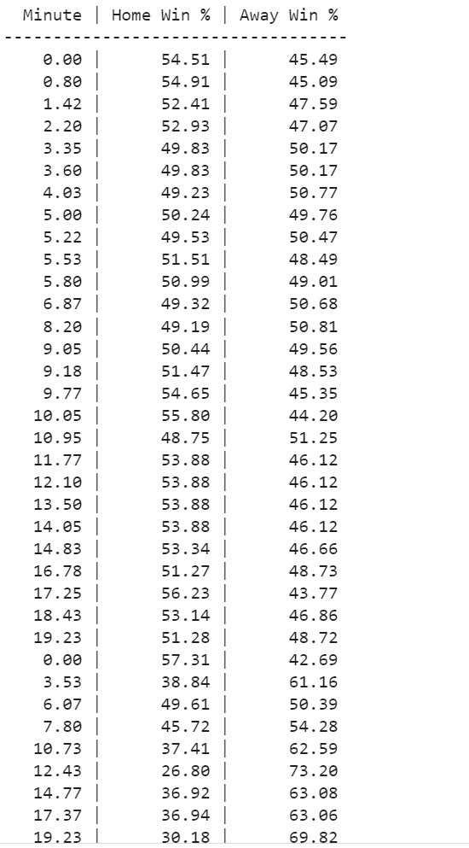
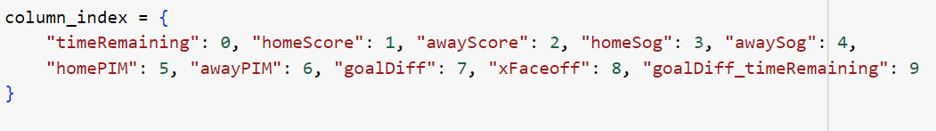
Our XGBoost takes many factors into account when making its predictions. It takes the time remaining in a game into account. This is because the score differential becomes more of a problem as a game goes on, because the enemy team has less time to make up the difference. It keeps track of what the score of a game is, because this is how an overall winner of each game is determined. It takes into account shots on goal. Shots on goal is how many times the opposing team is able to make a scoring attempt on the goal. This is valued because the more shots on goal are occurring, the greater the chances a teams defence will falter and a score will be let through. A high number of shots on goal can also indicate either a strong offense or a weak defence, both hints as to who will win a game. It takes penalties into account, because this can alter the outcome of a game by removing key players from the ice.
Using all these factors to make its decisions, it trains on the data from the hockey API to increase its ability to guess correctly. Our calculations regarding prediction rate are specifically derived from training the model on thirteen-hundred games from the 2023 season and before. It could theoretically train on more data to achieve greater accuracy.

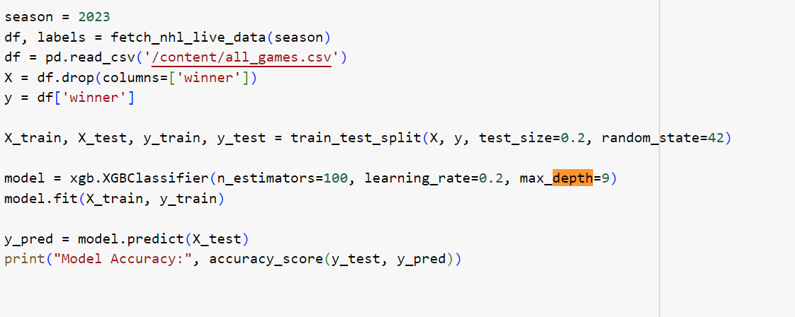
Our XGBoost uses one hundred decision trees. These decision trees are how the model will make its predictions, and were elaborated on earlier. They can also be referred to as boosting rounds. Our model has a learning rate set to 0.2. This is a number meant to adjust how much each new decision tree affects the overall model. Stopping it from adjusting wildly when it makes mistakes. Our model is set to a depth of nine. This means each tree has a maximum depth of nine when it is built out. This allows our decision making trees to become fairly complex. As the model guesses correct and incorrect, it sets a percentage assigned to learn from so it can improve its guess rate. This “split” also ensures it's not just memorizing the data it's given but actually improving its ability to accurately guess.
Overall, the use of Gradient Boosting in this manner seems effective, and it seems likely that live updates are the big next step for the use of AI in sports analytics.

User’s Guide to GUI
To run the program, install all the requirements in “requirements.txt”. So launch the site, write “streamlit run homepage.py” in the terminal and the app will pop up in a new browser.
Once the program is launched using “streamlit run homepage.py”, users are presented with a browser-based interface consisting of three core pages. Each page offers a unique function of the application. Displaying upcoming NHL games with predicted win probabilities derived from a convolutional neural network, analyzing in-game win likelihoods using XGBoost, and visualizing fan sentiment derived from Reddit discussions online.
The first page, Convoluted Neural Network, provides users with a visual overview of the next scheduled games. For each matchup, the page displays the home and away teams along with their respective logos, predicted win probabilities formatted as percentages, and the scheduled game time. A centered “vs” image separates the two teams to enhance readability. These predictions are generated in advance and automatically populate, requiring no user input. At the bottom of the page, a note says that upcoming games and probabilities are updated daily at 13:00 UTC. 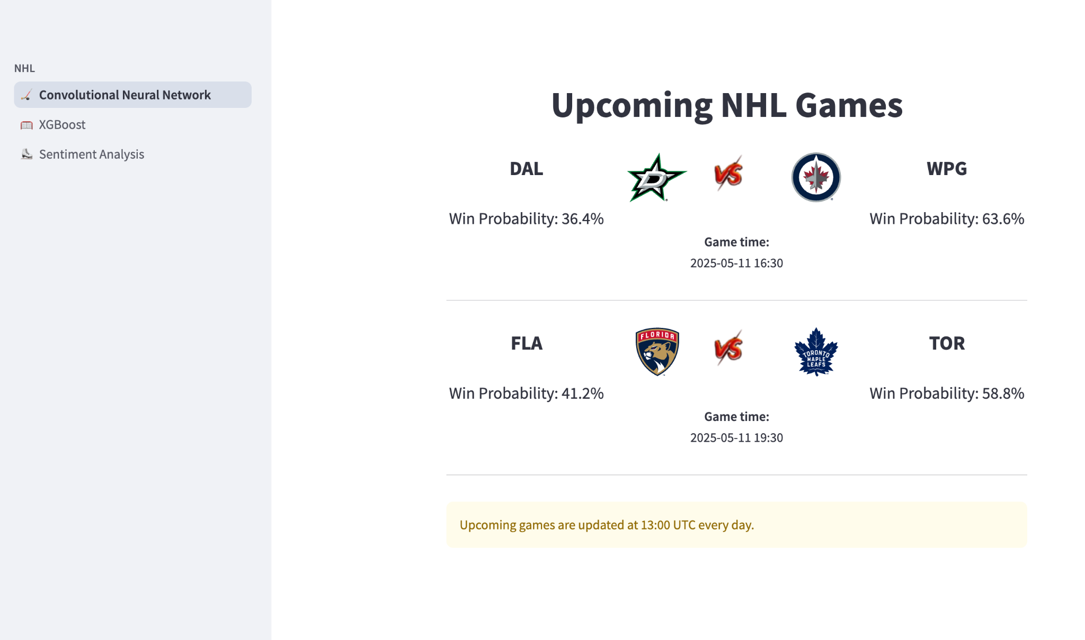

The second page, titled Game Win Probability Predictor (XGBoost), is an interactive tool that allows users to explore how the win probability evolves throughout a specific game. Users begin by entering an NHL game ID (for example, 2023020034) into the provided text input field. Upon clicking the “predict” button, the application fetches the corresponding play-by-play data and uses a trained XGBoost classifier to estimate the win probability for both teams over time. This process may take up to a few minutes, but results are cached so they will be saved after the first computation. The results are then displayed as a line chart showing home and away win percentages as a function of game minutes. Below the chart, a data table provides the same information in numerical form.
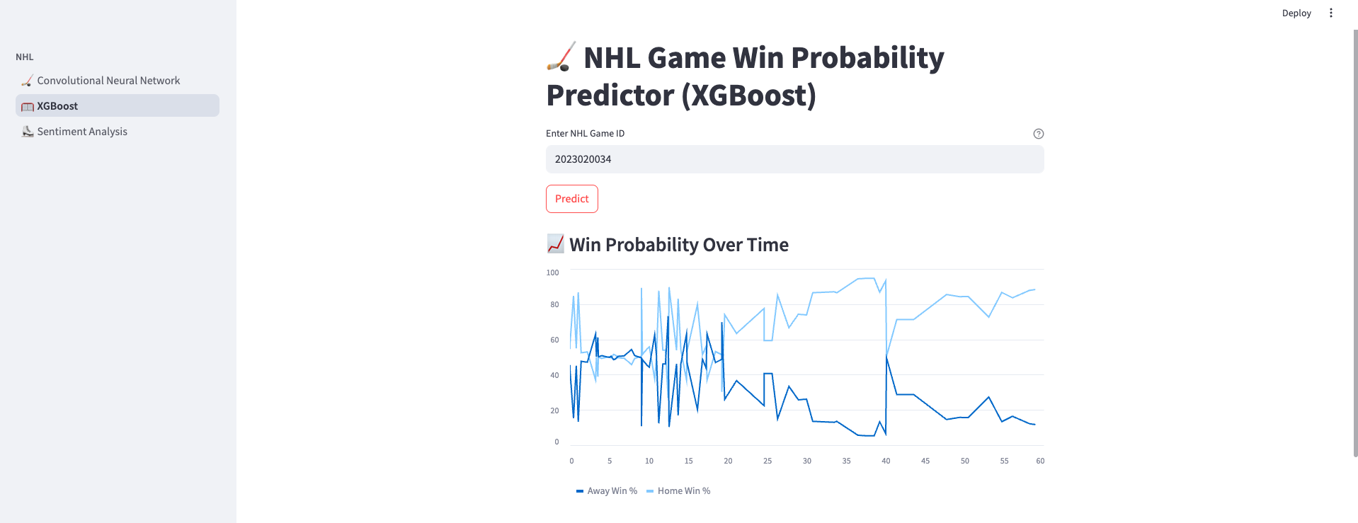
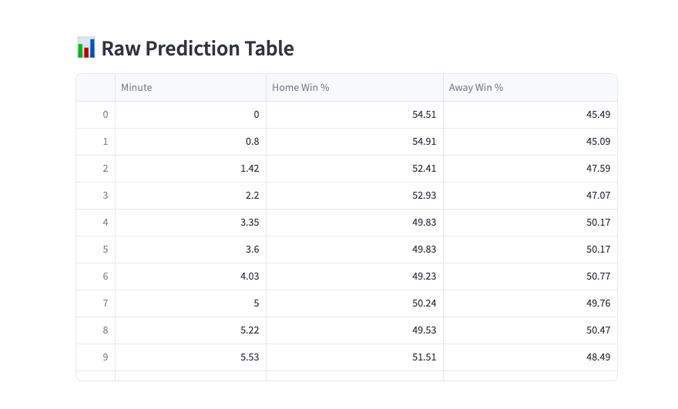

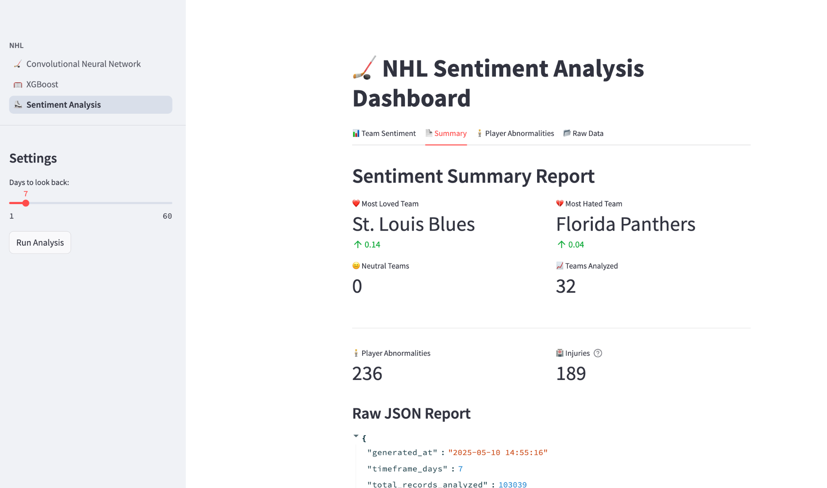
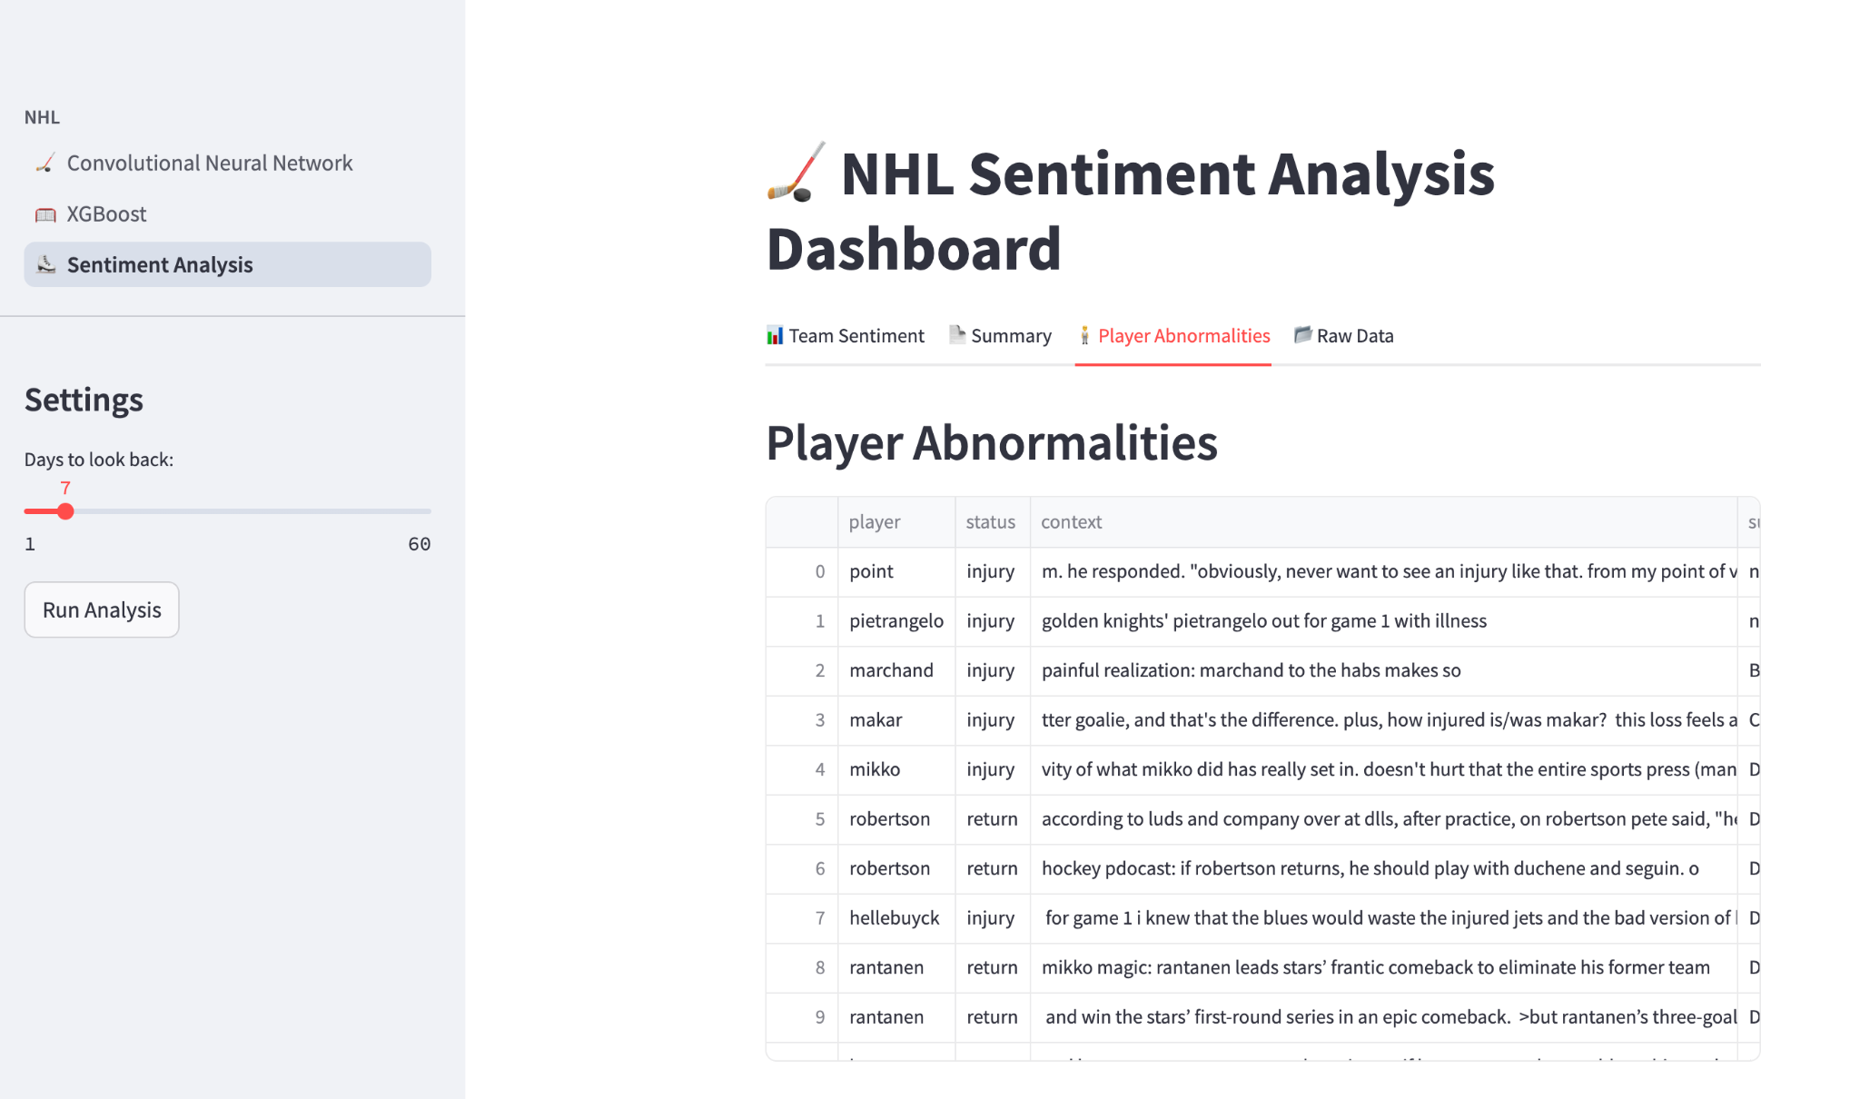
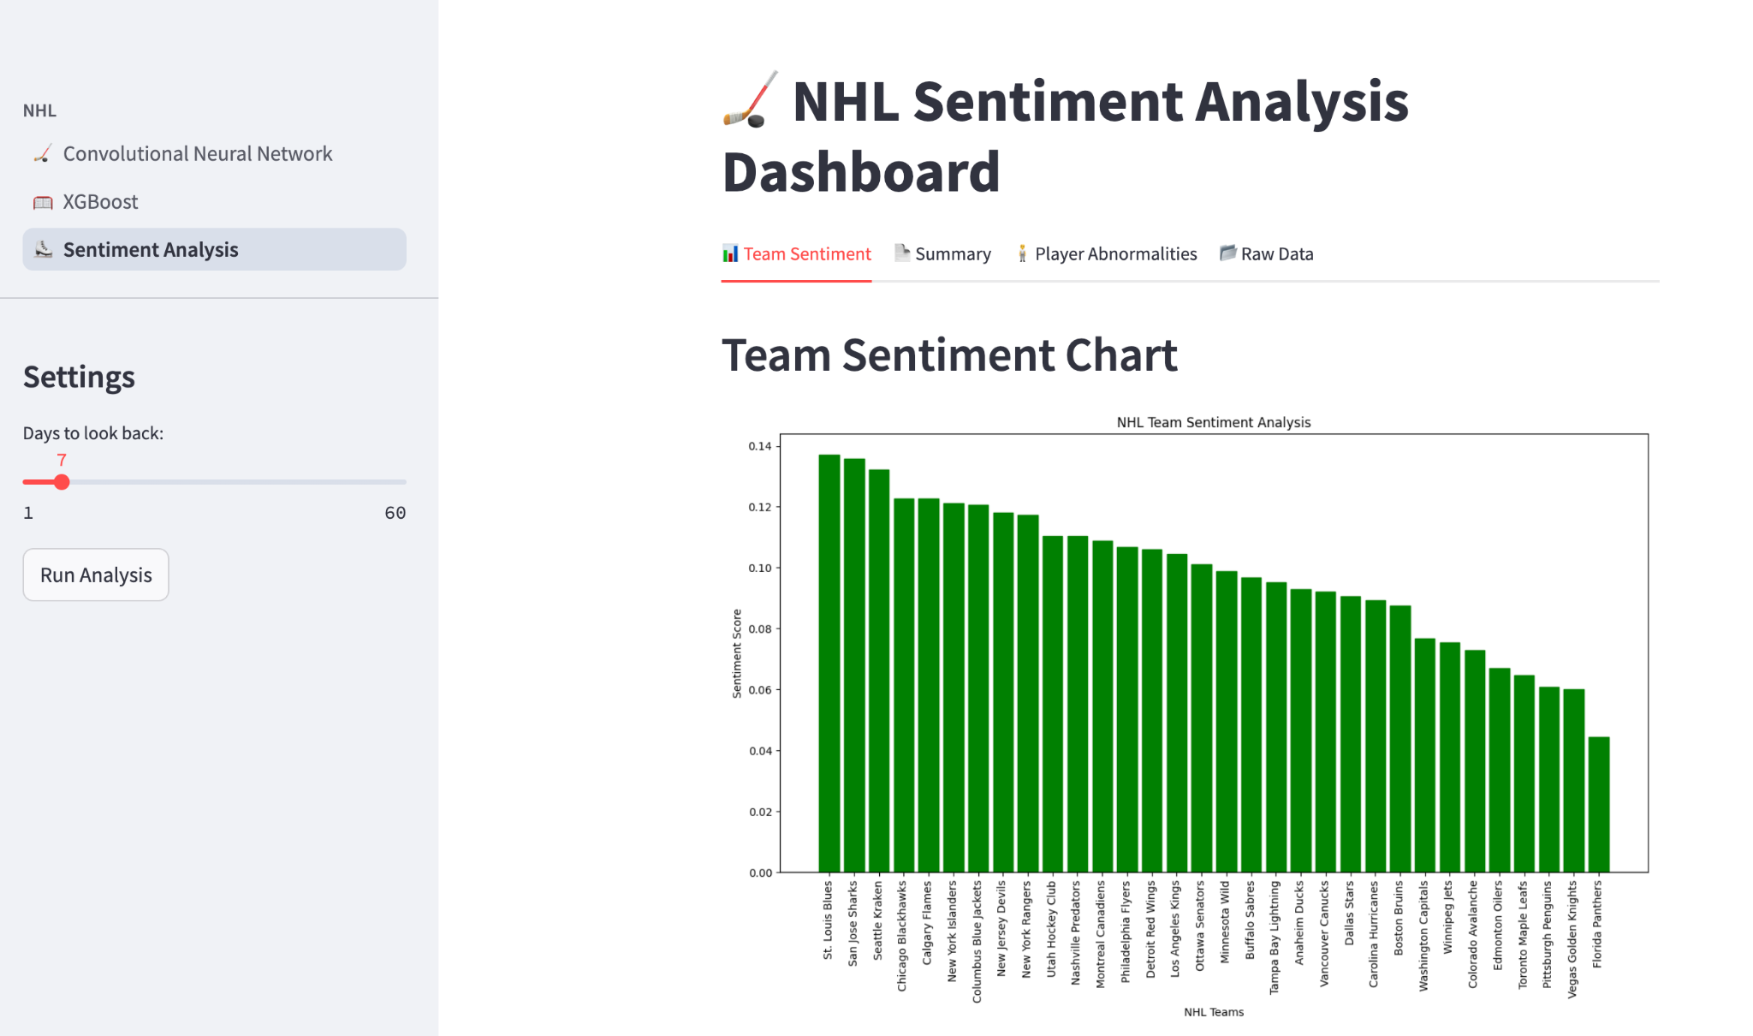
The third page, NHL Sentiment Analysis (Reddit), presents a dashboard aggregating fan sentiment based on Reddit posts and comments. This page includes a sidebar with interactive controls: a slider that lets users choose how many days of Reddit data to analyze (ranging from 1 to 60), and a button to initiate the scraping and sentiment process. After clicking “Run Analysis”, results may take a few minutes to load, depending on the number of past days chosen to analyze. Once the analysis is complete, the results are displayed across four tabs. The “Team Sentiment” tab shows a bar chart of sentiment scores for each team. The “Summary” tab highlights key metrics, such as the most loved and hated teams, the number of neutral teams, total teams analyzed, and detected player abnormalities and injuries. This tab also displays the full JSON report. The “Player Abnormalities” tab lists potential injury or return-related mentions for players based on Reddit discussions. Lastly, the “Raw Data” tab allows users to explore the first 100 Reddit posts and comments used in the analysis. If users attempt to access any of these tabs before running the analysis, the system will guide them accordingly.
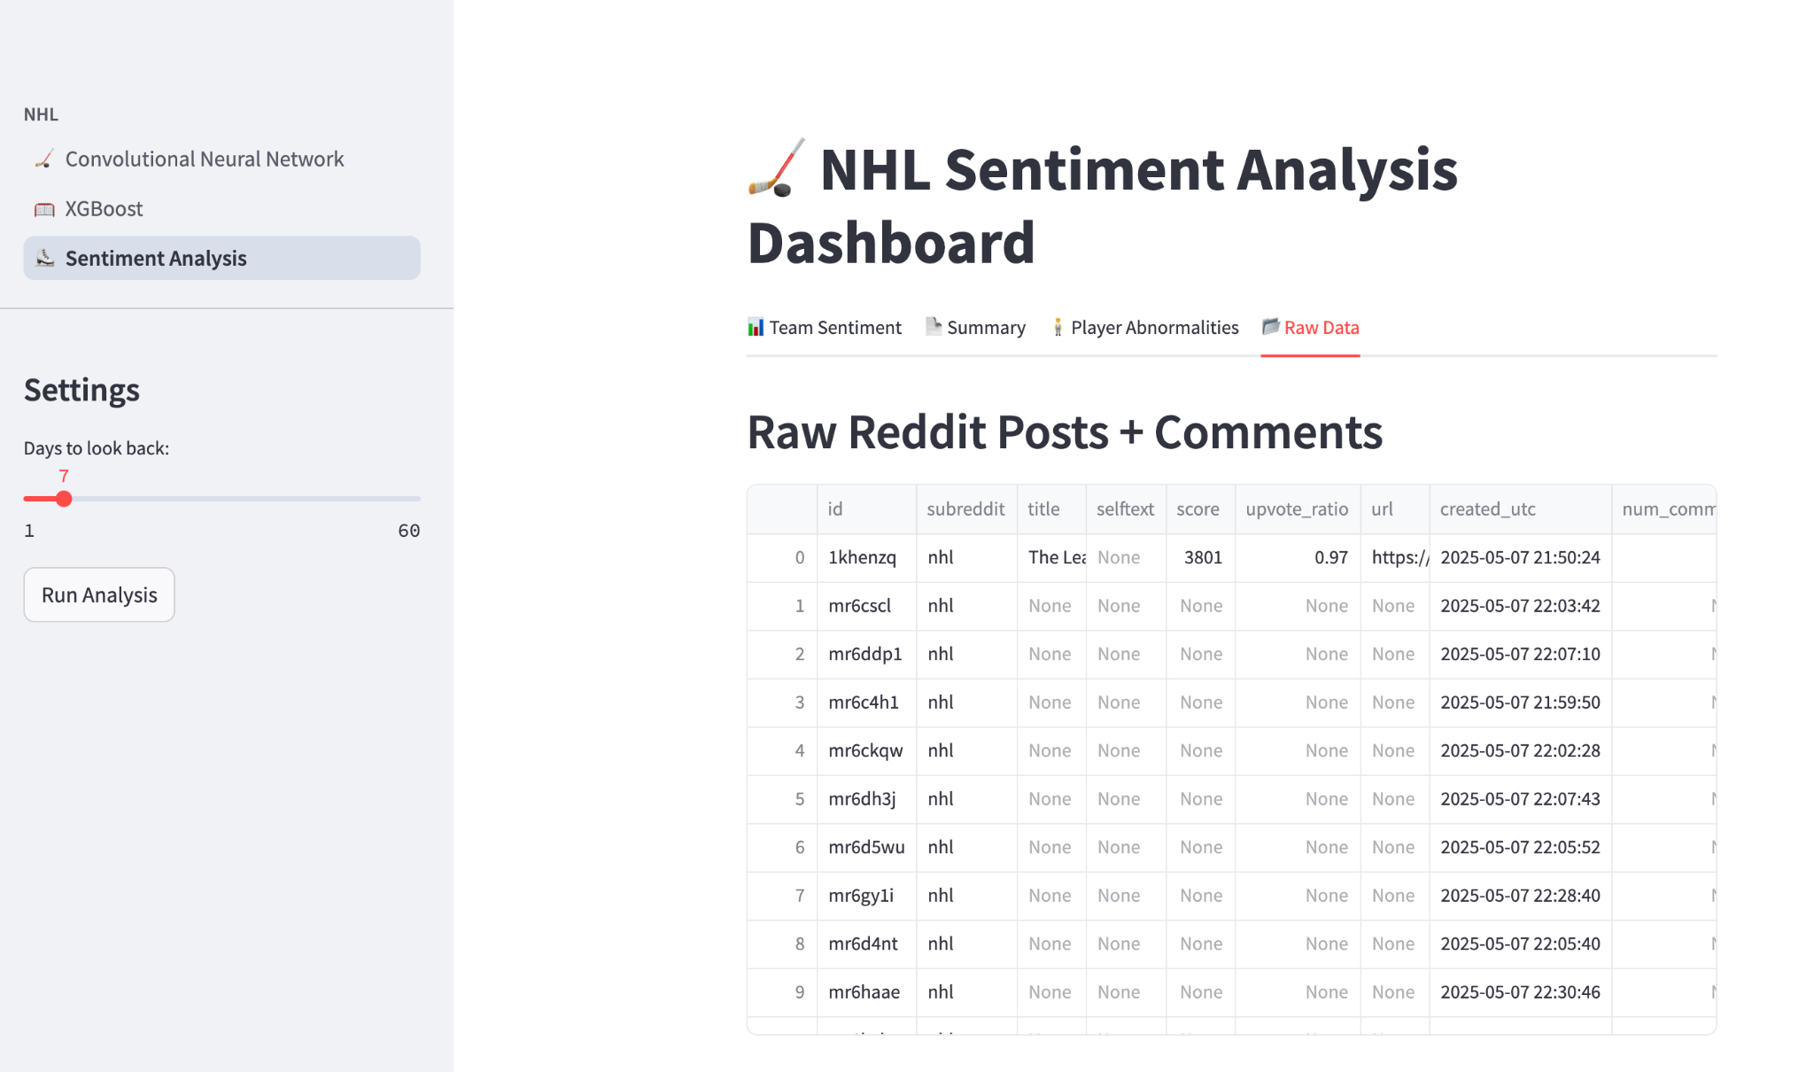

References
- Sovacool, B. K., Heffron, R. J., McCauley, D., & Goldthau, A. (2016). Energy decisions reframed as justice and ethical concerns. Nature Energy, 1(5), Article 16024. https://doi.org/10.1038/nenergy.2016.24
- Lee, C. (2021, March 24). Identifying the best predictors of NHL game outcomes using random forest. Hockey Stats. https://medium.com/hockey-stats/identifying-the-best-predictors-of-nhl-game-outcomes-using-random-forest-b4c11f46bc97
- Hohl, G. (2017, December 1). Behind the numbers: What makes a stat good. Hockey Graphs. https://hockey-graphs.com/2017/12/01/behind-the-numbers-what-makes-a-stat-good/
- Kim, S., & Kim, Y. (2021). Predicting the outcomes of NHL games using machine learning techniques. Journal of Sports Analytics, 7(2), 123–135. https://doi.org/10.1016/j.jsa.2021.03.005
- Brownlee, J. (2020, August 28). 1D convolutional neural network models for human activity recognition. Machine Learning Mastery. https://machinelearningmastery.com/cnn-models-for-human-activity-recognition-time-series-classification/
- Mohammadreza Pourreza (2023, November 10) Comparing the Performance of LLMs: A Deep Dive into Roberta, Llama 2, and Mistral for Disaster Tweets Analysis with Lora. Huggingface Github Blog. https://github.com/huggingface/blog/blob/main/Lora-for-sequence-classification-with-Roberta-Llama-Mistral.md

