编译32bit的libmockcpp.a

本文描述的是在64bit的Linux操作系统上编译生成32bit的libmockcpp.a的实操步骤.

为什么要编译32bit的libmockcpp.a?64bit的不能用吗?

MBB代码的目标主机是ARM32,使用64bit的库做LLT测试时,会引入不必要的麻烦.(比如,地址变量遭遇32位强制转换等) 所以测试代码时最好使用32bit的libmockcpp库来测试.

1. 准备工作: 为保证gcc能够编译出32bit的可执行程序,需要安装gcc-multilib和g++-multilib.
2. 下载mockcpp源码. <https://code.google.com/archive/p/mockcpp/downloads>



1. 解压代码,在代码目录下建立build目录.
2. 修改代码目录下的CMakeLists.txt文件(目的是向编译器指明目标为32bit)

蓝色框框中的内容为新增内容. 

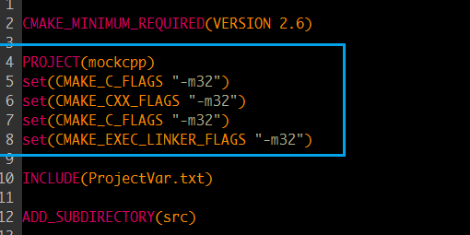

1. 进入build目录,执行 cmake ../ 进行配置.(如果没有安装cmake,需要安装cmake)

配置执行log如下所示:

nick@nick:~/learn/mockpp/mockcpp/build$ cmake ../

-- The C compiler identification is GNU 4.8.4

-- The CXX compiler identification is GNU 4.8.4

-- Check for working C compiler: /usr/bin/cc

-- Check for working C compiler: /usr/bin/cc -- works

-- Detecting C compiler ABI info

-- Detecting C compiler ABI info - done

-- Check for working CXX compiler: /usr/bin/c++

-- Check for working CXX compiler: /usr/bin/c++ -- works

-- Detecting CXX compiler ABI info

-- Detecting CXX compiler ABI info - done

-- Found PythonInterp: /usr/bin/python (found version "2.7.6")

-- Configuring done

-- Generating done

-- Build files have been written to: /home/nick/learn/mockpp/mockcpp/build

1. 在build目录下运行make, 执行编译. 结果在build/src目录下. 编译日志如下:

nick@nick:~/learn/mockpp/mockcpp/build$ make

Scanning dependencies of target arg_related_headers

[ 3%] Built target arg_related_headers

Scanning dependencies of target vtbl_related_headers

[ 9%] Built target vtbl_related_headers

Scanning dependencies of target mockcpp

[ 10%] Building CXX object src/CMakeFiles/mockcpp.dir/AfterMatcher.cpp.o

[ 11%] Building CXX object src/CMakeFiles/mockcpp.dir/AnyBase.cpp.o

[ 12%] Building CXX object src/CMakeFiles/mockcpp.dir/AnyCast.cpp.o

[ 13%] Building CXX object src/CMakeFiles/mockcpp.dir/Any.cpp.o

……

[ 94%] Building CXX object src/CMakeFiles/mockcpp.dir/GlobalMockObject.cpp.o

[ 95%] Building CXX object src/CMakeFiles/mockcpp.dir/JmpOnlyApiHook.cpp.o

[ 96%] Building CXX object src/CMakeFiles/mockcpp.dir/JmpCode.cpp.o

[ 97%] Building CXX object src/CMakeFiles/mockcpp.dir/ApiHook.cpp.o

[ 98%] Building CXX object src/CMakeFiles/mockcpp.dir/ports/failure/stdexcept_report_failure.cpp.o

[100%] Building CXX object src/CMakeFiles/mockcpp.dir/UnixCodeModifier.cpp.o

Linking CXX static library libmockcpp.a

[100%] Built target mockcpp