**Overview of the analysis: Explain the purpose of this analysis.**

The Alphabet Soup foundation sought a solution to choose the most promising applicants for funding. Our team utilized machine learning, neural networks, and the data provided to build a binary classifier that predicts the success of potential grantees. The data set comprised over 34,000 past grant recipients from Alphabet Soup.

**Results: Using bulleted lists and images to support your answers, address the following questions.**

I experimented with 3 different models to improve accuracy and reach a target of 75%. This goal was achieved in V4 and V5 using the test data with a 76% accuracy rate when the "names" feature was reintegrated and divided into categories.

V1

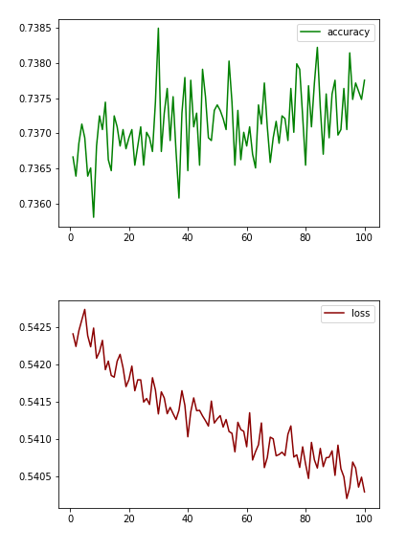

V2

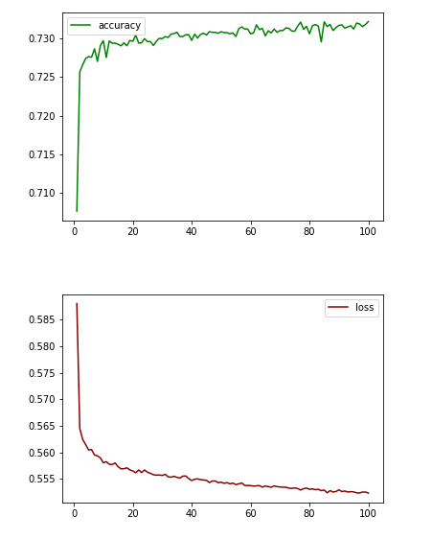

V3

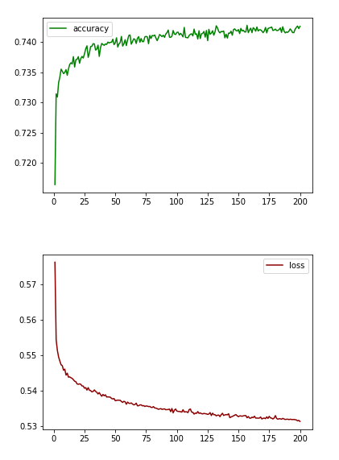

**Data Preprocessing**

What variable(s) are the target(s) for your model?

'IS_SUCCESSFUL'

What variable(s) are the features for your model?

APPLICATION_TYPE,

AFFILIATION,

CLASSIFICATION,

USE_CASE,

ORGANIZATION, *

STATUS,

INCOME_AMT,

SPECIAL_CONSIDERATIONS,

ASK_AMT,

NAME

What variable(s) should be removed from the input data because they are neither targets nor features?

'EIN' and 'NAME' were omitted from the data.

**Compiling, Training, and Evaluating the Model**

How many neurons, layers, and activation functions did you select for your neural network model, and why?

Two hidden layers as an effective starting point for optimizing deep learning models.

30 Neurons - 3x the starting input features

ReLU - Recognized as a valuable starting point.

Were you able to achieve the target model performance?

What steps did you take in your attempts to increase model performance?

**Summary: Summarise the overall results of the deep learning model. Include a recommendation for how a different model could solve this classification problem, and then explain your recommendation.**

We achieved the target accuracy of 75% or above. Despite trying various hyperparameters, the data showed minimal improvement from the initial settings. The greatest increase in accuracy was achieved by including the "NAME" feature and utilizing binning.

It may be worth considering a Random Forest Classifier model for this dataset as it is commonly used in the banking industry for credit modeling and the data may share similarities.