Formative Assessment 2
Database Normalisation (UNF to 3NF) | CPU4 103

Task 1 – Problems with the UNF table
The original table has more than one module and phone number in some cells. This is why it is not in 1NF. If a lecturer changes, we may need to update many rows. It is also difficult to add a module before a student joins. If we delete a student, we might lose some module information.

Task 2 – First Normal Form (1NF)
I separated the phone numbers and modules into their own tables. Now each cell has one value. The lecturer name in the original data is shown beside each student. The question does not tell us which lecturer teaches each module.

Student (1NF)
StudentID (PK) | StudentName | Course | ListedLecturer
1001 | Alice Brown | BSc Computing | Dr Smith
1002 | Ben Carter | BSc Computing | Dr Smith
1003 | Chloe Patel | BSc Cybersecurity | Dr Jones
1004 | David Khan | BSc Cybersecurity | Dr Jones
1005 | Emma Wilson | BSc Data Science | Dr Taylor

StudentPhone (1NF)
StudentID (PK, FK) | PhoneNumber (PK)
1001 | 07700900111
1001 | 01274555123
1002 | 07700900444
1003 | 07700900666
1003 | 01614447777
1004 | 07700900888
1005 | 07700900999
1005 | 02075551234

StudentModule (1NF)
StudentID (PK, FK) | ModuleCode (PK, FK)
1001 | CPU4101
1001 | CPU4103
1001 | CPU4105
1002 | CPU4101
1002 | CPU4104
1003 | CYB4101
1003 | CYB4102
1003 | CPU4103
1004 | CYB4101
1004 | CYB4104
1005 | DAT4101
1005 | DAT4102
1005 | CPU4101

Task 3 – Second Normal Form (2NF)
The combined keys are StudentID with PhoneNumber, and StudentID with ModuleCode. The student name and course depend only on StudentID. So, I kept these details in the Student table. This helps to avoid repeating student information.
Table | Primary key | Foreign key
Student | StudentID | —
StudentPhone | StudentID + PhoneNumber | StudentID → Student
StudentModule | StudentID + ModuleCode | StudentID → Student; ModuleCode → Module
Module | ModuleCode | —
The Module table has one record for each different module code shown in the question.

Task 4 – Third Normal Form (3NF)
For 3NF, I separated course and lecturer details into their own tables. The tables are linked using primary keys and foreign keys. We do not know which lecturer teaches each module, so I have not guessed this information.
Final 3NF table | Attributes and keys
Course | CourseID (PK), CourseName (UNIQUE)
Lecturer | LecturerID (PK), LecturerName
Student | StudentID (PK), StudentName, CourseID (FK), ListedLecturerID (FK)
StudentPhone | StudentID (PK, FK), PhoneNumber (PK)
Module | ModuleCode (PK), LecturerID (FK; assignment to confirm)
StudentModule | StudentID (PK, FK), ModuleCode (PK, FK)
The courses are Computing, Cybersecurity and Data Science. The lecturers listed are Dr Smith, Dr Jones and Dr Taylor. Their names appear with students in the original data, but this does not confirm their module assignments.

Task 5B – Physical model
This model shows example data types and rules for each table. The module lecturer information is not fully given in the question.
Table | Attribute | Data type | Key | Constraint
Course | CourseID | CHAR(3) | PK | NOT NULL
Course | CourseName | VARCHAR(60) | — | NOT NULL, UNIQUE
Lecturer | LecturerID | CHAR(3) | PK | NOT NULL
Lecturer | LecturerName | VARCHAR(60) | — | NOT NULL
Student | StudentID | INT | PK | NOT NULL
Student | StudentName | VARCHAR(80) | — | NOT NULL
Student | CourseID | CHAR(3) | FK | NOT NULL; references Course(CourseID)
Student | ListedLecturerID | CHAR(3) | FK | May be NULL; references Lecturer(LecturerID)
StudentPhone | StudentID | INT | PK, FK | NOT NULL; references Student(StudentID)
StudentPhone | PhoneNumber | VARCHAR(20) | PK | NOT NULL; with StudentID forms composite PK
Module | ModuleCode | VARCHAR(10) | PK | NOT NULL
Module | LecturerID | CHAR(3) | FK | References Lecturer(LecturerID); assignment not supplied, so temporarily nullable
StudentModule | StudentID | INT | PK, FK | NOT NULL; references Student(StudentID)
StudentModule | ModuleCode | VARCHAR(10) | PK, FK | NOT NULL; references Module(ModuleCode)
When the module lecturers are confirmed, LecturerID in Module can be required. I used text for phone numbers because they can start with zero.

Conceptual vs logical vs physical models
Conceptual | Logical | Physical
High-level business entities and relationships | Tables, attributes, PKs, FKs and cardinalities | Implementation details: data types, sizes and constraints
Example: Student studies Module | StudentModule resolves many-to-many | StudentID INT, ModuleCode VARCHAR(10), composite PK and FKs
Note: The question gives lecturer names next to students, but it does not clearly say who teaches each module. I have left this information unconfirmed instead of guessing.

Normalisation Overview – UNF to 3NF
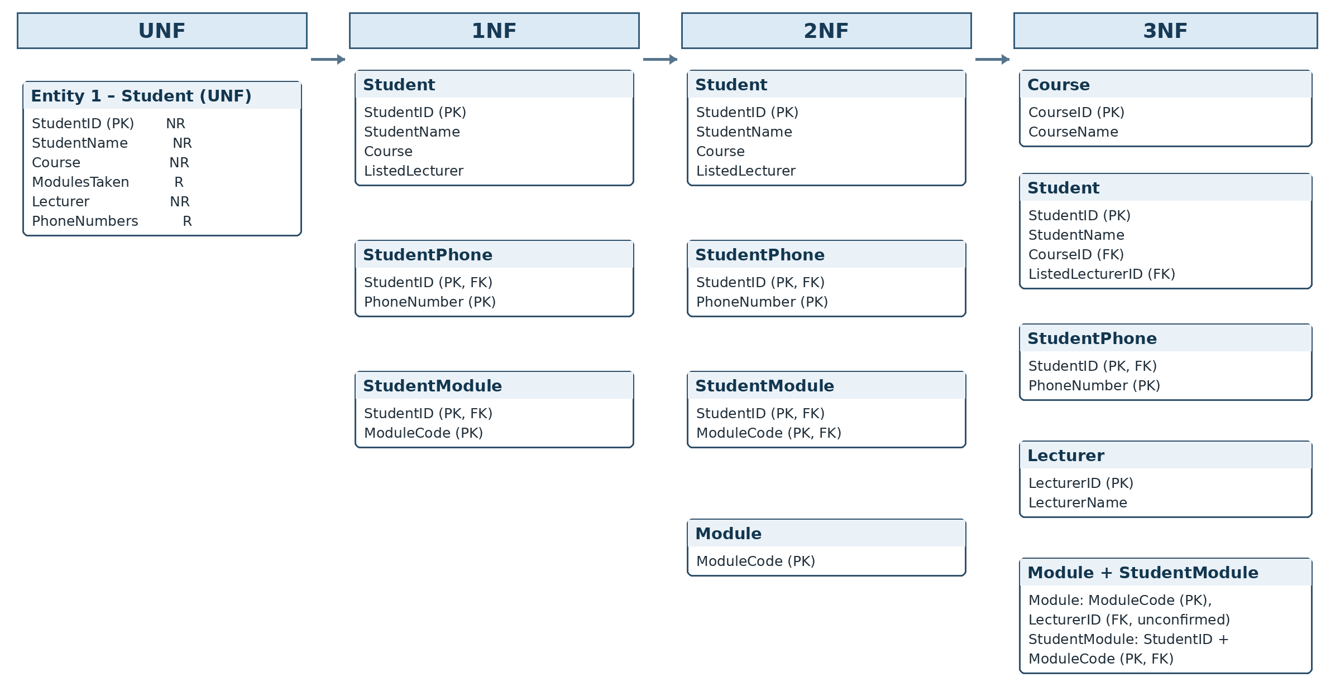
R = repeating; NR = non-repeating. The lecturer-to-module assignment is not confirmed in the given scenario.

