Formative 3 – Database Implementation and SQL Queries

Step 1 – Unnormalised Form (UNF)
The first step is to list the attributes from the original book order.
Attributes:
- Order Number
- Date
- Department Code
- ISBN
- Author
- Title
- Publisher Number
- Publisher Name
- Number of Copies
- Price
- Subtotal
- Grand Total

Step 2 – First Normal Form (1NF)
In 1NF, we remove repeating groups and make sure each record can be identified by a primary key. The book order is divided into two entities.

Entity 2 – Non-Repeating Attributes
Attribute | Key
Order Number | PK
Date
Department Code
Grand Total

Entity 3 – Repeating Attributes
Attribute | Key
Order Number | PK
\ISBN | PK
Author
Title
Publisher Number
Publisher Name
Number of Copies
Price
Subtotal

Entity 2 stores the main order details. Entity 3 stores the book details for each order. Order Number is the primary key in Entity 2. In Entity 3, Order Number and ISBN together make a composite primary key.

Step 3 – Second Normal Form (2NF)
In 2NF, we remove partial dependencies. This means the attributes should depend on the whole primary key, not just part of it. We now have three entities.

Entity 2 – Order Details
Attribute | Key
Order Number | PK
Date
Department Code
Grand Total

Entity 3.1 – Order Book Details
Attribute | Key
Order Number | PK, FK
ISBN | PK, FK
Number of Copies
Subtotal

Entity 3.2 – Book Details
Attribute | Key
ISBN | PK
Author
Title
Price
Publisher Number
Publisher Name

In 2NF, we separate the book information from the order information. Author, Title and Price depend on ISBN. Number of Copies and Subtotal depend on the combination of Order Number and ISBN. This reduces repeated information.

Step 4 – Third Normal Form (3NF)
In 3NF, we remove transitive dependencies. Publisher Name depends on Publisher Number, so we separate publisher details into a new entity. We now have four entities.

Entity 2 – Order Details
Attribute | Key
Order Number | PK
Date
Department Code
Grand Total

Entity 3.1 – Order Book Details
Attribute | Key
Order Number | PK, FK
ISBN | PK, FK
Number of Copies
Subtotal

Entity 3.2.1 – Book Details
Attribute | Key
ISBN | PK
Author
Title
Price
Publisher Number | FK

Entity 3.2.2 – Publisher Details
Attribute | Key
Publisher Number | PK
Publisher Name

Publisher Number stays in Book Details as a foreign key connecting the book to its publisher. This reduces repeated publisher information. All four entities are now in Third Normal Form (3NF).
PK = Primary Key | FK = Foreign Key

Task 1 – Database Creation and Tables
- Create Database
CREATE DATABASE book_order;
USE book_order;
- Create Tables
Table 1 – Publisher Details
CREATE TABLE PublisherDetails (
PublisherNumber INT PRIMARY KEY,
PublisherName VARCHAR(100) NOT NULL
);
Table 2 – Book Details
CREATE TABLE BookDetails (
ISBN VARCHAR(20) PRIMARY KEY,
Author VARCHAR(100),
Title VARCHAR(150),
Price DECIMAL(10,2),
PublisherNumber INT,
FOREIGN KEY (PublisherNumber)
REFERENCES PublisherDetails(PublisherNumber)
);
Table 3 – Order Details Main
CREATE TABLE OrderDetailsMain (
OrderNumber INT PRIMARY KEY,
OrderDate DATE,
DepartmentCode VARCHAR(20),
GrandTotal DECIMAL(10,2)
);
Table 4 – Order Book Details
CREATE TABLE OrderBookDetails (
OrderNumber INT,
ISBN VARCHAR(20),
NumberOfCopies INT,
Subtotal DECIMAL(10,2),
PRIMARY KEY (OrderNumber, ISBN),
FOREIGN KEY (OrderNumber)
REFERENCES OrderDetailsMain(OrderNumber),
FOREIGN KEY (ISBN)
REFERENCES BookDetails(ISBN)
);
Screenshot – Four Created Database Tables
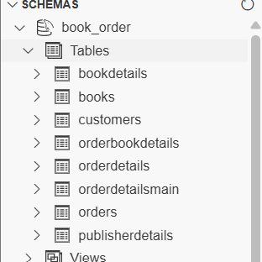

- Insert Records
Table 1 – Publisher Details
INSERT INTO PublisherDetails
(PublisherNumber, PublisherName)
VALUES
(1, 'Pearson'),
(2, 'Oxford University Press'),
(3, 'McGraw Hill'),
(4, 'Springer'),
(5, 'Cambridge University Press');

Table 2 – Book Details
INSERT INTO BookDetails
(ISBN, Author, Title, Price, PublisherNumber)
VALUES
('ISBN001', 'John Smith', 'Database Basics', 35.00, 1),
('ISBN002', 'Mary Jones', 'Learning SQL', 40.00, 2),
('ISBN003', 'David Brown', 'Python Programming', 45.00, 3),
('ISBN004', 'Sarah Wilson', 'Computer Networks', 30.00, 4),
('ISBN005', 'James Taylor', 'Data Science', 50.00, 5);

Table 3 – Order Details Main
INSERT INTO OrderDetailsMain
(OrderNumber, OrderDate, DepartmentCode, GrandTotal)
VALUES
(101, '2026-10-01', 'IT', 35.00),
(102, '2026-10-02', 'BUS', 40.00),
(103, '2026-10-03', 'IT', 45.00),
(104, '2026-10-04', 'SCI', 30.00),
(105, '2026-10-05', 'BUS', 50.00);

Table 4 – Order Book Details
INSERT INTO OrderBookDetails
(OrderNumber, ISBN, NumberOfCopies, Subtotal)
VALUES
(101, 'ISBN001', 1, 35.00),
(102, 'ISBN002', 1, 40.00),
(103, 'ISBN003', 1, 45.00),
(104, 'ISBN004', 1, 30.00),
(105, 'ISBN005', 1, 50.00);

Task 2 – SQL QUERIES
Query 1 – Select All Books
SELECT * FROM BookDetails;

Query 1 Explanation
This query uses the SELECT statement to retrieve all records from the BookDetails table. The asterisk (*) means that every column will be displayed, including ISBN, Author, Title, Price, and PublisherNumber. The query helps users view the complete list of books stored in the database. It is useful for checking that the book records have been entered correctly.

Query 1 Screenshot
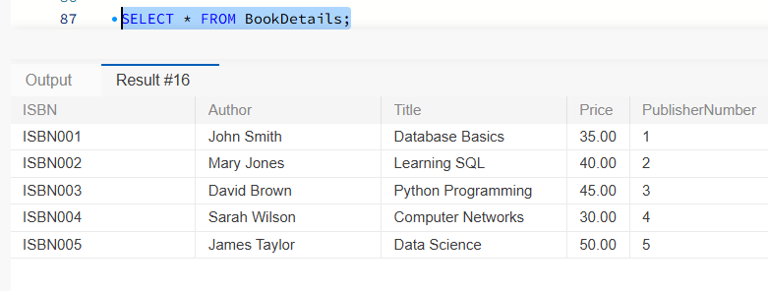

Query 2: SELECT Books Using WHERE
SELECT * FROM BookDetails
WHERE Price > 35;
This query uses the WHERE clause to display books that cost more than £35. The SELECT statement retrieves all columns from the BookDetails table, but only records that meet the price condition are shown. The results include Learning SQL (£40), Python Programming (£45), and Data Science (£50). This query is useful when users want to find books within a particular price range.
Query 2 Screenshot
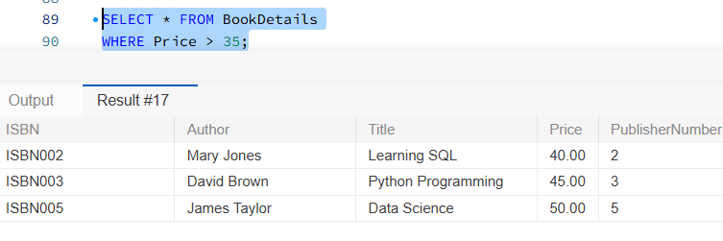

Query 3: INNER JOIN Books and Publishers
SELECT
BookDetails.Title,
BookDetails.Author,
PublisherDetails.PublisherName
FROM BookDetails
INNER JOIN PublisherDetails
ON BookDetails.PublisherNumber = PublisherDetails.PublisherNumber;

This query uses an INNER JOIN to combine information from the BookDetails and PublisherDetails tables. The tables are connected using PublisherNumber, which is a foreign key in BookDetails and a primary key in PublisherDetails. The query displays each book's title, author, and publisher name. It is useful because users can see which publisher produced each book without having to check two separate tables.

Query 3 Screenshot
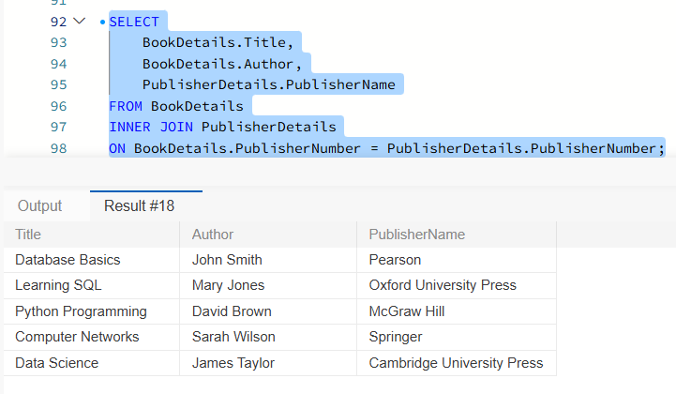

Task 3 – Individual Group Collaboration Report
During this database assignment, I worked on designing and implementing the book order database using MySQL Workbench. I used the normalisation work from Workshop 2 to create four related tables: PublisherDetails, BookDetails, OrderDetailsMain, and OrderBookDetails. I added sample records and used primary and foreign keys to connect the tables correctly.
I also created and tested three SQL queries using SELECT, WHERE, and INNER JOIN. These queries helped me understand how to retrieve and combine information from a database. Working on this assignment improved my knowledge of database design, SQL commands, and problem-solving. I learned the importance of checking my work carefully and keeping the database organised.

