Q1)

Q2)

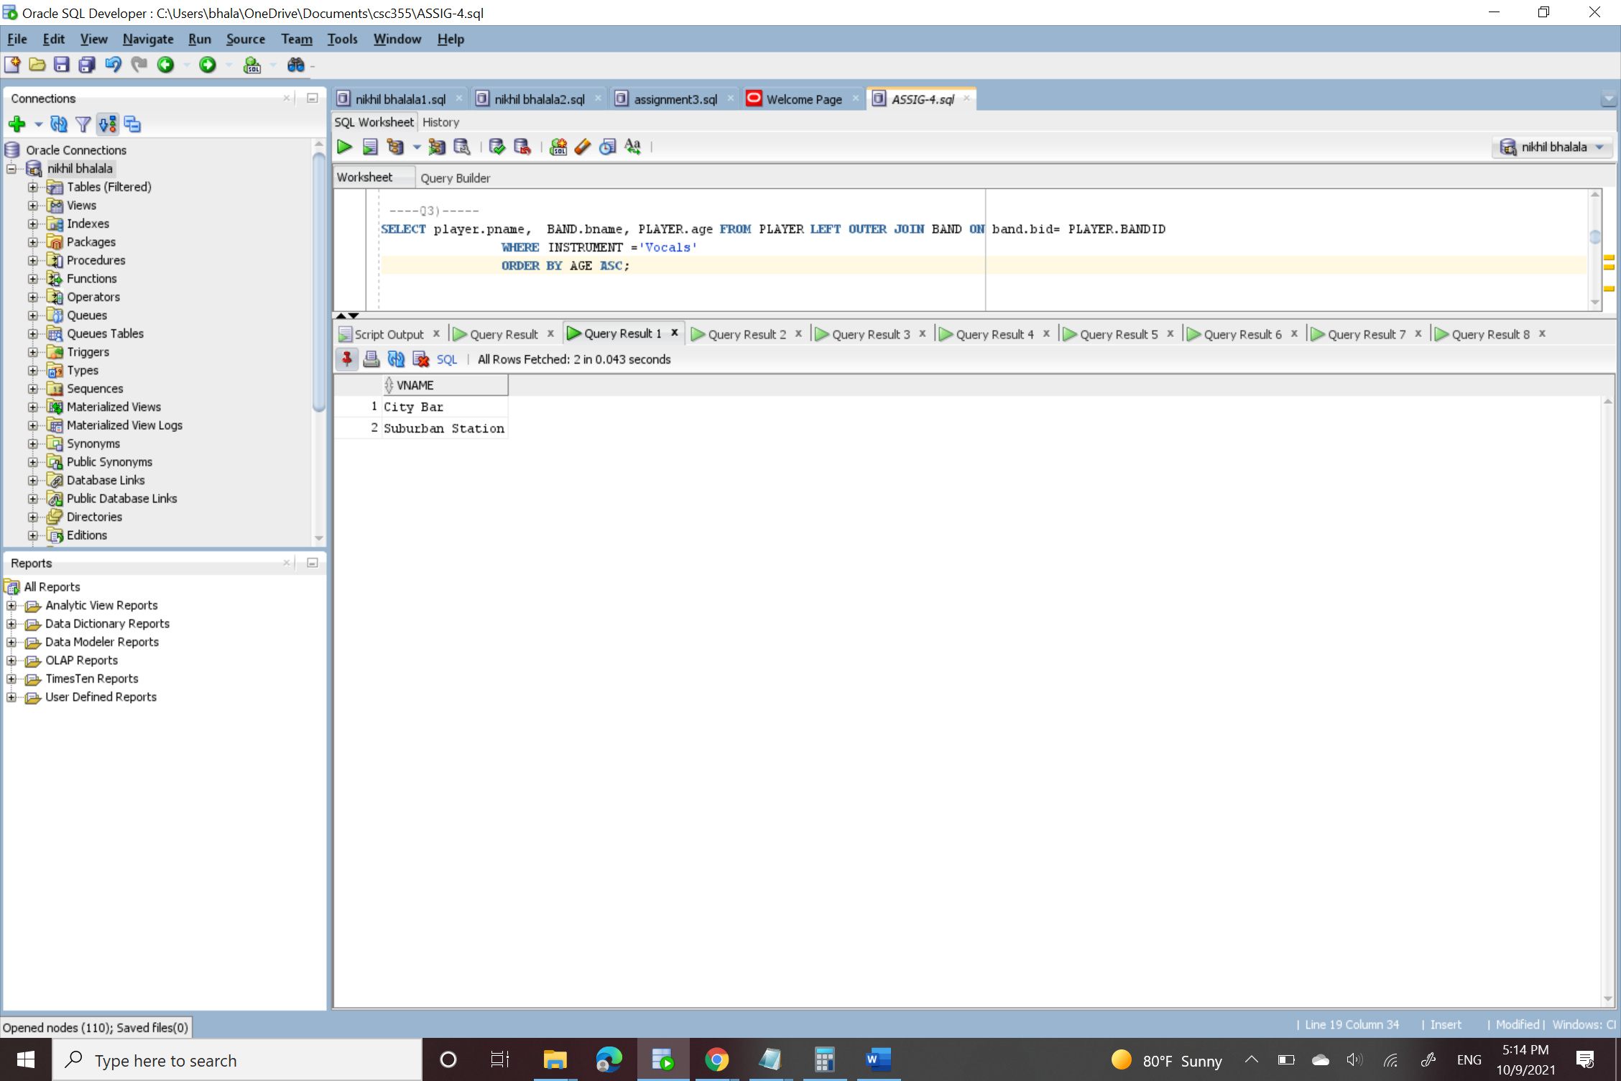

Q3)

Q4)

Q5)

Q6)

Q7)

Q8)

