CSC 555 / DSC 333 Mining Big Data
Assignment 4
Nikhil Bhalala
Dsc-333

- Describe how to implement the following query in MapReduce terms (you do not have to code anything for that part).

select sum(lo_revenue), d_year, p_brand1
from lineorder, dwdate, part
where lo_orderdate = d_datekey
and lo_partkey = p_partkey
and p_category = 'MFGR#14'
group by d_year, p_brand1
order by d_year, p_brand1;

- (lo_orderdate=datekey)MAP1a: Key=lo_orderdate/d_datekey,
Value=(lo_revenue,d_year,p_brand1).
for mapper combines where linedate=datekey

(lo_partkey=p_partkey)Map1b: key=lo_partkey/p_partkey,
Value=(lo_revenue,d_year,p_brand1).
for mapper combination of lineorder and part.

(Part)map 1c: Key= p_category ,
value==(lo_revenue,d_year,p_brand1).
for Mapper filters row where category= “MFGR#14”

REDUCE1; The key-values are pass and the aggregated SUM
(lo_revenue) is done.

MAP2: Key=d_year,p_brand1 value=sum(lo_revenue)
Sorting is done.

REDUCE2; d_year,p_brand1 key= SUM(lo_revenue)
- Consider a Hadoop job that will result in 193 blocks of output to HDFS.
Suppose that writing one output block to HDFS takes 1 minute. The HDFS replication factor is set to 3 unless otherwise noted (the cost of writing output should include the replication blocks).

  - How long will it take for the reducer to write the job output on a 5-node Hadoop cluster? (ignoring the cost of Map processing, but counting replication cost in the output writing).

- 193/5=38.6 so it is 39 iterations
39 *1 =39 min
39 * 3 replication factor = 117 minutes

  - How long will it take for reducer(s) to write the job output to 20 Hadoop worker nodes? (Assume that data is distributed evenly and replication factor is set to 1)
- 193/20 =9.65 so it is 10 iterations
10*1=10min
10*1 replication factor =10min

  - How long will it take for reducer(s) to write the job output to 20 Hadoop worker nodes? (Assume that data is distributed evenly and replication factor is set to 3)
- 193/20 =9.65 so it is 10 iterations
10*1=10min
10*3replication factor =30min

  - How long will it take for reducer(s) to write the job output to 100 Hadoop worker nodes? (Assume that data is distributed evenly and replication factor is set to 1)
- 193/100 =1.93 so it is 2 iterations
2*1=2min
2*1 replication factor =2min

  - How long will it take for reducer(s) to write the job output to 100 Hadoop worker nodes? (Assume that data is distributed evenly and replication factor is set to 3)
- 193/100 =1.93 so it is 2 iterations
2*1=2min
2*3 replication factor =6min

You can ignore the network transfer costs as well as the possibility of node failure.

- Given the following keys: 1, 2, 4, 6, 8, 11, 13, 15, 16, 17, 25, 26, 29, 50, 53, 59, 88, 89, 95, 98, design the following:

  - A distribution of these keys across 3 reducers using the default key partitioner (% 3)

- In the question, the partitioner is specified as "%3," which refers to the remainder left after dividing the key by three. Because the remainder has only three possible values, 0, 1, and 2, we can use it to determine the key for a reducer because the function "%3" has the same number of possible outputs as reducers.
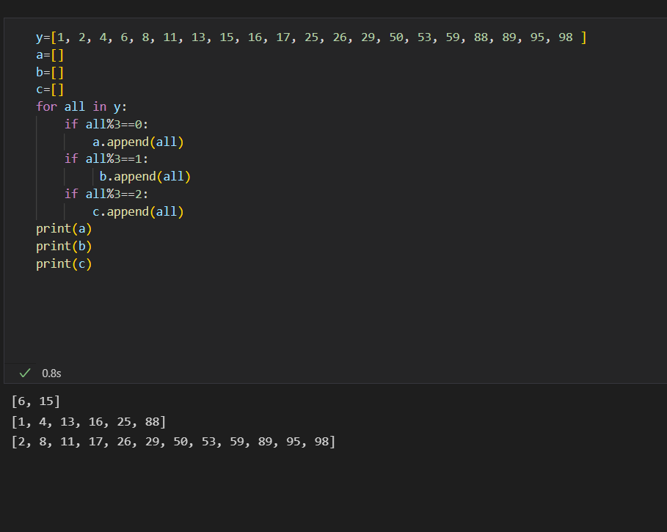

  - Design a custom sorting partitioner instead of the default one and describe the resulting output across the same 3 reducers

- The output of the function can only be 0, 1 or 2 and hence this can be used to assign a reducer to key as done:
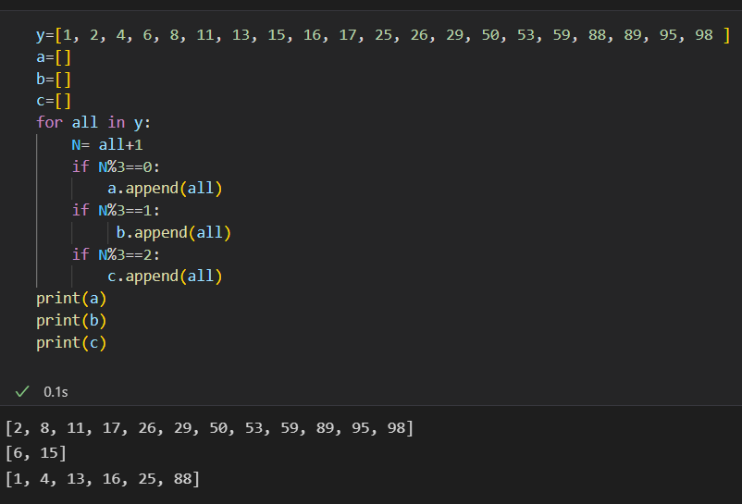

  - What is the downside (i.e., extra overhead) of employing a custom partitioner?

- The same precise combination of numbers is provided by a custom partition, but in a different bin. In other words, the combination in a and b does not change, but the reducer to which they are assigned does.

- Implement the following query using Hadoop streaming and python with the lineorder table.
http://cdmgcsarprd01.dpu.depaul.edu/CSC555/SSBM1/SSBM_schema_hive.sql
http://cdmgcsarprd01.dpu.depaul.edu/CSC555/SSBM1/lineorder.tbl

SELECT lo_shipmode, AVG(lo_tax)
FROM lineorder
WHERE lo_quantity BETWEEN 16 AND 28
GROUP BY lo_shipmode;

Don’t forget to submit your python code and the command lines you used to execute Hadoop streaming. I also recommend submitting the screenshot of execution to simplify the grader’s job.

I am getting error in streaming
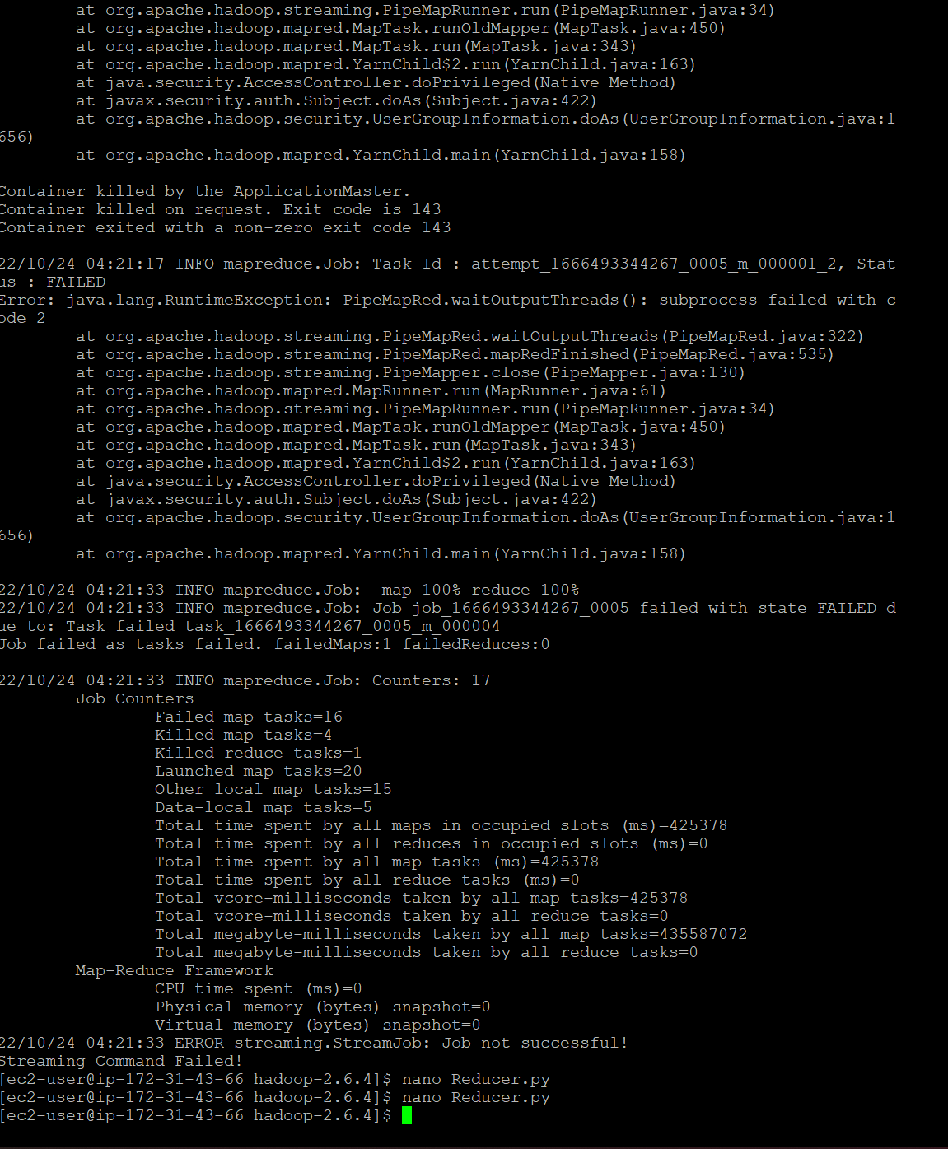

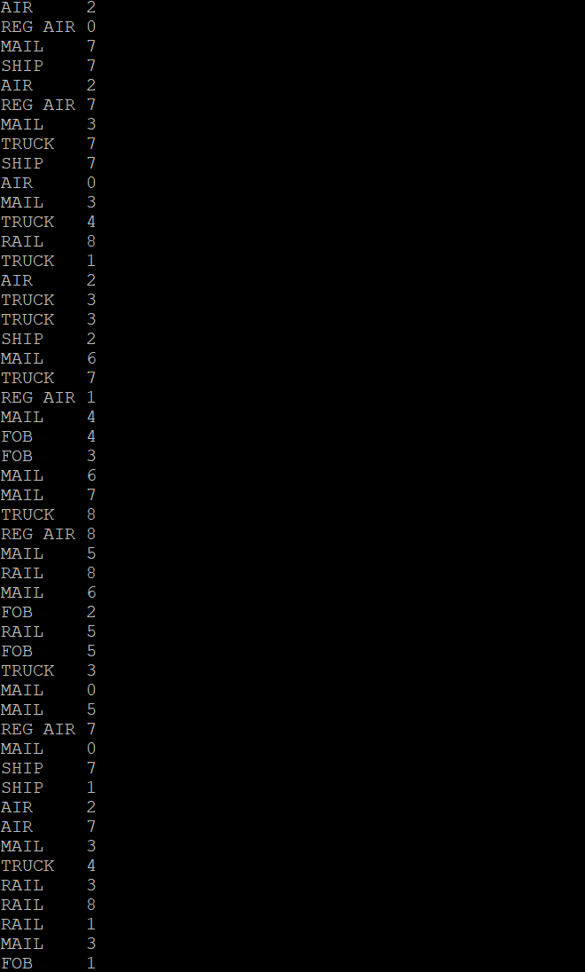

Mapper

#!/usr/bin/python
import sys
for line in sys.stdin:
vals=line.strip().split('|')
qua= int(vals[8])
if qua>16 and qua<28:
print('%s\t%s' %(vals[16],vals[14]))

Reducer

#!/usr/bin/python
import sys

curr_id = None
curr_cnt = []
id = None

# The input comes from standard input (line by line)
for line in sys.stdin:

line = line.strip()
ln = line.split('|')

# grab the ke y
id = ln[0]
lo_tax = int(ln[14])

if curr_id == id:
curr_cnt.append(lo_tax)
# avg=mean(curr_cnt)
else:
if curr_id!=None: # output the count, single key completed
sum =0
for i in range(curr_cnt):
sum += curr_cnt[i]
mean=sum/len(curr_cnt)
#lst_avg = sum_lst/len(inp_lst)
print( '%s\t%d' % (curr_id, mean))

curr_id = id # Reset the current key to the new key (e.g., 94)
curr_cnt = 1

# output the last key
if curr_id == id:
sum=0
for i in range(curr_cnt):
sum +=curr_cnt[i]
mean=sum/len(curr_cnt)
print '%s\t%d' % (curr_id, curr_cnt)

- (We will discuss compression on Tuesday, 10/18) Given the following data: QQQQZZZZZAAAAANNN and assuming that each letter takes 1 byte (8 bits). The goal of this exercise is to quantify compression effects, while the math itself is completely trivial.

  - What is the storage size of the uncompressed string?

Data: QQQQZZZZZAAAAANNN as 1 byte (8 bits).
size of the uncompressed string of letters = 17*1 bytes = 17 bytes.

  - Suppose you apply Run Length Encoding compression (e.g., replace QQQQ by Q4). What is the size of the RLE-compressed string? You can assume that 5 also requires 1 byte just as Q.
Data: Q4Z5A5N3 letter and digit take 1 byte (8 bits).
RLE-compressed string = 8 * 1 bytes = 8 bytes.

  - Suppose you build a dictionary that represents each letter with a 5-bit code. What is the size of the dictionary-compressed string (where each letter is replaced by a 5 bit code)?
Data: QQQQZZZZZAAAAANNN letter takes 1 byte (8 bits).
The size of dictionary-compressed string: 17 * 5 = 85 bits.

  - Repeat the computation in 3-b and 3-c using QQBQQZZUZZAANNA string (which only has 15 characters and thus takes 15 bytes uncompressed)
(b) Data: Q2BQ2Z2UZ2A2N2A letter and digit take 1 byte (8 bits).
RLE-compressed string = 15 * 1 bytes = 15 bytes.

(c) Data: QQBQQZZUZZAANNA letter takes 1 byte (8 bits).
size of dictionary-compressed string: 15 * 5 = 75 bits.

- In this section you will practice using HBase. Note that HBase runs on top of HDFS, bypassing the MapReduce engine.
cd
(Download HBase)
wget http://dbgroup.cdm.depaul.edu/Courses/CSC555/hbase-0.90.3.tar.gz
gunzip hbase-0.90.3.tar.gz
tar xvf hbase-0.90.3.tar
cd hbase-0.90.3

(Start HBase service, there is a corresponding stop service and this assumes Hadoop home is set)
bin/start-hbase.sh
(Open the HBase shell – at this point jps should show HMaster)
bin/hbase shell
(Create an employee table and two column families – private and public. Please watch the quotes, if ' turns into ‘, the commands will not work)
create 'employees', {NAME=> 'private'}, {NAME=> 'public'}
put 'employees', 'ID1', 'private:ssn', '111-222-334'
put 'employees', 'ID2', 'private:ssn', '222-338-446'
put 'employees', 'ID3', 'private:address', '123 State St.'
put 'employees', 'ID1', 'private:address', '243 N. Wabash Av.'
scan 'employees'

Now that we have filled in a couple of values, add 3 new columns to the private family, 1 new column to the public family and create a brand new family with at least 2 columns. For each of these you should introduce at least 2 values -- so a total of (3+1+2) * 2 = 12 values inserted. Verify that the table has been filled in properly with scan command and submit a screenshot.
NOTE: In order to add a new column family to an HBase table called test, you would need to run the following commands
disable 'test'
alter 'test', 'myNewFavoriteColumnFamily'
enable 'test'

Submit a single document containing your written answers. Be sure that this document contains your name and “CSC 555 Assignment 4” at the top.

put 'employees', 'ID4', 'private:course', 'Dsc333'
put 'employees', 'ID5', 'private:dept', 'Data science'
put 'employees', 'ID6', 'private:DOB', '09/09/09'
put 'employees', 'ID1', 'public:university', 'depaul university'

put 'employees', 'ID7', 'private:course', 'csc300'
put 'employees', 'ID8', 'private:dept', 'computer science'
put 'employees', 'ID9', 'private:DOB', '08/08/08'
put 'employees', 'ID2', 'public:university', 'uic university'

disable 'employees'
alter 'employees', 'NewColumnFamily1', 'NewColumnFamily1'
enable 'employees'

put 'employees', 'ID2', 'NewColumnFamily1:name', 'Nikhil bhalala'
put 'employees', 'ID2', 'NewColumnFamily1:zipcode', '60960'

