

Cold Caller

## User Guide

## 

## Nicholas Bonat – April 28, 2019

Table of Contents

**Introduction** 1

**Getting Started** 2

**System Requirements** 2

**Launching the Application** 2

**Using Remove/Concern Buttons and Key Mapping** 3

**Removing a student from the queue** 3

**Adding a concern indication to a student** 4

**Daily/Summary Log** 5

**Daily log** 5

**Exporting summary log** 6

**Importing/Exporting Roster** 6

**Importing** 6

**Exporting** 6

**Menu Bar** 7

# **Introduction**

Making sure students are equally interacting in class is a challenge. You can’t control students for not wanting to raise their hands to answer a question. However, you can control the ability to randomly selection students and give everyone a chance to speak. This is possible with Cold Caller.

This Cold-Call Assistant application will create a list with 3 students from the student roster for the instructor (user) to call. The instructor can put marks for students according to their performance. After class, the instructor can review everyone’s behavior in the daily log. At the end of the term, she can export the daily log as summary to see the performance for each student during the entire school term.

## **Getting Started**

## **System Requirements**

Macintosh OSX 10.13 (High Sierra) or 10.14 (Mojave)(Hornof 8.1).

# **Launching the Application**

To launch the application click the Cold Caller coldphone.png icon

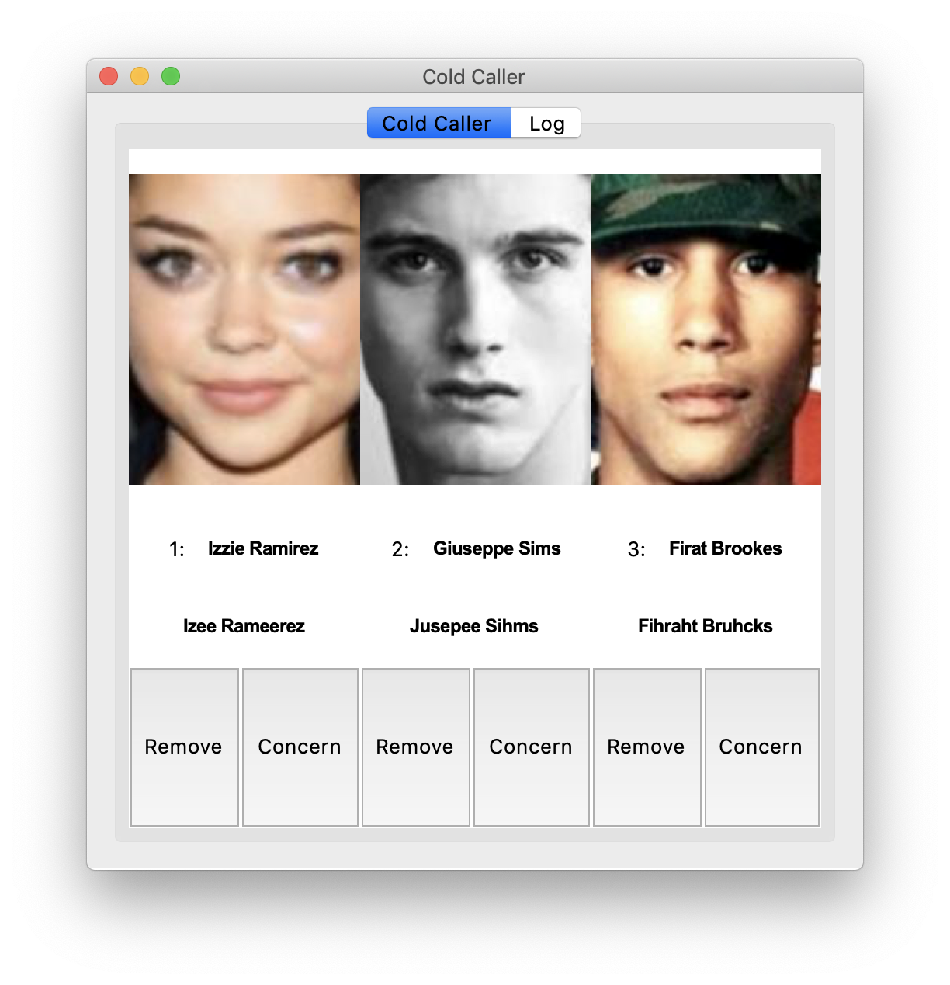

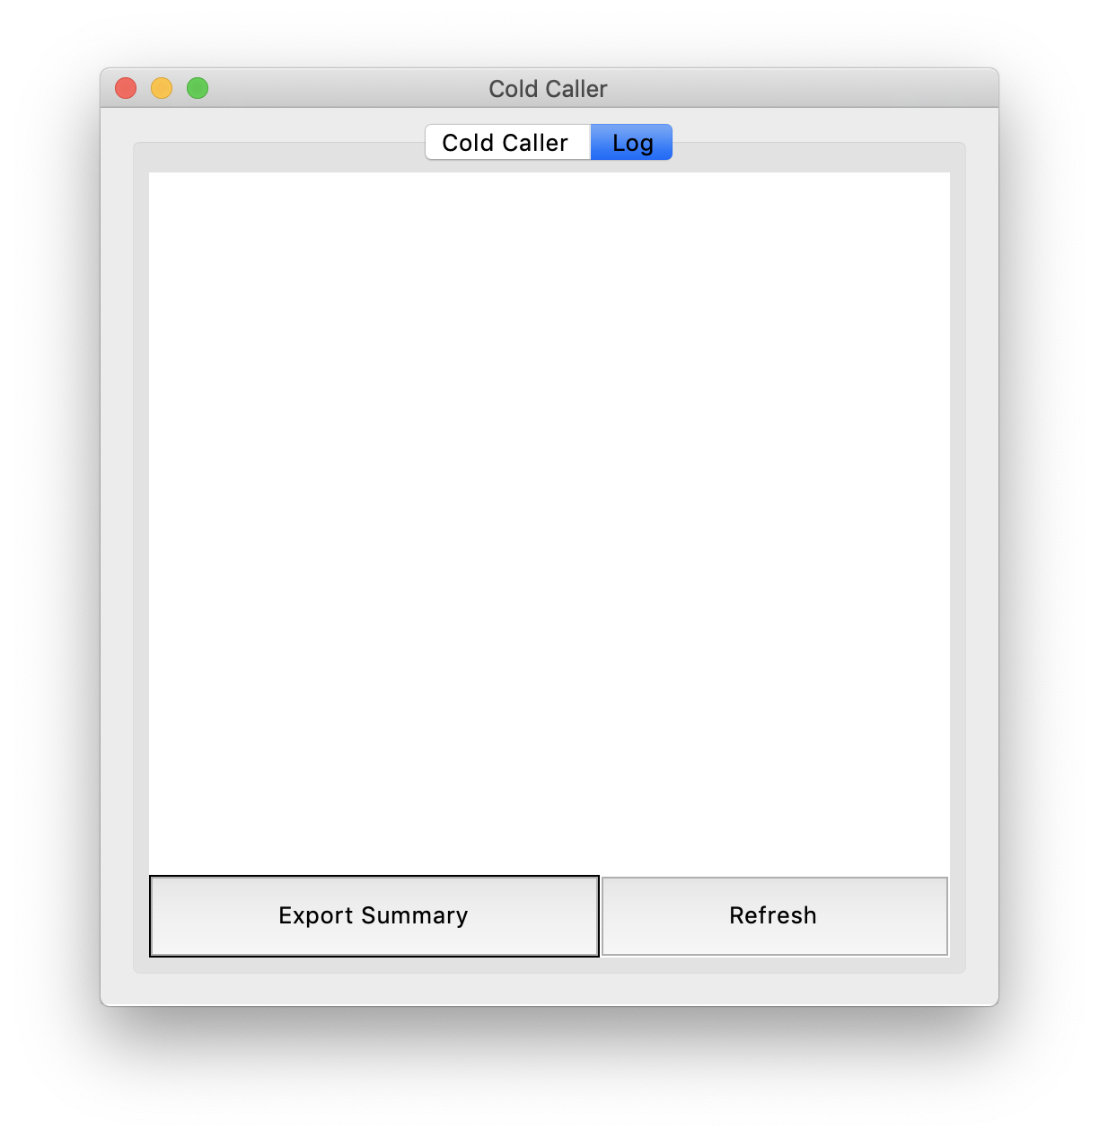

A tab-style user interface with internally stored student images, names, and phonetic spellings will be displayed along with “Remove” and “Concern” buttons for each student. Clicking on the “Log” tab will show the daily log, a “Refresh” button, as well as an “Export Summary” button.

# **Using Remove/Concern Buttons and Key Mapping**

## **Removing a student from the queue**

Clicking the “Remove” button below the corresponding student will remove that student from their current position while also adding their name and email to the daily log.

* Keys “1” and spacebar removes the student from the front of the queue.
* Key “2” removes the student from position two
* Key “3” removes the student from position three

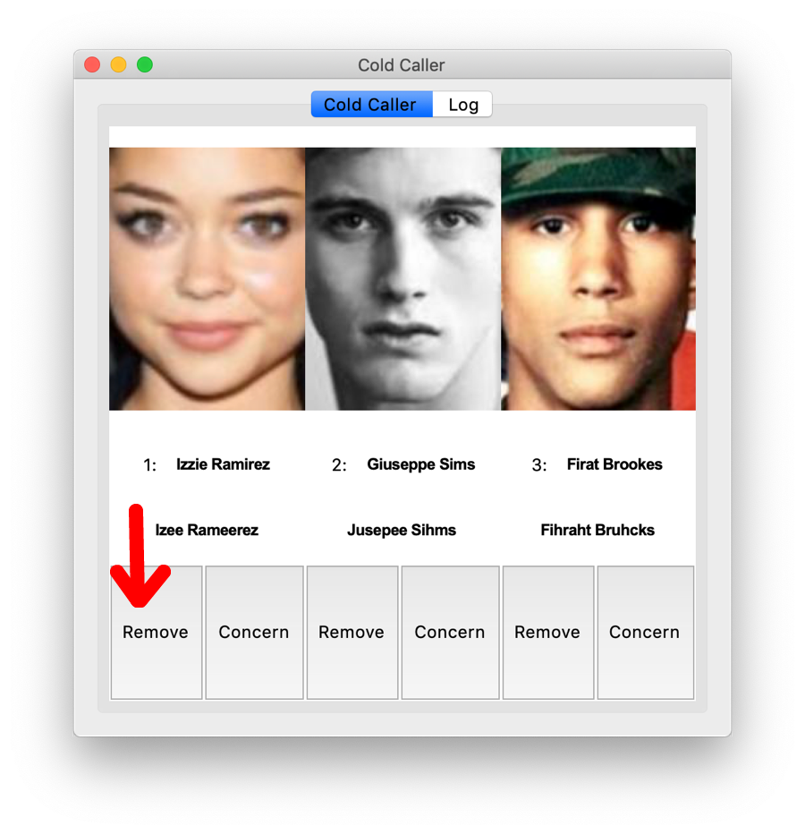

## **Adding a concern indication to a student**

Clicking “Concern” directly after a student as been removed will add “X” at the beginning of their daily log entry, indicating that student needs to be followed up with.

* Keys “c” and “v” add the concern feature for the student in the front of the queue
* Key “b” adds the concern feature for the student in position two
* Key “n” adds the concern feature for the student in position three

# **Daily/Summary Log**

Click the “Log” tab to access these features

## **Daily log**

After students have been removed from the queue their first name, last name, and email are stored in the daily log file named “dailylog.txt”. A “X” in the front of their name indicates the concern button was hit for them. Clicking “Refresh” will update the log file in the user interface while the dailylog.txt file itself is updated automatically and can be viewed at any time

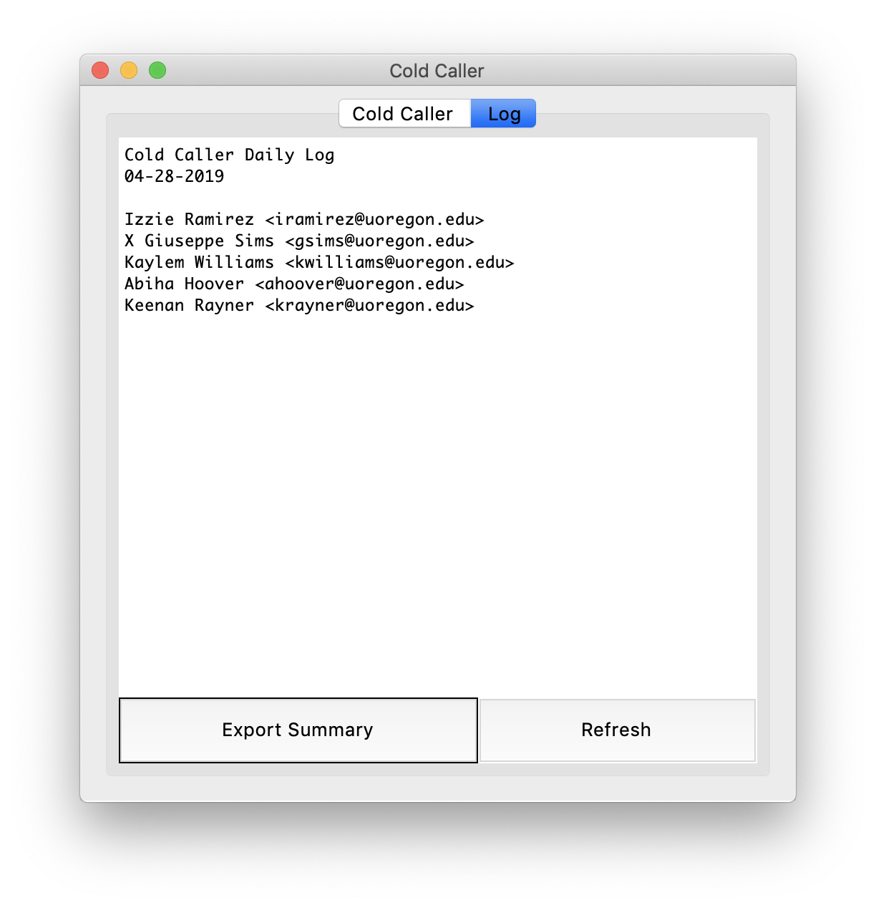

## **Exporting summary log**

The “Export Summary” button displays a file manger window that allows the user to save the summary file with any name in any directory. The only format it can be in is .txt.

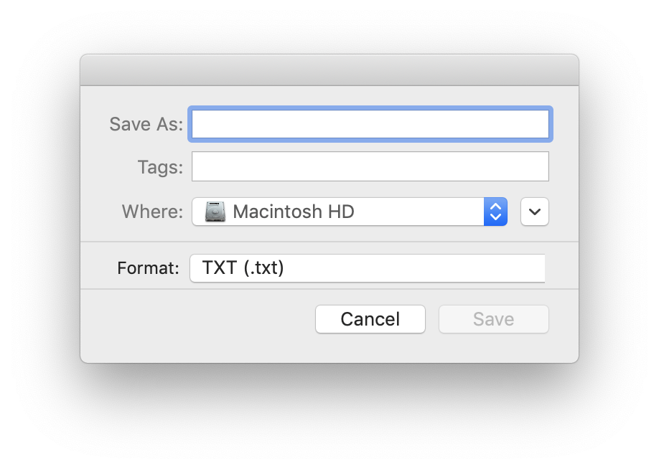

# **Importing/Exporting Roster**

Clicking the “Import/Export” menu option in the top menu bar will display three options: Import, Export, and Exit(exit the application).

### **Importing**

Upon clicking the “Import a Roster” option, a file selector window will pop-up, allowing the selection of a .tsv or .csv file. From there, if there are changes from the new roster to the internal roster, a warning window will pop-up asking if the changes want to be made. Clicking “Yes” will finalize the changes.

### **Exporting**

Selecting “Export to a Roster” will display a file manager window that allows the user to export the current roster in .tsv or .csv format

# **Menu Bar**

In the top menu bar, next to the “Import/Export” option, there is a “Misc” button. This button brings a dropdown list of three more options:

1. Set Photos Folder – opens a file manager window allowing the user to select a photos folder that will be used for displaying student images.
2. Font Size – ability to change interface font size between 12-

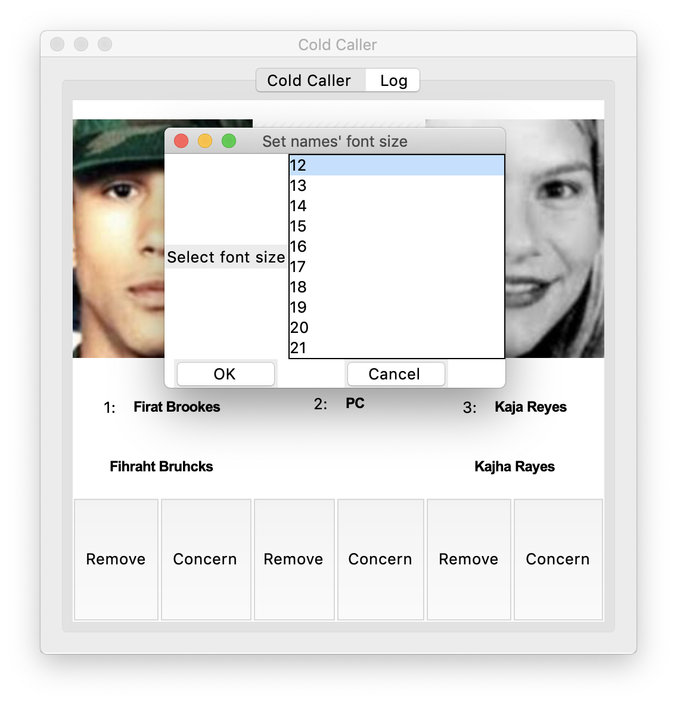

3. About – brief description of the application