VITA MODULAR · PROJECT HUB
User Guide
A complete reference for everything the hub does
Version 4 · May 2026

Contents
1. Introduction | 3
2. Dashboard | 5
3. Quotations | 7
4. Pipeline | 9
5. Schedule | 11
6. Costs | 14
7. Projects | 16
8. Reports, downloads & printing | 23
9. Team & users | 25
10. Tips & troubleshooting | 27
11. What’s coming next | 29

1. Introduction
The Vita Modular Project Hub is a single web page that runs entirely in your browser. It tracks every project from quote through to handover, generates branded quote PDFs and contracts, manages your build schedule and install capacity, captures notes and tasks against each project, and produces print-ready reports for any view.
The whole hub is one HTML file. Open it, and you have everything. No login, no installation, no server required for day-to-day use. Project data is saved in your browser's storage so it persists between sessions.

1.1 Who this guide is for
This guide is written for everyone at Vita Modular who interacts with the hub — sales, operations, site team, and management. It assumes no prior knowledge. Read it cover to cover the first time, then dip back into specific sections as you need them.

1.2 How the hub fits together
At the top of every page sits the topbar — your navigation between the main views, the search bar, the active-user picker, and the sync status indicator.
The topbar is always visible. Click any view button to jump there.
The seven main views are:
- Dashboard — business performance at a glance: KPIs, conversion funnel, recent activity, active projects.
- Quotations — generate new quotes for extensions, annexes and garden rooms via the embedded forms.
- Pipeline — every project in flight as a sortable, filterable table with stage, value, source, and lead temperature.
- Schedule — Gantt timeline of all live projects plus 12-month capacity outlook for install slots.
- Costs — cost variation reports and margin analysis from CVR / final account spreadsheets.
- Projects — drill into any individual project: contract document, build schedule, notes & tasks, files.
- Reports — landing page for printable reports across every section.

1.3 Quick-start: your first five minutes
- Open the hub. Double-click the HTML file or drag it into a browser tab.
- Load demo data. On the dashboard, find the "Load demo project" link. This populates 12 sample projects so you can explore every feature without affecting real data.
- Set up your team. Click the user picker (top right) and choose "Manage team". Replace the default seed names (Sales, Operations, Site team) with your real team members.
- Click around. Visit each main view. Try opening a project from the Pipeline. Click the "Download" button in any view header to see the report and Excel options.
- Go back to dashboard. Use the demo button to clear the demo data when you're ready to start with real projects.

2. Dashboard
The dashboard is the home screen of the hub — open it any time to see how the business is performing at a glance.
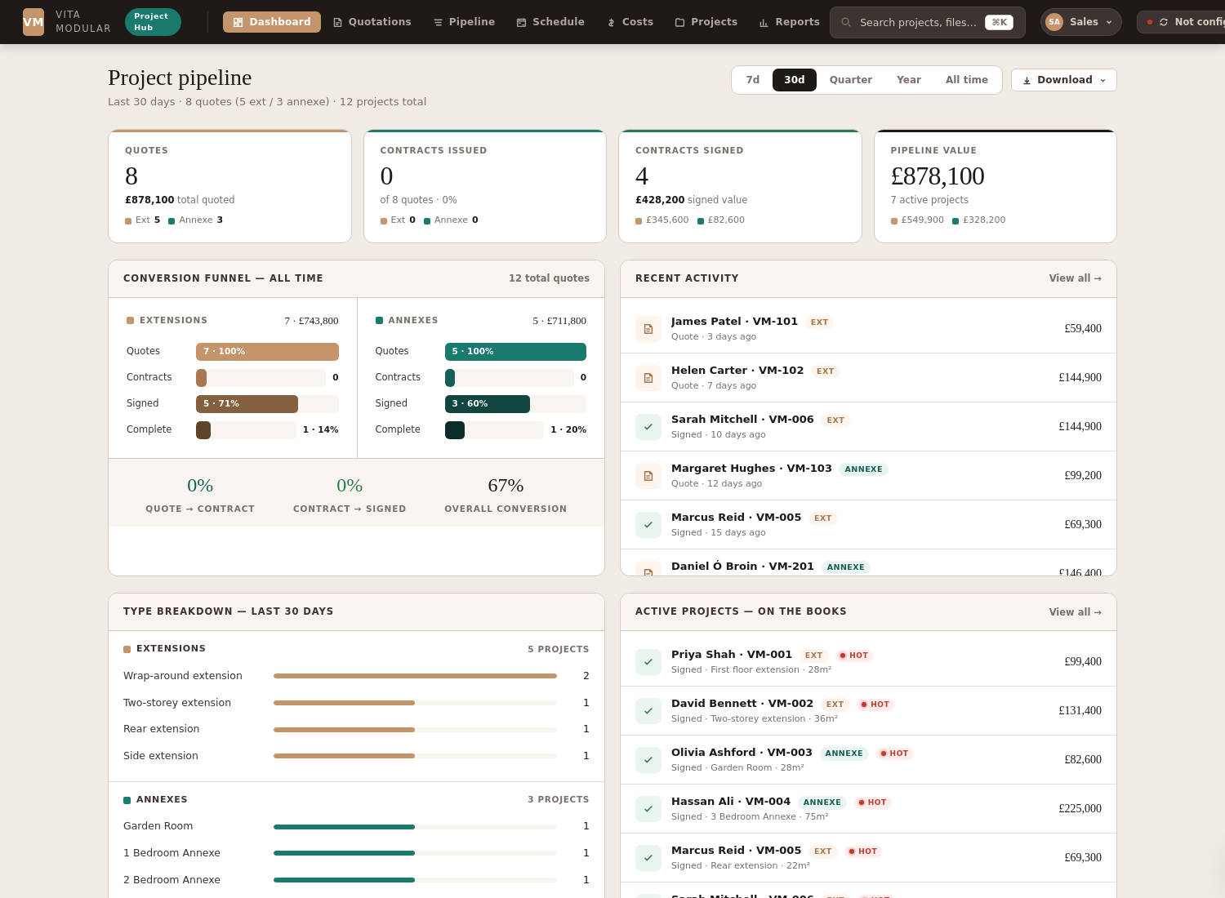
The dashboard with demo data loaded.

2.1 The four KPI cards
At the top of the dashboard, four cards summarise key numbers for the date range you've selected:
- Quotes — count and total value of quotes generated. The colour-coded breakdown shows how many were extensions, annexes, or garden rooms (terra / teal / green dots respectively).
- Contracts issued — how many of those quotes have moved to "Contract issued" stage. The percentage tells you the quote-to-contract conversion rate.
- Contracts signed — how many have been signed and are now committed projects with associated revenue.
- Pipeline value — total value of all signed projects currently in the build pipeline (signed → installing → handover).

2.2 Date range selector
Top right of the dashboard, five buttons let you change the reporting period: 7 days, 30 days, Quarter, Year, or All time. Click any one to recompute every number on the dashboard against that window. Default is "Last 30 days".

2.3 Conversion funnel
The middle-left card shows the full quote → contract → signed → complete funnel, split into three columns by project type: extensions (terra), annexes (teal), and garden rooms (green). Each row has a horizontal bar showing the absolute count and the percentage that made it that far.
Below the funnel, three KPI ratios summarise conversion at each step (Quote → Contract, Contract → Signed) and overall (Quote → Signed). Use these to see where deals are getting stuck.

2.4 Recent activity
Right-hand column shows the 10 most recent project events (new quote, contract issued, contract signed, etc.) so you can see at a glance what's happened lately. Each row links straight to the project — click to jump there.

2.5 Type breakdown
Bottom left shows how many of each specific build type you've quoted in the period — wrap-around extensions, two-storey, garden rooms, 2-bedroom annexes, etc. Useful to see what your customer base actually wants.

2.6 Active projects
Bottom right lists every signed project still in flight, sorted by next milestone. Each row shows ref, name, type, area, and value with a stage pill and a temperature indicator. Click any project to drill in.

2.7 Download
Try this
Click the "Download" button in the dashboard header. You'll get a dropdown with two options: "PDF report" opens a 3-page formatted report in a new tab (cover summary stats, lead source breakdown, top-10 quotes by value), or "Excel spreadsheet" downloads the underlying data as an .xlsx file with two sheets (Summary KPIs and Quotes detail).

3. Quotations
The Quotations view holds the live extension, annexe and garden room quote forms. Use these to generate a branded, multi-page PDF quote for any new opportunity. Quotes are saved automatically into the project hub.
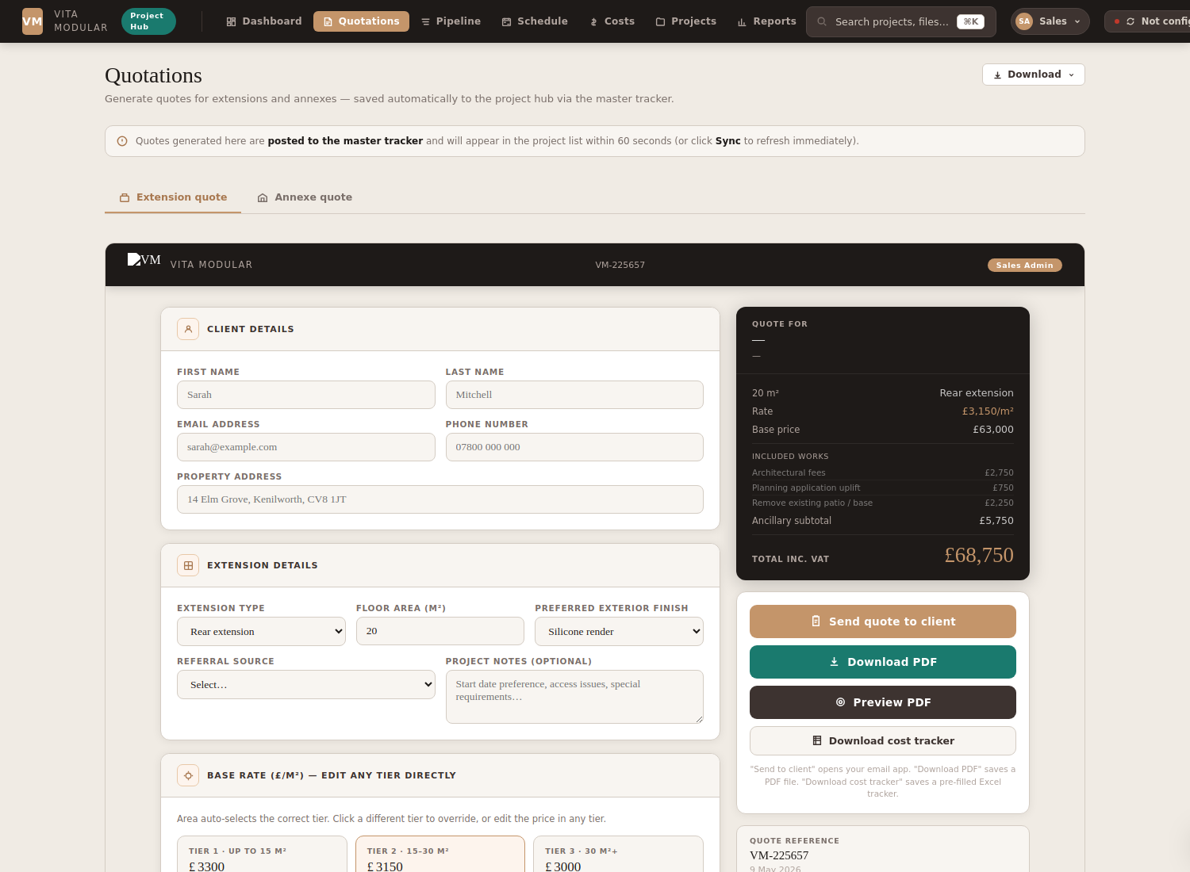
The Quotations view — choose extension, annexe or garden room, then fill in the form.

3.1 Two form types
- Extension form — for rear, side, two-storey, wrap-around, first-floor, and air-space extensions.
- Annexe form — for 1-, 2-, and 3-bedroom annexes plus garden rooms.

3.2 The quote PDF
Each quote PDF is a 4-5 page A4 landscape document, branded with the Vita Modular cover image, hero photos, breakdown table, floor plan, exclusions, recent project gallery, accreditation badges, and an acceptance signature page.
When you click "Generate quote PDF" on a project, the form opens silently in a hidden iframe, captures the rendered PDF, and saves it as a versioned file in the project. Each subsequent generation increments the version number (v1, v2, v3...) so you have a full audit trail.

3.3 Where the quote ends up
After generation, the PDF appears in the project's "Project files" tab under the "Quote PDFs" group, with a version pill (v1, v2, etc.). It also triggers a local download so you can email it to the client immediately.
Versions matter
Every time you re-generate a quote PDF, the previous version is kept. This means you can always go back and see what was quoted at each stage of the conversation with the client. Useful when reviewing changes that happened during negotiation.

3.4 Quote → contract flow
Once a quote is sent and the client confirms, the typical flow is:
- Generate quote PDF (saves v1, downloads to your machine).
- Email PDF to client.
- If client wants changes, edit the project (area, ancillaries, finish, etc.) and re-generate (saves v2).
- When client accepts, mark stage as "Contract issued" from the stage dropdown on the project header.
- Generate the contract document (saves a versioned XLSX contract file).
- On signature, mark stage as "Signed" and the project drops into the build pipeline.

4. Pipeline
The pipeline view is your sales-team-friendly table of every project in flight, with all the metadata you need to manage the funnel.
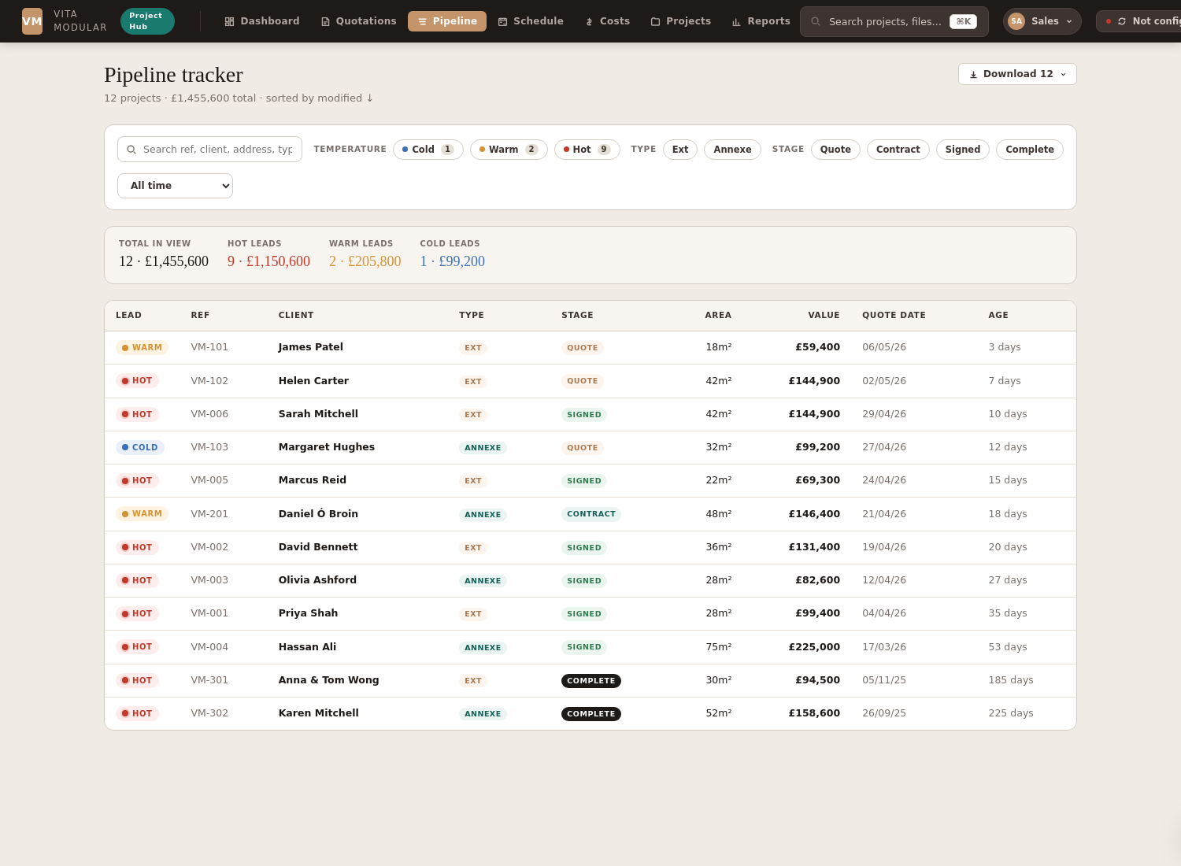
The pipeline tracker. Sortable, filterable, exportable.

4.1 What's in the table
Each row is one project with these columns: ref, client name, lead temperature (cold/warm/hot), project type (extension / annexe / garden room), specific build type, area in m², contract value, current stage, lead source, and date created. Click any column header to sort by that column.

4.2 Lead temperature
Three coloured indicators show how hot a lead is:
- Hot — actively engaged, likely to close soon.
- Warm — interested, in discussion, but not committed yet.
- Cold — enquired but gone quiet, or expected long lead time.
Click the indicator dots on a project's detail page to change its temperature.

4.3 Stages
Each project has a stage:
- Quote — quote provided, awaiting decision.
- Contract issued — contract document sent, awaiting signature.
- Signed — contract signed, project in the build pipeline.
- Complete — handover done, build finished.
Change stage from the dropdown on the project's detail page header.

4.4 Filtering and download
Click any column header to sort. The header row above the table shows total count, total value, and the breakdown by lead temperature.
The "Download" button (top right of the pipeline header) lets you export the current view two ways: "PDF report" opens a print-friendly version in a new tab, and "Excel spreadsheet" downloads an .xlsx file with all 18 columns of project data — useful for sharing with people who don't have access to the hub or for further analysis.

5. Schedule
The Schedule view tracks every signed project's build timeline and helps you plan install capacity. Two tabs at the top switch between modes.

5.1 Build timeline (Gantt)
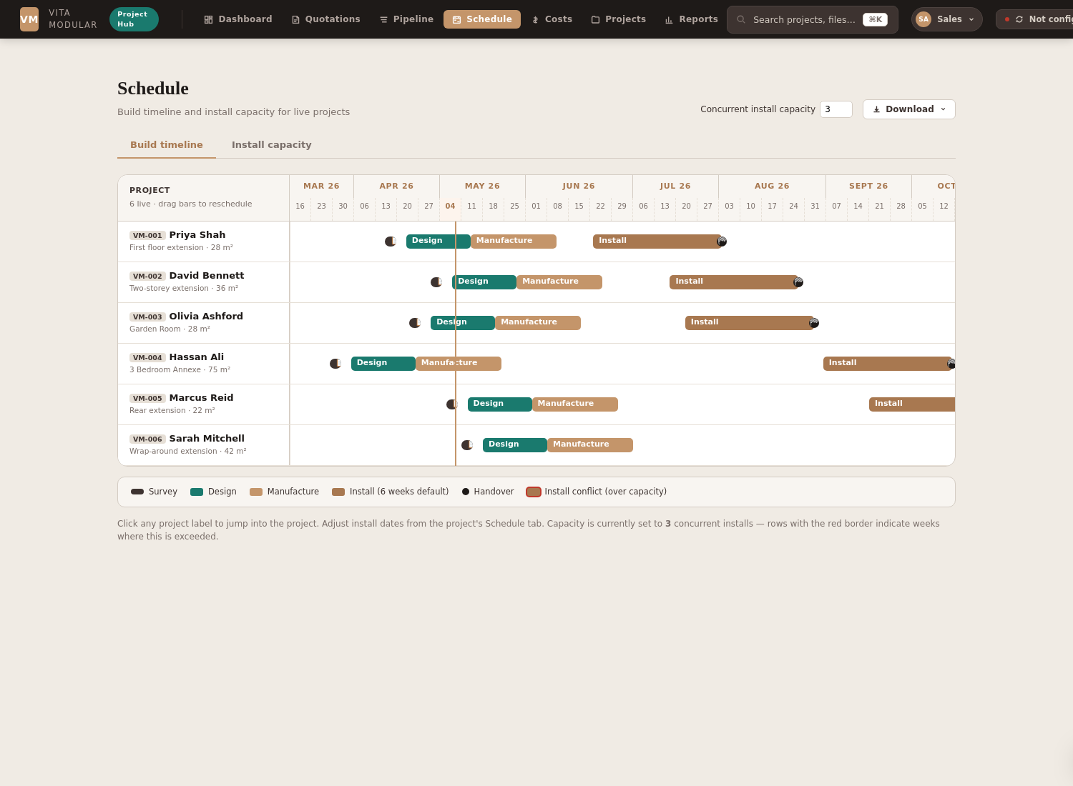
Gantt timeline — each row is a project, bars show phases.
Every project that has reached the Signed stage shows up as a row, with five colour-coded phase bars across the months:
- Survey — small ink-coloured dot, single visit to confirm dimensions and access.
- Design — teal bar, 21 days by default. Drawings and final spec.
- Manufacture — terracotta bar, 28 days by default. Off-site construction of the modular elements.
- Install — darker terracotta bar, 42 days (6 weeks) by default. On-site assembly. This is the slot that counts against your install crew capacity.
- Handover — ink-coloured circle marking the end of install.
A vertical terracotta line marks "today" so you can see at a glance where you are in the calendar.

5.2 Conflict detection
When more projects are scheduled to install simultaneously than your capacity allows, the latest-starting projects (the ones beyond capacity) get flagged with a red left border on their row and a "⚠ install conflict" marker in their meta line.
Click a project label to jump straight into that project's Schedule tab where you can adjust dates.

5.3 Install capacity
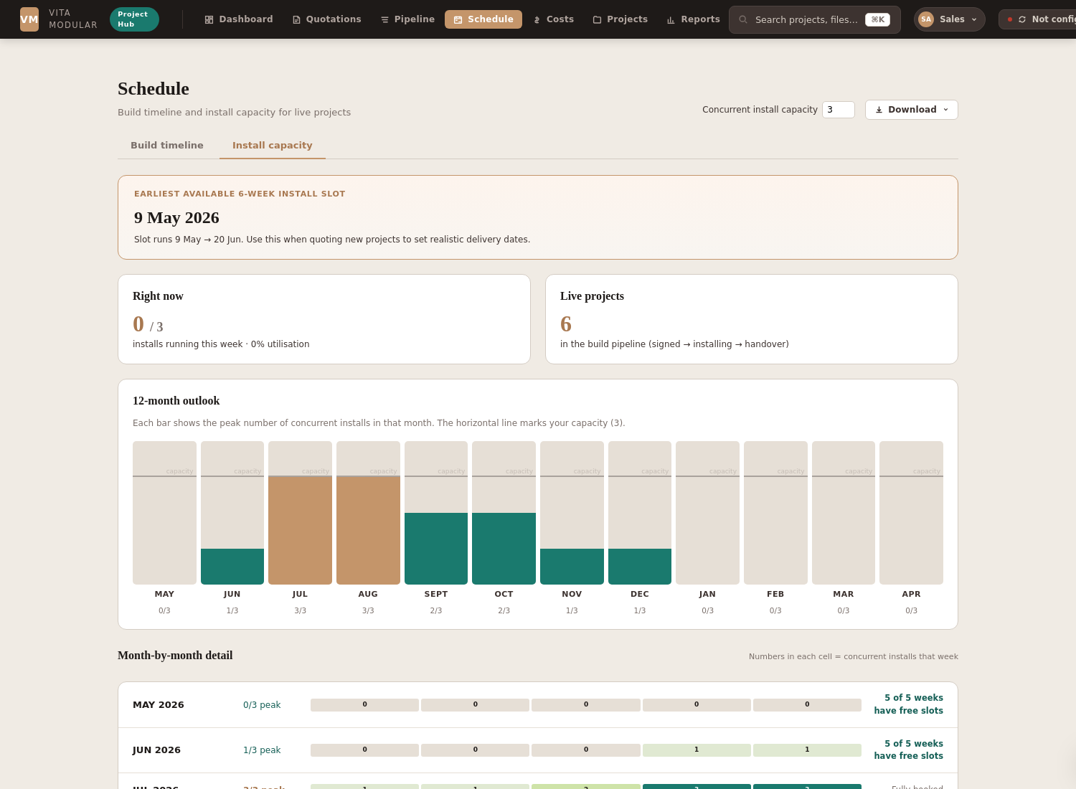
12-month capacity outlook with peak load per month.
Click "Install capacity" to switch to the planning view:
- Earliest available 6-week install slot — the headline. Use this date when quoting new projects to set a realistic delivery promise.
- Right now — current week utilisation, e.g. 0/3 means no installs running this week against capacity 3.
- Live projects — how many are in the build pipeline.
- 12-month outlook chart — each bar shows the peak number of concurrent installs in that month, with your capacity line overlaid. Months above capacity render red.
- Month-by-month detail — breakdown of every week showing exact concurrent install count, with a status pill (Slots available / Fully booked / Over capacity).

5.4 Capacity setting
Top right of the Schedule header, the "Concurrent install capacity" number can be adjusted between 1 and 10. Default is 3. Set this to match your actual install crew capacity. Both the Gantt and Capacity views recalculate live when you change it.
Setting persists in your browser's storage so it survives reloads.
Use the quote helper
When quoting a new project, open the Schedule view and look at the "Earliest available 6-week install slot" date. Use that date as the install start in your client conversation. It accounts for everything already in your pipeline so you don't end up promising dates you can't deliver.

6. Costs
The Costs view aggregates per-project cost analysis from your CVR (cost variation report) or final-account spreadsheets. Use it to see margins across all completed projects and spot patterns.
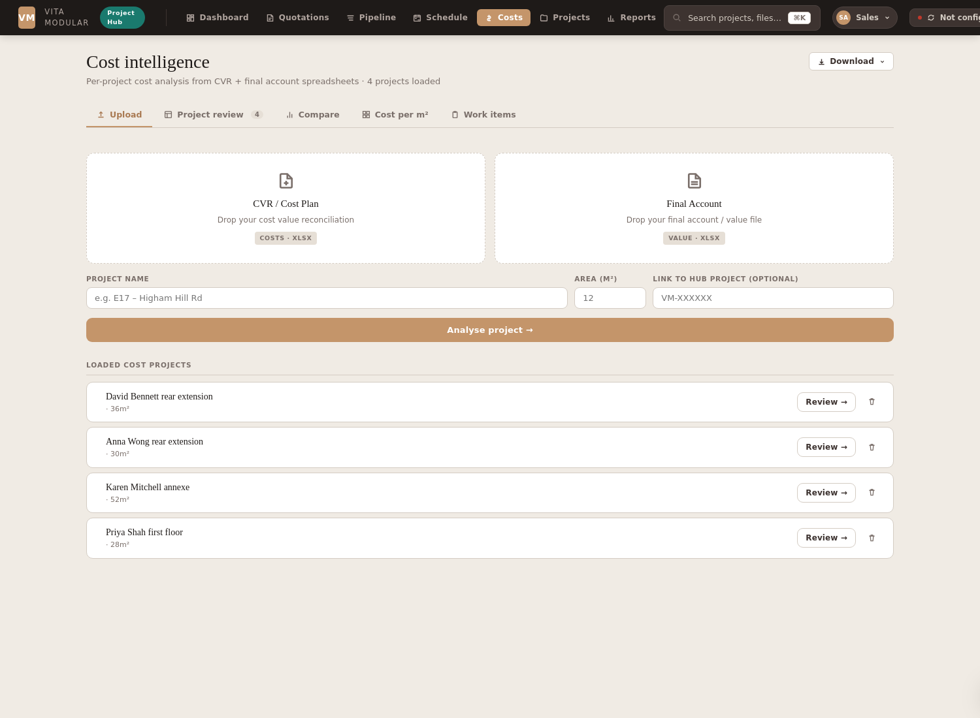
Cost intelligence view with sample data loaded.

6.1 Loading cost data
Drop a cost spreadsheet (XLSX) onto the Costs view, or click "Add cost project". The hub parses the spreadsheet and extracts contract value, actual cost, and a breakdown of items. Each loaded project becomes a row in the cost intelligence list.

6.2 Per-project margin analysis
Each project shows: contract value, actual cost (CVR), gross margin, margin percentage, and cost per m². Margin percentages are colour-coded:
- Green pill — ≥20% margin, healthy.
- Amber pill — 10–20% margin, tight but acceptable.
- Red pill — <10% margin, at risk — investigate.

6.3 Cost per m²
A useful comparison number across projects of similar type. If one rear extension is costing you significantly more per m² than typical, it's worth investigating why. Common causes: ground conditions, scope creep, supplier price changes.

6.4 Download
The "Download" button in the Costs header gives you two options: "PDF report" opens a multi-page formatted report (total contracted vs. total cost, blended margin %, healthy/tight/at-risk project counts, and a per-project detail table). "Excel spreadsheet" downloads the per-project margin data as an .xlsx so you can run your own analysis or filter it differently.

7. Projects
The Projects view is where you drill into a single project. Pick a project from the sidebar list (or jump there from any other view) and four tabs let you work with different aspects.

7.1 Contract document tab
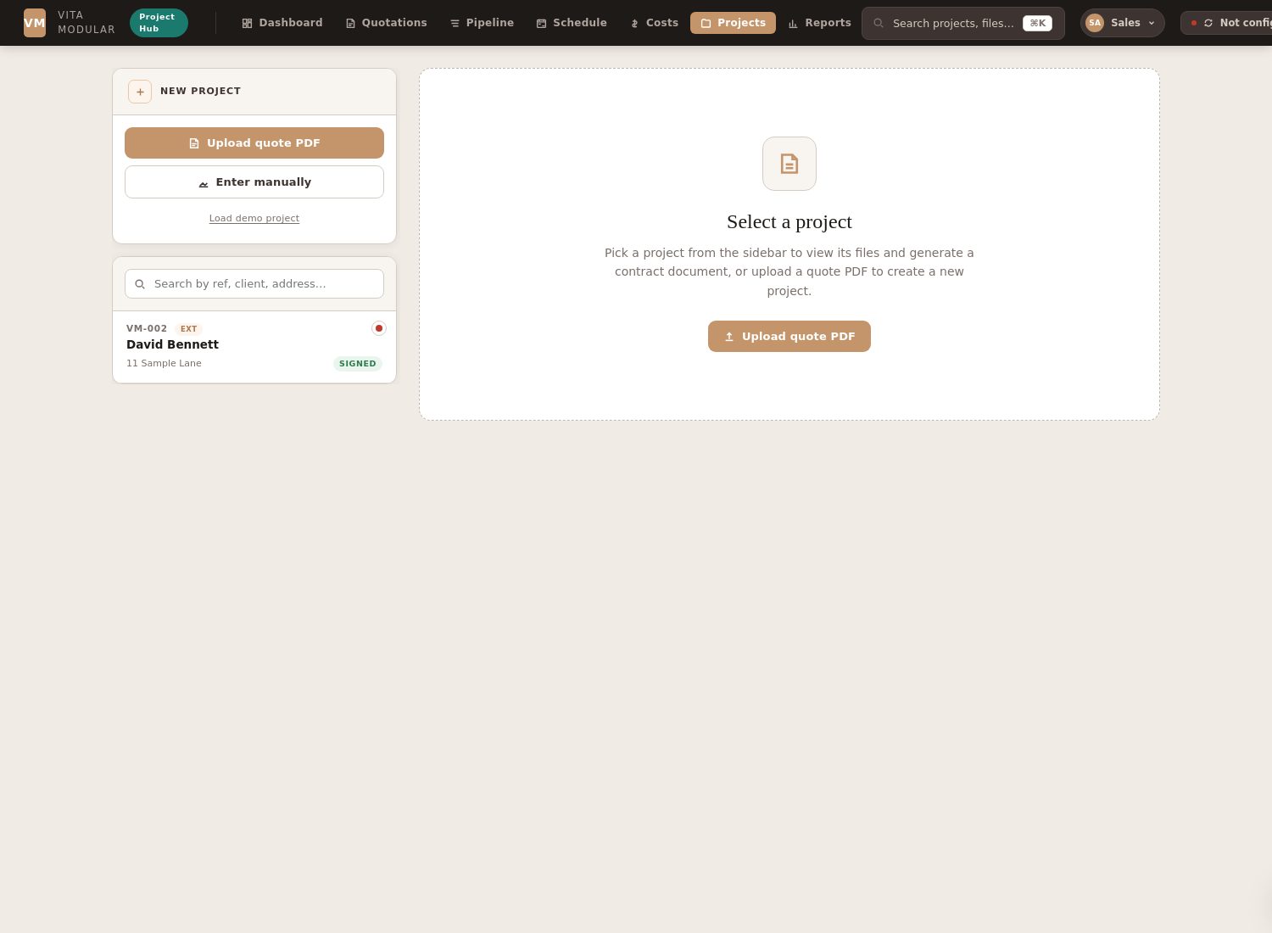
The contract document tab — full editable form for the project.
This tab holds every editable field that goes into a contract:
- Client details (name, email, phone, address)
- Project details (extension type, finish, area in m², rate, base price)
- Ancillary services and works (add/remove rows for each item with prices)
- Discount (percentage or fixed amount)
- Specifications (kitchen, sanitary, floor, glazing, doors, heating, roof, external)
- Allowances and electrical fittings
- Project notes (free-form text for any commercial notes)
At the bottom of the tab, the contract total is computed live as you edit. Changes are saved automatically.

Action buttons
At the bottom of the project view, four buttons let you generate documents:
- Download project — dropdown with two options: PDF report (a polished single-project summary suitable for handover) or Excel spreadsheet (4-sheet workbook with all client, contract, schedule, and files data).
- Generate quote PDF — creates a versioned PDF quote and saves it to the project files.
- Generate cost tracker — exports an XLSX cost tracker for site management.
- Generate contract — produces the formal XLSX contract document, versioned per generation.

7.2 Build schedule tab
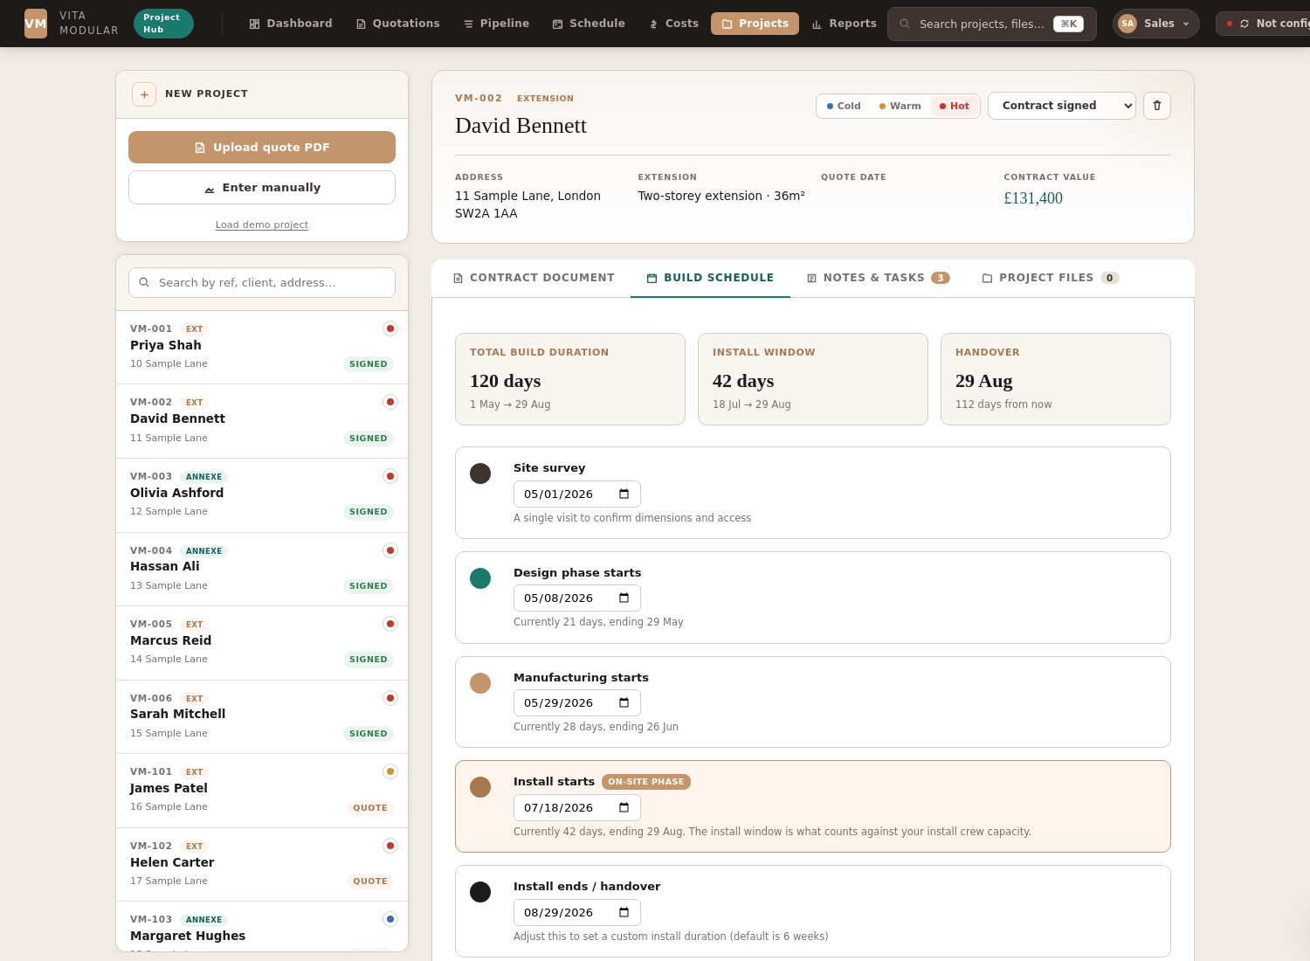
Per-project schedule editor with summary cards.
Every project has scheduling dates that drive its appearance on the Schedule view. The Build schedule tab is where you set them.

Summary cards
Three cards at the top show: total build duration (from survey to handover), install window length, and handover date with a countdown.

Phase editors
Below, five date editors let you change each phase's start date:
- Site survey
- Design phase starts
- Manufacturing starts
- Install starts (highlighted — this is the date that counts against capacity)
- Install ends / handover
Defaults are computed from the contract signed date (survey +7 days, design 21 days, manufacture 28 days, install 42 days). Override any of them and the change applies immediately.

Reset to defaults
Click "Reset to defaults" at the bottom to remove all custom dates and revert to the auto-computed schedule. Useful if you've been experimenting with dates and want to start over.

7.3 Notes & tasks tab
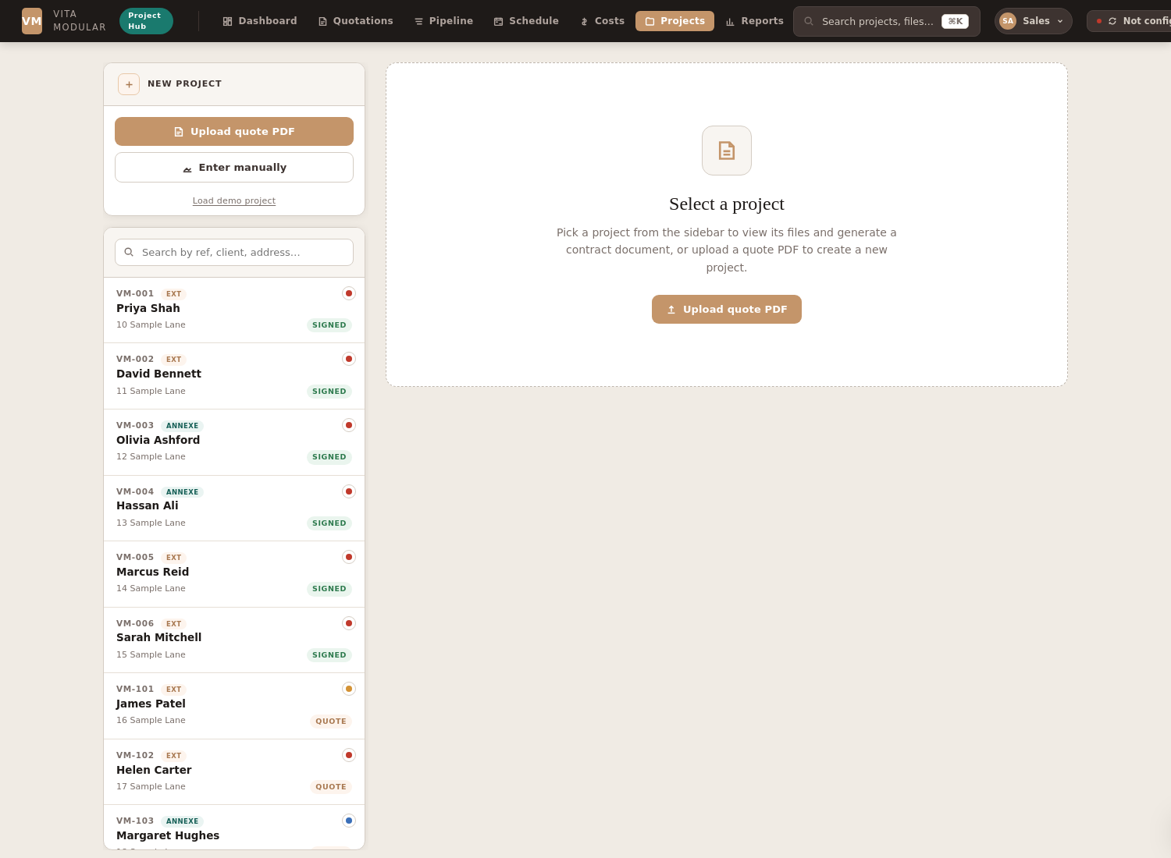
Notes & tasks tab with sample data — tasks at the top, notes feed below.

Tasks
A tickable checklist of things to do for the project. Each task has:
- Title (what needs doing)
- Optional description (any extra context)
- Assignee (a team member from your team list)
- Due date (with overdue marker in red if past)
- Status (open or done)
Filter pills at the top let you switch between Open / Mine / All. The "Mine" filter only shows tasks assigned to you (the active user). Tasks sort with overdue first, then open by due date, then completed at the bottom.
Click the checkbox to mark a task done. It moves to the bottom of the list with a "completed [date]" marker. Click again to re-open it.

Notes
A chronological audit log of project activity. Each note has the author's avatar, name, full timestamp, and the body text. Use these to capture conversations, decisions, observations, and anything else you need a record of.
Notes can't be deleted — they're an audit trail. The author and timestamp are snapshotted at write time, so even if you change your team list later, historical notes keep their original attribution.

Download
A small "Download" button at the top of the tab gives two options. "PDF report" opens a 3-page formatted report (cover summary, full task list with completed tasks at the bottom, chronological note feed) — useful for printing at handover or sharing with a client. "Excel spreadsheet" downloads a workbook with two sheets (Tasks and Notes) for further analysis.

7.4 Works checklist tab
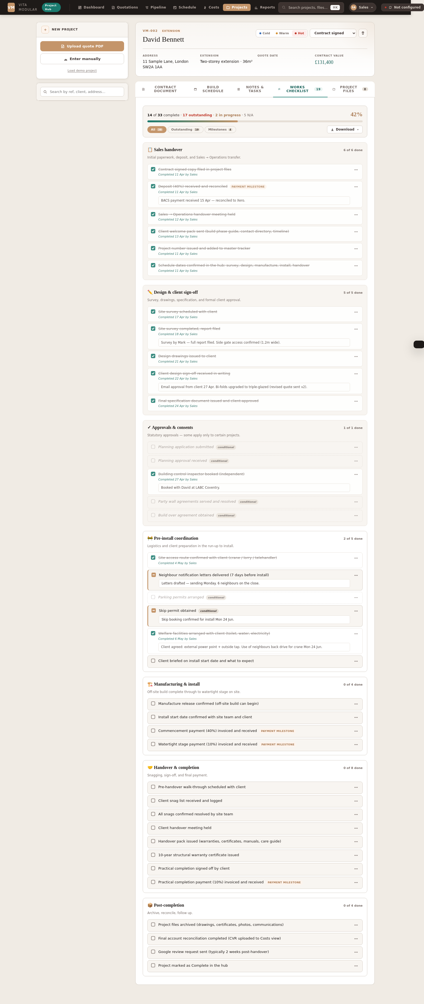
Works checklist — sales/ops items grouped by phase, with progress bar at top.
The Works checklist tracks every operational step that sales and operations own, from the moment a contract is signed through to project archive. 38 items grouped into 7 phases, each tickable with notes and photo evidence.

Progress bar and filters
The header shows your overall progress as both a percentage and a count ("14 of 33 complete · 17 outstanding · 2 in progress · 5 N/A"). The progress bar fills with a teal-to-terra gradient as you tick items off. Three filter pills below let you switch between All, Outstanding (open + in progress), and Milestones (the four payment milestones only).

The seven phases
- Sales handover — deposit reconciliation, sales-to-ops handover meeting, client welcome pack, project setup in the hub.
- Design & client sign-off — site survey, drawings, written client approval, final spec.
- Approvals & consents — planning, building control, party wall, build over (most marked conditional — only apply on certain projects).
- Pre-install coordination — site access, neighbour letters, parking permits, skip permits, welfare facilities, install briefing.
- Manufacturing & install — manufacture release, install confirmation, the 40% commencement payment (due when on site), and 10% watertight payment.
- Handover & completion — pre-handover walk-through, snag list, handover meeting, warranty certificate, practical completion sign-off, and the final 10% payment.
- Post-completion — project archive, CVR upload, Google review request, mark complete in the hub.

Item statuses
Click the checkbox on any item to cycle through statuses: outstanding (empty box) → in progress (terra square with dash) → complete (teal square with tick) → back to outstanding. The completed date and the user who marked it complete are recorded automatically.
Items marked "conditional" (e.g. planning application, party wall, skip permit) can also be marked "Not applicable" via the … menu — they then appear dashed and italic so you can see at a glance they were considered and dismissed.

Payment milestones
Four items are flagged as payment milestones with a terra "PAYMENT MILESTONE" badge:
- Deposit (40%) — at contract signature.
- Commencement (40%) — when work starts on site.
- Watertight (10%) — when the build reaches watertight stage.
- Practical completion (10%) — at handover.
Use the Milestones filter pill to see just the four — useful as a billing checklist.

Notes and photos per item
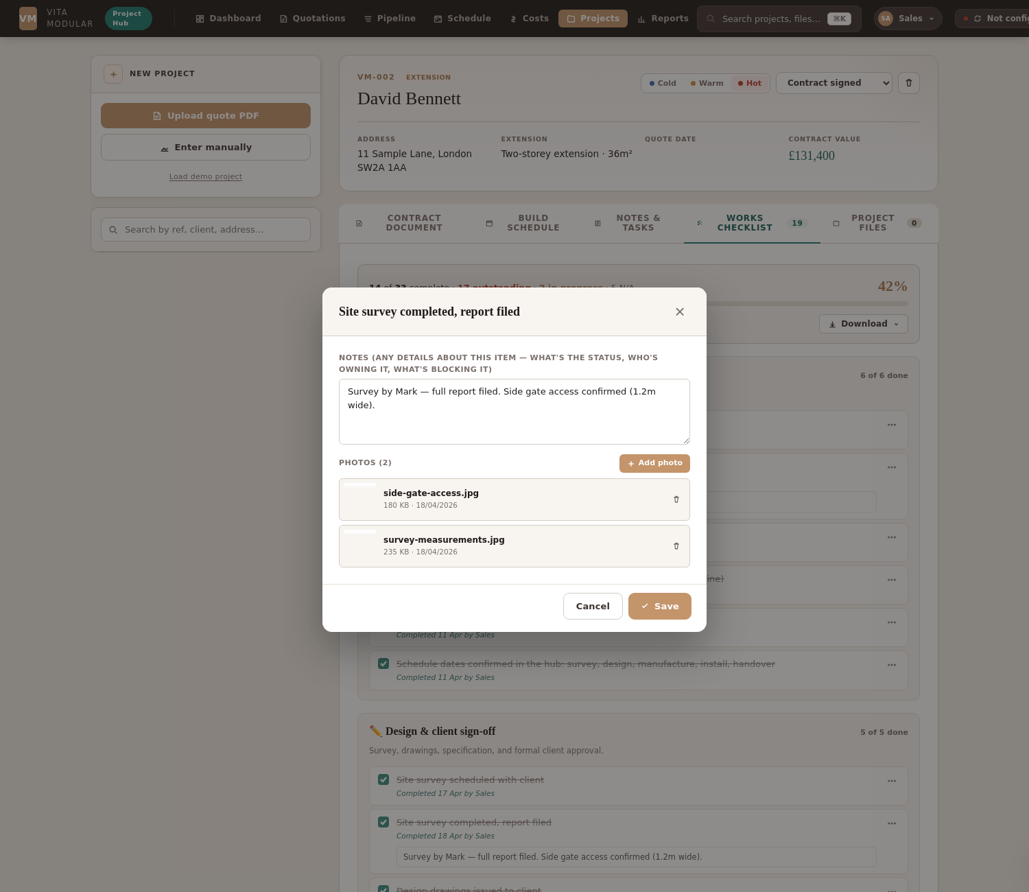
The item editor — add notes and photos as evidence.
Click the … button on any item, choose "Edit notes & photos", and you can attach detail to that step:
- Notes — free text, e.g. "BACS payment received 15 Apr — reconciled to Xero", or "Letters drafted — sending Monday. 6 neighbours on the close." Notes appear inline on the item row in the checklist view.
- Photos — upload images from your device. Useful for site access shots, snags, completion evidence, or anything visual worth recording. Thumbnails appear inline on the item row, and full-size images are included in the print report's photo evidence appendix.

Download
A "Download" button at the top of the tab gives the same two options as elsewhere in the hub. PDF report opens a multi-page printable version (cover summary, full checklist by section, photo evidence appendix at the end). Excel spreadsheet downloads a 2-sheet workbook (Summary KPIs and full Checklist).
Use the Milestones filter for billing
When invoicing, switch to the Milestones filter — you'll see only the four payment-trigger items. Tick each one off as the invoice goes out and is reconciled. The completed dates form a payment trail you can refer back to without digging through accounts.

7.5 Project files tab
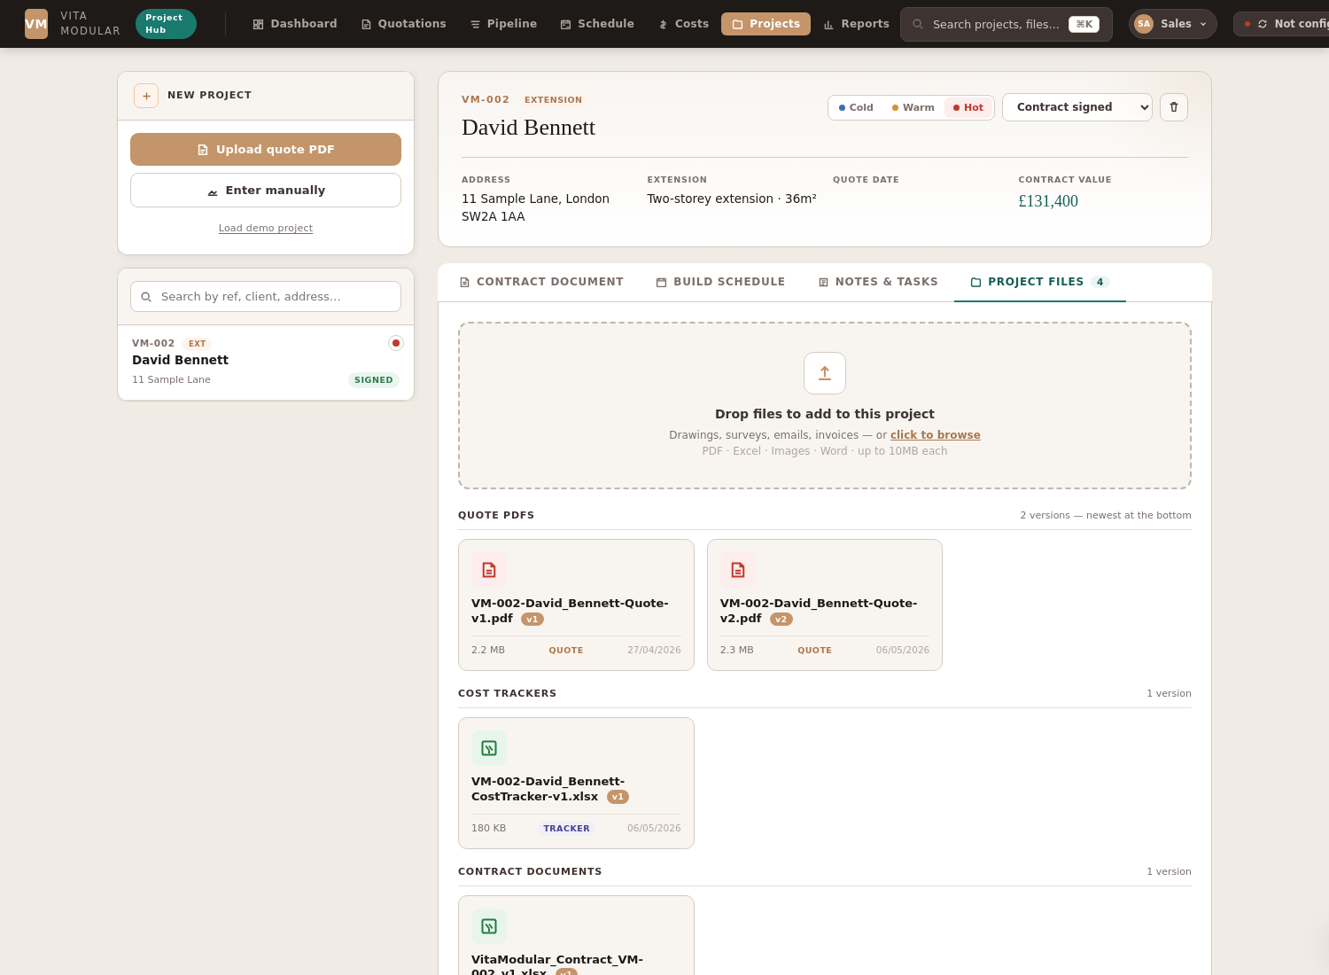
Files tab — grouped by kind, with version pills.
All files attached to the project, grouped by kind:
- Quote PDFs — each generation of the quote, versioned (v1, v2, v3...).
- Cost trackers — XLSX files for site cost management.
- Contract documents — versioned XLSX contracts.
- Other files — anything else uploaded to the project (drawings, photos, etc.).
Drag and drop any file onto the tab to upload it. Click any file to download it. The version pill on each file makes it easy to find the latest one.

8. Reports, downloads & printing
Every main view in the hub has a "Download" button in its header. Click it to open a dropdown with two options: PDF report (formatted, print-ready) or Excel spreadsheet (raw data, editable). Pick the format that fits what you need to do next.
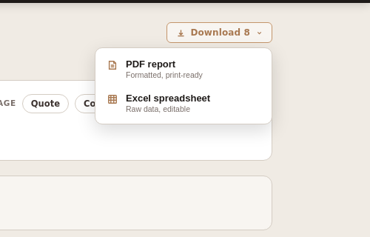
The Download menu — same place in every view, two options.

8.1 PDF or Excel — which to pick
- PDF report — pick this when you need a polished, branded document to print, email to a client, or save for the record. Includes a cover page with KPIs, summary tables, charts where relevant, and is laid out for the page.
- Excel spreadsheet — pick this when you need to do something with the data: filter it differently, build a pivot table, share it with someone who wants to slice it themselves, or feed it into another system. Includes only the underlying data with column headers — no formatting or charts.

8.2 The reports

Dashboard
PDF: business performance for the selected date range — 4 KPI cards, lead source breakdown, top 10 quotes by value. Excel: 2 sheets — Summary (all KPIs + lead source counts) and Quotes (every quote in the period with key fields).

Pipeline
PDF: every project in flight as a sortable table with header KPIs. Excel: 18-column workbook with reference, client, type, area, value, stage, source, dates, and notes.

Schedule
PDF: 4 pages — cover with earliest install slot and current utilisation, A3 Gantt timeline, 12-month capacity outlook, project detail list. Excel: every signed project with all 6 phase dates plus install conflict flag.

Costs
PDF: per-project margin analysis with cover stats. Excel: contract value, actual cost, margin £ and %, cost per m², and at-risk/tight/healthy status for every loaded project.

Quotations
PDF: 50 most recent quotes split into extension, annexe and garden room sections. Excel: a single sheet with all 50 plus their stage, value, source, and lead temperature.

Project (single project)
PDF: full deliverable for one project — A4 portrait, suitable for client handover. Excel: 4-sheet workbook (Summary with all client and contract details, Ancillaries line items, Schedule phase dates, Files list).

Notes & tasks (per project)
PDF: A4 portrait with cover summary, task list with status pills, chronological note feed. Excel: 2-sheet workbook (Tasks and Notes) for filtering or analysing per-team-member workload.

Works checklist (per project)
PDF: A4 portrait with cover progress stats, full checklist grouped by phase with completion dates and inline notes, plus a photo evidence appendix at the end of the document. Excel: 2-sheet workbook (Summary KPIs and full checklist with status, completion date, completer, notes, and photo count per item).

Reports view
A flexible report builder where you can filter projects by date range, type, and stage, then download with the same PDF/Excel choice. The PDF goes to the matching report (pipeline or quotations) and the Excel is custom to the filter you set.

8.3 Printing tips
Save as PDF
When the PDF report opens in a new tab, click "Print or save as PDF" in the corner. In the print dialog, select "Save as PDF" as the destination instead of a printer — gives you a clean PDF file you can email or archive. Tick "Print backgrounds" in More settings; without it, the terracotta cover band and coloured pills won't render in some browsers.

9. Team & users
The hub supports a small team list — anyone in your business who creates notes or gets assigned tasks. Setup is quick and only needs to be done once.

9.1 The user picker
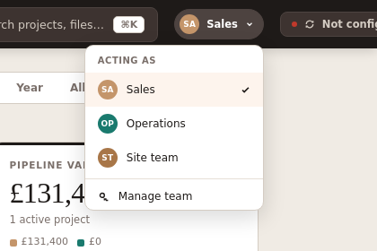
User menu — click your avatar in the topbar to open it.
Top right of the topbar, the user picker shows whoever is currently the active user. The active user is who notes and tasks are attributed to. Click the picker to open a dropdown showing all team members, with the active one highlighted. Click a name to switch.
The picker also has a "Manage team" link at the bottom that opens the team modal.

9.2 Team modal
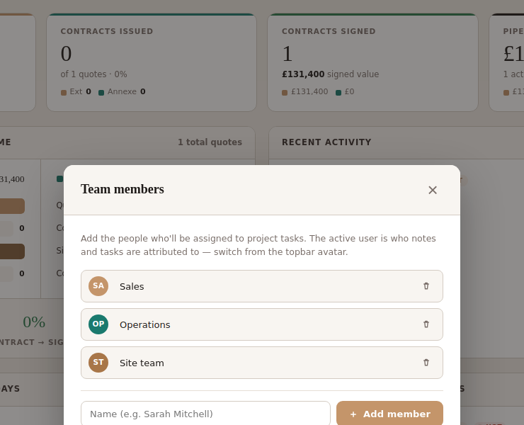
Team modal — add, rename, or remove members.
In the team modal you can:
- Edit any member's name (click into the name field, type, click out)
- Delete a member (bin icon — confirms first; their open tasks become unassigned, but their historical notes keep their author info)
- Add a new member (type their name in the bottom input, click "Add member")
Each member gets an automatic colour from a 12-colour palette. You can't change colours manually — this keeps the avatar visuals consistent.

9.3 Default team
On first load, the hub seeds three default team members: Sales, Operations, and Site team. Replace these with your actual team members when you set up. The default seed exists so the feature works out of the box without configuration.

9.4 What persists
Team list and active user selection are stored in your browser's localStorage, so they're per-browser. Each person using the hub on their own device will have their own active user and can pick whoever they're acting as.
If two people share the same browser, they'll see the same team list — the active user picker is for setting attribution on notes and tasks they create.

10. Tips & troubleshooting

10.1 Keyboard shortcuts
- ⌘K (Cmd+K) — open the search bar to find any project by ref, name, or address.
- ⌘+Enter — inside a note text area, save the note without moving to the button.
- Esc — close any open modal (team, search).

10.2 Search
The search bar (top of the topbar) accepts partial matches on:
- Project reference (e.g. "VM-002" or just "002")
- Client name (e.g. "Bennett")
- Address (e.g. "Sample Lane")
- File names (e.g. "v3" to find all version-3 files)

10.3 Demo project loader
On the dashboard, the "Load demo project" link adds 12 sample projects with realistic data spread across all stages. Use it to explore the hub or train a new team member without touching real data. Click again to refresh the demo data.

10.4 Sync indicator
Top right of the topbar shows a sync status indicator. Green dot means everything is up to date with the master tracker spreadsheet. Red "Not configured" means the tracker URL isn't set up — that's fine for offline-only use, but means new quotes from the live forms won't auto-sync.
Click the sync button to manually trigger a sync at any time.

10.5 Common issues

"Pop-up blocked" when downloading a PDF report
PDF reports open in a new tab. Some browsers block this by default. The first time you see this, click the pop-up icon in the address bar and choose "Always allow pop-ups from this site". Then re-click Download → PDF report.

Quote PDF generation seems stuck
PDF generation runs in a hidden iframe and can take 5–15 seconds for the first generation (because the embedded form has to load all its assets). Subsequent generations are faster. If it's been more than 30 seconds with no result, check the browser's console (F12) for errors and reload the hub.

"This site can't be reached" or assets failing to load
The hub uses a CDN to load supporting libraries (jsPDF for PDF generation, etc.). On first load, your browser needs internet access to fetch these. After that, they're cached and the hub works offline. If you need to use the hub on a fully offline machine, reach out for a fully bundled version.

Browser storage full
After many quote PDFs, the browser's localStorage can fill up (typical limit is 5–10 MB per origin). If saving a project fails with an out-of-space error, delete some old completed projects from the Pipeline view, or clear the demo data.

10.6 Backups
Project data lives in your browser's storage. If you switch browsers or wipe your profile, the data is gone. We recommend periodic backups:
- Download pipeline to Excel weekly — gives you a snapshot of every project's key metadata. Use Pipeline → Download → Excel spreadsheet.
- Save print reports as PDF at major milestones (project signed, project complete) — captures the state at that moment. Use any view's Download → PDF report.
- Keep generated quote and contract files on your file server — they're saved in the project's files tab but should also live somewhere stable.

11. What's coming next
The hub is fully featured for sales and operations day-to-day work. A few things are on the roadmap for future iterations:
- Drag-to-reschedule on the Gantt timeline — grab and slide a project's install bar to a new date, with conflict detection updating live.
- Global "my open tasks" inbox on the dashboard — surface every overdue or upcoming task assigned to you across all projects.
- Bulk operations from the pipeline — select multiple projects and update temperature, stage, or assignee in one go.
- Deeper conversion analytics — time-to-conversion, source ROI, and seasonal patterns visualisations.
- Email and calendar integration — surface client communications inline on the project page.

11.1 Feedback
The hub is built for you. If something doesn't work the way you'd expect, or you have an idea for a feature that would save time, raise it — that's how the hub keeps improving.

