

A

Project Report

On

Sorting Visualizer

Submitted in partial fulfillment of the requirement for the V semester

Bachelor of Technology

By

Nitin Bisht

Aman Mehta

Rohit Belwal

Rohan Salal

Under the Guidance of

Mr. Lalit Kumar

Assistant Professor

Department of CSE

DEPARTMENT OF COMPUTER SCIENCE & APPLICATIONS GRAPHIC ERA HILL UNIVERSITY, BHIMTAL CAMPUS

SATTAL ROAD, P.O. BHOWALI,

DISTRICT- NAINITAL-263132

2022 - 2023


STUDENT’S DECLARATION

We, Nitin Bisht, Aman Mehta, Rohit Belwal, Rohan Salal hereby declare the work, which is being presented in the project, entitled “Sorting Visualizer” in partial fulfillment of the requirement for the award of the degree B.Tech in the session 2022-2023, is an authentic record of our own work carried out under the supervision of “Mr. Lalit Kumar”, Assistant Professor, Department of CSE, Graphic Era Hill University, Bhimtal.

The matter embodied in this project has not been submitted by us for the award of any other degree.

Date: …………

……………….

(Full signature of students)

CERTIFICATE

The project report entitled “Sorting Visualizer” being submitted by Nitin Bisht, Aman Mehta, Rohit Belwal, Rohan Salal to Graphic Era Hill University Bhimtal Campus for the award of bonafide work carried out by them. They have worked under my guidance and supervision and fulfilled the requirement for the submission of report.

(…………………)

Project Guide

(……………………)

(HOD, CSE Dept.)

ACKNOWLEDGEMENT

We take immense pleasure in thanking Honorable “Mr. Lalit Kumar” (Assistant Professor, CSE, GEHU Bhimtal Campus) to permit us and carry out this project work with his excellent and optimistic supervision. This has all been possible due to his novel inspiration, able guidance and useful suggestions that helped me to develop as a creative researcher and complete the research work, in time.
Words are inadequate in offering our thanks to GOD for providing me everything that we need. We again want to extend thanks to our President “Prof. (Dr.) Kamal Ghanshala” for providing us all infrastructure and facilities to work in need without which this work could not be possible.

Many thanks to Professor “Dr. Manoj Chandra Lohani” (Director Gehu Bhimtal), other faculties for their insightful comments, constructive suggestions, valuable advice, and time in reviewing this thesis.

Finally, yet importantly, we would like to express my heartiest thanks to our beloved parents, for their moral support, affection and blessings. We would also like to pay my sincere thanks to all my friends and well-wishers for their help and wishes for the successful completion of this research.

Nitin Bisht,

Aman Mehta,
Rohit Belwal,

Rohan Salal

Table of Contents

1. Introduction……………………………………………………….…….

2. Objectives………………………………………………………...........

3. Feature ………………………………………………………………..

4. Technology Used……………….. …………………………….………

5. Code journey ………………………………………….........…........

6. Screenshots of Project…….………………....................................

7. Testing of project …………………………………………………….

INTRODUCTION

The “Sorting Visualiser” project is basically a web development project which is used to visualize the sorting algorithms and performs the operation of algorithms step by step as the algorithms works like Bubble Sort, Selection Sort , Merge Sort etc. We shuffle the bars in a random order that is in a unsorted order. We perform sorting algorithms on these bars to sort these bars in a ascending order by applying the different algorithms by clicking on the buttons of these sorting algorithms.

The project is based on GUI application,It is a graphical user interface application which is an interface or a window based application or software which runs without the help of internet. The application generates an array and sorts the array according to the selected sorting algorithms.

OBJECTIVE

The main objective of “Sorting Visualizer” project is to learn and visualise the sorting algorithms how these algorithms works We can see the steps of swapping or any divide and conquer part of these bars. Here 5 different types of sorting algorithms is used to visualise.

A visualization of data is implemented as a bar graph, after which a data sorting and algorithm may be applied .The resulting animation is then performed either automatically or by the user, who then sets their own pace.

Sorting_Visualizer
A web application showcasing the inner workings of sorting algorithms.
Implemented algorithms:
- Bubble sort
- Selection sort
- Insertion sort
- Merge sort
- Quick sort
- Heap sort

- Colored representation of step being executed. 1.1) Blue:default 1.2) Yellow: Being compared 1.3) Red: Identified as in incorrect position and to be moved 1.4) Green: In correct position
- 3 Controls for visualizations 2.1) Speed of visualization (5 speed levels) 2.2) Data size () 2.3) Generation of new data (Randomly generate new data).
- Time and Space complexity of algorithm being visualized.

.

Features

• Visualize sorting part: Users can see the steps followed by these
sorting visualizer as it contains five buttons of different algorithms
to sort the bars.

• Shuffle bars : Users can easily shuffle the bars in random order
i.e. with small height or large height of bars

• User Friendly: It’s easy for users and quite simple to operate.

• Ease of Use: Being user friendly environment it is very easy to
operate by just clicking the button for the desired result.

• Colours used: Colours should be used to show whether or not
anything is being compared

• Observe the swapping of bars: when a users apply any sorting
algorithms by clicking the button than these bars start sorting by
swapping according to their height .


Overall Description
Tools and Technology used:-

HTML

Html is a basic low level programming language used to make a
base of the web .It stands for Hypertext Markup Language. For
example, content could be structured within a set of paragraphs, a
list of bulleted points, or using images and data tables. It can be
assisted by technologies such as Cascading Style Sheets and
scripting languages such as JavaScript.

CSS (Cascading Style Sheets)

CSS is the language for describing the presentation of Web
pages, including colours, layout, and fonts. It allows one to adapt
the presentation to different types of devices, such as large
screens, small screens, or printers. CSS is independent of HTML
and can be used with any XML-based markup language.

JavaScript

JavaScript, often abbreviated as JS, is a programming language
that conforms to the ECMAScript specification. JavaScript is high-
level, often just-in-time compiled, and multi-paradigm. It has curly-
bracket syntax, dynamic typing, prototype-based object-
orientation, and first-class functions.
JavaScript is a text-based programming language used both on
the client-side and server-side that allows you to make web pages
interactive. Where HTML and CSS are languages that give
structure and style to web pages, JavaScript gives web pages
interactive elements that engage a use.

WORKING

Bubble Sort VISUALISATION

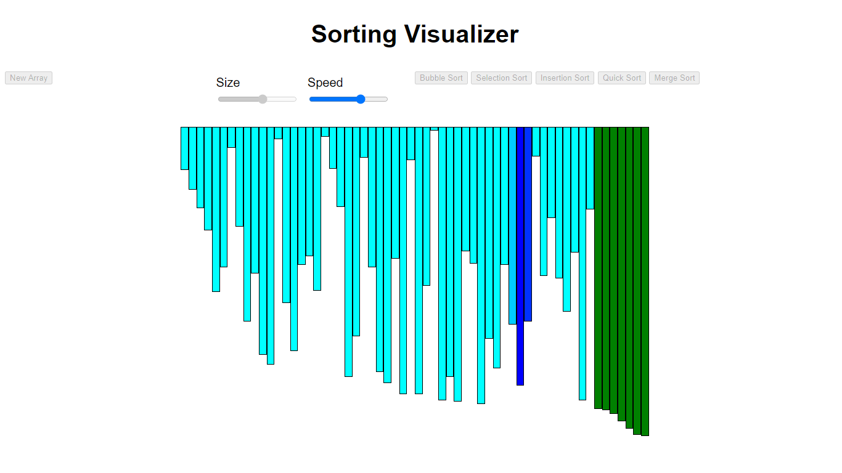

Merge sort visualization
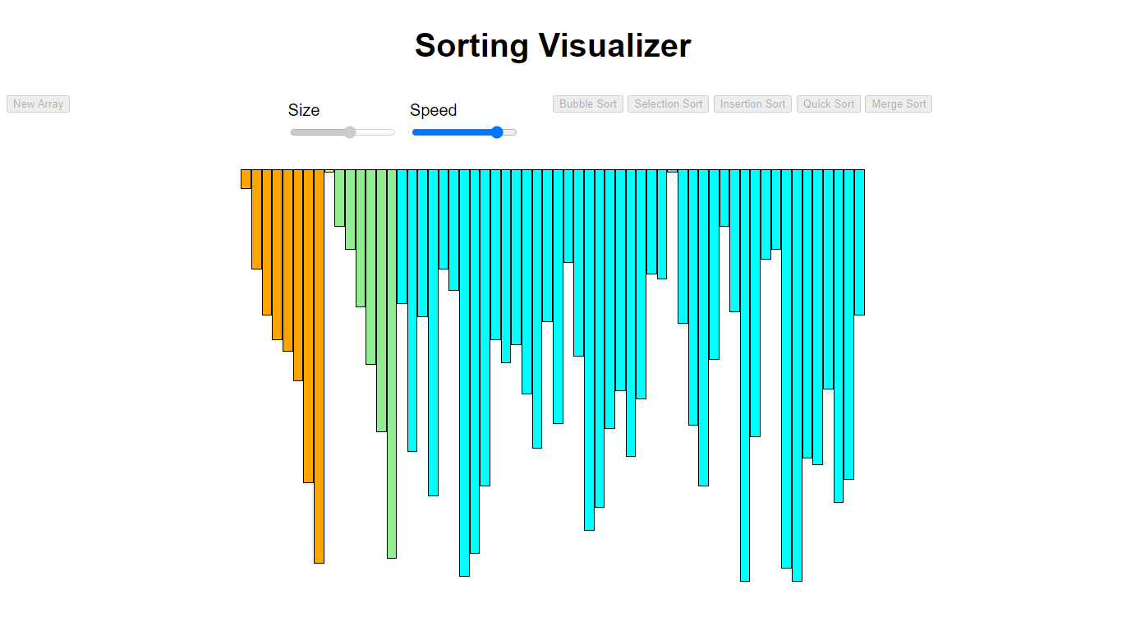

Html Code :

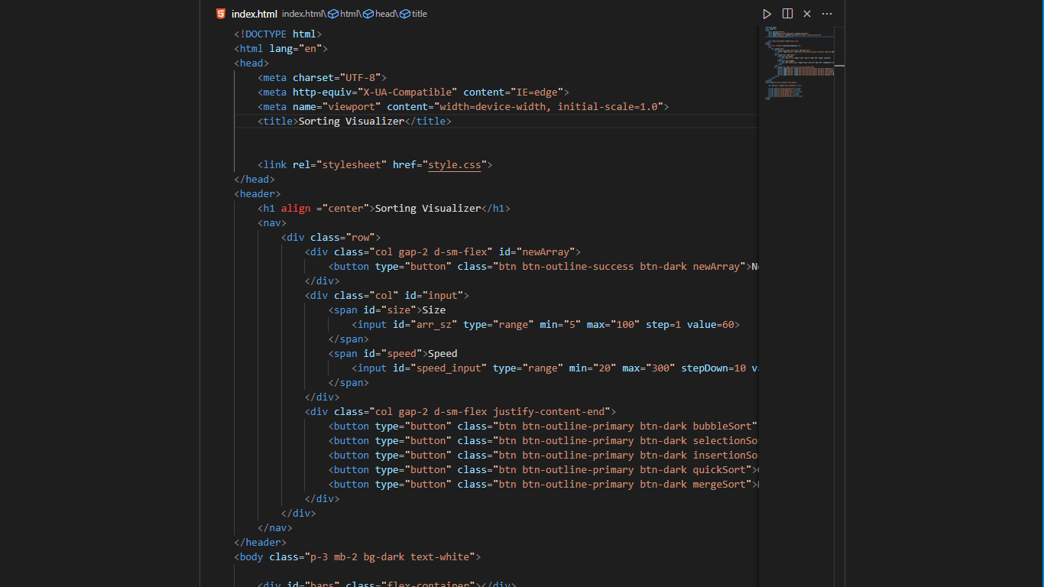

CSS code:

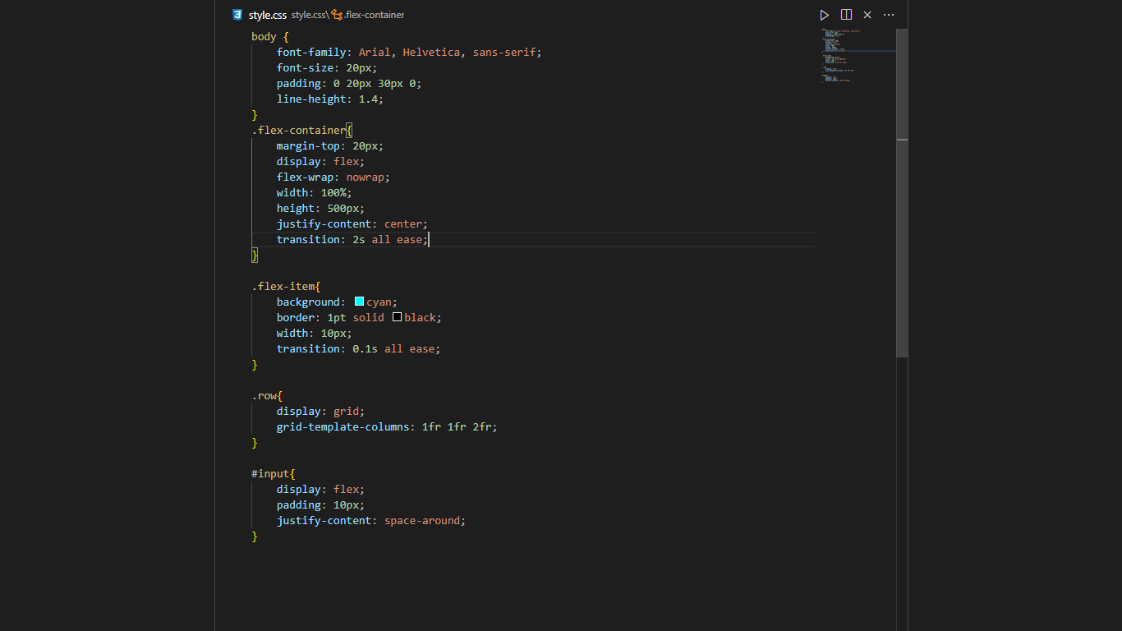

JavaScript Code:
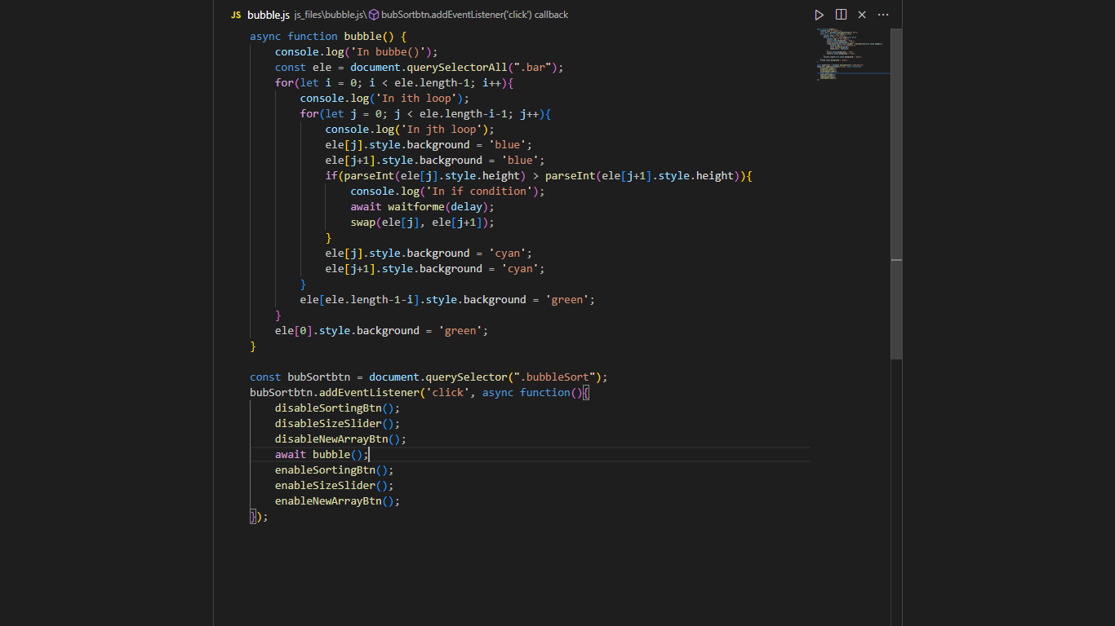
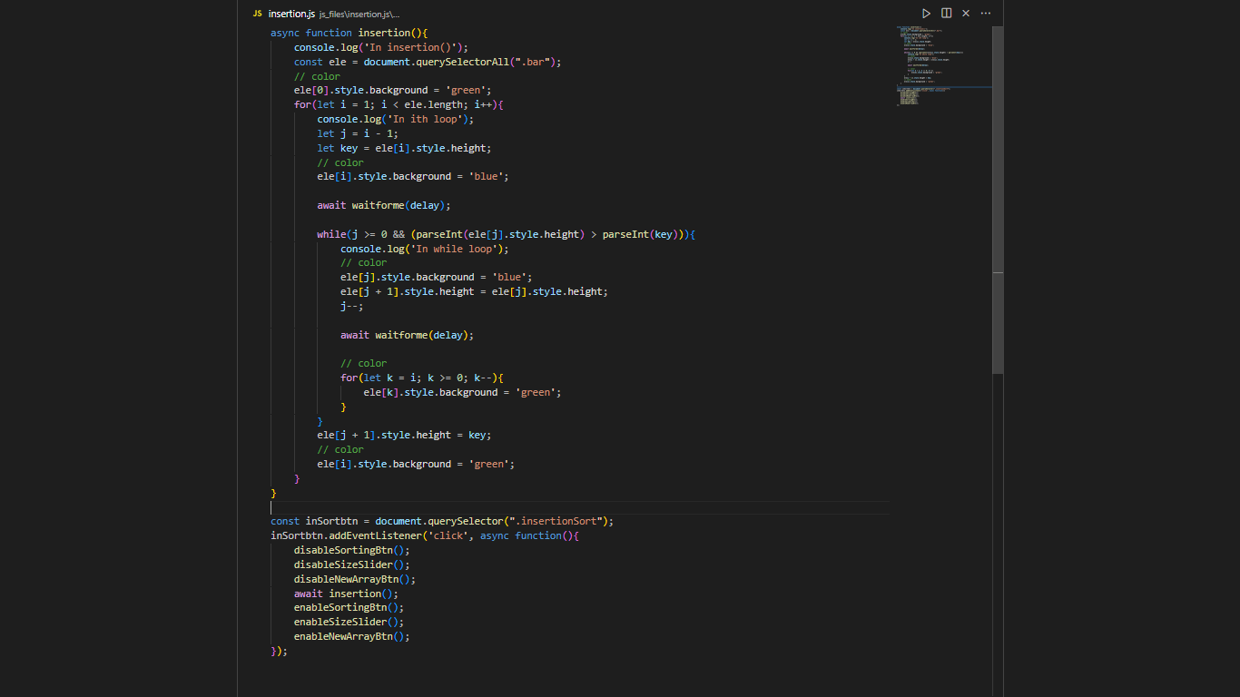
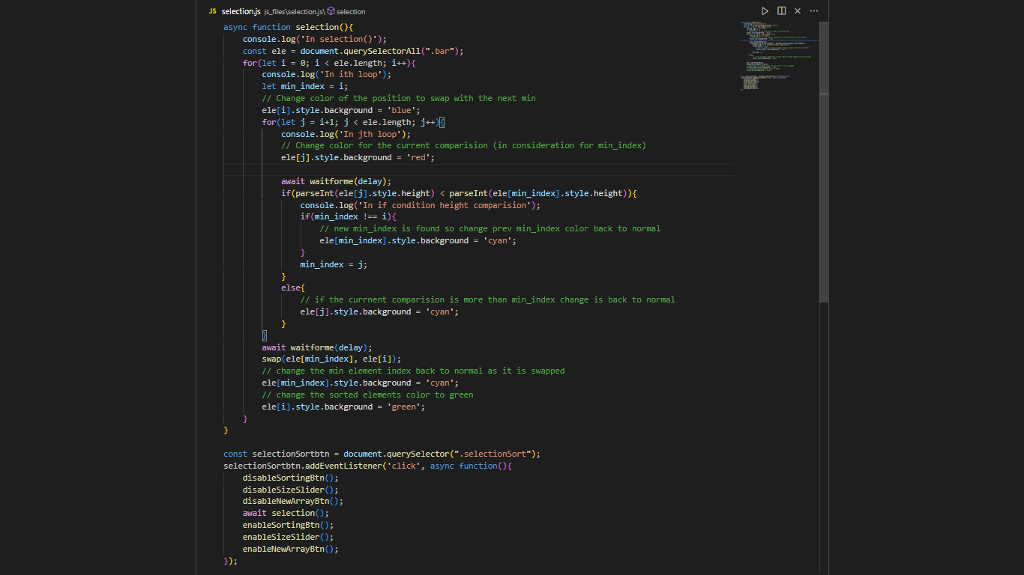

Benefits Of Project
Advantages:

• Efficient Way to visualize the working of sorting algorithms.

• This technique is quite simple to explain to someone in
conversation.

• Colours should be used to show whether or not anything is being
compared.

• Shows expected time to finish up the working of the algorithm to
sort the array.

• User friendly and easy to use.


PROBLEM STATEMENT

We have learnt sorting algorithms like bubble sort, selection sort, insertion sort, quick sort. But often we fail to understand the core idea of a particular algorithm maybe because we are unable to visualize how they work. So the most important thing to understand about these algorithms is visualization.
That’s why we are making this project to let everyone understand how these algorithms work and through this project you also will get a deep understanding of such sorting algorithms.

TESTING OF PROJECT

Software testing can be stated as the process of verifying and validating
that a software or application is bug free, meets the technical
requirements as guided by it’s design and development and meets the
user requirements effectively and efficiently with handling all the
exceptional and boundary cases.

Software Testing can be broadly classified into two types:

- Manual Testing

Manual testing includes testing a software manually, i.e., without
using any automated tool or any script. In this type, the tester takes
over the role of an end-user and tests the software to identify any
unexpected behavior or bug. There are different stages for manual
testing such as unit testing, integration testing, system testing, and
user acceptance testing. Testers use test plans, test cases, or test
scenarios to test a software to ensure the completeness of testing.
Manual testing also includes exploratory testing, as testers explore
the software to identify errors in it.

- Automation testing

Automation testing, which is also known as Test Automation, is when
the tester writes scripts and uses another software to test the product.
This process involves automation of a manual process. Automation
Testing is used to re-run the test scenarios that were performed
manually, quickly, and repeatedly.

CONCLUSION

This web-based animation tool for viewing the following sorting algorithms functions in great part because of all the time and effort that I invested into it.
Overall, I am not concerned that a large rework to a different language will be required soon because JavaScript is still one of the most popular web languages: resolving the memory difficulties.
Following this, we would implement Merge/Insertion Sort, which takes into account the Merge Sort. Then, I would start up Quick Sort so as to finish the job because the code is ready to be integrated.
Finally, I would make the online tool available to the public, with the feature I want most, which is to make it available to the public. This might be tough as well. The application that created the animation tool knows that it's available locally, but because of concurrency, it can serve numerous requests to the web site by separate users.
As I try to figure out how to make the code as efficient as possible, I'd need to spend some time thinking about how to make it work with numerous people using it. This would be excellent, as it would enable a form of comparison study.
Reference

[1.] T. Bingmann. “The Sound of Sorting - ‘Audibilization’ and Visualization of Sorting Algorithms.” Panthemanet Weblog. Impressum, 22 May 2013. Web. 29 Mar. 2017

[2.] http://panthema.net/2013/sound-of-sorting.

[3.] https://en.wikipedia.org/wiki/Html

[4.] https://en.wikipedia.org/wiki/CSS

[5.] https://en.wikipedia.org/wiki/javascript

[6.] https://neilpatel.com/blog/essential-html-tags/

[7.] https://www.geeksforgeeks.org/types-software-testing/

[8.] https://www.youtube.com/watch?v=lyZQPjUT 5B4

