CALCULATION AND GRAPHICS WORK (CGW)
Operations on Texture Coordinates
Variant 18: Sievert Surface

Texture Rotation Around a User-Defined Point
with Normal Mapping (WebGL)

Student: Mykyta Kryliev
Group: TR-51mp

1. Task Description
This calculation and graphics work demonstrates operations on texture coordinates for a parametric surface rendered in WebGL. The chosen object is the Sievert surface (Variant 18). The project reuses the texture mapping pipeline from the previous control task and extends it with a texture-coordinate rotation around a user-defined pivot point.
The required functionality is:
- Reuse existing texture mapping for the surface (UV generation, texture sampling, and rendering pipeline).
- Implement texture-coordinate transformation around a user-specified point in the (u, v) space.
- For even variants (Variant 18), implement rotation of texture coordinates around the pivot point.
- Provide keyboard control to move the pivot point along the surface parameter space:
- A / D: move the pivot along the u direction.
- W / S: move the pivot along the v direction.
To demonstrate rotation in an interactive way, the implementation also provides angle control (Q/E keys) and/or automatic rotation. This does not contradict the task requirements, and helps visually confirm that the transformation affects the texture coordinates rather than the geometry.
The final result must show a textured Sievert surface with normal mapping. When the pivot point is moved, the center of texture rotation must move accordingly, so the pattern rotates around the new pivot location.

2. Theory

2.1. Texture Coordinates and UV Mapping
In a typical rasterization pipeline, each vertex of a mesh is assigned a pair of texture coordinates (u, v), also called UV coordinates. These coordinates define how a 2D image (texture) is mapped onto a 3D surface. During rendering, the GPU interpolates UV coordinates across triangles, and the fragment shader samples a texture using the interpolated UV value.
For a parametric surface, UV mapping can be derived directly from the surface parameters. If a surface is defined as P(u, v) in 3D, a simple mapping is to normalize (u, v) into [0, 1] and use it as UV. This approach provides a stable and predictable texture layout and is especially convenient for analytical surfaces.

2.2. Rotation of Texture Coordinates Around a Pivot Point
Variant 18 requires rotation of texture coordinates around a user-defined pivot point in UV space. Let uv be the original texture coordinate at a fragment and P be the pivot point. To rotate the texture around P, we apply a standard 2D rotation to the offset (uv - P) and then translate back.
The algorithm:
- Compute offset: d = uv - P.
- Rotate offset by angle θ using a 2D rotation matrix R(θ).
- Compute transformed coordinate: uv' = P + R(θ) * d.
- Sample textures at uv' instead of uv.
R(θ) = [ cosθ -sinθ ; sinθ cosθ ]
Rotation is performed in texture space, so the geometric position of the surface does not change. Only the mapping of the texture image to the surface changes, which is exactly the purpose of this task.

2.3. Texture Addressing and Clamping
After rotation, uv' can leave the [0, 1] range. In WebGL, the behavior is controlled by texture wrap modes. Common options are REPEAT (wrap around) and CLAMP_TO_EDGE (stick to the border). In this project CLAMP_TO_EDGE is used, which prevents visible seams at the cost of flattening the pattern near edges.
If REPEAT were used, the rotated texture would wrap around and could create periodic patterns. Both approaches are acceptable if documented, but CLAMP_TO_EDGE is safer when working with non-tiling textures.

2.4. Normal Mapping (Overview)
Normal mapping improves lighting detail by replacing the geometric normal with a normal sampled from a normal map texture. The normal map encodes normals in tangent space in the [0, 1] range. The fragment shader converts it to [-1, 1] and transforms it to view space using the TBN basis (Tangent, Bitangent, Normal).
Given a tangent T, a normal N, and handedness w, the bitangent is computed as B = normalize(cross(N, T)) * w. The TBN matrix is then formed as mat3(T, B, N). The perturbed normal is:
N_p = normalize(TBN * n_tex)
Using the perturbed normal N_p, standard Lambert (diffuse) and Phong/Blinn-Phong (specular) terms can be computed to produce the final shaded color.

3. Implementation Details

3.1. Project Structure
The application consists of an HTML page and several JavaScript modules:
- index.html: creates the WebGL canvas and a small UI panel.
- main.js: initializes WebGL, compiles shaders, handles the rendering loop, and processes user input.
- Model.js: generates the Sievert surface mesh (positions, indices, normals, tangents, UV) and contains WebGL buffer setup.
- TextureHandler.js: loads textures (diffuse, specular, normal) asynchronously and binds sampler parameters.
- shader.gpu: stores the vertex and fragment shader source code as JavaScript strings.

3.2. Surface Generation and Tangent Space
The surface mesh is generated as a regular grid in the parameter domain. The parameters are sampled as u ∈ [uMin, uMax] and v ∈ [vMin, vMax], and each grid point is evaluated to obtain p(u, v). The UV coordinates are computed by mapping the parameter ranges linearly into [0, 1].
The Sievert surface point evaluation uses dual numbers to compute partial derivatives with respect to u and v. This provides Su = ∂p/∂u and Sv = ∂p/∂v without manual symbolic differentiation.
- Position p(u, v).
- Partial derivatives Su and Sv.
- Normal N = normalize(cross(Su, Sv)).
- Tangent T derived from Su and orthogonalized against N (Gram-Schmidt).
- Handedness w determined by comparing cross(N, T) with Sv.
Tangent and handedness are stored as a vec4 attribute (tangent.xyz, tangent.w). This enables correct reconstruction of the bitangent in the fragment shader. The result is a stable TBN basis even on curved surfaces.

3.3. Shader Pipeline
The vertex shader transforms vertex positions into clip space and passes the following varyings to the fragment shader: interpolated UV coordinates vTex, view-space position vPosView, normal vN, tangent vT, and handedness vTw.
The fragment shader performs three major steps: (1) UV transformation (rotation around pivot), (2) normal mapping using the TBN basis and the normal map texture, and (3) lighting computation using diffuse and specular textures.

3.4. Pivot Movement and Uniform Management
Two additional uniforms are introduced to implement the required UV operation: PivotUV (vec2) and TexAngle (float). PivotUV represents the user-selected point in normalized UV space. TexAngle is the rotation angle in radians.
Keyboard events are handled in JavaScript. Each key press updates pivotU/pivotV by a small step and clamps the values to [0, 1]. The updated values are sent to the shader every frame using gl.uniform2f and gl.uniform1f.
A visual pivot marker is implemented in the fragment shader: if the transformed UV coordinate is close to PivotUV (e.g., distance < ε), the output color is blended with red. This makes it easy to verify that the pivot moves and that rotation happens around the correct point.

3.5. Rendering Loop and Lighting
Rendering is performed in an animation loop driven by requestAnimationFrame. Each frame, the application:
- Clears the color and depth buffers.
- Builds the projection matrix (perspective) and a model-view matrix (trackball rotation + translation).
- Computes a normal matrix for correct lighting transformations.
- Updates a rotating point light in world space and transforms it into view space.
- Binds textures and draws the indexed triangle mesh.
The light rotates around the object to provide dynamic highlights and emphasize normal mapping. Depth testing is enabled (gl.enable(gl.DEPTH_TEST)) to correctly render hidden surfaces.

3.6. Performance Notes
Mesh tessellation (uSegments, vSegments) affects both visual quality and performance. Higher values produce smoother geometry and more accurate normal mapping, but increase vertex count and fragment workload. The optional sliders allow changing tessellation at runtime by rebuilding the buffers.
Texture sampling (diffuse, specular, normal) is done per fragment. To keep the result stable across devices, linear filtering is used and textures are loaded asynchronously with a 1x1 placeholder pixel displayed until loading finishes.

4. User Instruction (with Screenshots)

4.1. How to Run
1) Place the project files in a single folder structure and make sure the textures exist at:
./textures/diffuse.jpg, ./textures/specular.jpg, ./textures/normal.jpg
2) Run the project via a local web server (recommended) to avoid browser security restrictions on texture loading.
- VS Code: use the Live Server extension.
- Python: python -m http.server (then open http://localhost:8000/).
3) Open index.html in a browser with WebGL support. The Sievert surface should appear in the canvas.

4.2. Controls
- Mouse drag: rotate the model (trackball).
- A / D: move the pivot point along the U direction.
- W / S: move the pivot point along the V direction.
- Q / E (optional): decrease/increase texture rotation angle.
- u segments / v segments sliders (optional): change mesh tessellation.

4.3. How to Verify the Requirements
To verify that the task is implemented correctly, perform the following checks:
- With angle = 0, the texture appears in the base (unrotated) mapping.
- Press Q/E (or enable automatic rotation): the texture pattern rotates, but the geometry remains unchanged.
- Press A/D/W/S: the pivot marker moves across the surface.
- After moving the pivot, rotate again: the texture now rotates around the new pivot position.
- Normal mapping is visible: small details and highlights change when the light moves.

4.4. Troubleshooting
Common issues and fixes:
- Textures do not load (object is solid blue):
- Run via a local server and verify the file paths. Check the browser console for 404 errors.
- Nothing is drawn:
- Check that WebGL context is created successfully and shaders compile without errors.
- Pivot moves but rotation seems wrong:
- Confirm that the shader samples textures using transformed UV (uv'), not the original vTex.
- Normal mapping looks flat:
- Verify that tangents are correct, the normal map is in tangent space, and the TBN basis is orthonormalized in the shader.

4.5. Screenshots

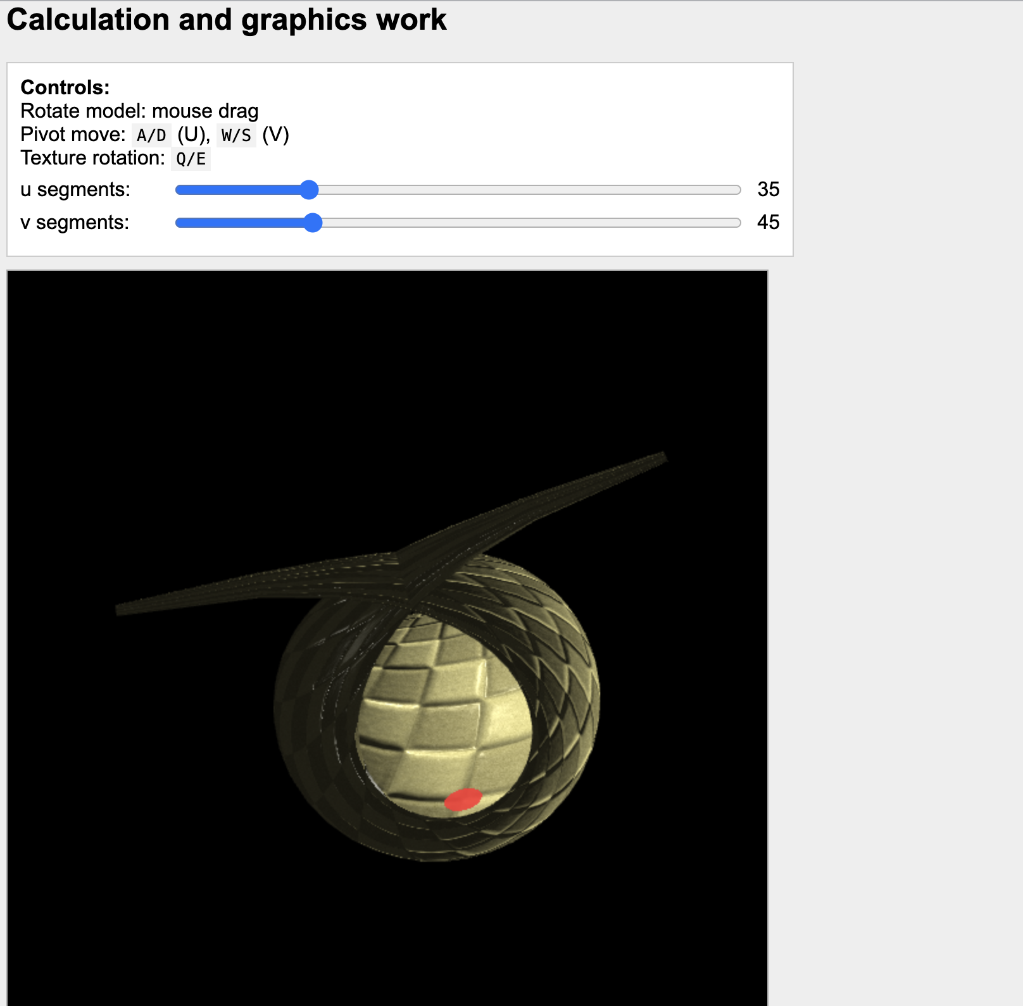
Figure 1. Initial view of the Sievert surface with textures.

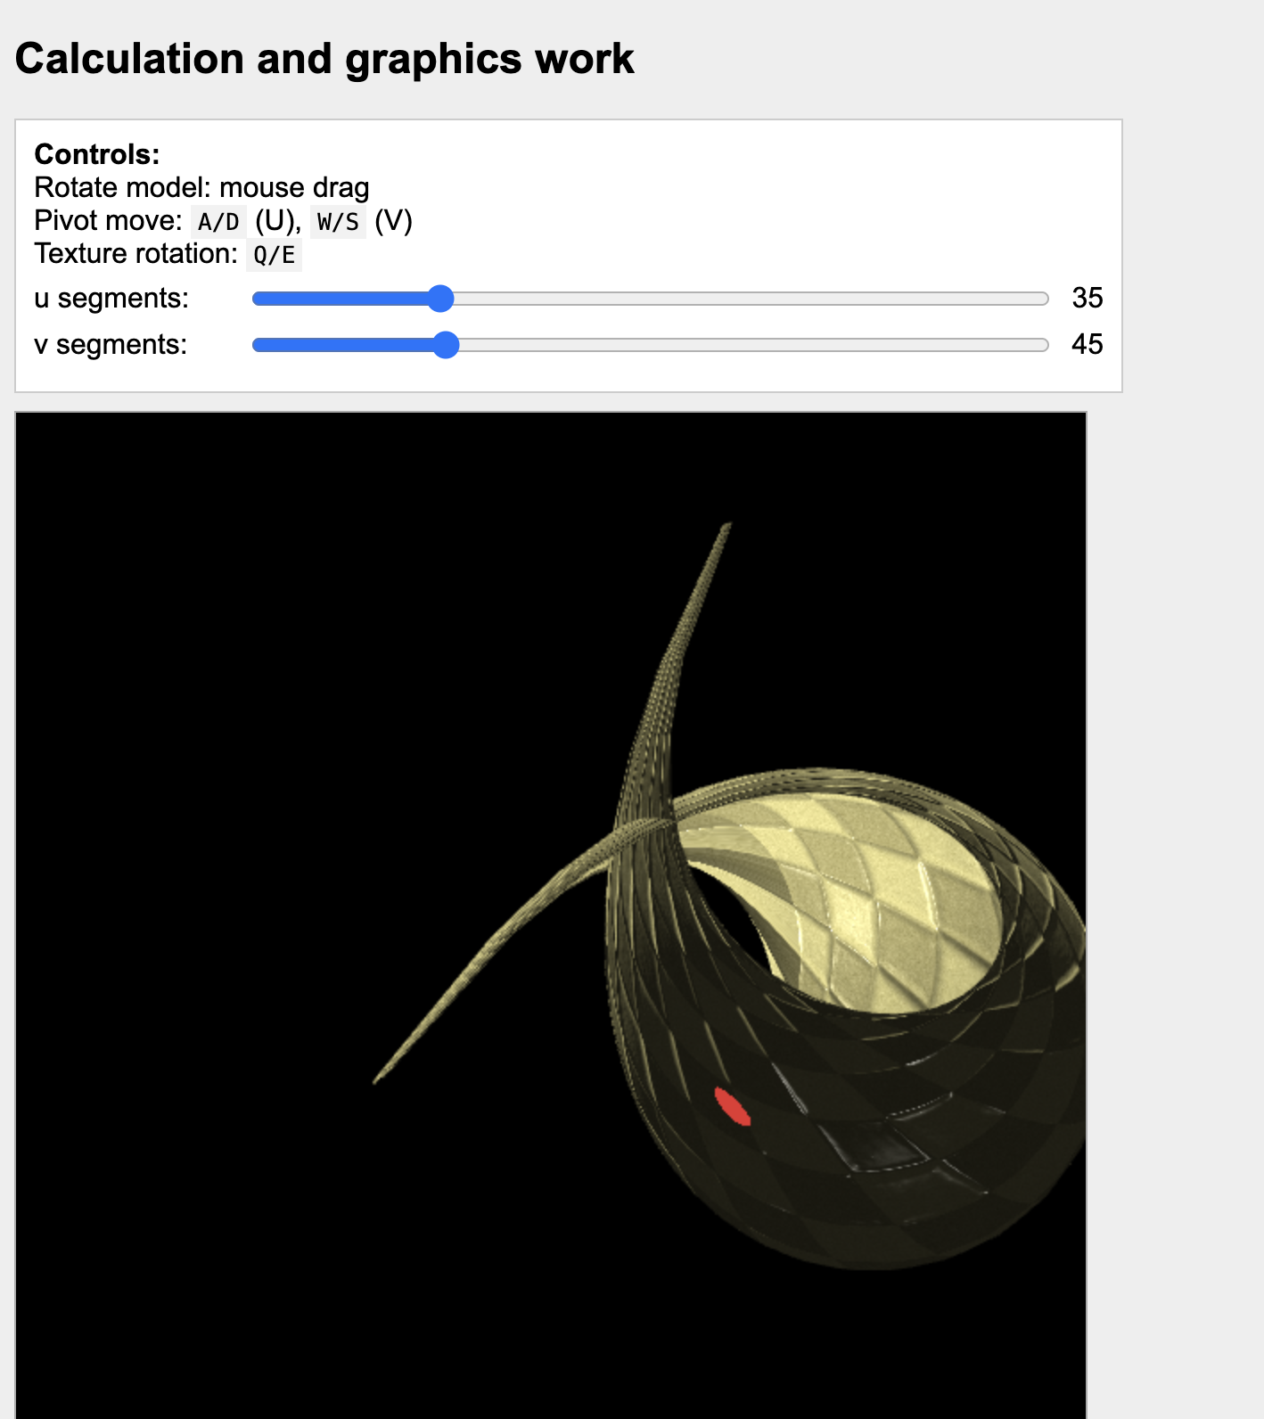
Figure 2. Pivot point moved along the surface parameter space.

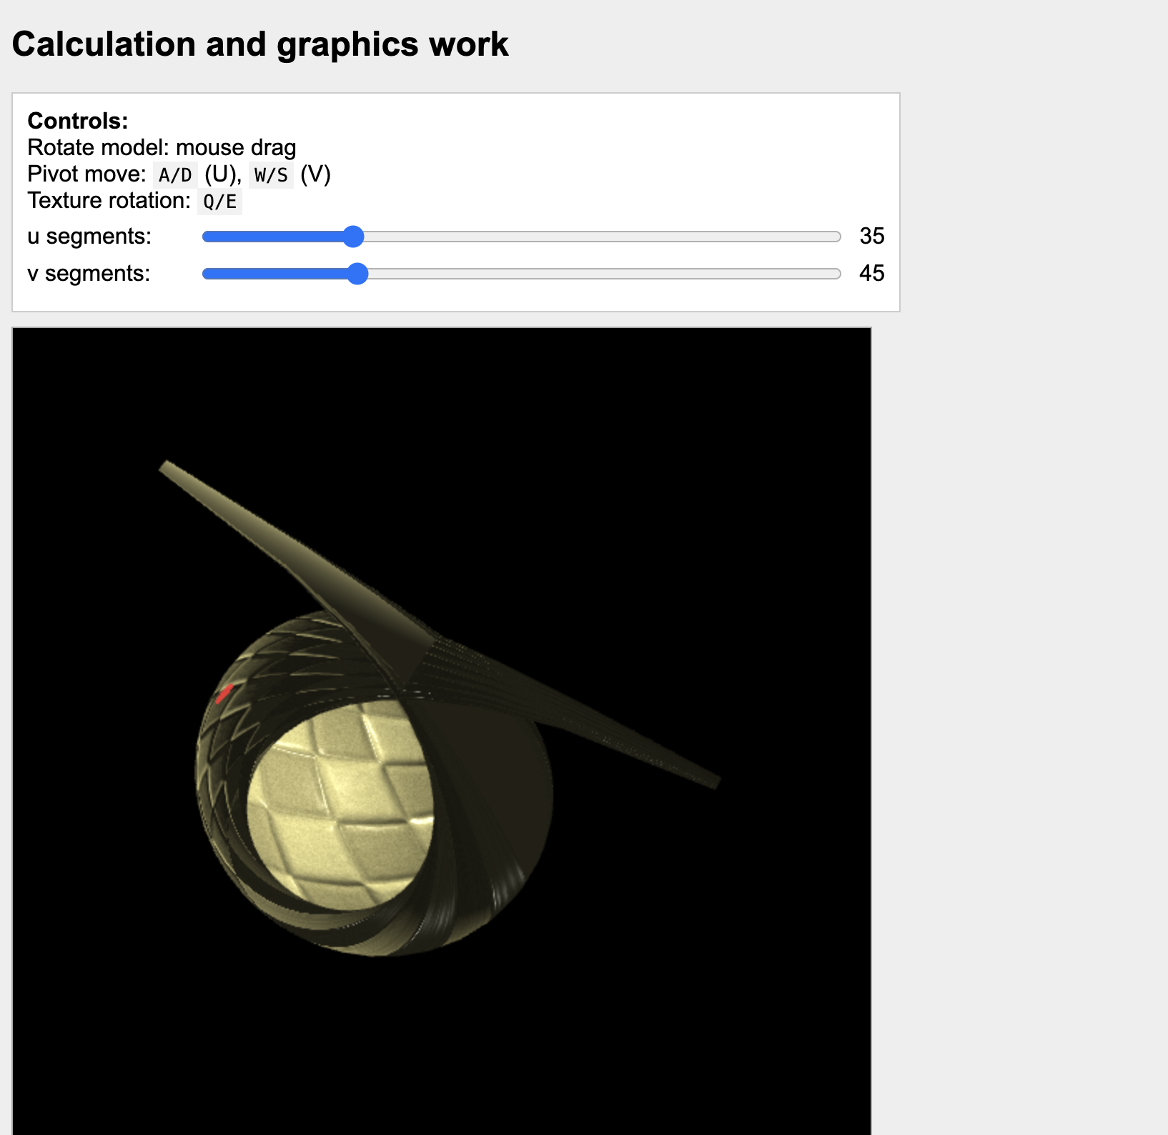
Figure 3. Texture rotated around the user-defined pivot point.

5. Sample of Source Code
'use strict';

let gl;
let surface;
let shProgram;
let spaceball;

let uSeg = 35;
let vSeg = 45;

let lightAngle = 0;
let lastT = 0;

let pivotU = 0.5;
let pivotV = 0.5;

let texAngle = 0.0;

const pivotStep = 0.02;

const autoRotateSpeed = 0.5;

const angleStep = 0.15;

function clamp01(x) {
return Math.max(0.0, Math.min(1.0, x));
}

function setupKeyboard() {
window.addEventListener('keydown', (e) => {
const k = e.key.toLowerCase();

if (k === 'a') pivotU -= pivotStep;
if (k === 'd') pivotU += pivotStep;
if (k === 'w') pivotV += pivotStep;
if (k === 's') pivotV -= pivotStep;

if (k === 'q') texAngle -= angleStep;
if (k === 'e') texAngle += angleStep;

pivotU = clamp01(pivotU);
pivotV = clamp01(pivotV);
});
}

function ShaderProgram(name, program) {
this.name = name;
this.prog = program;

this.iAttribVertex = -1;
this.iAttribTexCoords = -1;
this.iAttribNormal = -1;
this.iAttribTangent = -1;

this.iModelViewProjectionMatrix = -1;
this.iModelViewMatrix = -1;
this.iNormalMatrix = -1;

this.iTMU0 = -1;
this.iTMU1 = -1;
this.iTMU2 = -1;

this.iLightPosView = -1;
this.iShininess = -1;

this.iPivotUV = -1;
this.iTexAngle = -1;

this.Use = function () {
gl.useProgram(this.prog);
};
}

function mat4MulVec4(m, v) {
return [
m[0] * v[0] + m[4] * v[1] + m[8] * v[2] + m[12] * v[3],
m[1] * v[0] + m[5] * v[1] + m[9] * v[2] + m[13] * v[3],
m[2] * v[0] + m[6] * v[1] + m[10] * v[2] + m[14] * v[3],
m[3] * v[0] + m[7] * v[1] + m[11] * v[2] + m[15] * v[3],
];
}

function normalMatrixFromModelView(mv) {
return new Float32Array([
mv[0], mv[1], mv[2],
mv[4], mv[5], mv[6],
mv[8], mv[9], mv[10],
]);
}

function drawFrame(t) {
const dt = (t - lastT) * 0.001;
lastT = t;

texAngle += dt * autoRotateSpeed;

gl.clearColor(0, 0, 0, 1);
gl.clear(gl.COLOR_BUFFER_BIT | gl.DEPTH_BUFFER_BIT);

const projection = m4.perspective(Math.PI / 8, 1, 8, 12);
const modelView0 = spaceball.getViewMatrix();

const rotateToPointZero = m4.axisRotation([0.707, 0.707, 0], 0.7);
const translateToPointZero = m4.translation(0, 0.6, -9);

const matAccum0 = m4.multiply(rotateToPointZero, modelView0);
const matAccum1 = m4.multiply(translateToPointZero, matAccum0);

const modelViewProjection = m4.multiply(projection, matAccum1);

gl.uniformMatrix4fv(shProgram.iModelViewMatrix, false, matAccum1);
gl.uniformMatrix4fv(shProgram.iModelViewProjectionMatrix, false, modelViewProjection);
gl.uniformMatrix3fv(shProgram.iNormalMatrix, false, normalMatrixFromModelView(matAccum1));

lightAngle += dt * 0.8;
const R = 3.0;
const H = 1.0;
const lightWorld = [R * Math.cos(lightAngle), H, R * Math.sin(lightAngle), 1.0];
const lightView4 = mat4MulVec4(matAccum1, lightWorld);

gl.uniform3f(shProgram.iLightPosView, lightView4[0], lightView4[1], lightView4[2]);
gl.uniform1f(shProgram.iShininess, 32.0);

gl.uniform1i(shProgram.iTMU0, 0);
gl.uniform1i(shProgram.iTMU1, 1);
gl.uniform1i(shProgram.iTMU2, 2);

gl.uniform2f(shProgram.iPivotUV, pivotU, pivotV);
gl.uniform1f(shProgram.iTexAngle, texAngle);

surface.Draw();

requestAnimationFrame(drawFrame);
}

function initGL() {
const prog = createProgram(gl, vertexShaderSource, fragmentShaderSource);

shProgram = new ShaderProgram('PA3', prog);
shProgram.Use();

shProgram.iAttribVertex = gl.getAttribLocation(prog, 'vertex');
shProgram.iAttribTexCoords = gl.getAttribLocation(prog, 'tex');
shProgram.iAttribNormal = gl.getAttribLocation(prog, 'normal');
shProgram.iAttribTangent = gl.getAttribLocation(prog, 'tangent');

shProgram.iModelViewProjectionMatrix = gl.getUniformLocation(prog, 'ModelViewProjectionMatrix');
shProgram.iModelViewMatrix = gl.getUniformLocation(prog, 'ModelViewMatrix');
shProgram.iNormalMatrix = gl.getUniformLocation(prog, 'NormalMatrix');

shProgram.iTMU0 = gl.getUniformLocation(prog, 'iTMU0');
shProgram.iTMU1 = gl.getUniformLocation(prog, 'iTMU1');
shProgram.iTMU2 = gl.getUniformLocation(prog, 'iTMU2');

shProgram.iLightPosView = gl.getUniformLocation(prog, 'LightPosView');
shProgram.iShininess = gl.getUniformLocation(prog, 'Shininess');

shProgram.iPivotUV = gl.getUniformLocation(prog, 'PivotUV');
shProgram.iTexAngle = gl.getUniformLocation(prog, 'TexAngle');

console.log('PivotUV loc:', shProgram.iPivotUV);
console.log('TexAngle loc:', shProgram.iTexAngle);

const data = {};
CreateSurfaceData(data, uSeg, vSeg);

surface = new Model('SievertSurface');
surface.BufferData(
data.verticesF32,
data.indicesU16,
data.texcoordsF32,
data.normalsF32,
data.tangentsF32
);

surface.idTextureDiffuse = LoadTexture('./textures/diffuse.jpg');
surface.idTextureSpecular = LoadTexture('./textures/specular.jpg');
surface.idTextureNormal = LoadTexture('./textures/normal.jpg');

gl.enable(gl.DEPTH_TEST);
gl.depthFunc(gl.LEQUAL);
}

function createProgram(gl, vShader, fShader) {
const vsh = gl.createShader(gl.VERTEX_SHADER);
gl.shaderSource(vsh, vShader);
gl.compileShader(vsh);
if (!gl.getShaderParameter(vsh, gl.COMPILE_STATUS)) {
throw new Error('Error in vertex shader: ' + gl.getShaderInfoLog(vsh));
}

const fsh = gl.createShader(gl.FRAGMENT_SHADER);
gl.shaderSource(fsh, fShader);
gl.compileShader(fsh);
if (!gl.getShaderParameter(fsh, gl.COMPILE_STATUS)) {
throw new Error('Error in fragment shader: ' + gl.getShaderInfoLog(fsh));
}

const prog = gl.createProgram();
gl.attachShader(prog, vsh);
gl.attachShader(prog, fsh);
gl.linkProgram(prog);
if (!gl.getProgramParameter(prog, gl.LINK_STATUS)) {
throw new Error('Link error in program: ' + gl.getProgramInfoLog(prog));
}
return prog;
}

function setupSliders() {
const uSlider = document.getElementById('uSlider');
const vSlider = document.getElementById('vSlider');
const uVal = document.getElementById('uVal');
const vVal = document.getElementById('vVal');

if (!uSlider || !vSlider) return;

uSlider.value = String(uSeg);
vSlider.value = String(vSeg);
if (uVal) uVal.textContent = String(uSeg);
if (vVal) vVal.textContent = String(vSeg);

const rebuild = () => {
uSeg = Math.max(10, parseInt(uSlider.value, 10) || 35);
vSeg = Math.max(10, parseInt(vSlider.value, 10) || 45);

if (uVal) uVal.textContent = String(uSeg);
if (vVal) vVal.textContent = String(vSeg);

const data = {};
CreateSurfaceData(data, uSeg, vSeg);
surface.BufferData(
data.verticesF32,
data.indicesU16,
data.texcoordsF32,
data.normalsF32,
data.tangentsF32
);
};

uSlider.addEventListener('input', rebuild);
vSlider.addEventListener('input', rebuild);
}

function init() {
let canvas;
try {
canvas = document.getElementById('webglcanvas');
gl = canvas.getContext('webgl');
if (!gl) throw 'Browser does not support WebGL';
} catch (e) {
document.getElementById('canvas-holder').innerHTML =
'<p>Sorry, could not get a WebGL graphics context.</p>';
return;
}

try {
initGL();
} catch (e) {
document.getElementById('canvas-holder').innerHTML =
'<p>Sorry, could not initialize the WebGL graphics context: ' + e + '</p>';
return;
}

spaceball = new TrackballRotator(canvas, () => {}, 0);
setupSliders();
setupKeyboard();

requestAnimationFrame(drawFrame);
}

